DEEPFISHMAN

A FP7 Project: Management and Monitoring
of Deep-sea Fisheries and Stocks

Case Study 3b:
Artisanal fisheries:
Vulnerable - Red blackspot seabream (Pagellus bogaraveo) fishery in the
eastern Mediterranean Sea

Project participant No 10:
Hellenic Centre for Marine Research, Athens GREECE
Athens, January 2010

Compiled by: Dimitrios Damalas
Chryssi Mytilineou
Chryssi-Yianna Politou

Table of contents

Executive summary 5
Section 1: Biological parameters with up to date description of the current knowledge of life history pattern, stock structure and status 6
1.1. General information 6
1.2. Stock identity and status 8
1.3. Life history characteristics (LHCs) 9
1.4. Life history pattern and general species ecology 11
Section 2: Historical development of the fisheries, including catches and fleets. 14
2.1 Background information 14
Section 3: Review of stock assessments carried out thus far 18
3.1. General overview 18
3.2 Input data 18
3.3 Assessment method(s) used 19
3.4 Biological reference points (BRPs): 19
3.5 Projections 19
3.6 Assessment packages/programs used (e.g. FLR, CEDA, ASPIC, Lowestoft XSA etc) 20
3.7 Quality control/peer review 20
Section 4: Data inventory 23
4.1 Fisheries data 23
4.1.1 Fleet composition 23
4.1.2 Effort data 24
4.1.3 Landings and discards data 25
4.1.4 VMS data 26
4.1.5. Observer data 27
4.1.6. Fishing footprint 28
4.1.7. Abundance indices derived from commercial catch and effort data 30
4.1.8. Information and data made available by fishers, fisher organisations or other stakeholders 31
4.1.9. Fisheries data in general 31
4.2 Fisheries-independent survey data 32
4.3 Biological data for your stock 40
4.4 Ecosystem, biodiversity and VME data (see footnote 1 on page 2 for definition of VME) 41
4.4.1 Background information 41
4.4.2 Data available in support of ecosystem based management. 43
4.4.3 Protected, Endangered and Threatened (PET) species (part of Descriptor 1) 45
4.4.4 Ecosystem modelling (Descriptors 4,5) 47
4.4.5 Fishery interactions (Descriptors 1,6) 47
4.4.6 Pollutants and contaminants (Descriptor 9): 48
4.4.7 Vulnerable Marine Ecosystems (VMEs) (Descriptor 1) 48
4.5 Socio-economic data 49
4.5.1 For each fleet ID please provide/detail/describe:- 50
4.5.2 For the country of each fleet ID please provide/detail/describe:- 53
4.5.3 General: 53
Section 5: Review of known and likely impact of the fisheries on deep-water biodiversity and VMEs. 54
Section 6: Review of current and historical management and monitoring procedures 55
6.1 Management procedures 55
6.2 Management procedures at the stock level 57
6.3 Management procedures at the fisheries level 58
6.4 Management procedures at the ecosystem level 58
6.5 Management procedures relating to VMEs 58
6.6 Management procedures relating to PET species 58
6.7 Comparison of management measures introduced against scientific advice 59
6.8 Data-poor stocks and the Precautionary Approach (PA) 59
6.9 Ecosystem and socio-economic considerations. 60
6.10 Stocks under moratorium/collapsed fisheries 60
6.11 Stocks managed under a management strategy framework 60
6.12 International Plan of Action (IPOA) 60
6.13 Current/short term (<5 yrs) management issues 60
6.14 Long-term (>5 yrs) management issues 61
6.15 Monitoring procedures 61
6.16 Monitoring at sea 61
6.17 Port-based monitoring 62
6.19 Gap analysis of past and present scientific projects and data collection programmes 63
6.20 Fisheries monitoring in general 63
Section 7: Please review the key uncertainties about the biology, data and management for your stock and any other issues relevant to DEEPFISHMAN 64

Executive summary

The eastern Ionian Sea hosts, among others, population(s) of the red blackspot seabream (Pagellus bogaraveo), which is a fish species residing in depths from 20m down to 700 m of depth. Although P. bogaraveo is a valuable commercial species, it has been disregarded by the scientific community so far, and as a result, solid scientific advice on the current status of the stock is not available to date. Uncertainties exist on various aspects of its life cycle such as: reproductive patterns, length at first maturity, spawning biomass, natural mortality, all of them hindering the reliable assessment of the stock
Fishing for P. bogaraveo in the Greek Ionian waters has been carried out since the beginning of 80’s till the end of 90’s mainly by long lines. Afterwards, a new fishery with gill nets has been developed. Bottom trawl landings are insignificant, however trawlers are considered the prime source of mortality on the immature part of the population, discarding most of their catches. In the gillnet fishery, P. bogaraveo consists a 75% in number and a 50% in weight. In the longline fishery these numbers are even higher. In the trammelnet and bottom trawl fisheries, the species comprises a negligible by-catch (< 1%). Approximately 280 boats are involved in the target fishery, while another 1100 boats catch P. bogaraveo incidentally (by-catch), landing between 150-200 tonnes annually. VMS data are not available for scientific analysis, and monitoring of the fleets is inadequate. Furthermore, observer data gathered in the framework of the EU-DCR, do not include the target fisheries.
As a result, analytical stock assessments have never been carried out for the species and a significant effort of this project was exerted towards estimating parameters describing the status of the stock. Both surplus production models applied (Schaefer and Fox) suggested that the current level of exploitation is within sustainable limits (MSY=157-168 tons, Effort_{MSY}= 20000-26000 Days At Sea). Pseudo-cohort VPA runs, revealed that the immature part of the population does not suffer from the intense fishing pressure that the older age classes do. Fishing mortality increases monotonically by age and this is a result of the malapportioned fishing pressure by the different fishing gears. The most recent research (2001), pointed out that the stock is under alarming fishing pressure. It was observed that the coastal longline fishery has collapsed, and has been replaced by a gillnet fishery, with catches plummeting throughout the years. However, data from 2004 and onwards show that the stock is recovering (increasing abundance indices; constant or increasing average size of population).
Ecosystem modelling work in the study area has not been conducted so far. In general, there is a gap in our knowledge regarding linkage of fisheries with ecosystem data. FAO guidelines on Vulnerable Marine Ecosystems (VME) identification and composition have not yet been interpreted in the stock area.
From a socio-economic point of view, approximately 2300 people are employed in the target fishery, which is seasonal in nature (summer months) and contributes a scant 2500 €/season/boat. However, these estimates are based on the official landings values. Most fishers market their catches unofficially in much higher prices, and their revenues from the P. bogaraveo fishery may actually be significantly higher.
From a managerial perspective, the absence of TAC’s as a management measure in the Mediterranean, has established the belief that stock assessment is of no use, if no quotas are to be set. Therefore, scientific advice has been directed to selectivity studies, suggesting technical measures such as minimum landing sizes or legal mesh sizes. Some management procedures that have been tried in the past, and have not been successful, include the establishment of a 12 cm TL Minimum Landing Size (MLS) for P. bogaraveo. Nowadays, MLS is set to 33 cm TL, which is actually inapplicable. Furthermore, prior to 2006, the mesh size of the trawl net was 28 mm, which was not successful. To date it is 40 mm. Its adequacy is to be evaluated in the future. Recently, recreational fishing was limited to the use of hooks and lines only, and all kind of net fishing was banned. Taking into account the vast number of amateur fishers in Greece, this measure might have a larger effect than actually anticipated. Improvements in the current management procedures would be the identification of spawning areas as well as nursery grounds. This would allow the establishment of spatial and seasonal closures.

Section 1: Biological parameters with up to date description of the current knowledge of life history pattern, stock structure and status

General information
1.1.1 Name of stock:
1.1.2 Please include map of the spatial area inhabited by your stock (include depth contours and topographical features).
1.1.3 What is the depth range inhabited by the adult stock?
1.1.4 Name the scientific organisation and Working Group responsible for carrying out stock assessments and providing scientific advice.
1.1.5 Name the Fisheries Management Organisation(s) responsible for managing the stock and supported fisheries.
1.1.6. Is the management unit the same as the stock assessment unit? If not please explain why.

The species under study is the Red blackspot seabream (Pagellus bogaraveo) and specifically the stock residing in the eastern Ionian Sea (FAO-GFCM Sub-Area GSA-20 – Fig. 1.1).
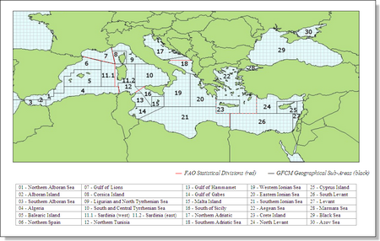
Figure 1.1.FAO-GFCM sub-areas map

Adult P. bogaraveo inhabit depths ranging around 300-700 m (specimens >20 cm TL are considered adults, since the smaller mature specimen was found to be 19.7 cm of TL) (unpublished data, Anonymous, 2001). Young specimens (<15 cm TL) are generally found in waters less than 100 m of depth.
A presence map of P. bogaraveo in the study area (Fig. 1.2) as inferred from scientific surveys and commercial fishing monitoring, depicts the wide distribution of the species both on the continental shelf, as well as the continental slope.
The consistent occurrence of some specimens in the continental shelf is most likely illustrating the increased abundance of juveniles in the shallow coastal areas, a fact that is strongly supported by the significant relation between size and depth (Fig. 1.3). However, juveniles may some times be found down to even 700 m of depth. (Fig. 1.3).
To date there are no clearly defined management/assessment units and the species is not currently assessed, since the species is not among the target species list of EU-DCR. However, FAO-GFCM suggests that the eastern Ionian Sea should be considered as a separate management unit (GSA-20). On a state level, the organization responsible for managing the fisheries is the Greek Ministry of Rural Development and Food. Scientific advice is occasionally provided by FAO-GFCM and the EU-STECF.

Figure. 1.2. Map of the studied stock area, showing the sites where P. bogaraveo was found during various surveys (left) and the main depth strata (light blue & red) of the presence of the species (right).
Figure 1.3. Size(TL) - Depth scatter-plot for P. bogaraveo in the eastern Ionian Sea

Stock identity and status
1.2.1 Describe and review the scientific basis used to identify and delineate the stock.
1.2.2 Is this robust? If not what studies are required to identify and delineate the stock more robustly?
1.2.3 Describe and review any past or ongoing studies of stock identity.
1.2.4 Are there any stocks of this species adjacent to the Case Study stock?
1.2.5 Is it suspected that immigration/emigration is occurring from/to areas outside the stock area? If so please describe.
1.2.6 Have any tagging studies been carried out? If not please state why. If they have please summarise methods used and
review results and conclusions.
1.2.7 Are there any aspects of stock identity knowledge data that [a] impact on assessments and/or [b] affect your ability to provide timely fisheries advice to managers?
1.2.8 Based on the latest scientific advice for this stock (please append below), what is the current status of the stock?
1.2.9 What is the recent historical trend in the stock (increasing, decreasing, stable).

No genetic or morphometric studies to identify and delineate the stock have ever been conducted in the study area. Furthermore, no tagging experiments have been carried out and movements to and from adjacent areas (GSA 19 – west Ionian; GSA23 – Aegean Sea) may be occurring. Although P. bogaraveo is a valuable commercial species, it has been disregarded by the scientific community so far, and as a result, further investigation is needed to delineate the stock reliably; just to mention some:
- genetic studies
- study of the morphometric characteristics among different regions
- tagging experiments
- ichthyoplankton studies

Some limited information related with the stock can be extracted out of various research projects aimed to achieve other objectives (Papaconstantinou et al. 1987; MEDITS reports 1994-2008; Petrakis et al. 1999; Petrakis et al. 2001; Anonymous, 2001; Mytilineou et al. 2003; EU-DCR NDCP reports 2003-2008). Such info may include:
- geographical and bathymetrical distribution,
- aspects of life history,
- feeding and
- population structure
- selectivity experiments

Consequently, solid scientific advice on the current status of the stock cannot be given. Petrakis et al. (2001) provided some plain advice concerning the management of red blackspot seabream gillnet fishery in the area. Their main suggestions were:
(1) establishment of a minimum mesh size of 90 mm, and
(2) fishery closure during the reproduction period

However, this straightforward “unsophisticated” management plan was not taken into consideration by the Ministry.
The new regulation (EU COM 1967/2006), increasing the MLS to 33 cm TL, seems not applicable (Mytilineou & Machias, 2007) and it is not taken into consideration by the fishers. Therefore, limited changes in the management of the stock could be considered the last decade:
- increase of the trawl mesh size to 40 mm in 2001 (Note: the species consists a small by-catch in the trawl fishery);
- ban of net-fishing in recreational fisheries (EU COM 1697/2006).
The recent historical trend in the stock, based on available landings data is contradictory. National Statistical Service of Greece (NSSG) trends are slightly declining from 1994 to 2004 (Mytilineou & Machias, 2007) with an increase afterwards, while EU-DCR NDCP annual landings estimations fluctuate through the years (NDCP, 2008). On the other hand, experimental fishery independent surveys have shown an increasing trend in the species biomass from 2003 and afterwards (MEDITS survey).

The lack of knowledge regarding both the biological parameters of the stock as well as the impact of the fishery on the population, stand as the most significant obstacles in the managers’ path to provide reliable fisheries advice.

Life history characteristics (LHCs)

1.3.1 Complete the following table citing (1) the most robust information available and (2) any other information available. Please cite the reasons for selecting the former. Cite information by sex & sexes combined, where appropriate. Please document any changes with time.

1.3.2 What are the main gaps in knowledge regarding LHCs?

1.3.3 Can these gaps be addressed by regular monitoring or are dedicated research initiatives required? Please describe programmes required.

1.3.4 Are there any aspects of LHC data (quality, temporal and spatial extent, time series, availability, accessibility, flow) that [a] impact on assessments and/or [b] affect your ability to provide timely fisheries advice to managers?

The main gaps in knowledge regarding LHCs concern population size structure, hermaphroditism, sex ratios, maturity and natural mortality rates.
Size composition from fisheries targeting the stock (gill nets, long lines) is lacking small specimens. The juvenile portion of the population is mainly caught and discarded by trawlers, which principally operate in waters shallower than those encountered by large specimens.
Although spawning period is assumed to take place during the winter months in the Western Mediterranean, in the British isles it is reported that spawning occurs in summer (Bauchot & Hureau, 1986). In the Greek waters, Petrakis et al. (2001), although lacking winter samples, assumed that this was the spawning period, mainly because no mature specimens were identified in their spring and summer samples. However, unpublished data from experimental surveys and observations on-board commercial boats revealed that late summer may actually be the spawning season. Samples from ichthyoplankton surveys (unpublished data) fortify this belief. Anyway, the reproductive potential (fecundity) and maturity estimates (Length at first maturity) are still to be confronted.
Specific LHC characteristics that are unknown to date include: natural mortality (M), recruitment (period, size at), young-adults separation, reproduction (spawning period, size at maturity), hermaphroditism.
A summarized report including the most robust information available to date is given in Table 1.3.1. below.

Table 1.3.1. Life history characteristics summarized information for P. bogaraveo in the eastern Ionian Sea.
LHC | Best estimate | Derived from? | Other estimates
Maximum observed length | 49 cm | Mytilineou & Machias, 2007 (and references therein)
Maximum observed age | 9 years (33.8 cm TL) – otolith reading  (considered more accurate because otoliths do not present so many false rings as scales, although re-reading seems necessary) | Chilari et al., 2006 | 13 years (38.2 cm TL) –scales reading (Chilari et al., 2006)  (re-reading seems necessary)
Length at 50% maturity | N/A |  | min length of mature female 19.7 cm (unpublished data, Anon., 2001)
Age at 50% maturity | N/A |  | Min age of mature female: 3 years (according to age-length key of Chilari et al., 2006)
Length at recruitment | Min length:15 cm (gillnets)  Min length: 7 cm (bottom trawl) | Petrakis et al., 2001  Papaconstantinou et al., 1987
Age at recruitment | 1+ (gillnets)  0+ (bottom trawl)  (according to the age- length key of Chilari et el., 2006)
Growth parameters: (von Bertalanffy parameters: k, t₀, L infinity, for example) | Females:  t₀ =-2.28, k=0.10,  L_{inf}=49.5  Males:  t₀ =-1.81, k=0.106,  L_{inf}=49.2  (considered more accurate since a large range of sizes was included in the analysis) | Chilari et al., 2006  Age classes : 2-9 | (Mytilineou & Papaconstantinou,, 1995)  Age classes : 0-3  t₀ =-2.72, k=0.186,  L_{inf}=25.1  (not accurate)
Fecundity, egg size etc | N/A
Natural mortality | N/A

Some of these gaps can be addressed by regular monitoring; e.g.: P. bogaraveo could be added to the Greek EU DCR-NDCP target species list, so that data will be routinely gathered under the established sampling scheme (on-board observations; market samplings; landings recording). Such valuable information may elucidate some aspects of the stock.
On the other hand, dedicated research initiative is needed, since regular monitoring under the EU DCR-NDCP scheme may not suffice to clarify all our uncertainties. This is mainly due to:
- the very small fraction of the fishing fleet that is actually sampled (no census sampling is carried out in the Greek scheme), and
- fishery closures and seasonality: trawlers are banned during summer, whereas the peak season for the target fisheries (nets and longliners) is summer, due to the increase of market prices and better weather conditions.
These limitations pose serious obstacles in obtaining homogenous and good quality data sets in time and space, and the need for fishery-independent research is obvious.
Experimental surveys carried out on a seasonal basis, by different depth strata and habitats, will allow for truthful determination of spawning period, size at maturity, sex ratio, and young-adults separation. Furthermore, they will confirm the protandric nature of the species, and finally provide a solid size composition for the stock.

Life history pattern and general species ecology
1.4.1 Reproductive type: is the species gonochoric or hermaphroditic? If hermaphroditic, please describe.
1.4.2 Spawning type: is the species a determinate or batch spawner? Please give details.
1.4.3 Spawning grounds: are the spawning grounds/areas known? If so please describe and include map.
1.4.4 Spawning time: when does spawning occur? Does this differ by spawning ground/area? If so please describe.
1.4.5 Early life history: are the early life stages well described and documented in the scientific literature? If so please describe.
1.4.6 Life stages and habitats: whereabouts in the water column are the various life cycle stages found?
1.4.7 Nursery areas: are there discrete nursery areas? Is so please describe and include map.
1.4.8 Are juveniles and adults associated with particular topographical features and/or sea-bed substrates? If so please describe.
1.4.9 Recruitment: what is the age and size of recruitment to the fishery? What is the age and size of smallest individuals in scientific cruises? What is known about recruitment variability and its causes?
1.4.10 Describe other salient aspects of the species life cycle not described above.
1.4.11 Feeding: list the main prey items of each life stage and rank in order of consumption rates/importance, where possible.
1.4.12 Predators: list the main predators of each life stage and rank in order of consumption rates/importance, where possible.
1.4.13 What are the main gaps in knowledge regarding life history patterns and general species ecology?
1.4.14 Further data collection/research requirements: can these gaps be addressed by regular monitoring or are dedicated research initiatives required? Please describe programmes required.
1.4.15 Are there any aspects of life history pattern and general ecological information and data (quality, temporal and spatial extent, time series, availability, accessibility, flow) that [a] impact on assessments and/or [b] affect your ability to provide timely fisheries advice to managers.

The species reproductive type is hermaphroditic. It is considered to be protandric and most males change sex to females (Krug, 1990). Hermaphrodite fish in the Greek seas were observed, in lengths between 200 and 320 mm. Almost all larger fish, were females. (Petrakis et al., 2001).
It is a batch spawner (Buxton & Garratt, 1990), however spawning period and grounds in the study area are issues yet to be confronted. Karrer (1984) has described the early life stages (larvae) in the NW African coast. Larvae are pelagic, floating in the water column just below the thermocline (Lo Bianco, 1909; Giovanardi & Romanelli, 1990). No scientific literature exists to date for the study area. However, unpublished data from ichthyoplankton surveys identified P. bogaraveo larvae (sized between 4-7 mm) during September in the central Aegean Sea.
Juveniles and adults are associated with particular topographic features and sea-bed substrates. Juveniles are frequently observed in shallower waters (<100 m) near estuaries, while adults reside in deeper waters, especially near banks (Bauchot et al., 1986).
Discrete nursery areas are not designated in the literature. However, some indications can bee drawn from size data of various scientific surveys (see Fig 1.4. below - red triangles indicate areas where juveniles (0+ group) were found in abundance). It is unknown if these areas are discrete, however the presence of juveniles was consistent throughout the years in some of these regions. Generally, young of the year were found in waters <50 m of depth and near major river mouths.
Size of recruits depends on the fishery. In the target fishery (static bottom gillnets) the smallest length class consists of fish 15 cm TL. In the bottom trawl fishery (by-catch), this size reduces to 7 cm TL. The smallest individuals encountered in scientific cruises were fish as small as 6.5 cm (0+ age group – MEDITS survey). No information on recruitment variability is available.
Info on feeding habits comes also in short supply. For a sample consisting of recruits/juveniles, prey items in order of occurrence in stomachs were: Crustaceans, Bivalves, Amphipods, Fish, Copepods (Papaconstantinou et al., 1994). Empirical information out of fishermen interviewed, suggests that stomachs were full of numerous small black fish, presumably Stomias boa boa.
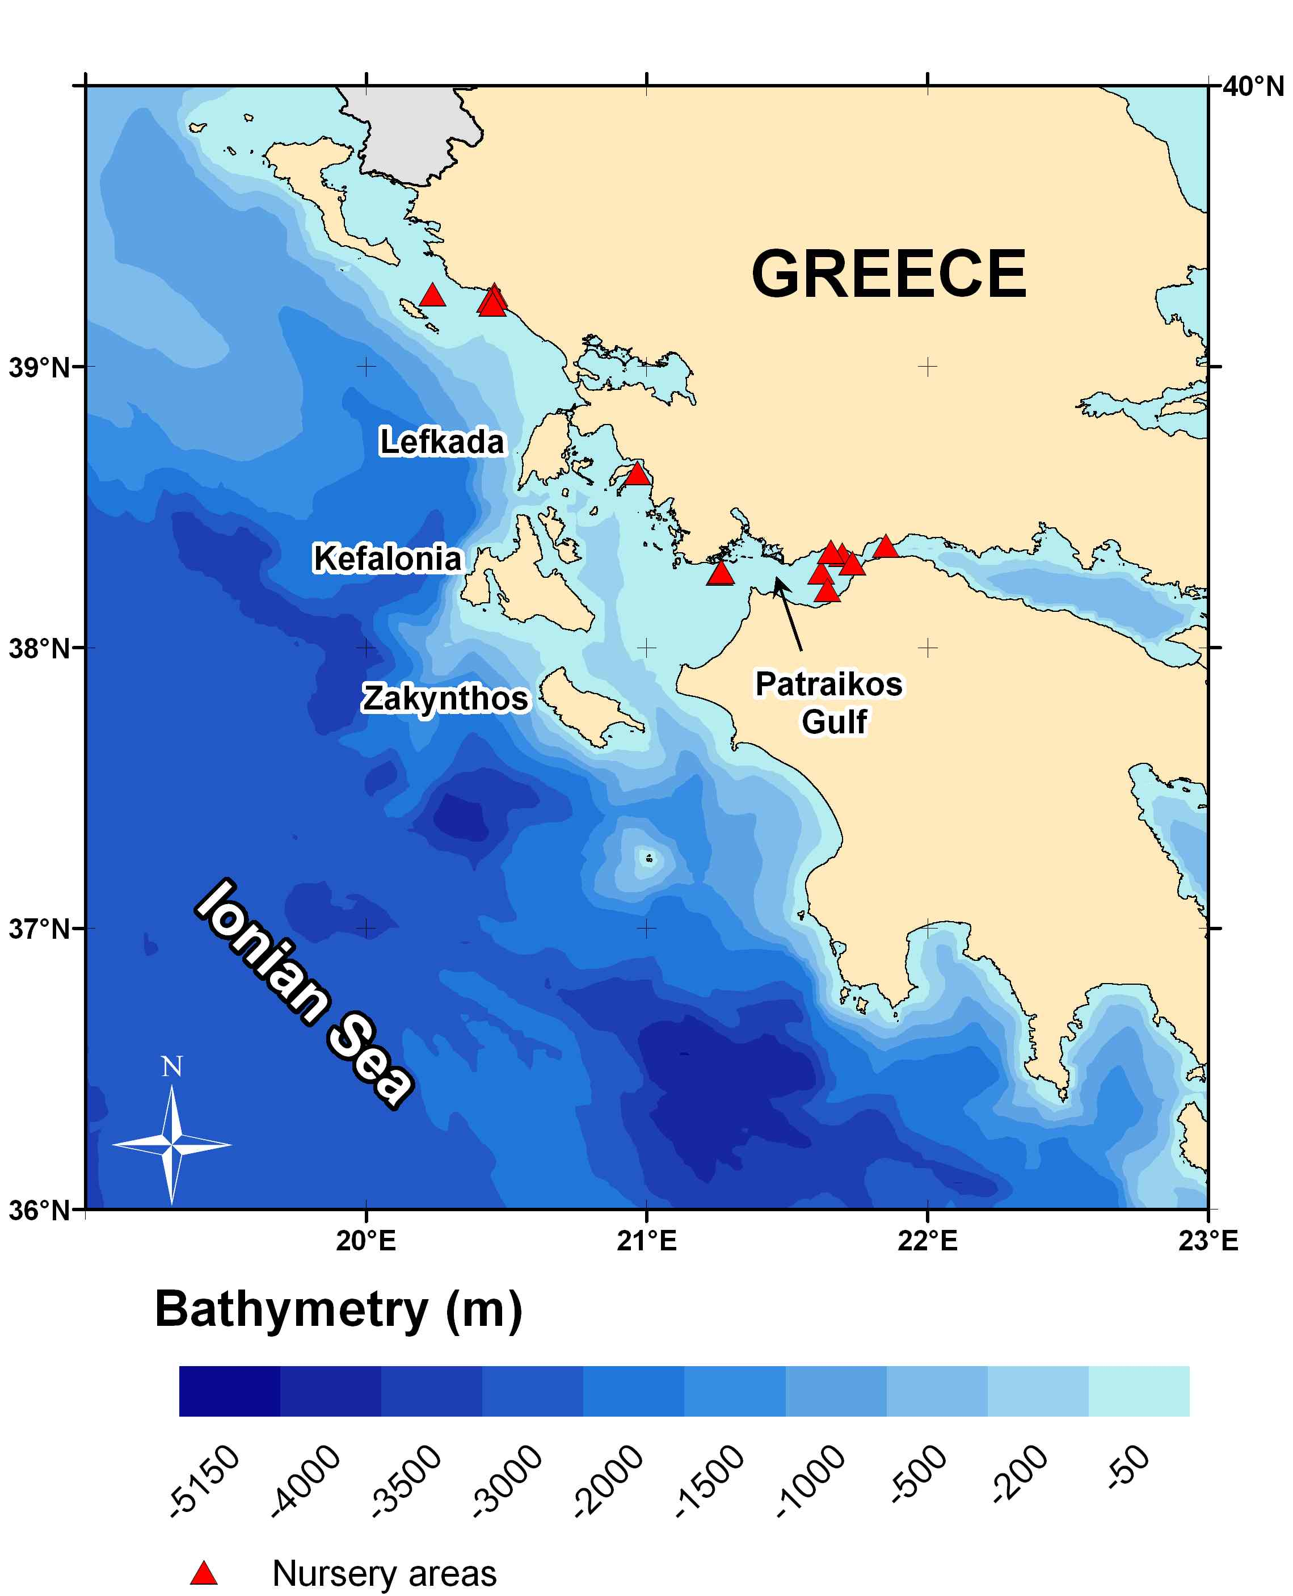
Main predators are unknown in the Greek waters, however studies in other areas (Azores – Gomes et al., 1998) cite that Conger conger, Raja clavata and Galeorhinus galeus must be considered as potential predators. All three species are present in the Ionian Sea area.

Figure. 1.4. Plausible nursery areas of P. bogaraveo in the eastern Ionian Sea

Concluding, the main gaps in knowledge regarding life history patterns and general species ecology can be summarized in:

- Reproductive pattern: Where are the potential spawning grounds? Fecundity estimates? Role of hermaphroditism in the catch composition?
- Feeding biology: how does it evolve during life stages? Which are the potential predators? Which areas designate the feeding grounds?
- Migration: is there a migratory pattern? Is it seasonal? Is it uni- or multi-directional? Why is the species migrating (feeding, spawning, wintering)? Is segregation by sex or age classes occurring?

Dedicated research initiatives are needed. Seasonal experimental surveys should be carried out, by different depth strata acquiring biological samples (gonads, stomachs, hard parts for ageing). Uncertainties exist on various aspects such as: Reproductive patterns, Length at first maturity, Spawning biomass, natural mortality, all of them hindering the reliable assessment of the stock

REFERENCES
Anonymous, 2001. Exploration of the renewable marine biological resources in the deep waters (INTERREG II Greece-Italy). Final Report, vol. IV, 281p.
Bauchot, M. L. and Hureau, J. C., 1986. Sparidae. In: Fishes of the North-eastern Atlantic and the Mediterranean. UNESCO, 2: 516-1007.
Buxton, C.D. and P.A. Garratt 1990 Alternative reproductive styles in seabreams (Pisces: Sparidae). Environ. Biol. Fish. 28(1-4):113-124.
Chilari A., Petrakis G. & Tsamis E., 2006. Aspects on the biology of blackspot seabream (Pagellus bogaraveo) in the Ionian Sea, Greece. Fisheries Research, 77: 84-91.
Giovanardi, O. and M. Romanelli 1990 Preliminary observations on the seasonal presence of teleostean larvae in the Tyrrhenian Sea. Rapp. Comm. Int. Mer Méditerr. 32(1):303.
Gomes, T.M., E. Sola, M.P. Grós, G. Menezes and M.R. Pinho 1998 Trophic relationships and feeding habits of demersal fishes from the Azores: importance to multispecies assessment. ICES C.M. 1998/O: 7.
Karrer, C., 1984. Beschreibung von Jugendstadien dreier Spariden-Arten aus dem nordwest- afrikanischen Auftriebsgebiet (Teleostei, Perciformes). Arch. FischWiss. 35(1/2):53-90.
Krug, H. M., 1990. The Azorean blackspot seabream, Pagellus bogaraveo (Brünnich, 1768) (Teleostei: Sparidae): Reproductive cycle, hermaphroditism, maturity and fecundity. Cybium, vol. 14, no. 2: 151-159.
Lo Bianco, S. 1909. Notizie biologiche riguardanti specialmente il periodo di maturita sessuale degli animali del golfo di Napoli. Mitt. zool Stn Neapel, 19: pp. 513-761.
Mytilineou Ch. & Papaconstantinou C., 1995. Aspects on the biology of blackspot seabream, P. bogaraveo (Brűnnich,1768) in the northern Aegean Sea (Greece). Rapp. Commm. Int. Mer Medit, 34: 251p.
Mytilineou, Ch., Tursi, A., Kavadas, S., D’onghia, G., Kapiris, K., Politou, C.-Y., Maiorano, P., Lefkaditou, E., Sion, L., Dogrammatzi, K., Dokos, J., Fourtouni, A., Papaconstantinou,C., Bekas, P., Christidis, G., Karkani, A., Chilari, A., Carlucci, R., Capezzuto, F. & Panza, M., 2003. Exploration of pristine red shrimp resources and comparison with exploited ones in the Ionian Sea (RESHIO). Final report, 209 p.
Mytilineou, Ch. & Machias, A., 2007. Deep-water fisheries resources in the Hellenic Seas. In: State of Hellenic Fisheries. Papaconstantinou, C., Zenetos, A., Vassilopoulou, V., & Tserpes, G. (eds), HCMR Publ.: 213-222.
NDCP, 2008. National Fisheries Data Collection Regulation (In application of regulation EC 1543/2000). Collection of data related to fishing effort. Hellenic Centre for Marine Research Annual Report 2008, 342 pp.
Papaconstantinou, C., E. Caragitsou , K.I. Stergiou, V. Vassilopoulou, G. Petrakis, Ch. Mytilineou & T. Panos, 1987. Population Dynamics of benthopelagic fish in the Korinthiakos & Patraikos Gulfs and the Ionian Sea. Vol. Ι. NCMR, Special Publication, Νο. 13, 208pp.
Papaconstantinou, C., C.-Y. Politou, E. Caragitsou, K.I. Stergiou, Ch. Mytilineou, V. Vassilopoulou, A. Fourtouni, M. Karkani, S. Kavadas, G. Petrakis, A. Siapatis, P. Chatzinikolaou and M. Giagnisi 1994 Investigations on the abundance and distribution of demersal stocks of primary importance in the Thermatikos Gulf and the Thracian Sea (Hellas). National Centre for Marine Research, Athens, Hellas, Technical Report, North Aegean Sea Series 4/1994. (In Hellenic). 356 pp.
Petrakis, G., Kapiris, K., Politou, C.-Y. And Papaconstantinou, C., 1999. Description of deep-water fisheries of Greece. In: Developing deep water fisheries: data for their assessment and for understanding their interaction with an impact on a fragile environment. EC FAIR project CT 95-0655. Final report of partner No 6 (NCMR), 20 pp.
Petrakis, G., Holst, R., Kavadas, S., Chilari, A. and Tsamis, E., 2001. Pagellus bogaraveo gill net metier in Ionian Sea: Gill net selectivity, assessment and biology. Final Report, EU Contract Number: 00/046. National Centre for Marine Research-Institute of Marine Biological Resources & ConStat. October 2001. 55 pp.

Section 2: Historical development of the fisheries, including catches and fleets.

2.1 Background information
2.1.1 Please provide the following information on the fleets that are prosecuting/have prosecuted your stock:-
If possible please use table below or a separate spreadsheet/data table/database if too large. For EU fleets, please match DCF and/or ICES/InterCatch metiers, using additional sub-categories if necessary.
2.1.2 Please describe the historical development and the current activity of each fleet in more detail.
2.1.3 What are the main gaps in knowledge regarding the fleets fishing your stock? Please prioritise.
2.1.4 Can these gaps be addressed by regular monitoring? If so, how?
2.1.5 Please complete the table below on the extent of time-series data of landings and discards data:-
2.1.6 Does the earliest data available correspond to the start of exploitation of the stock. If not please describe. If earlier data exist please list where these can be found.
2.1.7 If discard data are not available please indicate by fleet ID if, in your opinion, discards are likely to be significant
2.1.8 If mis-reporting or under-reporting is/has been a problem please indicate years in table below:
2.1.9 Please document available information on gear selectivity by fleet ID.
2.1.10 Are there any aspects of data (quality, temporal and spatial extent, time series, availability, accessibility, flow) that [a] impact on assessments and/or [b] affect your ability to provide timely fisheries advice to managers?

The fishery of P. bogaraveo in Greek waters was carried out from the beginning of 80’s till the end of 90’s mainly by long lines. Afterwards, a new fishery with gill nets has been developed. Initially, catches were extremely high (46 Kg/1000 m of netting, whereas for the sole trammel net metier was 9 Kg/1000 m of netting) (Petrakis et al., 1998; Petrakis et al., 1999). Not long after, the catches started to decline.
One reason, according to the fishermen, was intensive fishing; when they trace down the fish they work on the same place as long as the catches are good. Another important issue was the introduction of nets and the impact of ghost-fishing. The fishing grounds are principally rough rocky banks at depths between 300-600 m and the possibility to misplace and lose part of a net is high. These lost pieces of net, when having the floats attached, go on fishing, while those without floats cover the sea bottom and obstruct the access of various fish to food and/or shelter.
As a response to the declining catch, some fishermen gave up this metier, while others decreased the mesh size resulting to a number of negative consequences:
- increased quantities of discards,
- lower prices in the market,
- more pressure on the immature population,
- reduction of the spawning stock.

The past decade, long-lines are entering back into the picture, as a significant ‘player’ in the fisheries production, but still the gillnets are responsible for the bulk of catches (NDCP, 2008). Bottom trawl landings are insignificant, however trawlers are considered the prime source of mortality on the immature part of the population, discarding most of their P. bogaraveo catches (NDCP, 2008). An illustrated version of the evolution of the fishery is depicted in Fig. 2.1.1.

Fig. 2.1.1. Evolution of the P. bogaraveo fishery in the eastern Ionian Sea.

Still, all the aforementioned estimations are based on information including a great deal of uncertainty. The Greek fleet comprises of circa 20,000 boats (~20% of all EU fleet) being registered in almost 200 different ports and landing their catches in more than 1200 ports. 94% of these boats are less than 15 m of length (40% below 6 m; 70% < 25Kw engine power), not bearing VMS devices, and not marketing their catches through official markets.
As a result, monitoring is very difficult and data gathered in the EU-DCR framework concern just a small portion of the fleet (~2%), from which the total Effort/Landings is estimated by applying some raising algorithms (extrapolation). No census sampling is applied.
Furthermore, P. bogaraveo is not amongst the 27 target species of the EU-DCR framework for Greek fishery data. It is a target species only in the experimental bottom trawl surveys (MEDITS). Hence, data gathering and estimation of total fleet, effort and production is a huge obstacle to confront.
Additionally to that, an unknown number of Italian trawlers are exerting their effort in the deep waters of the area, with information on their catches being not available yet.

These gaps may be addressed in the future, only if the data sampling scheme incorporates:
- Collection of data on a metier basis (perhaps in the new EU-DCR NDCP scheme)
- Quick-draft information through a series of questionnaires applied on the fishermen
- Input from the Italian NDCP for the Italian fishers operating in the eastern Ionian Sea

Even in this case, still most of the fishery aspects will be estimations, since census sampling seems impossible with the current Greek fleet capacity.

A summarized report of what is currently available to estimate these fisheries is given in tables 2.1.1.-2.1.3., below:

Table 2.1.1. Outline of the fleets prosecuting the stock

Nationality | Gear type | Fleet ID for use in tables below and throughout questionnaire2 | Fishery type:-  target/mixed fishery/bycatch | If mixed or bycatch what are other or target spp? | Number of vessels  ( *) | Large scale or artisanal | Time period
Greek | GNS | GRGNS | Target |  | 243 | Artisanal | Mar-Sep  mainly
Greek | GTR | GRGTR | By-catch | Merluccius merluccius,  Mullus surmuletus,  Mullus barbatus  Solea solea,  Sepia officinalis,  Lophius spp | 1107 | Artisanal | Year Round
Greek | LLS | GRLLS | Target |  | 37 | Artisanal | Mar-Sep  mainly
Greek | OTB | GROTB | By-catch | Merluccius merluccius,  Mullus barbatus,  Pagellus erythrinus,  Lophius spp | 22 | Large scale | Oct-May
Italian | OTB | ITOTB | By-catch | Red shrimps  (Aristaeomorha foliacea,  Aristeus antennatus) | Unknown | Large scale | Year round
*The above table refers to mean estimates for the years 2003-2008
GNS: static gillnet
GTR: trammelnets
LLS: static bottom longlines
OTB: otter bottom trawl

Table 2.1.2. Time-series of landings/discard data by fleet

Fleet ID | Time-series of landings data |  | Time-series of discard data (*)
GRGNS | 2003-2008 (DCR-NDCP) | 1990-2007 (NSSG) All coastal gears grouped | 2006-2008 (DCR-NDCP)
GRGTR | 2003-2008 (DCR-NDCP) | 1990-2007 (NSSG) All coastal gears grouped | 2003-2008 (DCR-NDCP)
GRLLS | 2003-2008 (DCR-NDCP) | 1990-2007 (NSSG) All coastal gears grouped | -
GROTB | 2003-2008 (DCR-NDCP) | 1990-2007 (NSSG) | 2003-2008 (DCR-NDCP)
ITOTB | - | - | -
* Data suffer from gaps amongst some years
NSSG: National Statistical Services of Greece

Table 2.1.3. Estimates of discards among fleets/gears and possibility of under/mis-reporting.

Fleet ID | Significant discards? | Mis-reporting?  State years | Under-reporting?  State years
GROTB | ~70%  (mostly  fish < 140 mm) | All years | All years
GRGNS | Insignificant | All years | All years
GRGTR | Insignificant | All years | All years
GRLLS | Insignificant | All years | All years

Selectivity
Available information on gear selectivity is limited only to gill-nets. Selectivity experiments have been conducted for the GRGNS fleet and investigated 6 different mesh sizes (Petrakis et al., 2001). Various models have been applied to estimate the modal length per each mesh size (length at which the probability of a fish to be caught is maximum). The modal lengths of the 60, 68, 80, 88, 90 and 100 mm mesh size gill nets were 207.5, 235.2, 276.7, 304.3, 311.2 and 345.8 mm respectively. The authors suggested that a mesh size of 90 mm minimum should be appropriate for the sustainable exploitation of the species.
Selectivity experiments were also carried out in the area during IMAS FISH project (2003-2004) both on gill nets and trawl net but P. bogaraveo was not the main species under investigation.

As a conclusion, small scale fisheries that are responsible for the bulk of the catches of the species are very difficult to monitor and in general, effort and landings data suffer from misreporting and incomplete monitoring.
This lack of information combined with the poor studied species biology, affects assessment and the ability to provide adequate advice. The need of further scientific investigation seems urgent.

REFERENCES
NDCP, 2008. National Fisheries Data Collection Regulation (In application of regulation EC 1543/2000). Collection of data related to fishing effort. Hellenic Centre for Marine Research Annual Report 2008, 342 pp.
Petrakis, G., 1998 (Edit): The red mullets (Mullus barbatus and Mullus surmuletus) metier in Greece. “Selectivity of fixed nets in Mediterranean” SELMED EEC contract No 95/C/76/12, Final Report.
Petrakis, G., Chilari, A. and Terrats, A., 1999: To sample the landings at Greek ports. In the Final Report of the “Developing Deep Water Fisheries: Data for their assessment and for understanding their interaction with and impact on a fragile ecosystem”, Contract No FAIR CT 95-0655, Coordinator J.D.M. Gordon, Sub-task 4.2.
Petrakis, G., Holst, R., Kavadas, S., Chilari, A. and Tsamis, E., 2001. Pagellus bogaraveo gill net metier in Ionian Sea: Gill net selectivity, assessment and biology. Final Report, EU Contract Number: 00/046. National Centre for Marine Research-Institute of Marine Biological Resources & ConStat. October 2001. 55 pp.

Section 3: Review of stock assessments carried out thus far

Analytical stock assessments have never been carried out for the species and a significant effort of the project was exerted towards estimating parameters describing the status of the stock. Some survey data (MEDITS) can be used as a relative index of abundance and biomass, but these indices refer chiefly to the small age classes caught in the trawl net.
As a result, most of what is included in this section was accomplished during this Project.

3.1. General overview
3.1.1 Please complete table below regarding previous assessments:-
3.1.2 How is the frequency of assessments linked to the advisory and management cycle?

No previous assessments have been conducted. A summary of the method applied herein is given in the table below:

Year | Assessment type3 | Assessment method(s) used | Assessment package/  program used | Are input data on DEEPFISHMAN website? | Assessment used for latest scientific advice? | If not, what was latest scientific advice based on? | Reference
2003-2008 | Exploratory | Pseudo-cohort analysis | FLR cohort analysis (additional R scripts) | No | No | Non existent | -
2003-2008 | Exploratory | Surplus production models | IMAS Fish web application | No | No | Non existent | -

  - Input data
3.2.1 For all exploratory assessments or the latest benchmark or update assessment, please list the input data citing length of time-series (where appropriate) and source
3.2.2 Are there any aspects of data (quality, temporal and spatial extent, time series, availability, accessibility, flow) that [a] impact on assessments and/or [b] affect your ability to provide timely fisheries advice to managers

For the exploratory assessments conducted, a summary list of the input data would be:

- Period: 2003 → 2008
- Age structured VPA using pseudo-cohort analysis
- Total catch (landings + discards) from all gears under study (GROTB, GRGNS, GRTR, GRLLS)
- Total effort (in Days At Sea)
- Population by age
- Natural mortality vector based on Chen-Watanabe equation
- Terminal fishing mortality fixed

Issues on data quality are numerous:
- Total catch is an estimation derived from raising a small sample of boats to the active fleet
- Fishery is seasonal (mainly summer) and plausible differentiations of the population (annual cycle) are not taken into account
- Size structure of the stock is based on a small sample
- Age-classes were converted from length-classes applying a growth equation
- 2007 was a year with under/mis-reportings of data
- Data available do not cover the potential spatial distribution of the stock

  - Assessment method(s) used
3.3.1 Justification of the method: for exploratory assessments please describe reasons for selecting the method(s) used. Was any guidance available as to the type of method to use? If so please describe.
3.3.2 Benchmark: for benchmark assessments please describe agreed best practise and rationale for selection.
3.3.3 Uncertainty: how is uncertainty addressed in all types of assessments?
3.3.4 Multispecies: is your stock included in any multi-species assessments? If so please describe. If not should it? If yes, please describe a suitable way to go forward
3.3.5 Retrospective analyses: do assessments include retrospective analyses?

Taking into account the data poor situation for this fishery, a pseudo-cohort VPA was almost our unique choice, to assess the stock. Especially, since no efforts toward confronting the stock status have ever been undertaken in the past, this approach does not just stand as an ‘exercise’ but will actually provide some first scientific evidence on ignored biological parameters such as: fishing mortality by age, total population biomass, spawning stock biomass etc.
Furthermore, Schaefer & Fox surplus production models were applied to determine the optimum level of effort that produces the maximum yield that can be sustained without affecting the long-term productivity of the stock (maximum sustainable yield-MSY). The theory behind these models can be reviewed in Ricker (1975).

  - Biological reference points (BRPs): do you have BRPs for your stock? If so what is the basis? In the table below please detail type and value e.g. MSY 400 t, F0.1, MEY etc

MSY was calculated in the framework of this project based on two different surplus production models: Schaefer and Fox.
The models outputs are summarized below:

Model | Effort (DAS) | MSY (tonnes)
Fox | 20790 | 157
Schaefer | 26015 | 168

3.5 Projections
3.5.1 Do you perform short, medium and/or long-term projections? If so, how is the length of the projection(s) defined and what is/are the length(s)?
3.5.2 Are projections deterministic or stochastic?
3.5.3 How is recruitment simulated in the projection/ (historical geometric mean, using S/R model etc)
3.5.4 How is stock growth simulated (e.g. exponential survival equation)?
3.5.5 How are biological parameters projected (stochastically, mean of last 3 years etc)
3.5.6 What reference points are used in the projections?
3.5.7 Harvest control rules (HCRs) and management strategy evaluation (MSE): does the stock have a pre-defined HCR? If so, please specify.
3.5.8 Has this rule been agreed with all stakeholders?
3.5.9 Has the rule been simulation tested using MSE? If so please describe methods and outcomes

3.5.10 Is the rule robust to uncertainties within the fishery system?
3.5.11 Do you have an estimate of virgin biomass, if so what is it, how was it derived and how reliable is it?

No projections will be performed.

3.6 Assessment packages/programs used (e.g. FLR, CEDA, ASPIC, Lowestoft XSA etc)
3.6.1 Were any technical problems encountered, were these resolved and if so how?
3.6.2 Were the packages/programs used suitable for use by scientists with little or no experience of them?
3.6.3 If not, how could they be improved?
3.6.4 Were the assessment diagnostics fit for purpose? If not how could they be improved?
3.6.5 Did you receive any training in the use of the assessment packages/programs?

For the pseudo-cohort VPA analysis we have used FLRs cohort analysis along with some additional R-scripts provided by Chassot et al. (2006).
For the application of surplus production models we used our Institutes’ web application named IMAS-Fish (IMAS-Fish, 2007). The application implements various statistical approaches on fisheries (Size distributions, CPUEs, L-W relationships, Age-Length keys, Age-Growth parameters, Maturity estimation, VPA, Yield per Recruit, MSY). The MSY module has been used to run the models.

3.7 Quality control/peer review
3.7.1 Were the assessments subjected to quality appraisal and/or peer review and if so how and by whom?
3.7.2 What were the outcomes for the latest benchmark/update assessment and for all exploratory assessments?
3.7.3 How could assessments be improved in terms of the data used and the methods used?
3.7.4 What additional data and information would be required?

Some preliminary runs of the exploratory assessments conducted, reveal that the immature part of the population does not suffer from the intense fishing pressure that the older age classes do. Fishing mortality increases by age and this is a result of the malapportioned fishing pressure by the different fishing gears.
The large age classes (>=3) are caught by the target fishery (gillnets-GNS), and the fishery actually depends on them. The younger individuals (age class <= 2) are not entangled in gillnets and are occasionally caught by trawlers (OTB) or coastal trammelnets (GTR) in which they comprise an insignificant (usually non-marketed) by-catch. The size structure of the catches by gear is depicted in Fig. 3.7.1.

Fig. 3.7.1.Age structure of the catch by different gear

The VPA analysis results translate the above size distribution graph of the catches to the population level, illustrating graphically (Fig. 3.7.2.) the almost monotonically increasing fishing mortality vector as well as the proportion of catches and natural losses by age class.

Fig. 3.7.2. Population status of the red blackspot seabream in the Ionian Sea

Fishing mortality does not fluctuate dramatically among years, although 2003 and 2008 were identified as years of strong recruitment, leading to high catches of young of the year specimens by the trawler fleet.

Since 2003, landings fluctuated between 112 and 200 tons, with an average of 150 tons annually. The corresponding effort ranged from 15000 to 40000 days at sea, with an average of 24000 days annually. Based on these values, both surplus production models (Schaefer and Fox) suggested that the current level of exploitation is within sustainable limits (MSY=157-168 tons, Effort_{MSY}= 20000-26000 DAS) (Fig. 3.7.3.).
Fig. 3.7.3. Production models outputs for the eastern Ionian red blackspot seabream stock

However, the uncertainties with the present assessment may stem primarily from the quality and structure of the input data as well as the unknown underlying dynamics of the stock.

REFERENCES

Chassot E, Guitton J., Gascuel, D., 2006. Corrected pseudo-cohort analysis. Activity ’DATA-POOR MODELS’ WG ISTAM, 6-12 November 2006.
IMAS-Fish, 2007. Integrated Database & GIS Fisheries Information System, Institute of Marine Biological Resources/Hellenic Centre for Marine Research. World Wide Web electronic version : http://amfitrion.ncmr.gr:7778/imasfish
Ricker, W.E., 1975. Computation and interpretation of biological statistics of fish populations. Bull. Fish. Res. Board Can. 191, 1–382.

Section 4: Data inventory
The data described below are to be collated by the Case Study Leader and made available to and stored on the DEEPFISHMAN data archive held by Ifremer for use during the project. Data not subject to confidentiality restrictions will be stored at the end of the project on a web-based library similar to PANGEA.

4.1 Fisheries data

4.1.1 Fleet composition
Are time-series data on the length, age, tonnage (GRT/GT) and power (KW) composition for each fleet ID listedat 2.1.1 above available? If so please append.

Time-series data on the fleet capacity, length, age, tonnage (GRT/GT) and power (KW) composition for each fleet prosecuting the stock in the area did not exist to date. Best estimates from analyses conducted in the framework of this Project are listed in the following table:
Fleet | Data | Years
Fleet | Data | 2003 | 2004 | 2005 | 2006 | 2007 | 2008
GRGNS | No of Vessels | 535 | 113 | 172 | 150 | 225 | 263
GRGNS | Average Length (m) | 10 | 10 | 10 | 9 | 10 | 10
GRGNS | Average Age (years) | 24 | 25 | 26 | 23 | 22 | 23
GRGNS | Average Engine Power (KW) | 14 | 14 | 14 | 15 | 15 | 15
GRGNS | Average of Tonnage (GT) | 120 | 117 | 115 | 258 | 301 | 297
GRGTR | No of Vessels | 835 | 1091 | 1041 | 1105 | 1163 | 1409
GRGTR | Average Length (m) | 10 | 10 | 10 | 9 | 10 | 10
GRGTR | Average Age (years) | 24 | 25 | 26 | 23 | 22 | 23
GRGTR | Average Engine Power (KW) | 14 | 14 | 14 | 15 | 15 | 15
GRGTR | Average of Tonnage (GT) | 120 | 117 | 115 | 258 | 301 | 297
GRLLS | No of Vessels | 10 | 18 | 43 | 37 | 40 | 78
GRLLS | Average Length (m) | 10 | 10 | 10 | 10 | 9 | 10
GRLLS | Average Age (years) | 21 | 22 | 21 | 21 | 20 | 21
GRLLS | Average Engine Power (KW) | 17 | 17 | 17 | 17 | 17 | 17
GRLLS | Average of Tonnage (GT) | 331 | 329 | 347 | 233 | 164 | 162
GROTB | No of Vessels | 30 | 20 | 20 | 21 | 20 | 20
GROTB | Average Length (m) | 23 | 23 | 23 | 23 | 23 | 23
GROTB | Average Age (years) | 23 | 24 | 24 | 26 | 24 | 25
GROTB | Average Engine Power (KW) | 281 | 276 | 279 | 270 | 272 | 272
GROTB | Average of Tonnage (GT) | 158 | 150 | 169 | 169 | 188 | 188

Note: Fleet estimate refers to boats that catch P. bogaraveo. This number is around 1400 boats annually in average. Involved in the target fishery are approximately 280 boats; the remaining ones fish P. bogaraveo as a by-catch.

4.1.2 Effort data
Please complete the tables below for each fleet ID and append all available time-series data disaggregated by fleet if possible. Please label with (1) an asterisk if data exist but are not available (but state where they exist), (2) leave blank if no data exist at all and (3) label N/K if the existence of data is not known.
Please cite minimum level at which anonymised data in each field can be provided (haul/day/trip/month/year) and add any additional relevant information here (e.g. data source – official logbooks or skippers tallybooks or both).
4.1.2.1 How could the content, availability and quality of fishing effort data be improved for the fleets fishing your stock?

Available time-series of data disaggregated by fleet: (asterisk: data exist but are not available; blank: no data exist at all; N/K: the existence of data is not known)
Note: Effort for the target fisheries (GRGNS, GRLLS) is ‘species specific effort’ and refers to effort exerted towards P. bogaraveo. The actual effort of these multi-specific fleets is much higher.

For demersal and pelagic trawlers:-
Fleet ID | Trawl type (single, double etc) | Min codend mesh size | Effort (days at sea-DAS) | Effort (days fishing) | Effort (hrs fishing) | GRT/GT of individual vessels | KW of individual vessels
GROTB | Single | 40 mm | 2003-2008 | N/K |  | N/K | N/K

Effort  DAS | Year |  |  |  |  |  | Average
Effort  DAS | 2003 | 2004 | 2005 | 2006 | 2007 | 2008 | Average
GROTB | 5760 | 3840 | 3840 | 4032 | 3840 | 3840 | 4192
The minimum level at which anonymised data can be provided is by Year. These estimations are derived from analyses using sale slips, sampling a portion of the fleet by local fisheries inspectors in the framework of EU-DCR NDCP.

For longliners:-
Fleet ID | L/L type (vert., horiz. etc) | Number of longlines | Hook type and size | Effort (days at sea - DAS) | Effort (days fishing) | Effort (soaktime) | GRT/GT of individual vessels
GRLLS | Vertical static bottom longline | Max 30  (30-100 hooks each) | J hook - Size No 10-11 | 2003-2008 | Same as DAS |  | N/K

Effort  DAS | Year |  |  |  |  |  | Average
Effort  DAS | 2003 | 2004 | 2005 | 2006 | 2007 | 2008 | Average
GRLLS | 581 | 1079 | 2574 | 2192 | 2500 | 4652 | 2263
The minimum level at which anonymised data can be provided is by Year.

For netters:-
Fleet ID | Net type (gill, trammel etc) | Number of fleets | Length of fleets | Mesh size | Effort (days at sea) | Effort (days fishing) | Effort (soak  time) | GRT/GT of individual vessels
GRGNS | Gillnet | 243  vessels | 8-10 pieces of net, 100 m each | 84-88-90 mm | 2003-2008 | Same as DAS |  | N/K
GRGTR | Trammel net | 1107  vessels | Varies largely | 16 - 60 mm | 2003-2008 | Same as DAS |  | N/K

Effort  DAS | Year |  |  |  |  |  | Average
Effort  DAS | 2003 | 2004 | 2005 | 2006 | 2007 | 2008 | Average
GRGNS | 32082 | 6761 | 10303 | 9800 | 13500 | 15800 | 14708
GRGTR | 741 | 1289 | 500 | 2087 | 3201 | 2095 | 1652
The minimum level at which anonymised data can be provided is by Year.

The content, availability and quality of fishing effort data could be improved for the fleets fishing the stock, under a new DCR scheme. Data collection must be organized by metier. It is a fact that the new DCR-NDCP scheme aims to gather effort data on a more detailed scale (metiers). However, this may be difficult to achieve shortly, since discrete metiers have not yet been identified clearly in the Greek fisheries.
May the gillnets targeting P. bogaraveo be included in the future metiers list of DCR, then specific data collection on this metier would allow a thorough examination of the fishery.

4.1.3 Landings and discards data
4.1.3.1 Please append all available time-series of landings and discard data, disaggregated by fleet ID where possible.

Estimated time-series of landings and discard data, disaggregated by fleet ID are given in the tables below:

Landings (tons) | Year
Landings (tons) | 2003 | 2004 | 2005 | 2006 | 2007 | 2008 | Average
GROTB | 1.3 | 1.5 | 1.5 | 1.3 | 1.0 | 1.0 | 1.3
GRGNS | 95.3 | 91.1 | 147.2 | 106.6 | 144.0 | 82.6 | 111.2
GRGTR | 13.6 | 24.4 | 1.3 | 17.5 | 20.0 | 24.3 | 16.8
GRLLS | 2.0 | 3.6 | 24.1 | 42.9 | 33.0 | 19.0 | 20.8
Grand Total | 112.2 | 120.6 | 174.2 | 168.3 | 198.0 | 126.9 | 150.0

In the gillnet fishery (GRGNS), P. bogaraveo consists a 75% in number and a 50% in weight. In the longline fishery (GRLLS) these numbers are even higher. Most important by-catch species are Squalus blainvillei, Centrophorus granulosus, Helicolenus dactylopterus, Lophius budegassa, Polyprion americanus and Merluccius merluccius.
In the trammelnet (GRGTR) and bottom trawl (GROTB) fisheries, the species comprises a negligible portion of the catch (< 1%).

Discards are observed only in the bottom trawl fishery. The main reason for discarding is undersized fish for which no market demand currently exists. Gillnets and longliners catch the larger size classes of the population, while trawlers the smaller ones. Although the number of small fish caught may be high (as much as 130,000 individuals in some years), their small average weight (~30g each) make them a small contribution to the whole biomass of catches.

Discards (tons) | Year
Discards (tons) | 2003 | 2004 | 2005 | 2006 | 2007 | 2008 | Average
GROTB | 4.45 | 0.09 | 0.29 | 0.13 | 0.14 | 0.47 | 0.93
Grand Total | 4.45 | 0.09 | 0.29 | 0.13 | 0.14 | 0.47 | 0.93

4.1.4 VMS data
4.1.3.1 Please complete the table below and append all available time-series of data or VMS plots,
disaggregated by fleet ID where possible:-
4.1.3.2 Please review any analyses of VMS data carried out for fleets fishing your stock.
4.1.3.3 How could the coverage, availability, quality and use of VMS data be improved?

VMS data is mandatory only for vessels above 15 m of length. As mentioned before the vast majority (94%) of the coastal fleet (GRGNS, GRGTR, GRLLS) is comprised of boats less than 15 m of length. However, trawlers (GROTB), mainly because of their size, are equipped with VMSs in most cases.
VMS data are gathered from 2006 and onwards, and are stored in the Ministry of Maritime Affairs database. Yet, these data are not available for scientific analysis, and are protected by information privacy laws which cover the protection of information on private individuals from intentional or unintentional disclosure or misuse.
A brief sketch of the situation regarding VMS data in the Greek fisheries is depicted in the following table:
Fleet ID | Is VMS monitoring mandatory? | Do VMS data exist?  State years | Are VMS data available for scientific analysis? | If an EU fleet, has funding for VMS been claimed under the DCF? | Have VMS data been linked with logbook or observer data? | Have they been post-processed to identify fishing gear? | Is a VMS footprint available for each fleet?
GROTB | Only for vessels > 15m | 2006-2008 | No | No | No | No | No
GRGNS | Only for vessels > 15m | 2006-2008 | No | No | No | No | No
GRGTR | Only for vessels > 15m | 2006-2008 | No | No | No | No | No
GRLLS | Only for vessels > 15m | 2006-2008 | No | No | No | No | No

4.1.5. Observer data
4.1.5.1 Please complete the table below on observer activity, where applicable:-
4.1.5.2 Fisheries data recorded by observers: please complete yes/no and cite time-series in the cells in the table below.Please append all available time-series data disaggregated by fleet ID if possible.:-
4.1.5.3 Are all species in retained and discarded catches recorded? If not please describe by fleet ID.
4.1.5.4 Are species ID keys available and are they fit for purpose?
4.1.5.5 Are species recorded as presence/absence, by weight or by number? Please describe by fleet ID
4.1.5.6 Please list fishing effort details recorded by observers on vessels in each fleet.
4.1.5.7 Are corals and sponges recorded as presence/absence, by weight or by number? Please describe by fleet ID.
4.1.5.8 To what taxonomic level are corals and sponges identified? Please describe by fleet ID
4.1.5.9 Are coral and sponge ID keys available and are they fit for purpose? Please describe by fleet ID
4.1.5.10 Please list any PET spp captured by fleet. What details are recorded?
4.1.5.11 Please list seabird spp captured by fleet. What details are recorded?
4.1.5.12 Please list marine mammal spp captured by fleet. What details are recorded?
4.1.5.13 Please list turtle spp captured by fleet. What details are recorded?
4.1.5.14 How could observer coverage, availability and quality of observer data, and the use of data be improved?

As mentioned earlier in the text (§ 2.1.), the huge fleet makes monitoring very difficult and data gathered in the EU-DCR framework concern just a small portion of the fleet, from which the total Effort/Landings is estimated by applying some raising algorithms (extrapolation). No census sampling is applied.
Observer activity by fleet ID is summarized below:

Fleet ID | Observer type: enforcement or scientific or both? | If EU vessels – funded under DCF or compliance with EC Deep-water Licensing Reg? | % of vessel trips covered | Sampling Plan /SOP available? | Data made available to stock assessments?
GROTB | Scientific | DCR | ~15% | No | *
GRGNS | Scientific | DCR | ~2% | No | *
GRGTR | Scientific | DCR | ~2% | No | *
GRLLS | - | - | - | - | -
* just for certain species (hake, red mullet, striped red mullet) and only in the framework of EU Projects or Workgroups (STECF, GFCM-FAO)

Fleet ID | Species composition of retained catch? | Species composition of discarded catch? | Fishing effort details (see under 4.1.2) | VME spps e.g.  corals and sponges etc | PET5  spp. | Seabirds | Marine mammals | Turtles
GROTB | 2003-2008  (with gaps) | 2003-2008 (with gaps) | 2003-2008  (with gaps) | Grouped under ‘Others’ | When identified | No | Yes | Yes
GRGNS | 2003-2008  (with gaps) | 2003-2008 (with gaps) | 2003-2008  (with gaps) | Grouped under ‘Others’ | When identified | No | Yes | Yes
GRGTR | 2003-2008  (with gaps) | 2003-2008 (with gaps) | 2003-2008  (with gaps) | Grouped under ‘Others’ | When identified | No | Yes | Yes
GRLLS | - | - | - | - | - | - | - | -
Detailed data are provided in the Data inventory DB.

Recordings concern species identification and weight. The total number of the catch is derived from extrapolating sub-samples. Effort details are limited to days at sea (DAS), although in some trawler samplings hours of trawling or area trawled may be available.
As a rule, not all species are identified. Some of them are grouped under the category ‘Others’. Species ID keys are available on-board, however they usually include only the commercial species. Corals and sponges are explicitly grouped under ‘Others’ while some species of the PET list may be occasionally recorded. However, this data concern only species ID and no further details (size, sex, etc…) are available.
As an example, marine mammals and sea turtles are recorded, but since species identification may be erratic, they are listed simply as ‘dolphins’ or ‘sea turtles’

To improve the coverage, availability and quality of observer data a series of actions is needed:
- Increase on-board observers sampling size
- Provide species ID keys for all marine taxa and
- Educate observers to identify non-commercial species

4.1.6. Fishing footprint
4.1.6.1 Does a spatial and temporal fishing footprint of effort exist for each of the fleets fishing your stock?
4.1.6.2 If so please describe the data used (VMS, logbook data etc) and include the latest charts.
4.1.6.3 How has the fishing footprint changed over time for each fleet
4.1.6.4 Is there any information on the distribution of fishing effort by depth strata? If so please describe trends with time.
4.1.6.5 Please describe highest level of resolution and lowest level of disaggregation available for data of position of fishing recorded in logbooks
.
No detailed data are available to date. In the DCR scheme, the very low % of boats sampled can give only a sketch of the ‘potential’ fishing grounds. Such an illustration is provided in Fig. 4.1.6. below. These points have been derived from on-board observers.
Note: Actually, trawlers (GROTB) extent further to the south than in the map. Also, gillnets (GRGNS) extent further to the North.

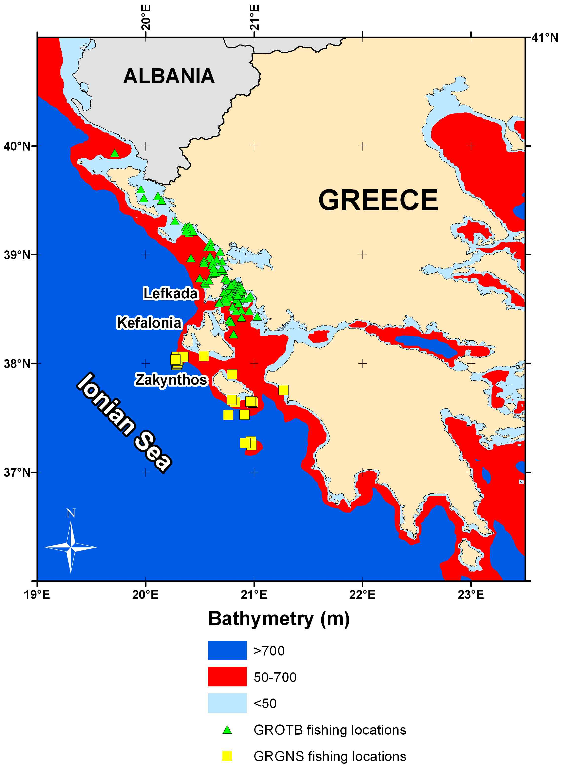
Fig. 4.1.6. Draft fishing footprint based on DCR observers data

4.1.7. Abundance indices derived from commercial catch and effort data
4.1.7.1 Please list available abundance indices indicating which are and which are not used in assessments.
4.1.7.2. Please include tables and figures of all available indices and append data at the lowest disaggregation level possible (ideally haul by haul)
4.1.7.3. Please describe how the indices are calculated. Are they standardised and if so please describe method used.
4.1.7.4 Please describe strengths and weaknesses of each index and if not used in assessments please explain why.
4.1.7.5 How can these indices be improved and are there any potential new indices that can be used in assessments.

Estimated landings per unit of effort (LPUE) are provided below for the 2003-2008 period, from data derived in the DCR-NDCP scheme. Catches per unit of effort (CPUE) are given for the trawler fleet, since it is the only fleet in which discarding is practiced.
These are nominal values and not standardized indices, derived as kg per Days at Sea. The lowest level of disaggregation is by Year.
Note: these commercial fishery indices are very dissimilar from the experimental surveys indices (e.g.: MEDITS survey)

LPUE (kg/day at sea)
Gear | Year
Gear | 2003 | 2004 | 2005 | 2006 | 2007 | 2008 | Average
GROTB | 0.2 | 0.4 | 0.4 | 0.3 | 0.3 | 0.3 | 0.3
GRGNS | 3.0 | 13.5 | 14.3 | 10.9 | 10.7 | 5.2 | 7.6
GRGTR | 18.3 | 18.9 | 2.6 | 8.4 | 6.2 | 11.6 | 10.2
GRLLS | 3.4 | 3.3 | 9.4 | 19.6 | 13.2 | 4.1 | 9.2
Grand Total | 2.7 | 8.1 | 9.1 | 8.4 | 7.9 | 4.5 | 6.0

CPUE (kg/day at sea)
Gear | Year
Gear | 2003 | 2004 | 2005 | 2006 | 2007 | 2008 | Average
GROTB | 1.0 | 0.4 | 0.5 | 0.4 | 0.3 | 0.4 | 0.5

In the LPUE’s, unreported landings as well as discard ratios are difficult to estimate, and biases are expected to be present in these indices. Currently, no assessment is carried on the stock based on such data.
In order to improve these indices so that to be used in future assessments the sampling scheme must alter. To date the sampling scheme focuses on observers by major fisheries (coastal, trawlers, purse seiners etc.). Coastal fisheries include numerous gear types (trammel nets, gillnets, bottom longlines, traps, pots etc), and metiers which pass un-monitored and un-reported.
Improvements can be achieved by collecting data on a metier scale, and especially the metiers targeting P. bogaraveo.

4.1.8. Information and data made available by fishers, fisher organisations or other stakeholders
4.1.8.1 Please describe any existing data collection programmes in place.
4.1.8.2 Please list the data and information for each fleet ID and describe if/how it has been used in monitoring and/or assessments. Please append the data at the lowest level of disaggregation possible.
4.1.8.3 How could fishers play a stronger role in providing data and information for monitoring and assessments?

Fishers may declare their landings to the local port police offices (Ministry of Maritime Affairs) and data are analysed by the National Statistical Service of Greece (NSSG – www.statistics.gr).
In addition, statistics (landings, value, average prices) from the 11 auction fish markets located around Greece are available by ETANAL (www.etanal.gr).
Info is not available by fleet and area combined, and these data can serve only to extract some indicative annual trends. If and when logbooks become mandatory for all fishing vessels, then by filling them in, the fishers will become a key partner in fisheries monitoring.

Fig. 4.1.8.1. Landings of P. bogaraveo in the eastern Ionian Sea during 1992-2008
(NSSG data, Auction markets data, EU-DCR data).

4.1.9. Fisheries data in general
4.1.9.1 Are there any aspects of fisheries data (quality, temporal and spatial extent, time series, availability, accessibility, flow) that [a] impact on assessments and/or [b] affect your ability to provide timely fisheries advice to managers.

Covered throughout the previous text

4.2 Fisheries-independent survey data
4.2.1 Please complete the table below for any surveys that are currently carried out or have taken place in the last 10 years and append all available time-series abundance, length and age data at the lowest level of disaggregation possible (ideally haul by haul for catch and effort data):-
4.2.2 For each survey please:-
• Describe main aims
• Describe the survey protocol and include map of survey grid
• Describe survey gear used in detail
• If survey does not cover entire area of stock – please explain why.
• Document gear selectivity where appropriate
4.2.3 Are the survey data used in assessments? If so please describe how. If not please explain why.
4.2.4 Please identify strengths and weakness of each survey and identify if and how they could be improved.
4.2.5 If any surveys have been terminated within the last 10 years please explain why.
4.2.6 Are any new surveys being considered? If so please describe.
4.2.7 Please append any survey abundance indices available for your stock (tables and figures) and comment on their strengths and weaknesses and how they could be improved.
4.2.8 Are there any aspects of fisheries-independent survey data (quality, temporal and spatial extent, time series, availability, accessibility, flow) that [a] impact on assessments and/or [b] affect your ability to providetimely fisheries advice to managers.

Surveys that are currently carried out or have taken place in the last 10 years include:
- MEDITS survey,
- INTERREG,
- RESHIO,
- DEEP FISHERY,
- IMAS Fish,
- EU-046.

Note: Only the last survey was designed to study P. bogaraveo.

A summarized report of these surveys is listed below:
Country | Name of survey | Name of vessel (RV or commercial? | Gear used: trawl, acoustic etc | Time of year | Frequency  &  duration | Time-series  available | Cover entire stock area? | If EU country, is DCF funded?
GR | MEDITS | various | trawl | summer | Annually – 1 month -27 sets | 1994-2001 | No | No
GR | NDCP-MEDITS | various | trawl | summer | Annually – 1 month -27 sets | 2003-2008 | No | Yes
GR | INTERREG | commercial | trawl | spring, summer  fall | 5 surveys,  2 years | 1999-2000 | No | No
GR | RESHIO | commercial | trawl | summer, fall | 3 surveys,  2 years | 2000-2001 | No | No
GR | IMAS Fish | commercial | trawl,  gill nets | summer, fall | 2 surveys,  2 years | 2003-2004 | No | No
GR | EU 046 | commercial | gillnets | spring, summer | 2 surveys,  1 year | 2001 | No | No

A more detailed description of the aforementioned surveys is given in the following pages:

MEDITS
The MEDITS Programme started in 1994 (DGXIV MED/93/4), as a collaboration of the northern Mediterranean countries, and continued until 2002, when it was included in the tasks of the National Programs for the collection of Fisheries Data of each country. The MEDITS program is devoted to the collection of data on demersal resources covering all trawlable areas from 10 to 800 m depth, by trawl surveys from Gibraltar Straits to the Aegean Sea, on an annual basis. The objectives include the study of the distribution, abundance and demographical structure of 36 target species. All members follow a common sampling protocol and use a common gear. The mesh size of the trawl cod end is 10 mm which strengthens the representativeness of the existing populations in the catches (comparing to those derived from commercial fishery using a 40 mm mesh size).
Detailed info on the MEDITS Project can be traced in:
http://www.sibm.it/SITO MEDITS/principalemedits.htm

NDCP-MEDITS
The same as previous, but in the framework of DCR-NDCP
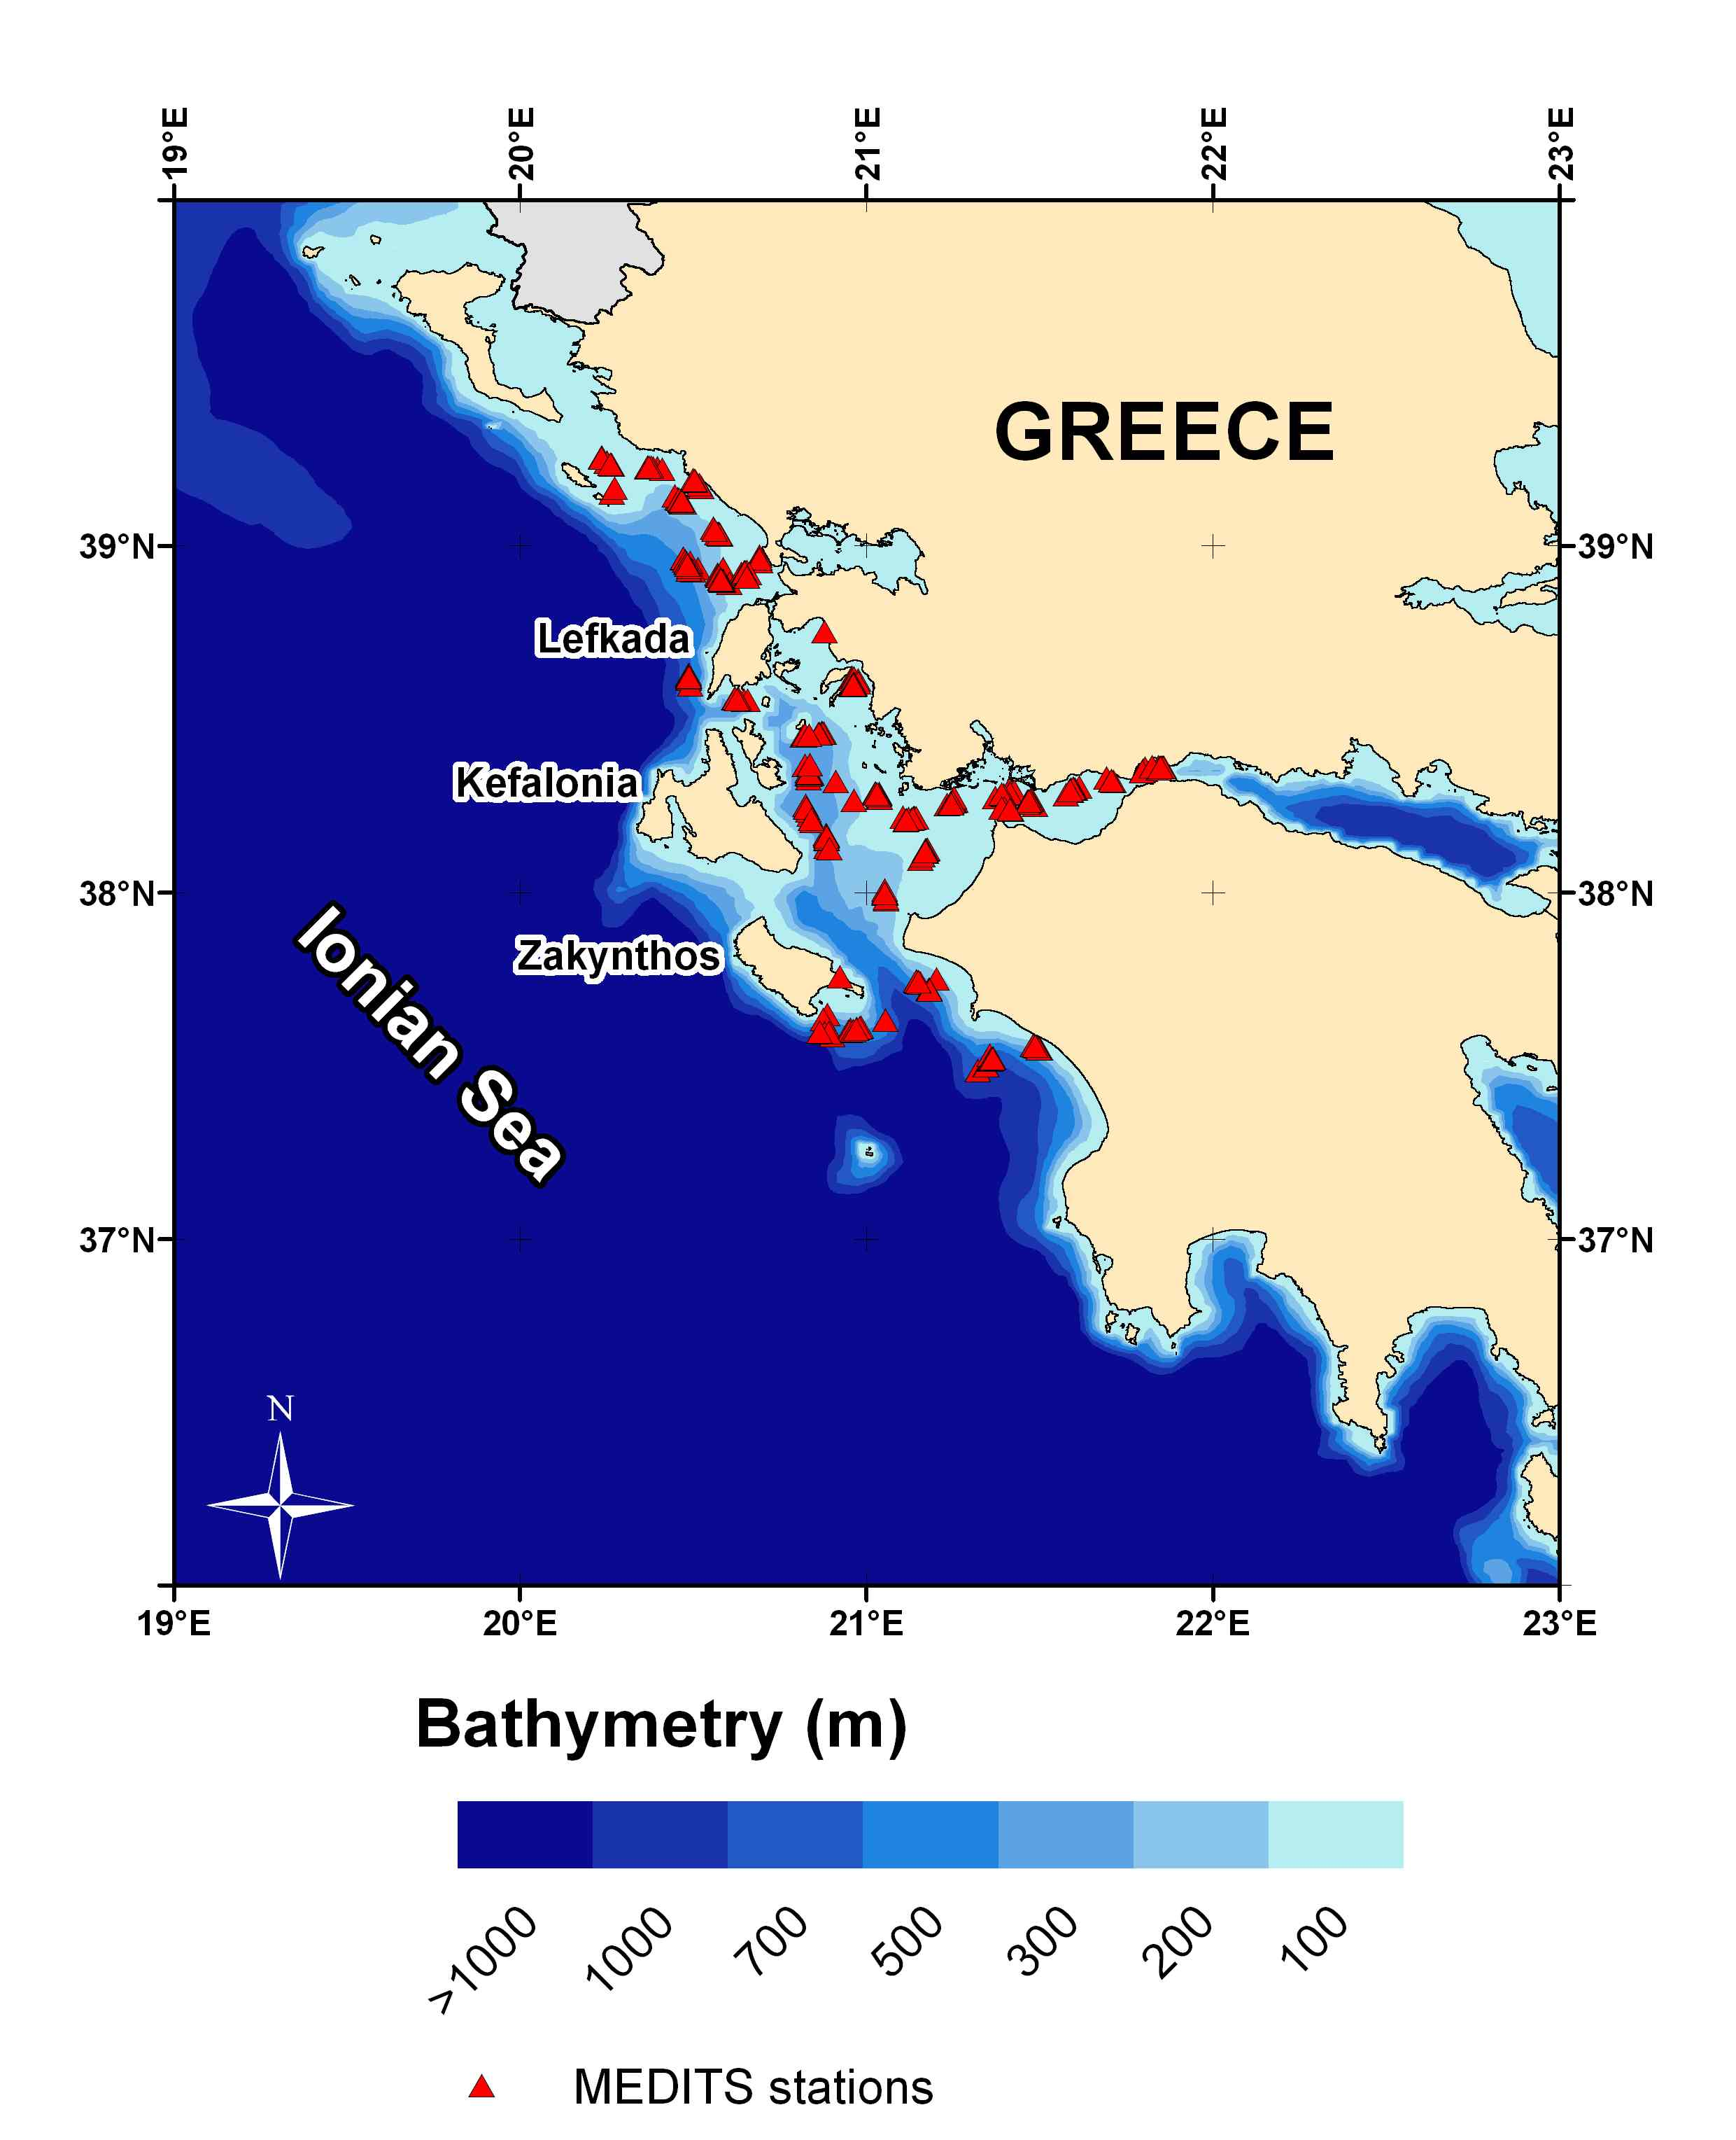
Fig.4.2.1. Map of the MEDITS project study area, with the corresponding sampling stations
INTERREG

The main objectives of this INTERREG II GREECE-ITALY, Measure 3.1, project (Anonymous, 2001a), were (a) to investigate the spatial distribution and abundance of important deep-water resources in the Ionian Sea, focusing on the red shrimps, A. foliacea & A.antennatus, (b) to collect useful information for the management of deep-water resources and particularly for the development of a sustainable Greek Deep-water Fishery, (c) to compare the results from the Greek to those of the Italian Ionian and (d) to transfer information and technologies to the local Authorities and fisher associations. Sampling was carried out seasonally in the northern Greek Ionian Ionian Sea (60 stations), from Othoni isl. to Zakynthos isl., and the north-western Italian Ionian (29 stations), between 300-1200 m of depth, from 1999 to 2000, using two commercial vessels, equipped with bottom trawl of 40 mm cod-end mesh size.
The survey did not cover the entire area of the stock (shallow waters) because its objective was to study the deep waters where red shrimps are found.

Fig.4.2.2. Map of the INTERREG II project study area

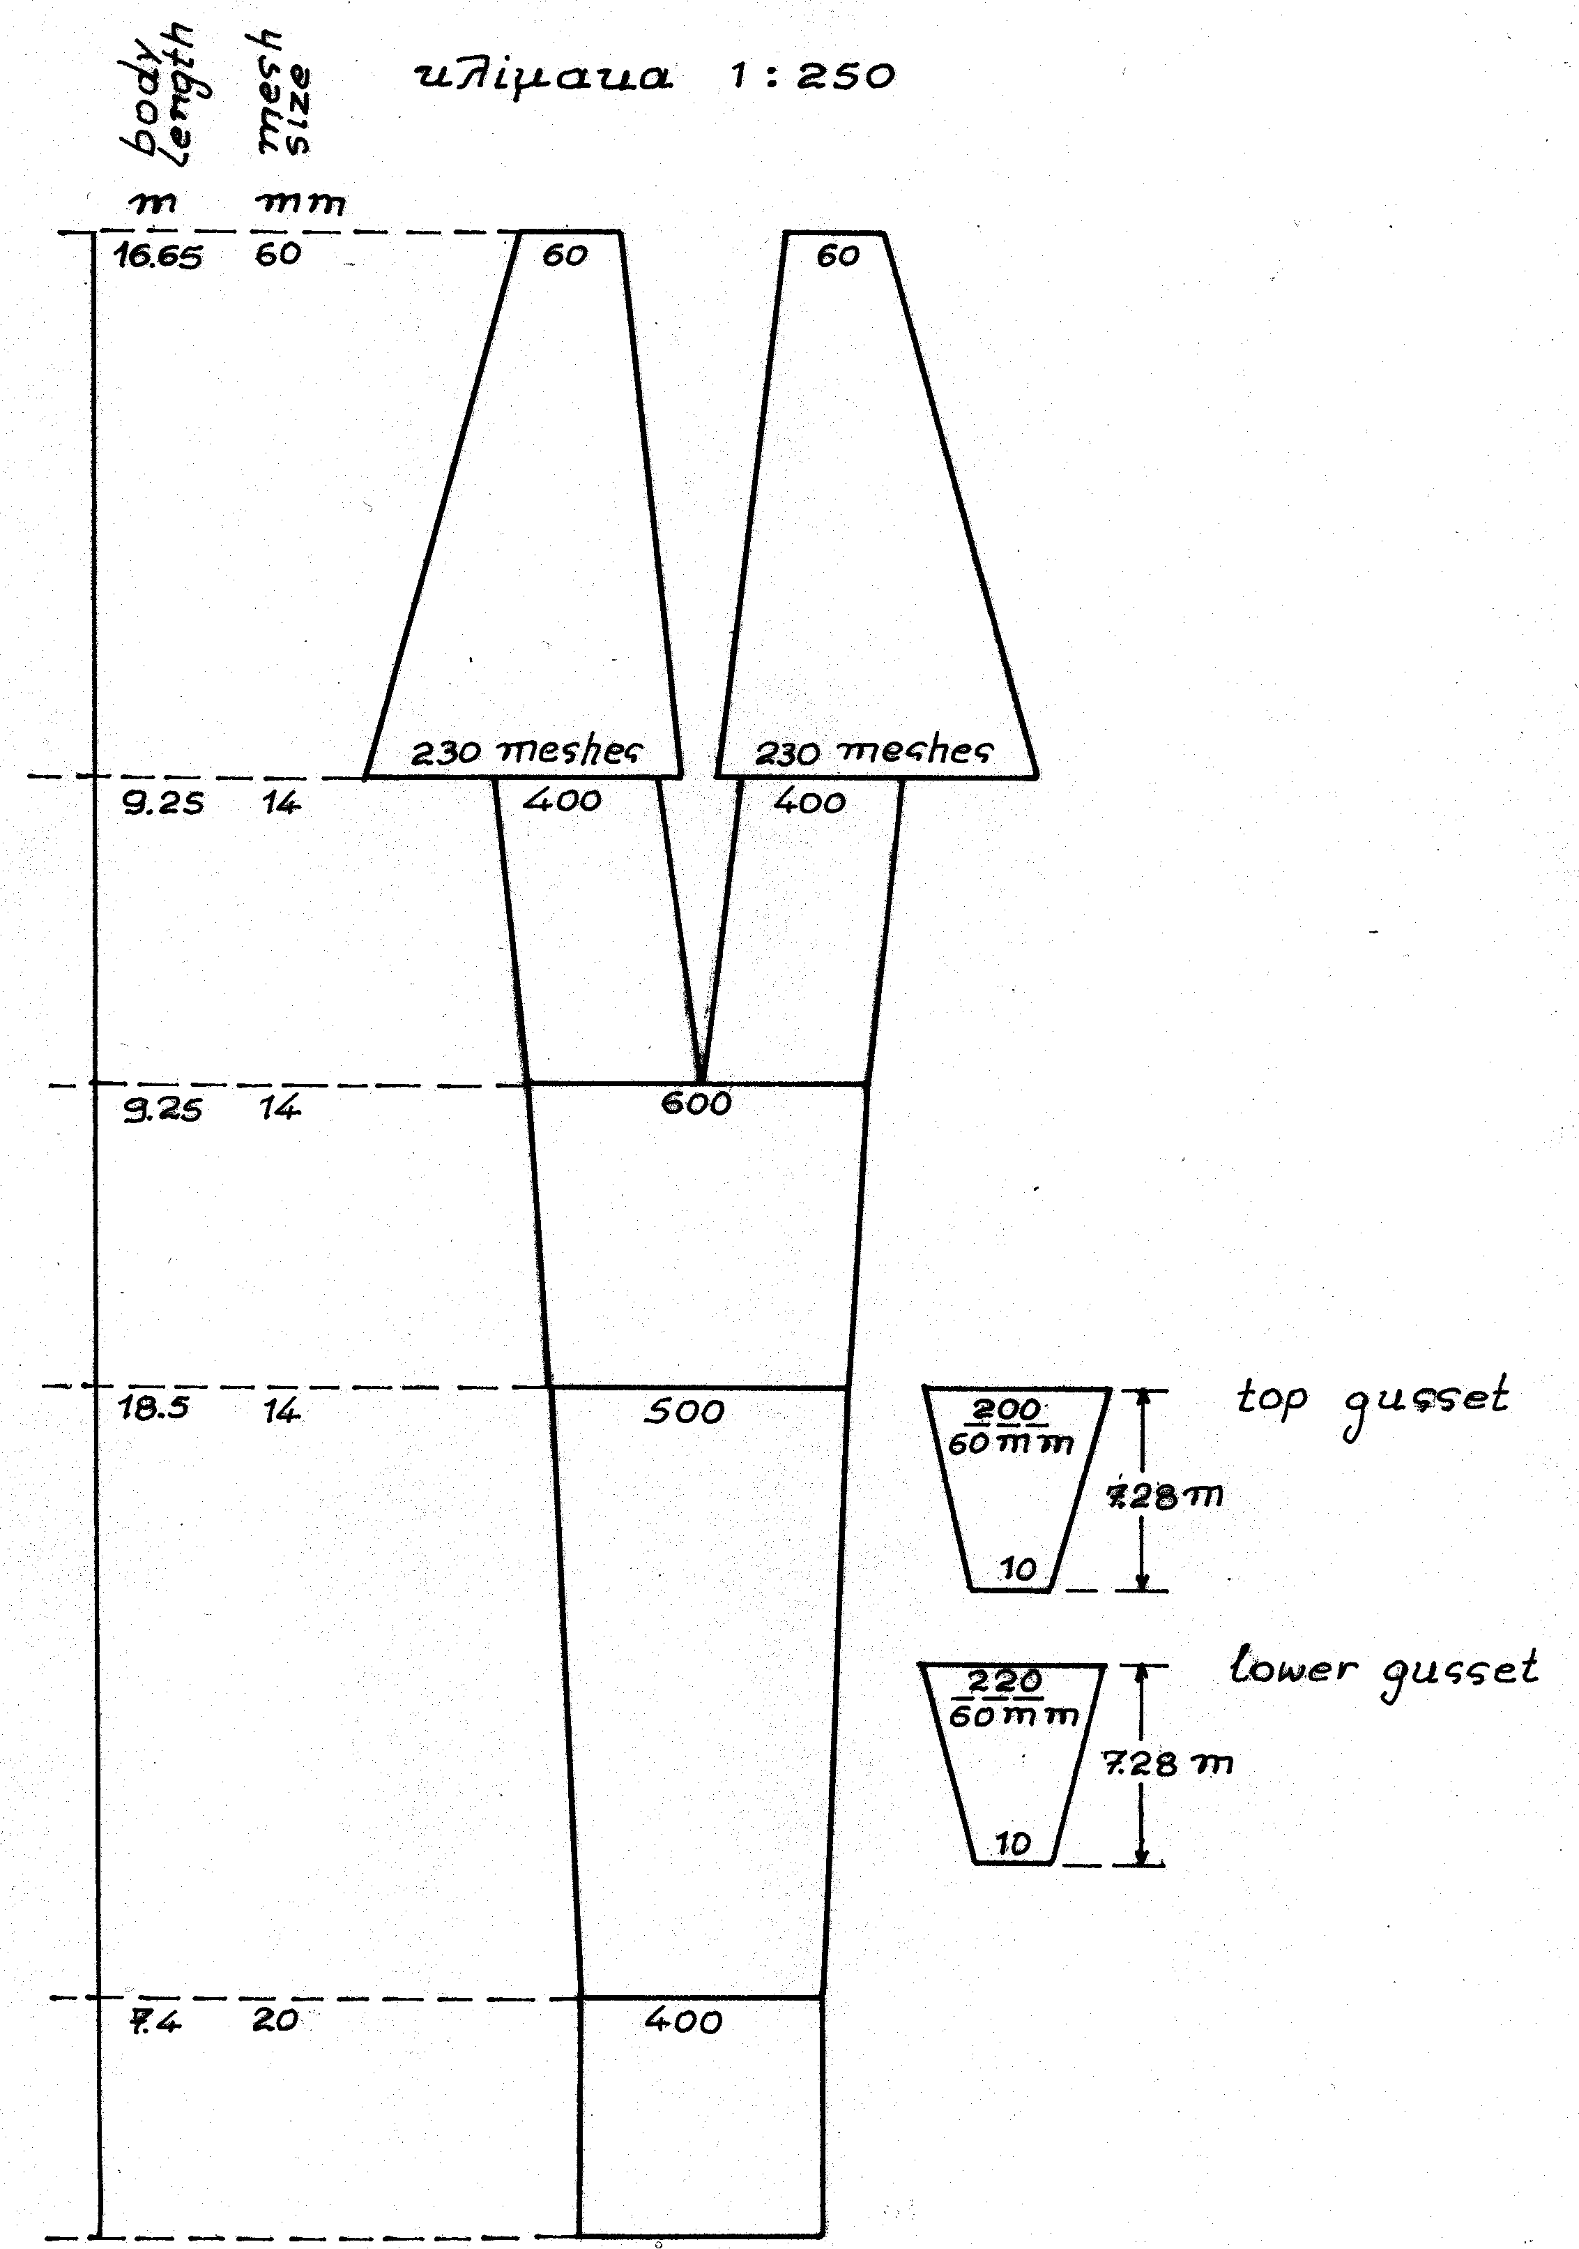
Fig.4.2.3. Scheme of the sampling gear for INTERREG II surveys

RESHIO

The objectives of this project, (DGXVI 99/29, Mytilineou et al., 2003b), were (1) the investigation of the distribution and abundance of A. foliacea and A. antennatus in the South-Eastern side of the Ionian Sea (Greek waters) and the study of their biological characteristics (2) the identification of differences in abundance, population structure and biological characteristics for both species, between an exploited area (Italian Ionian) and an unexploited one (Greek Ionian) and (3) the determination of the composition and abundance of the by-catch species, particularly between the exploited and the unexploited area. Sampling was carried out off the coast of the south-eastern Greek Ionian Sea (83 stations) and in the Italian Ionian Sea (25 stations), between 300-900 m of depth, from 2000 to 2001, using a commercial vessels, equipped with bottom trawl of 40 mm cod-end mesh size.The scheme of the gear is the same as in Fig.8.
The survey did not cover the entire area of the stock (shallow waters) because its objective was to study the deep waters where red shrimps are found.

Fig.4.2.4. Map of the RESHIO project study area
IMAS Fish

In the framework of the project, tasks 5.1.-5.3.: Estimation of the selectivity of trammel nets and bottom trawl codend was conducted. The aim of this task was the estimation of selectivity parameters of trammel nets for four different mesh sizes (44 mm, 56 mm, 72 mm and 80 mm) and two types of bottom trawl codend (40 mm), with and without knots. For the selectivity of bottom trawl codend the following parameters were estimated: a) the lengths at which 50% of the fish entering into the gear are retained, b) Selection factor, SF and c) Selection range, SR. Data collected during experimental fishing with trammel nets were analyzed using the SELECT model. For the trammel nets, the probability of capture per length class and the length of the maximum probability of capture lo were estimated..86 stations for trammel nets and 39 stations for bottom trawl were conducted.
The project had other objectives and for this reason did not cover the entire area of the stock.

IMAS-Fish 2007: Integrated Database & GIS Fisheries Information System, Institute of Marine Biological Resources Hellenic Centre for Marine Research World Wide Web electronic version http:/amfitrion.ncmr.gr:7778/imasfish

Fig. 4.2.5. Map of the IMAS FISH project study area

EU-046

The aim of this project was: a) to measure the size selectivity of commercial gill nets at three separate seasons by using a number of appropriate mesh sizes. Together with other parts of the project, this information will be used for recommending a minimum mesh size for that fishery, b) the assessment of P. bogaraveo fishery (inventory of the fleet, gear used, effort estimation, total production) & c) the biology (age and growth, reproduction) in order to propose a new minimum landing size. Data were collected during five missions with a hired professional fishery boat in the north-west coast of Greece (Ionian Sea) from March 2001 to August 2001. A total of 57 stations were sampled. The depth of the stations ranged between 117-300 fathoms. Selectivity experiments have been conducted and 6 different mesh sizes were investigated. Various models have been applied to estimate the modal length per each mesh size (length at which the probability of a fish to be caught is maximum). The modal lengths of the 60, 68, 80, 88, 90 and 100 mm mesh size gill net were 207.5, 235.2, 276.7, 304.3, 311.2 and 345.8 mm respectively. The authors suggest that a mesh size of 90 mm minimum should be appropriate for the sustainable exploitation of the species. The project had other objectives and for this reason did not cover the entire area of the stock.

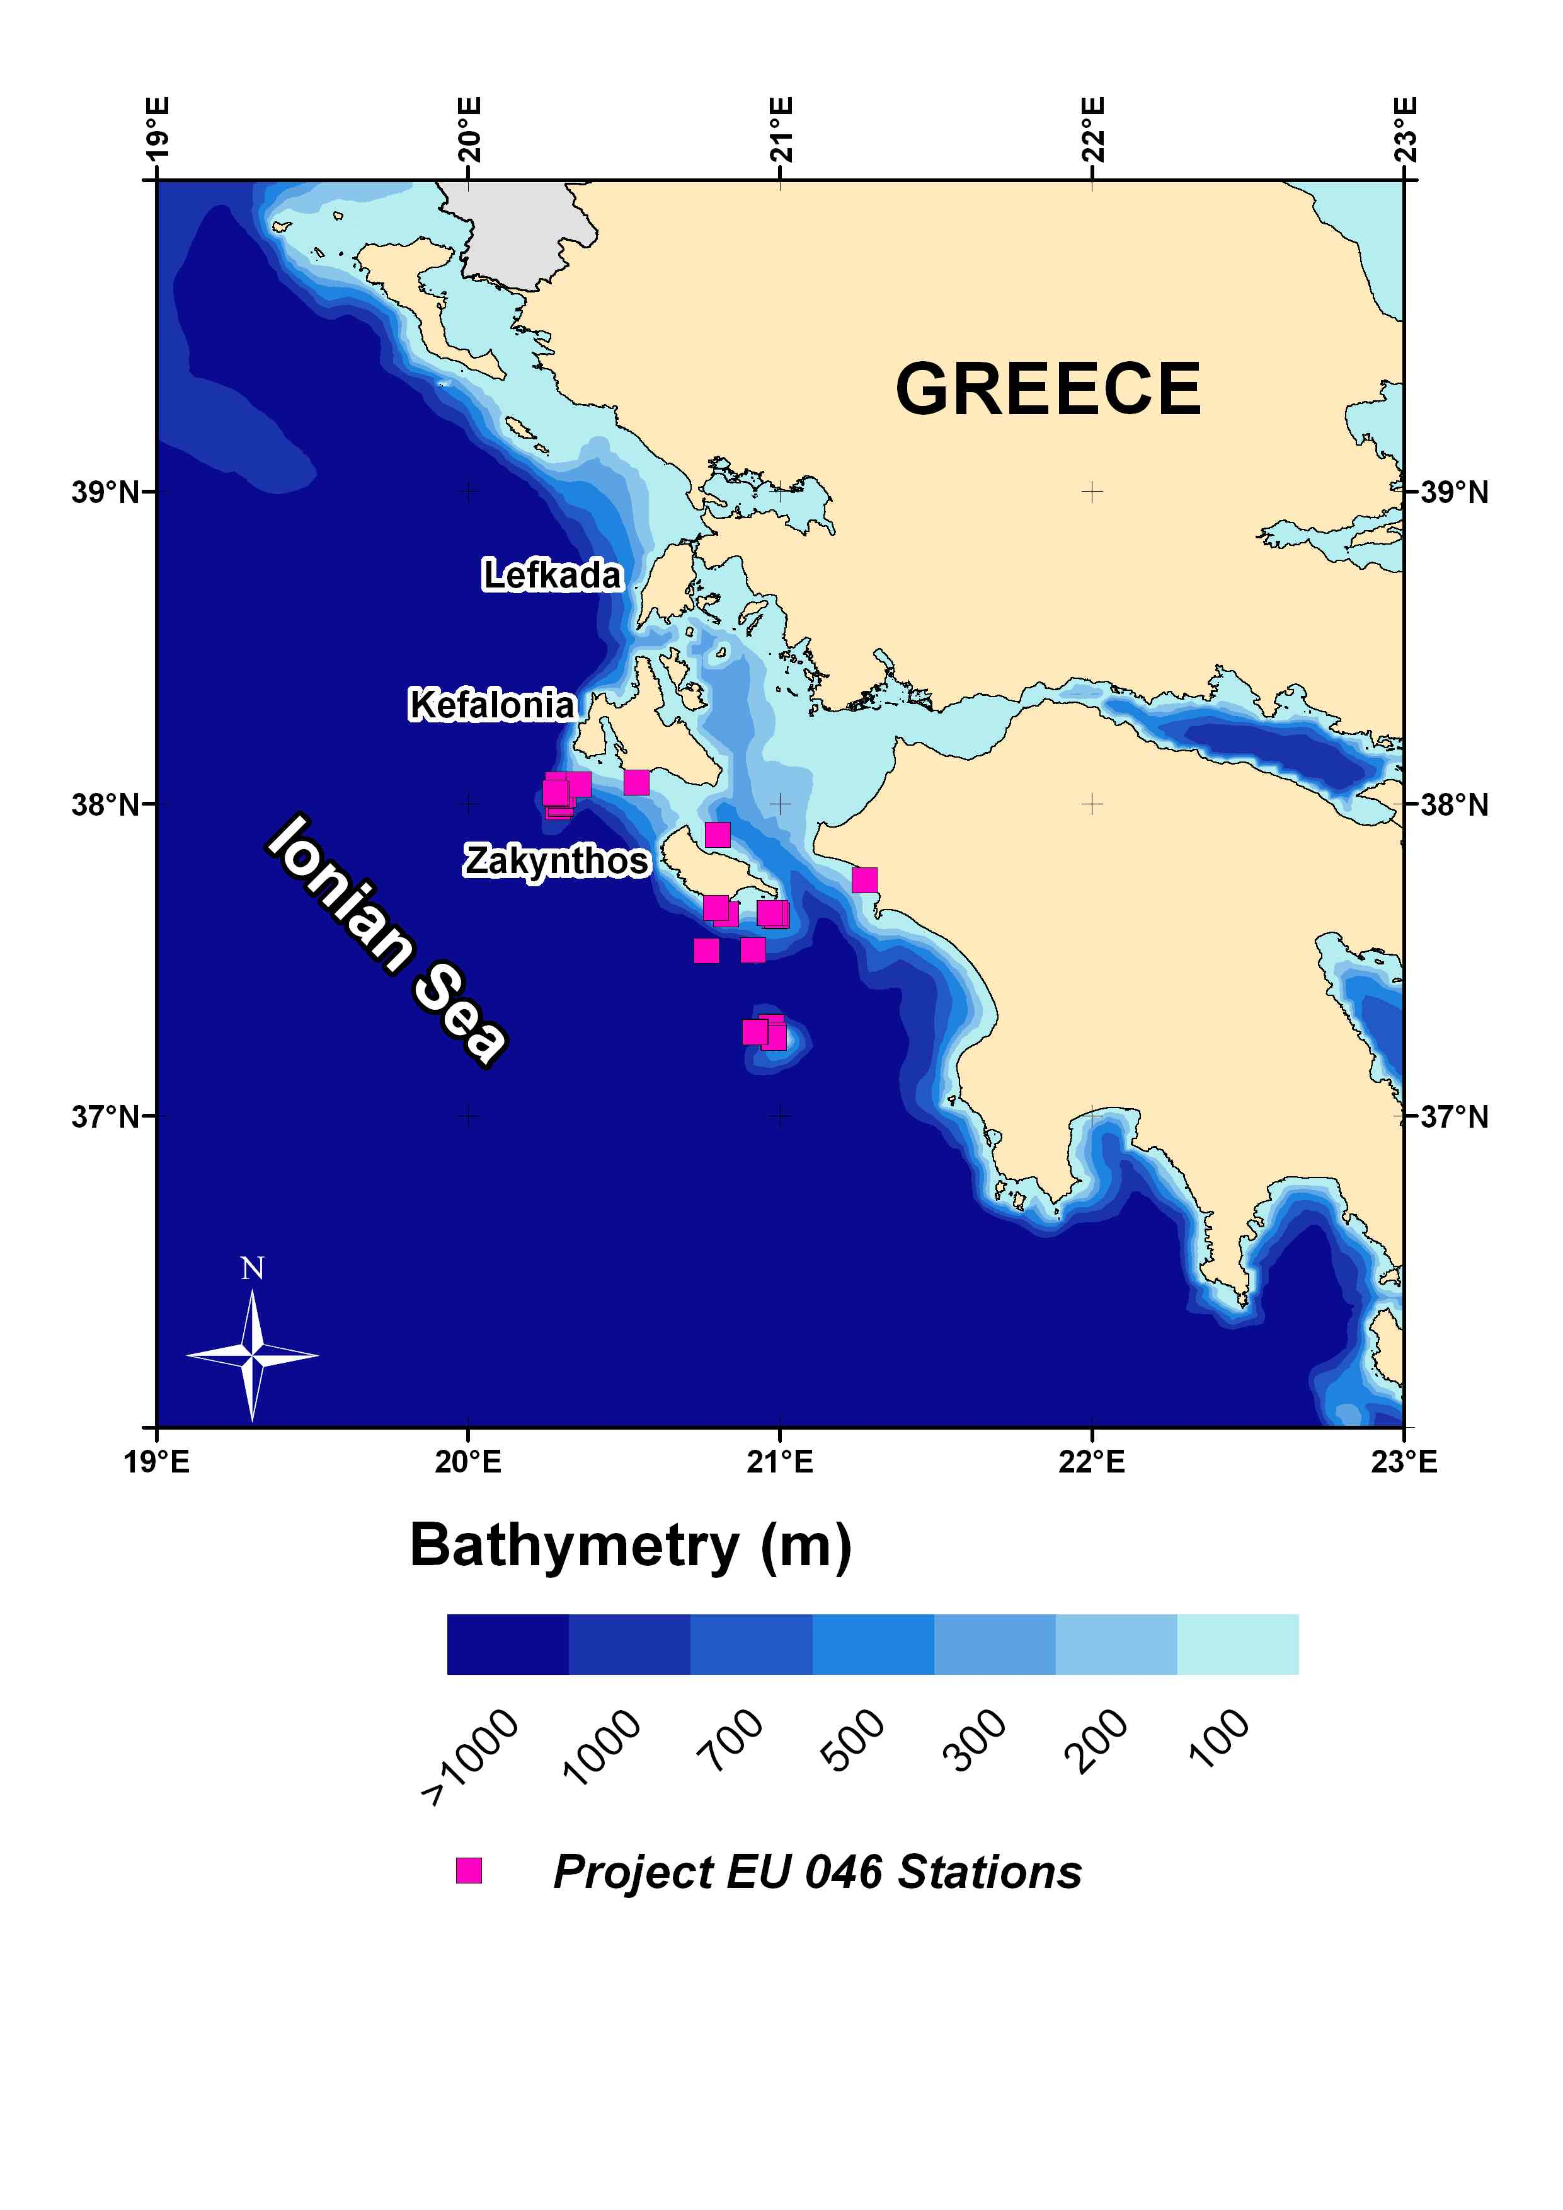

Fig. 4.2.6. Map of the EU-046 project study area

These survey data were not used in assessments:
MEDITS: Lack of age data.
INTERREG: Limited time series, absence of age data
RESHIO: Limited time series, absence of age data
DEEP FISHERY: Limited time series
IMAS Fish: Limited time series, absence of age data
EU-046: Limited time series

Strengths and weakness of each survey are identified below:

MEDITS: Strength: Multi-annual series of data concerning size structure, sex and maturity of the populations.
Weakness: The specific bottom trawl gear, catches generally small individuals of the P. bogaraveo stock, it lacks age estimations and since sampling is carried out only in summer, it cannot give reliable estimations of size at maturity.

INTERREG: Weakness: Limited time series, P. bogaraveo was not the target species

RESHIO: Weakness: Limited time series, P. bogaraveo was not the target species

IMAS Fish: Weakness: Designed to study the selectivity pattern of the fleets. Limited time series, P. bogaraveo was not the target species

EU-046: Strength: The project was designed for P. bogaraveo.
Weakness: Limited time series (only 1 year – no annual cycle).

All the abovementioned surveys (except MEDITS) were terminated since they were funded for a finite time period (usually 1-2 years). From our knowledge, no new surveys are being considered to initiate in the near future.

The most extended time-series of abundance indices available for the stock in the area comes from the MEDITS survey and covers a decade. It seems like the stock is not collapsing as it was initially assumed in 2001 (Petrakis et al., 2001).

Fig. 4.2.7. Biomass and abundance indices of P. bogaraveo in the eastern Ionian Sea
(MEDITS survey)

REFERENCES

Anonymous, 2001. Exploration of the renewable marine biological resources in the deep waters (INTERREG II Greece-Italy). Final Report, vol. IV, 281p.
Petrakis, G., Holst, R., Kavadas, S., Chilari, A. and Tsamis, E., 2001. Pagellus bogaraveo gill net metier in Ionian Sea: Gill net selectivity, assessment and biology. Final Report, EU Contract Number: 00/046. National Centre for Marine Research-Institute of Marine Biological Resources & ConStat. October 2001. 55 pp.

  - Biological data for your stock
4.3.1 Please complete the table below for each fleet/survey inserting in each cell the time series of data available, if quarterly (q) or annual (a), and if collected by observers (O), by market sampling (MS) or both (OMS). Please append all available time-series of quarterly and annual data.
4.3.2 For the most recent assessment, how was total international catch data raised from fleets and what are the strengths and weakness of the current raising regime?
4.3.3 If age data are available please describe the age determination materials and methods used.
4.3.4 How have ages been validated?
4.3.5 Are the age data considered to be reliable?
4.3.6 Has there been any ageing workshops for your species? If please review outcomes.
4.3.7 Are there any aspects of data (quality, temporal and spatial extent, time series, availability, accessibility, flow) that [a] impact on assessments and/or [b] affect your ability to provide timely fisheries advice to managers

The table below summarizes available info for each fleet/survey:

Fleet ID/  Survey ID | Retained or Survey |  |  |  |  | Discarded
Fleet ID/  Survey ID | Length comp. | Age  comp. | Sex comp. | Length &  weight at age | Maturity comp. | Length comp. | Age comp. | Sex comp. | Length &  weight at age | Maturity  comp.
GROTB/NDCP* | 2003-2008 (q) | No | No | No | No | 2003-2008 (q) | No | No | No | No
GRGNS/NDCP* | 2003-2008 (q) | No | No | No | No | 2003-2008 (q) | No | No | No | No
GRGTR/NDCP* | 2003-2008 (q) | No | No | No | No | 2003-2008 (q) | No | No | No | No
GRLLS/NDCP* | No | No | No | No | No | No | No | No | No | No
GROTB/MEDITS** | 1994-2001 | No | 1994-2001 (a) | No | 1994-2001 (a)
GROTB/MEDITS/NDCP* | 2003-2008 | No | 2003-2008 (a) | No | 2003-2008 (a)
GROTB/INTERREG SURVEY | 1999-2000 | No | 1999-2000 | No | 1999-2000
GROTB/RESHIO SURVEY | 2000-2001 | No | 2000-2001 | No | 2000-2001
GRGNS/Project EU-046 SURVEY | 2001 | 2001 (a) | 2001 (a) | 2001 (a) | 2001 (a)
GROTB/DEEP FISHERY SURVEY | 1997 (q) | 1997 (q) | 1997 (q) | 1997 (q) | 1997 (q)
(q) :quarterly; (a) annual; (O) collected by observers; (MS) market sampling; both (OMS)
*: 2007 excluded
**: 1994-1998 data suffer from gaps

Detailed data are to be traced in the Projects database.

Based on the above biological data, no assessment has ever been conducted on the studied species.

Age data and age-growth estimates were available during the Project EU-046 (Petrakis et al., 2001; Chilari et al., 2006) and were obtained using hard parts as otoliths and scales.
Age data were also collected during 1994 in the north Aegean Sea (Papaconstantinou et al., 1994) and the corresponding age estimates (from otoliths) can be traced in Mytilineou & Papaconstantinou (1995) .Age data were also gathered (from otoliths) during the DEEP FISHERY Project (Petrakis et al., 1999).
The results of Chilari et al. (2006) seem to be the most reliable, since they refer to a greater range of individual size data, although the study lacks specimens < 15 cm of length.

Note: No validation has been applied. Furthermore, otolith and scale age estimates were not consistent.

Conclusively, the main aspects of the data affecting our ability to provide timely fisheries advice to managers are:
- No long and consistent time series of data
- No accurate age estimates
- No estimation of mortality rates
- No maturity data in an annual cycle

REFERENCES

Chilari A., Petrakis G. & Tsamis E., 2006. Aspects on the biology of blackspot seabream (Pagellus bogaraveo) in the Ionian Sea, Greece. Fisheries Research, 77: 84-91.
Mytilineou Ch. & Papaconstantinou C., 1995. Aspects on the biology of blackspot seabream, P. bogaraveo (Brűnnich,1768) in the northern Aegean Sea (Greece). Rapp. Commm. Int. Mer Medit, 34: 251p.
Papaconstantinou, C., C.-Y. Politou, E. Caragitsou, K.I. Stergiou, Ch. Mytilineou, V. Vassilopoulou, A. Fourtouni, M. Karkani, S. Kavadas, G. Petrakis, A. Siapatis, P. Chatzinikolaou and M. Giagnisi, 1994. Investigations on the abundance and distribution of demersal stocks of primary importance in the Thermatikos Gulf and the Thracian Sea (Hellas). National Centre for Marine Research, Athens, Hellas, Technical Report, North Aegean Sea Series 4/1994. (In Hellenic). 356 pp.
Petrakis, G., Kapiris, K., Politou, C.-Y. And Papaconstantinou, C., 1999. Description of deep-water fisheries of Greece. In: Developing deep water fisheries: data for their assessment and for understanding their interaction with an impact on a fragile environment. EC FAIR project CT 95-0655. Final report of partner No 6 (NCMR), 20 pp.
Petrakis, G., Holst, R., Kavadas, S., Chilari, A. and Tsamis, E., 2001. Pagellus bogaraveo gill net metier in Ionian Sea: Gill net selectivity, assessment and biology. Final Report, EU Contract Number: 00/046. National Centre for Marine Research-Institute of Marine Biological Resources & ConStat. October 2001. 55 pp.

4.4 Ecosystem, biodiversity and VME data (see footnote 1 on page 2 for definition of VME)

4.4.1 Background information
4.4.1.1 Please list the known ecosystem types in your stock area (include maps if available).
4.4.1.2 If these are not known, are there any research programmes currently underway to identify and delineate ecosystems in your area? If so please describe.

Identification of ecosystem types in the stock area has been done according to NATURA (EC 92/43 Annex I) on the coastal areas of the Ionian Sea, delineating certain regions of interest. Seven main areas have been studied in detail (see Map below):

Area Habitats
- Kerkyra-Kanoni Posidonia beds;Reefs

- Parga-Preveza Sandbanks which are slightly covered by sea water all the time; Posidonia beds; Estuaries;Reefs

- Inner Ionian Archipelagos Posidonia beds;Reefs

- Argostoli-Vlachata Sandbanks which are slightly covered by sea water all the time; Posidonia beds;Reefs

- Kalogria Kyllini Sandbanks which are slightly covered by sea water all the time; Posidonia beds;Reefs

- Laganas-Zakynthos Sandbanks which are slightly covered by sea water all the time; Posidonia beds;Reefs

- Kyparissia Gulf Sandbanks which are slightly covered by sea water all the time; Posidonia beds;Reefs

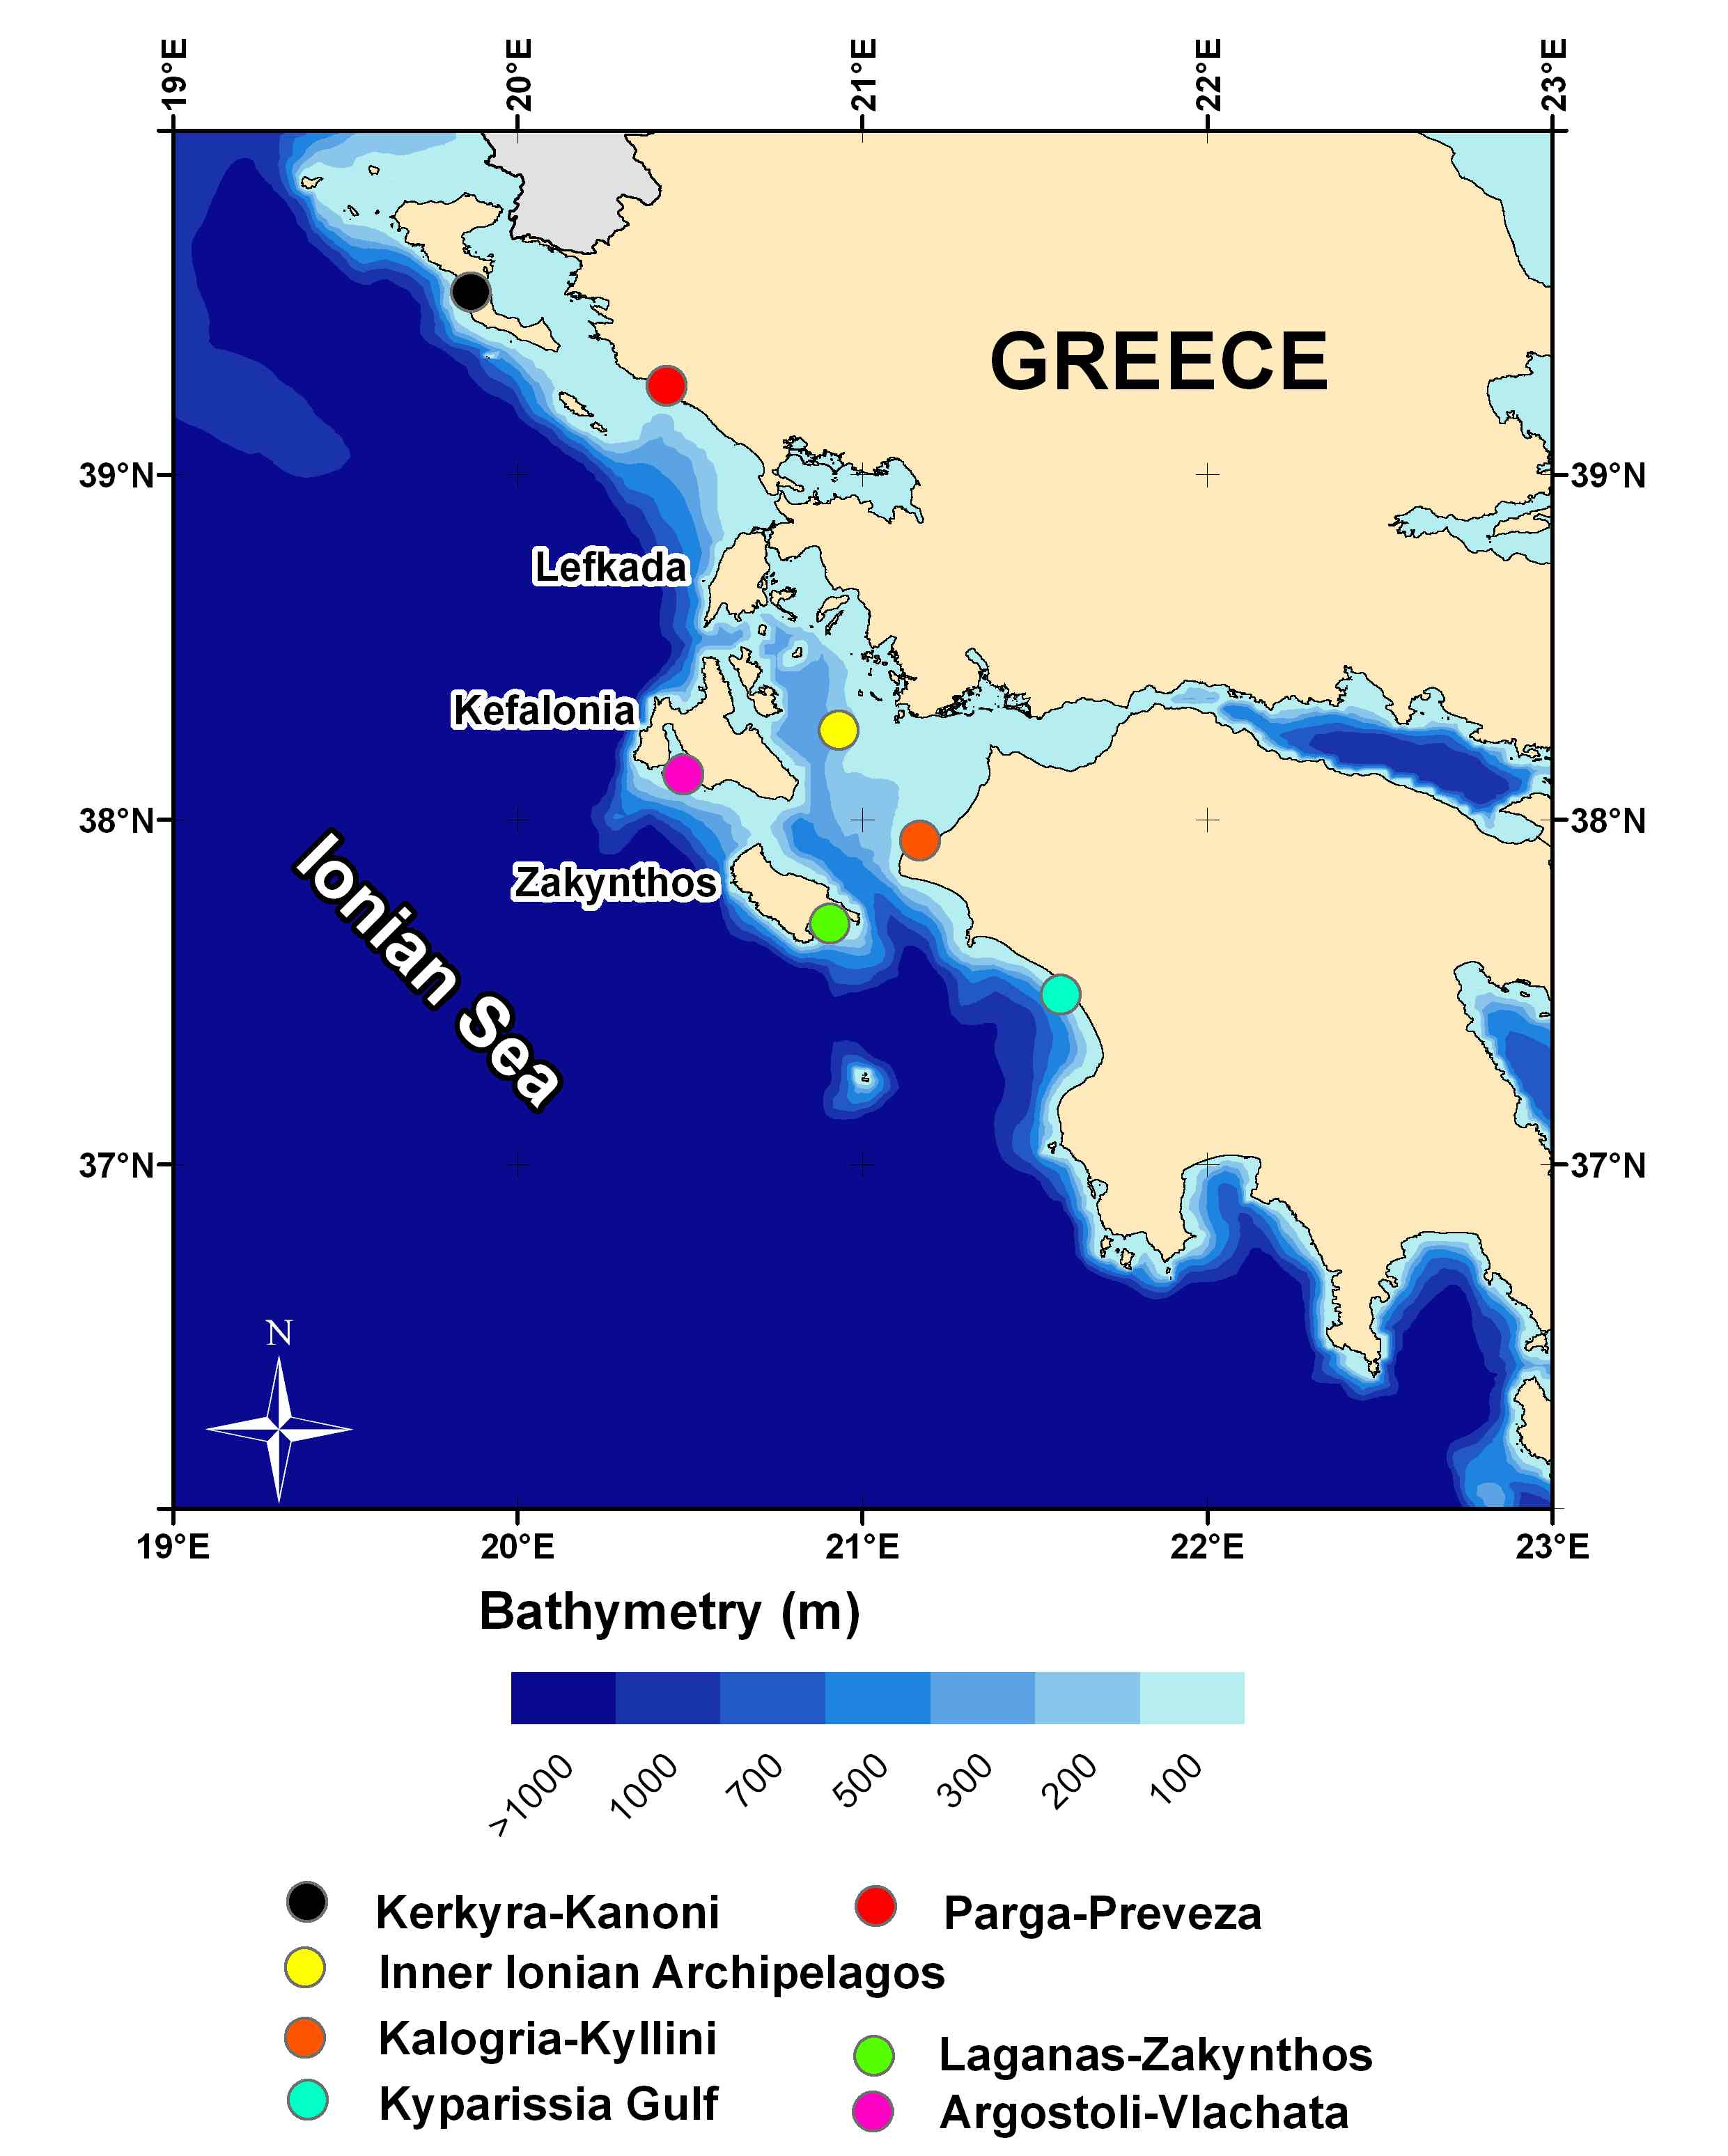
Fig. 4.4.1.1. Map of areas with identified ecosystem types, in the eastern Ionian Sea.

The P. bogaraveo stock resides in deep waters of the open sea, and only juveniles are known to exist in coastal areas at depths < 100 m. For the deep open Ionian waters some studies have dealt with the faunal assemblages (Politou et al., 2008) as well as the biodiversity of the different depth strata communities (D’Onghia et al., 2003). These studies can by no means serve as tools for identifying the ecosystem types of the open Ionian Sea.

A research programme is currently underway to identify and delineate ecosystems of the deep waters in the area (CORALFISH http://eu-fp7-coralfish.net/ ).

4.4.2 Data available in support of ecosystem based management.
4.4.2.1 Please complete the following table where data are available and append all available time-series data at the lowest level of disaggregation possible:
4.4.2.2 Where data are available please describe, review and append4.
4.4.2.3 In the area inhabited by your stock are there any research initiatives related to climate change? If so please review (Descriptor 7).
4.4.2.4 Has there been any baseline studies on ecosystems in your stock area? If so please describe.
4.4.2.5 Are you aware of any major changes e.g. regime shifts, in ecosystems in your stock area? If so please review.
4.4.2.6 How is the health of ecosystems in your stock area monitored? e.g. size spectra studies, biodiversity studies, diversity indices, presence/absence of indicator species, other indicators etc. Please describe and review (Descriptor 1)
4.4.2.7 Is primary production monitored in your stock area? If so please review.
4.4.2.8 Are changes in the spatial and temporal distribution of plankton species monitored? If so please review.
4.4.2.9 Are there any aspects of ecosystem data and knowledge (quality, temporal and spatial extent, time series, availability, accessibility, flow) that [a] impact on assessments and/or [b] affect your ability to provide timely fisheries advice to managers.
4.4.2.10 Are there any other human activities that impact the ecosystem significantly? If so please describe.

A summarized depiction of data available is given in the table below:

Marine Strategy descriptor | Data in support of ecosystem based management | Data source(s) | Are there any data issues?
(1) Biological diversity | Species assemblage composition | MEDITS  DEEP FISHERY,  RESHIO,  INTERREG | MEDITS:Summer survey, trawlable areas only  DEEP FISHERY: only 1 year  RESHIO:only summer  INTERREG: spring, summer, autumn for 2 years
 | VME -spatial distribution | NATURA
 | VME – species composition | N/A
 | Fishery interactions with VMEs | N/A
 | Presence of PET – spp | MEDITS  DEEP FISHERY  RESHIO,  INTERREG  DCR_NDCP
 | PET – population biology | N/A
 | PET – fishery interactions | N/A
(2) Non-indigenous species | Invasive | http://elnais.ath.hcmr.gr | Only distribution maps of invasive species
 | Introduced | N/A
(3) Populations of commercially exploited fish and shellfish | Addressed in Sections 1, 3, 4 | Survey and Fishery
(4) Food webs | Data on prey, predators.  Fishery impacts on prey/predators abundance, addressed in 4.4.4 | TMR Program  (FAIR GT 97-1376) | P. bogaraveo was not included among the studied species
(5) Eutrophication |  | N/A
(6) Sea-floor integrity | Addressed in 4.4.5 and 4.4.7 below
(7) Hydrographical conditions |  | INTERREG II (2000) | Only one year, two surveys
(8) Contaminants in waters/ecosystem | Any data on levels of e.g. metals PCBs | INTERREG II (2000) | Only one year, two surveys
(9) Contaminants in fish and other seafood | Addressed in 4.6.6 below | N/A
(10) Properties and quantities of marine litter |  | N/A
(11) Introduction of energy, including underwater noise |  | N/A
In the stock area there no research initiatives related to climate change, except some submitted proposals.

Some baseline studies on ecosystems in the stock area are listed below:

Lefkaditou, E., Maiorano P., And Ch., Mytilineou, 2003. Cephalopod species captured by deep-water exploratory trawling in the Northeastern Ionian Sea. J. Northw. Atl. Fish. Sci., vol. 31: 213-219.
Mytilineou, Ch., C.-Y. Politou, C. Papaconstantinou, S. Kavadas, G. D’ Onghia And L. Sion, 2004. Deep-water fish fauna in the eastern Ionian Sea (Greece). Belg. J. Zool., 134 (Suppl. 1): 109-114.
Politou, C.-Y., Tursi, A., Kavadas, S., Mytilineou, Ch., Lembo And R. Carlucci, 2003. Fisheries resources in the deep waters of the Eastern Mediterranean (Greek Ionian Sea). J. Northw. Atl. Fish. Sci., vol. 31: 35-46.
Politou, C.Y., P. Maiorano, G. D’ Onghia And Ch. Mytilineou, 2004. Deep water decapod crustacean fauna in the eastern Ionian. Belg. J. Zool.., 134 (Suppl. 1): 111-122.
Valavanis VD, Smith C (2007). Essential Fish Habitats. In: State of Hellenic Fisheries. Papaconstantinou C, Zenetos A, Vassilopoulou V, Tserpes G (eds). HCMR Publications, Athens: 385-390 reprint
Valavanis VD, Georgakarakos S (2007). Remote Sensing and Geographical Information Systems. In: State of Hellenic Fisheries. Papaconstantinou C, Zenetos A, Vassilopoulou V, Tserpes G (eds). HCMR Publications, Athens: 400-410. reprint

The health of ecosystems in the stock area is monitored with the indicators established within the DCR and MEDITS frameworks (e.g.: average size of individuals, abundance trends). Most recent works published for the study area that review some ecosystem indicators are listed:

D’Onghia, G., Mastrotaro, F., Matarrese, A., 2003. Biodiversity of the upper slope demersal community in the eastern Mediterranean: Preliminary comparison between two areas with and without trawl fishing. J. Northw. Atl. Fish. Sci. 31: 263-273.
D’ Onghia G., Capezzuto F., Mytilineou Ch., Maiorano P., Kapiris K., Carlucci R., Sion L., Tursi A., 2005. Comparison of the population structure and dynamics of Aristeus antennatus (Risso, 1816) between exploited and unexploited areas in the Mediterranean Sea. Fisheries Research 76: 23-38.
Mytilineou Ch., Maiorano P., Kavadas S, D' Onghia G., Kapiris K., Capezzuto F., 2001. Size structure comparison in some demersal species between two areas of different fishing impact in the Eastern-Central Mediterranean. Symposium: Deep-sea Fisheries. Book of Abstracts: P. 17.
Politou, C.-Y., Mytilineou, C. D’Onghia, G and Dokos, J., 2008. Demersal faunal assemblages in the deep waters of the eastern Ionian Sea. Journal of Natural History 42: 661-672

In general, there is a gap in our knowledge regarding linkage of fisheries with ecosystem data for the studied area.
Finally, the stock area is on the route of commercial vessels (passenger cruise liners, cargo ships, oil tankers), and the impact of this activity on the ecosystem remains unchallenged.

4.4.3 Protected, Endangered and Threatened (PET) species (part of Descriptor 1)
4.4.3.1 Please list any PET species in your area that interact or could interact with fisheries for your stock.
4.4.3.2 Are there currently any research programmes active to identify the presence and extent of these interactions? If so, please review.
4.4.3.3 Please describe any mitigation methods applied to reduce the impact of fishing on PET species.
4.4.3.4 Are there any aspects of PET data and knowledge (quality, temporal and spatial extent, time series, availability, accessibility, flow) that [a] impact on assessments and/or [b] affect your ability to provide timely fisheries advice to managers.

The PET species in the area that interact with fisheries prosecuting the stock are listed in the following tables. These data were available from the list of the identified species within the DCR data collection scheme.

Fleet : GRGNS
Species | Treaties-Agreements
Caretta caretta caretta | A-II/IV - B + - C II - D EN - E VU - G I/A - H V - I II
Hexanchus griseus | B + - E VU
Scyllarides latus | A V- C III - I III - K +

Fleet: GROTB
Species | Treaties-Agreements
Dalatias licha | E VU
Heptranchias perlo | B +
Hexanchus griseus | B + - E VU
Hippocampus hippocampus | C II - E VU -I II
Homarus gammarus | C III- I III
Maja squinado | C III- I III
Scyllarus arctus | C III- I III
Squatina squatina | C III
Torpedo nobiliana | B+
Deep water corals
Leiopathes glaberrima | CITES II

Fleet: GRLLS
Species | Treaties-Agreements
Hexanchus griseus | B + - E VU
Currently there is only one research programme active to identify the presence and extent of these interactions (CORALFISH http://eu-fp7-coralfish.net/). From recent local fishermen interviews (unpublished/unprocessed data), it has been confirmed (photo identifications) that numerous deep sea coral species are frequently caught on bottom static gillnets targeting P. bogaraveo or Polyprion americanus (wreckfish). Fishermen actually tend to fish in areas where deep sea corals are abundant, since they believe them to be ‘good’ places to find fish.
Some mitigations methods applied to reduce the impact of fishing on PET species, concern the marine mammal acoustic repellents (pingers). According to the allegations of local fishermen these devices were efficient only for a few weeks. Gradually dolphins got used and stopped avoiding them.

4.4.4 Ecosystem modelling (Descriptors 4,5)
4.4.4.1 Is there any ecosystem modelling work carried out in your area? If so please specify the ecosystems studied and the modelling methods used (e.g. ecopath, ecosim etc).
4.4.4.2 Are predator/prey relationships well understood and if not what research is being undertaken?
4.4.4.3 Is there sampling of stomach contents? If so, how frequently, by whom, and how have the results been used?

Ecosystem modelling work in the study area has not been conducted so far. An on-going thesis is dealing with this subject and specifically to study dolphin populations using Ecopath and Ecosim (Piroddi Ch. The application of Ecopath with Ecosim to study dolphin population dynamics in the central Mediterranean. M.Sc. Thesis. Department of Zoology and Fisheries Centre, University of British Columbia, British Columbia, Canada).
Ecopath model has been used in the adjacent Aegean Sea.

Predator/prey relationships are not studied, although sampling of stomach contents has been carried out in the framework of some research projects:

Madurell, T., 2003. Feeding strategies and energy requirements of deep-sea demersal fish in the Eastern Mediterranean. EU TMR Program, FAIR GT 97-1376. Final report, 92 p.
Kapiris, K., 2004. Feeding ecology of Parapenaeus longirostris (Lucas, 1846)(Decapoda: Penaeidae) from the Ionian Sea (Central and Eastern Mediterranean Sea) Scientia Marina Vol. 68, no. 2, pp. 247-256.
Anastasopoulou, A., Kapiris, K., 2008. Feeding ecology of the shortnose greeneye Chlorophthalmus agassizi Bonaparte, 1840 (Pisces: Chlorophthalmidae) in the eastern Ionian Sea (eastern Mediterranean). Journal of applied ichthyology/Zeitschrift fur angewandte Ichthyologie Vol. 24, no. 2, pp. 170-179.
Kapiris, K., 2004. Feeding ecology of Parapenaeus longirostris (Lucas, 1846)(Decapoda: Penaeidae) from the Ionian Sea (Central and Eastern Mediterranean Sea) Scientia Marina Vol. 68, no. 2, pp. 247-256.

4.4.5 Fishery interactions (Descriptors 1,6)
4.4.5.1 Please review any gear trials conducted to assess gear/habitat interactions.
4.4.5.2 Has there been any research into environmentally friendly gears? If so please review.
4.4.5.3 Do you have a reporting system for lost and abandoned fishing gear (particularly gillnets)? If so how effective is it and is it supported by interviews with fishers?
4.4.5.4 Are there any lost/abandoned fishing gear retrieval survey/mitigation exercises regularly carried out? If so please review.
4.4.5.5 If bait is used in any of your fisheries, is the bait sourced sustainably? Is its use monitored? If so, how?
4.4.5.6.Are there any aspects of data and knowledge relating to fishery interactions (quality, temporal and spatial extent, time series, availability, accessibility, flow) that [a] impact on assessments and/or [b] affect your ability to providetimely fisheries advice to managers?

Gear trials to assess bottom trawl/habitat interactions in shallow waters, are currently conducted in the on-going project COMSOM (Program funded by the Spanish CSIC, Consejo Superior de Investigaciones Científicas, Ciencia e Investigación. Participants: Spain, Italy, Greece).
No research into environmentally friendly gears has been exerted. There is neither a reporting system for lost and abandoned fishing gear, nor are there any lost/abandoned fishing gear retrieval survey/mitigation exercises carried out. From recent interviews on local fishermen it has been pointed out that ghost fishing is a huge issue. One fisher stated that only in the past month he has lost 3000(!) fathoms (~5400 m) of nets in a deep submarine canyon fishing for hakes, seabreams and wreckfish.

Bait is used in the longline fishery and occasionally in the gill-nets. As a rule the bait consists of Sardina pilchardus, Sardinella aurita and Trachurus sp. Whenever the bait is fresh, its origin is the Greek seas where the species are monitored in the framework of DCR-NDCP. Frozen baits are of foreign origin, mainly Spanish (Atlantic), for which no info on the way they are harvested is available.

4.4.6 Pollutants and contaminants (Descriptor 9):
4.4.6.1 Are contaminant levels in your stock species monitored? If so how and by whom? Please review results.
4.4.6.2 Do you assess the ecosystem effects (negative and positive) of marine debris and examine options for its collection and disposal? (Descriptor 10) If so how?
4.4.6.3 Are there any aspects of data and knowledge (quality, temporal and spatial extent, time series, availability, accessibility, flow) that [a] impact on assessments and/or [b] affect your ability to provide timely fisheries advice to managers?

Contaminant levels in the stock species are un-monitored. Furthermore, the effects of marine debris on the ecosystem are not assessed.

4.4.7 Vulnerable Marine Ecosystems (VMEs) (Descriptor 1)
4.4.7.1 FAO have recently circulated guidelines on VME identification and composition, how have you interpreted these in your stock area?
4.4.7.2 Has any mapping of VMEs been carried out in your stock area? If so, please provide information on location, extent and mapping methods used (multi-beam sonar, ROV, etc). Please attach maps where available.
4.4.7.3 Please complete the following table for your stock area:
4.4.7.4 If your stock area, or a substantial part of your area, has not been mapped, do you consider it likely that VMEs may exist? If so, have any precautionary measures (e.g. closed areas) been implemented (e.g. to protect seamounts that have not been specifically mapped)? If so please describe.
4.4.7.5 Have you any plans to develop/extend mapping activities with regard to VMEs? If so please describe.
4.4.7.6 If management measures have been introduced to protect VMEs, how have these impacted on fishing?
4.4.7.7 Are there any aspects of data and knowledge (quality, temporal and spatial extent, time series, availability, accessibility, flow) that [a] impact on assessments and/or [b] affect your ability to provide timely fisheries advice to managers?

FAO guidelines on VME identification and composition, have not yet been interpreted in the stock area. The deep waters of the Ionian Sea are very poorly studied to date, and VME identification has not carried out until now. As a result no mapping of VMEs is available to date.

However, identification and mapping of deep water corals is on the way in the framework of the project CORALFISH: http://eu-fp7-coralfish.net/

A summarized table of data available on VME is given below:

VME | Present | How Monitored? | Issues?
Seeps
Vents
Carbonate mounds
Corals | Yes | CORALFish project  (2008-2013)
Sponges | Yes
Fish components
Seamounts
Others

Even though the area has not been mapped, it is most likely that VMEs exist. Some precautionary measures will be proposed after the completion of CORALFISH project.

4.5 Socio-economic data
Have socio-economic studies been conducted for the fleets fishing for your stock? Are socio-economic
surveys need-specific or are they part of monitoring programmes? If so please complete the table below and answer the remainder of the questions in this section and append data where possible. Please label with (1) an asterisk if data exist but are not available (but state where they exist), (2) leave blank if no data exist at all and (3) label N/K if the existence of data is not known.

No particular socioeconomic studies have been conducted for fleets targeting P. bogaraveo. Monitoring for various fleets in the framework of DCR-NDCP is carried out from 2005 and thereafter. Socioeconomics data are available by fleet category and concern only certain aspects as:
- fixed costs
- variable costs
- revenues
- fuel costs
These data are collected in accordance to EU Data Collection Regulation (DCR EC 1543/2000).

In addition, some socioeconomic data are also available from NSSG (www.statistics.gr) by gear for the whole fishing sector.

Available time-series of socio-economic data are given below:
"No access to data" where data exist but are not available (but state where they exist;
"No data at all" where no data exist at all and
“N/K” if the existence of data is not known

Fisheries socio-economic data | Indicate which fleet IDs | How are the data currently used in MSE and stock/fisheries management? | Are the data available to you? If so please append as a separate document. If not please identify source. Are there any data issues?
Fixed costs | GROTB  (GRGNS, GRGTR, GRLLS are grouped as ‘Coastal’)
Variable costs | GROTB  (GRGNS, GRGTR, GRLLS are grouped as ‘Coastal’)
Revenues | GROTB  (GRGNS, GRGTR, GRLLS are grouped as ‘Coastal’)
Demographics | N/K
Migration | N/K
Sexual equality | N/K
Full-time vs part-time employment | N/K
Sea based employment | No access to data (www.statistics.gr) |  | Data are available to us but they are not available at a fleet level
Land based employment | N/K
Grey5 market data | N/K
Dependency and distribution links | N/K
Ethnicity data | N/K
Fish consumption | N/K
Export data | N/K
Import data | N/K
CITES | N/K
Capital costs | N/K
Repair costs | N/K
Equipment/gear | N/K
Global markets | N/K
HACCP6 | N/K
Catch values | No access to data (www.etanal.gr) |  | Data are available to us but they are not available at a fleet level
Fuel costs | N/K

4.5.1 For each fleet ID please provide/detail/describe:-
4.5.1.1 A map showing the geographic location of fishing grounds (by season/quarter if spatial pattern changes).
4.5.1.2 An estimate of the mean distance from home port to main fishing grounds, by season/quarter if variable.
4.5.1.3 An estimate of the mean distance from main fishing grounds to landing ports (if different from homeport), by season/quarter if variable.
4.5.1.4 Jurisdiction of fisheries i.e. within national EEZs (please list countries) or in international waters (please indicate RFMO responsible for management).
4.5.1.5 Number of vessels, vessel size in terms of length or GRT (average, min, max and stdev), mean
engine power : kW or BHP (average, min, max and stdev).
4.5.1.6 Main type of fishing gear used (please supply as much information as possible).
4.5.1.7 An estimate of the average length of trips and the average number of crew per vessel.
4.5.1.8 Total number of fishermen in the fleet, split into full-time/part-time if appropriate, and by gender.
4.5.1.9 Main type of vessel ownership within the fleet e.g. fishing companies, skipper/owner, co-operative etc
4.5.1.10 Total quantity and value of the case study species landed and all species landed in each of the last 3 years
4.5.1.11 Total revenues, costs and profits in each of the last 3 years.
4.5.1.12 Unionisation or other types of fishermen’s association present.
4.5.1.13 Main wage structure (e.g. fixed wages or share wages etc)
4.5.1.14 Are landings of case study species (1) sold on local market(s) for direct consumption, (2) sold on local markets for processing (3) sold on non-local markets (please describe where) for direct consumption or processing, (4) exported fresh or (5) other (please describe).
4.5.1.15 What are the market characteristics (1) open auction, (2) contract, (3) single buyer, (4) other (please describe)
4.5.1.16 What were total landings and the average prices for each category above, in each of the last 3 years.
4.5.1.17 How is the case study species processed (fresh, frozen, salted, cured, canned etc) and in what form? (fillets, wholefish, fishmeal etc).
4.5.1.18 What was the total quantity and value of the product produced in each of the last 3 years.
4.5.1.19 Number and location of processing units and the total number and gender split of employees.
4.5.1.20 Revenues, costs and profits of processing units in each of the last 3 years
4.5.1.21 Please describe any subsidies currently in force.
4.5.1.22 Please supply data on any other issues listed in table at 4.5

National jurisdiction for all fleets applies within the 6 nautical miles zone. All areas outside this zone are considered international waters. No EEZ is currently in action.
Details regarding the fleets capacity, effort, gear configuration etc. have been given in § 4.1.1. - 4.1.2. previously.

An estimate of the average length of trips and the average number of crew per vessel is:
- GRGNS & GRLLS: 1 day trips; 1-3 crew members
- GROTB: 1-2 days trips; 5-6 crew members

An estimation of the total number of fishermen in the fleet is provided in the following table:
Total number of fishermen | Year
Total number of fishermen | 2003 | 2004 | 2005 | 2006 | 2007 | 2008 | Average
GROTB | 165 | 110 | 110 | 116 | 100 | 100 | 117
GRGNS | 802 | 169 | 343 | 270 | 450 | 789 | 471
GRGTR | 1253 | 1636 | 2083 | 1989 | 2326 | 4226 | 2252
GRLLS | 15 | 27 | 86 | 66 | 80 | 233 | 84
Grand Total | 2235 | 1942 | 2622 | 2440 | 2956 | 5348 | 2924

Boats are commonly owned by the skippers and are in most cases family businesses. Numerous regional fishermen cooperatives for artisanal fishery and one for trawlers are present in the area.

Total quantity, revenues, variable and fixed costs for the case study species landed is given in the following tables:

LANDINGS (tonnes) | Year
Gear | 2003 | 2004 | 2005 | 2006 | 2007 | 2008 | Average
GROTB | 1.3 | 1.5 | 1.5 | 1.3 | 1.0 | 1.0 | 1.3
GRGNS | 95.3 | 91.1 | 147.2 | 106.6 | 144.0 | 82.6 | 111.2
GRGTR | 13.6 | 24.4 | 1.3 | 17.5 | 20.0 | 24.3 | 16.8
GRLLS | 2.0 | 3.6 | 24.1 | 42.9 | 33.0 | 19.0 | 20.8
Grand Total | 112.2 | 120.6 | 174.2 | 168.3 | 198.0 | 126.9 | 150.0

Revenues (Euros/Boat/year | Year
Gear | 2003 | 2004 | 2005 | 2006 | 2007 | 2008 | Average
GROTB | 219 | 414 | 270 | 212 | 196 | 200 | 252
GRGNS | 881 | 4468 | 3092 | 2436 | 2515 | 1256 | 2441
GRGTR | 80 | 123 | 4 | 54 | 68 | 69 | 67
GRLLS | 1010 | 1101 | 2028 | 4020 | 3242 | 982 | 2064
Grand Total | 2190 | 6107 | 5394 | 6723 | 6020 | 2507 | 4824

Income, Variable, Fixed and Fuel costs are available for the period 2004-2007.

Income (Euros/Boat/Year) | Year
Gear | 2003 | 2004 | 2005 | 2006 | 2007 | 2008
GROTB |  | 439108 | 619958 | 389865 | 834341
GRGNS  GRGTR  GRLLS |  | 52476 | 98585 | 94021 | 125818

Variable costs (Euros/Boat/Year) | Year
Gear | 2003 | 2004 | 2005 | 2006 | 2007 | 2008
GROTB |  | 33876 | 19447 | 34316 | 62619
GRGNS  GRGTR  GRLLS |  | 3375 | 8884 | 5569 | 6163

Fixed costs (Euros/Boat/Year) | Year
Gear | 2003 | 2004 | 2005 | 2006 | 2007 | 2008
GROTB |  | 4431 | 5351 | 4594 | 2236
GRGNS  GRGTR  GRLLS |  | 423 | 493 | 441 | 665

Fuel costs (Euros/Boat/Year) | Year
Gear | 2003 | 2004 | 2005 | 2006 | 2007 | 2008
GROTB |  | 137721 | 64409 | 74166 | 124471
GRGNS  GRGTR  GRLLS |  | 11377 | 9164 | 9321 | 13442

Landings of P. bogaraveo are sold on local markets for direct consumption, or transported to non-local markets of metropolitan areas (Patra, Preveza, Mesolonghi, Athens).
For the trawlers landings there is an open auction procedure, while fish caught from nets and long-lines are usually sold to a single buyer (fish merchant, restaurants, hotels, individuals).
In all cases the market demand is for fresh fish.

4.5.2 For the country of each fleet ID please provide/detail/describe:-
4.5.2.1 Proportion of total national employment in (1) catching, marketing, processing etc of all species and (2) catching, marketing, processing of the case study species.
4.5.2.2 Proportion of total national gross domestic product (GDP) in (1) catching, marketing, processing etc of all species and (2) catching, marketing, processing of the case study species.
4.5.2.3 Percentage unemployment in (1) total population (2) fishermen in general
4.5.2.4 Average annual earnings in (1) total population (2) fishermen in general
4.5.2.5 Please describe any immigration/emigration issues impacting on your case study stock

More detailed info regarding:
- Proportion of total national employment
- Proportion of total national gross domestic product (GDP)
- Percentage unemployment in (1) total population (2) fishermen in general
- Average annual earnings in (1) total population (2) fishermen in general

are available through the National Statistical Service of Greece (www.statistics.gr), however these estimates concern the whole fishing sector and the whole Greek territory, and is of no use in this case study.

4.5.3 General:
4.5.3.1 How are economic and social factors considered in scientific analyses and advice to fisheries
management?
4.5.3.2 How are socio-economic studies coordinated, and how may they be improved?
4.5.3.3 What are the priorities for future monitoring, data collection and analysis?
4.5.3.4 For EU fleets, are socio-economic data provided under the DCF? Please list.
4.5.3.5 Are there any aspects of data and knowledge (quality, temporal and spatial extent, time series, availability, accessibility, flow) that [a] impact on assessments and/or [b] affect your ability to provide timely fisheries advice to managers?

Economic and social factors were considered in scientific analyses of various recent EU funded Projects (e.g.: CAFÉ, TECTAC, EFIMAS, AFRAME), although the outcomes of these studies have not been translated into advice for fisheries management.

Currently, socio-economic studies are coordinated in the framework of the DCR scheme. Under this scheme data provided include:
- Income
- Total cost (crew, fuel, repair, maintenance)
- Fixed cost
- Landing and Value of landings
- Employment
- Fleet capacity by gear
- Fishing effort

However, since P. bogaraveo is not among the 27 target species of the DCR, fishery specific socio-economic data are not readily available, and all the previous information provided, were estimated for the completion of this Case study.

Section 5: Review of known and likely impact of the fisheries on deep-water biodiversity and VMEs.
5.1 Please list below all previous and current studies of biodiversity in the area inhabited by your stock and append time-series data used.
5.2 Please review each study identifying the aims, methods and data used, outcomes and recommendations made.
5.3 Have any of these studies related biodiversity trends to fishings impacts? If so please review.
5.4 If biodiversity studies have not been carried out are there any existing data that can be used? Please append.
5.5 What in you opinion would be the best way forward to investigate the impacts of fishing on biodiversity in your stock area?
5.6 Please list below all previous and current studies of the condition of VMEs in the area inhabited by your stock.
5.7 Please review each study identifying the aims, methods and data used, outcomes and recommendations made.
5.8 Have any of these studies investigated the impacts of fishing on VMEs? If so please describe.
5.9 If VME/fishing interaction studies have not been carried out are, what in you opinion would be the best way forward to investigate the impacts of fishing on VMEs in your stock area ?
5.10 Are there any aspects of data and knowledge (quality, temporal and spatial extent, time series, availability,accessibility, flow) that [a] impact on assessments and/or [b] affect your ability to provide timely fisheries advice to managers?

Most recent studies of biodiversity in the area inhabited by the stock are listed below:

D’Onghia, G., Mastrotaro, F., Matarrese, A., 2003. Biodiversity of the upper slope demersal community in the eastern Mediterranean: Preliminary comparison between two areas with and without trawl fishing. J. Northw. Atl. Fish. Sci. 31: 263-273.
Lefkaditou, E., Maiorano P., And Ch., Mytilineou, 2003. Cephalopod species captured by deep-water exploratory trawling in the Northeastern Ionian Sea. J. Northw. Atl. Fish. Sci., vol. 31: 213-219.
MEDITS, 2007. Assessment of indicator trends related to exploited demersal fish populations and communities in the Mediterranean. DCR Medits Working group. Nantes (France), 15-18 March 2005 and Kavala (Greece), 2-6 April 2006. Available at http://www.ifremer.fr/docelec/default-en.jsp. 168 p.
Mytilineou Ch., Maiorano P., Kavadas S, D' Onghia G., Kapiris K., Capezzuto F., 2001. Size structure comparison in some demersal species between two areas of different fishing impact in the Eastern-Central Mediterranean. Symposium: Deep-sea Fisheries. Book of Abstracts: P. 17.
Politou, C.-Y., Mytilineou, C. D’Onghia, G and Dokos, J., 2008. Demersal faunal assemblages in the deep waters of the eastern Ionian Sea. Journal of Natural History 42: 661-672
Vassilopoulou, V., Machias, A., Tsagarakis, K., 2007. By-catch and discards in multi-species fisheries and their impact in the Hellenic waters. In: SoHelFI, 2007. State of Hellenic Fisheries. C. Papaconstantinou, A. Zenetos, V. Vassilopoulou & G. Tserpes (Eds), HCMR Publ., 466 pp.

The above are studies on fish assemblages in deep waters (Ionian Sea included), suggesting that the area is not intensively exploited.

Biodiversity analyses can be conducted using existing data, such as the ones available since 1994 from the MEDITS scientific survey. This would be the easiest way forward to investigate the impacts of fishing on biodiversity in the stock area.
However, initiation of a dedicated research project to identify the VMEs and study the impact of fishing seems to be the best way to confront these issues adequately.

Section 6: Review of current and historical management and monitoring procedures

6.1 Management procedures
6.1.1 Please tick which mechanisms are in currently place to manage your stock, fisheries, ecosystems, VMEs and PET species?
6.1.2 What are the possibilities of entry i.e. how and how easily newcomers can enter the fishery? Are there legal, economic or social barriers to entry?
6.1.3 Who controls the fishing area, sets the management polices and carries out surveillance (i.e. monitoring and enforcement of fisheries management)? Please describe the monitoring and surveillance methods used
6.1.4 Is IUU (Illegal, unregulated and unreported) fishing a problem for your stock? If so please describe.
6.1.5 How do you interact with other agencies and fisheries management bodies to combat IUU fishing?
6.1.6 Are measures in place in place to track the products of harvested species? If so, please describe and review.
6.1.7 At each level (stock, fisheries etc), please describe any management procedures that have been tried in the past and
have not been successful. Please describe why they did not work?
6.1.8 Please prepare for your stock a figure similar to the example shown below:-

Summary table of mechanisms currently in place to manage the stock, fisheries, ecosystems, VMEs and PET species.

Management mechanism | Stock | Fisheries | Ecosystems | VMEs | PETs
Free access (totally unregulated) | X | X
TAC |  | Only bluefin tuna
ITQ (individual transferable quotas)
IQ (individual non-transferable quotas)
TURF (territorial use of right fishing)7
Effort limitation (gear, days at sea etc) |  | Trawlers have seasonal closures (4 months – Jun to Oct)
Licensing |  | No new licenses are given for trawlers. Max 3 gear licenses per vessel.
Capacity limits |  | no new vessels can enter the fishery – replacement only
Technical Measures | 33 cm TL MLS (minimum landing size) | mesh size 40 mm (trawlers)
Spatial closures |  | Closed areas only for trawlers | Shallow-coastal areas  (no trawlers in waters <50 m depth or 1.5 mile from the coast) | Posidonia meadows  (no trawlers allowed) | MPA established for sea turtles and monk seals in Zakynthos island
Temporal Closures |  | June-September  (only for trawlers)
VME Encounter protocols
PET Encounter protocols
Others

- No more new licenses are given, and this measure covers all fleets categories. Existing licenses can be transferred to newcomers. No new boats can enter the fishery, except in the case of replacing an old boat. In this case the old boat must be decommissioned and destroyed or exported.
- No economic or social barriers exist for an individual to enter the fishing sector as an employee or employer.
- Areas within the 6 nautical miles coastal zone fall in the Greek state jurisdiction. Waters outside this zone are considered international waters.
- No EEZ is currently in action.
- Management policies are set by the Ministry of Agriculture, the FAO-GFCM and the EU.
- Monitoring, control and enforcement is carried out by the coast guard and the port police.
- Price control Service of the Ministry of Commerce may inspect auction procedures and press charges against violators.

Regarding IUU (Illegal, unregulated and unreported) fishing:
All coastal Mediterranean fisheries are multi-specific in nature, not targeting certain species. They are highly unregulated with a large amount of catches being unreported. Greece has almost a quarter of the EU’s fleet capacity (in No), with the vast majority of these boats being small coastal boats <12m, using static nets & longlines. Greece has also a coastline of 16,000 km and more than 2000 islands, making monitoring of the fleets an impossible task.
Purse seiners and trawlers are mandated to distribute their catches through 11 auction markets established in specific ports. On the other hand the coastal fleets can land their catches literally everywhere (>1200 ports), with their main customers being individuals or restaurants-taverns. As a result most of their catches pass unnoticed by the official monitoring scheme, and the actual catches are unknown.
Ministry of Maritime Affairs could help to combat IUU by providing the VMS data to the Port Police Authorities. To date these data remain confidential.
A measure in place to track the products of harvested species is the labelling of all commercial species with FAO area of origin and date of production.
Professional fishers claim that recreational fishing has a huge impact on the stock, since the effort is enormous (especially in summer) and the activity is unregulated.

Some management procedures that have been tried in the past and have not been successful, include the establishment of a 12 cm TL MLS for P. bogaraveo. Nowadays, MLS is set to 33 cm TL, which is actually inapplicable.
Furthermore, prior to 2006, the mesh size of the trawl net was 28 mm, which was not successful. To date it is 40 mm. Its adequacy is to be evaluated in the future. Recently (EC COM 1967/2006), recreational fishing was limited to the use of hooks and lines only, and all kind of net fishing was banned. Taking into account the vast number of amateur fishers in Greece, this measure might have a larger effect than actually anticipated.

An illustration depicting the status of fisheries prosecuting the stock is shown in Fig. 6.1.8. below:

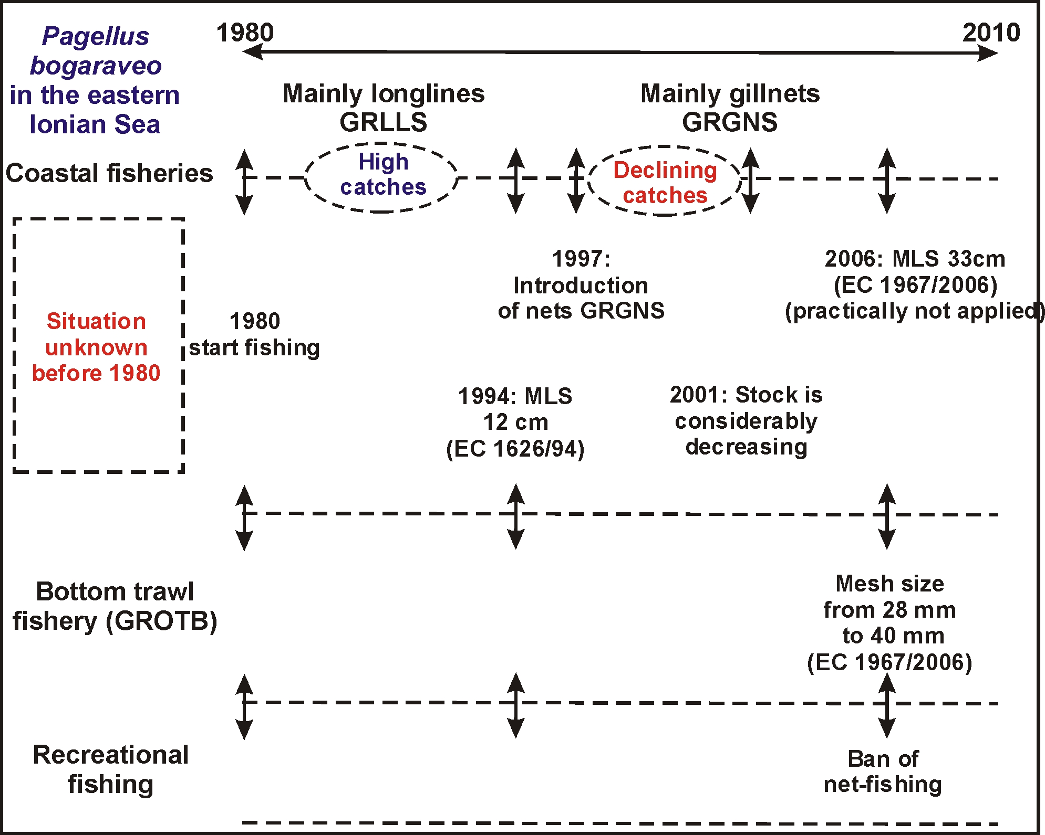
Fig. 6.1.8. Evolution of the P. bogaraveo fishery in the eastern Ionian Sea

6.2 Management procedures at the stock level
6.2.1 Please describe the management procedures currently in place.
6.2.2 What has been the strengths and weakness of these procedures?
6.2.3 How could they be improved?
6.2.4 Should other types of management procedures be considered? Is so please describe and identify expected benefits.

Currently, MLS is set to 33 cm, which is not followed by the fishers. All fish caught in the trawl fishery and more than 90% of fish caught in the net fisheries are smaller than 33 cm TL. If the measure is to be enforced in a strict way, then landings of P. bogaraveo should be absent in the trawler fishery and minimized in the artisanal fisheries. Since the artisanal fisheries are highly unregulated, this seems to be unlikely the case…
Improvements in the current management procedures would be the identification of spawning areas as well as spawning and nursery grounds. This would allow the establishment of spatial and seasonal closures.

6.3 Management procedures at the fisheries level
6.3.1 Please describe the management procedures currently in place.
6.3.2 What has been the strengths and weakness of these procedures?
6.3.3 How could they be improved?
6.3.4 Should other types of management procedures be considered? Is so please describe and identify expected benefits.

Management procedures currently in place consider:
- GROTB: seasonal (June to September) and spatial (<1.5 n.m. from coast or 50 m isobath) closures; 40 mm trawl cod end mesh size
- GRGNS, GRGTR, GRLLS: no restrictions
The positive view of the above measures is that the trawl fishery is closed during summer which is most likely the spawning period for P. bogaraveo.
The negative side is that even with the new trawl cod end mesh size (40 mm) important proportion of young specimens are still present in the catch.

Management procedures that should be considered in the future should focus on:

- Protection of juveniles and spawners. Closure of fishing during the spawning period,
- Limitations should be introduced in the net and long line fisheries based on scientific advice.
Increase of the mesh size of gill and trammel nets and the size of the hooks of long lines.
- Obligatory use of VMS for all vessels of this fishery
- Obligatory report of their catches (census sampling)
- Inspection of the gears (configuration) used by the Port Police authorities
- Inspections/control on recreational fishermen. Max harvest quantity is 5 kg/individual but inspections are loose if not absent.

6.4 Management procedures at the ecosystem level

6.4.1 Please describe the management procedures currently in place.

6.4.2 What has been the strengths and weakness of these procedures?

6.4.3 How could they be improved?

6.4.4 Should other types of management procedures be considered? Is so please describe and identify expected benefits.

6.5 Management procedures relating to VMEs

6.5.1 Please describe the management procedures currently in place.

6.5.2 What has been the strengths and weakness of these procedures?

6.5.3 How could they be improved?

6.5.4 Should other types of management procedures be considered? Is so please describe and identify expected benefits?

6.6 Management procedures relating to PET species

6.6.1 Please describe the management procedures currently in place.

6.6.2 What has been the strengths and weakness of these procedures?

6.6.3 How could they be improved?

6.6.4 Should other types of management procedures be considered? Is so please describe and identify expected benefits.

Management procedures currently in place:
- Prohibition of trawl fishing in waters <50 m
- Protection of Posidonia sp. grounds
- Prohibition of fishing of PET species according to Annex 1 of EC 43/1992

However, thorough study of the various ecosystem types in the deep waters of the Ionian Sea may suggest additional strategies and/or areas of interest for managing.
More details on biological data for PET species should be recorded and scientific personnel must be educated to confront these issues.

6.7 Comparison of management measures introduced against scientific advice
6.7.1 Please complete the following table for your stock and related fisheries. In your opinion has the scientific advice been followed by Management Bodies? Please score 0 (not at all) to 10 (fully adhered to) in column on right
.
Year | Scientific advice | Agreed management measures | Adherence (score 0 to 10)
2000
2001(*) | - minimum mesh size 90 mm for GRGNS  - closure of the fishery when the reproduction is taking place  - further investigation of the biology of the species | None | 0
2002
2003
2004
2005
2006
2007
2008
2009
*: Based on the outcomes of Petrakis et al. (2001)

This advice hasn’t been followed by the Management Bodies involved. The EU (COM 1967/2006) has introduced a MLS of 33 cm TL, mainly based on the findings from the western Mediterranean Sea, which probably hosts a different stock.

6.8 Data-poor stocks and the Precautionary Approach (PA)
6.8.1 In your opinion, is your stock/fishery data-poor? Please score on a scale 1 (extremely data-poor) to 10 (extremely data-rich). Please justify your scoring.
6.8.2 In your opinion have Management Bodies made adequate use of the Precautionary Approach. If they have, please cite examples. If they have not, please cite examples.

In our opinion, the P. bogaraveo eastern Ionian stock/fishery can be evaluated as a data poor situation (score 3 on a 0-10 scale).
This is mainly due to the fact that P. bogaraveo is not a target species of the DCR scheme, making data gathering a huge task, by collating data from surveys focusing on other species.

PA can be applied only in the case that some basic scientific advice is provided and the stock is clearly delineated by adjacent stocks, something that has not been achieved to date.

6.9 Ecosystem and socio-economic considerations.
6.9.1 Describe and review how existing managing procedures take into account ecosystem considerations.
6.9.2 How can this be improved?

No ecosystem based management procedures are currently in action

6.10 Stocks under moratorium/collapsed fisheries
6.10.1 Is your stock under moratorium or have fisheries recently collapsed?
6.10.2 If yes, is a Recovery Plan in place? If yes, please describe.
6.10.3 Please review the strengths and weaknesses of the plan and, if appropriate, please identify how it could be improved.
6.10.4 If a recovery plan is not in place please explain why and express what, in your opinion, is required .

The P. bogaraveo fishery showed a considerable decrease in the late 90’s, and it was then considered as ‘collapsing’ (Petrakis et al., 2001). However, abundance indices from commercial fishery and experimental surveys confirmed that this decline was only temporal, and the stock is showing indications of a recovery.
Nevertheless, the stock is not analytically assessed and there is no adequate info to consider the stock status reliably.

6.11 Stocks managed under a management strategy framework
6.11.1 Is a management strategy framework in place for your stock? If yes please describe.
6.11.2 Please review the outcomes from the most recent Management Strategy Evaluation and describe what effects the outcomes have had on management.

No such a framework is in action

6.12 International Plan of Action (IPOA)
6.12.1 Where applicable do the fisheries for your stock follow IPOA guidelines8? If so please describe

Greece, to date, has not adopted the IPOA-IUU to a national level.

6.13 Current/short term (<5 yrs) management issues
6.13.1 What are the main management issues currently facing your stock/fisheries Please prioritise.
6.13.2 If the issue is currently being addressed, please describe how, below.
6.13.3 If the issue is only partially or not being addressed please describe what further/additional procedures/measures are required.

The main management issues the stock is currently facing (by priority):

Priority | Description of issue | Is issue being addressed? Yes /no
1 | Uncertainty on the fish’s biology (spawning period, maturity, feeding habits, migration, nursery areas) | Partially
2 | Actual catches are unknown | Partially in the DCR scheme
3 | No stock assessment conducted | Partially
4 | No stock identification | Not yet
5

A dedicated research project on P. bogaraveo would be the best approach.

6.14 Long-term (>5 yrs) management issues
6.14.1 What are the main management issues currently facing your stock/fisheries? Please prioritise.
6.14.2 Express in your opinion how these issues could be addressed.

Current management of species is poor if non-existent.
Consequently, long-term management is not applicable for the time being, current/short term management is a priority.

6.15 Monitoring procedures
6.15.1 What are the main monitoring issues currently facing your stock/fisheries? Please prioritise.
6.15.2 Express in your opinion how these issues could be addressed.

The main monitoring issues which the stock/fishery is currently facing can be sorted by priority:

Priority | Description of issue
1 | P. bogaraveo is not a target species in DCR-NDCP
2 | Huge coastal fleet – Monitoring is a huge task
3 | Artisanal fisheries are unregulated
4 | VMS data set is not accessible for scientific use
5 | Coverage of the artisanal fleet must be increased substantially in order to attain an adequate-representative sample of the fleet activities.
6

It is obvious that research initiatives should be put in action shortly

6.16 Monitoring at sea
For each fleet identified in 2.1.1 with vessels carrying observers:-
6.16.1 Please list and prioritise the problems observers encounter at sea.
6.16.2 How can these problems be addressed?
6.16.3 Is there any coordination of observer sampling plans and observer activity across and between fleets from different Member States and other non-EU countries? If so please review.
6.16.4 Please describe and review any other sea-going monitoring programmes in place.
6.16.5 Please identify the strengths and weaknesses of existing monitoring programmes at sea
6.16.6 How could they be improved?

The most common problems that observers encounter at sea are:
- in general on board observers are inexperienced non-permanent staff
- GRGNS & GRGTR fleet: small boats (<12m) with limited space for an observer. Observers gradually become a burden to the fishers and are not welcomed on board
- GROTB: The fishing and processing of catches is continuous making it difficult to monitor all catches (especially discards)

Some of these problems can be addressed by organizing seminars to educate the observers and allow them to identify rare/uncommon species (e.g.: PET).

Strengths of existing monitoring programmes at sea (DCR) are the recording of real data while their weaknesses can be summarized in low coverage of the fleets’ activities.
Improvements would be the use of more experience observers on board and increase in the number of vessels monitored.

6.17 Port-based monitoring
For each fleet identified in 2.1.1:-
6.17.1 Please review any port-based sampling schemes, citing % landings/discards coverage, essential data collected and other non-essential data collected?
6.17.2 Please list and prioritise the problems encountered sampling landings/discards from your stock.
6.17.3 How can these problems be addressed?
6.17.4 Is there any coordination of port sampling plans across and between Member States and non-EU countries? If so please review.
6.17.5 Please describe and review any other shore-based monitoring programmes in place
6.17.6 Please identify the strengths and weaknesses of existing shore-based monitoring programmes.
6.17.7 How could they be improved?

DCR sampling scheme is based on landings (sale slips) recorded by the local fisheries inspectors (effort, landings, socio-economics).
The main problems encountered during these sampling are:
- Species misidentification(pooled catches categorized under a group of species e.g.: skates & rays)
- Only landings are recorded, absence of discards
- Not representative sample of each fleet category (low sample number)
- Underestimation of catches
- Underestimation of effort

More detailed monitoring, combined with more inspectors with higher level of experience would solve most of the aforementioned issues.

Other shore-based monitoring programmes in place include the NSSG sampling scheme which is based on declaration forms of catches reported to the local port police authorities. Only a small portion of fishers fill up these forms and under/mis-reporting is taking place.
As a solution, mandatory logbooks should be introduced in the fishery.

6.18 EU Data Collection Framework (DCF)
6.18.1 For each fleet identified in 2.1.1, please list data and information currently collected under the DCF.
6.18.2 Please identify the strengths and weaknesses of the EU DCF?
6.18.3 How could it be improved for your stock?

Data are collected under the following DCR regulation EU-COM 199/2008:

Council Regulation (EC) No 199/2008 of 25 February 2008 concerning the establishment of a Community framework for the collection, management and use of data in the fisheries sector and support for scientific advice regarding the Common Fisheries Policy, Official Journal L 060 , 05/03/2008 P. 0001 - 0012

A major improvement regarding the stock under study, would be to include P. bogaraveo in the DCR target species list (especially market sampling).

6.19 Gap analysis of past and present scientific projects and data collection programmes
6.19.1 What are the main gaps in scientific knowledge and in data collection programmes. Please prioritise.

The main gaps in scientific knowledge and in data collection programmes are (priority sorted):

Category | Issue
Scientific | - Unknown species biology (hermaphroditism, maturity, spawning period, feeding, migration, nursery grounds)  - Unknown actual catches → absence of stock assessment  - Unknown trends in population status  - Unknown interaction with other species/habitat  - Unknown stock identification  - Poor knowledge on food webs  - Ecosystem, VMEs are not yet identified
Data collection | - Unknown actual catches, effort, discards  - Discrepancies among years  - Absence of samplings throughout all seasons  - Not stratified sampling by depth  - Socio-economics

6.20 Fisheries monitoring in general
6.20.1 Are there any aspects of monitoring data and information (quality, temporal and spatial extent, time series, availability, accessibility, flow) that [a] impact on assessments and/or [b] affect your ability to provide timely fisheries advice to managers?

Fisheries monitoring in order to provide timely fisheries advice to managers could be improved in a series of ways, such as:
- Acquire better quality of fisheries dependent data
- Improve spatial and temporal coverage in the sampling scheme
- Gain accessibility to VMS data.
- Initiation of ecosystem monitoring

Section 7: Please review the key uncertainties about the biology, data and management for your stock and any other issues relevant to DEEPFISHMAN

Our main obstacles are:
- Data poor situation
P. bogaraveo is not a target species in the bottom trawl fishery, and only occasionally is a target in longlines and nets.
The exact portion of the fleet targeting the species is unknown and as a result estimations on various parameters are approximate: Effort; Catches; Discards; Landings; Revenues
Only one scientific Project has been conducted so far to study the species biology (EU-046 - Petrakis et al., 2001), which covered spring and summer of 2001, focusing mainly on gear selectivity and age-growth parameters. As a result, key aspects of the species biology such as: spawning period, size at maturity, feeding habits, preferred habitat and, migration, remain to be challenged.
Numerous scientific surveys conducted the past 20 years, hold significant amount of data on P. bogaraveo, among other species. These data are inconsistent seasonally and spatially, since their goal was not to study the certain species, but marine species assemblages in general. The bulk of data consider total catch (in No & W) and length. In rare cases, sex and maturity were identified.
Most data are of bottom trawl origin and come from shallow waters in general (<300 m depth). Sets in deeper strata (where the mature portion of the population resides) are usually from gillnets. Samplings on gillnets are limited (mainly conducted according to DCR scheme) and in most cases do not cover the metier targeting P. bogaraveo.

- Absent of analytical stock assessments
To date, no attempts have been made to assess the stock and draw an outline of the stock status. The absence of TAC’s as a management measure in the Mediterranean, has established the belief that stock assessment is of no use, if no quotas are to be set. Therefore, scientific advice has been directed to selectivity studies, suggesting technical measures such as minimum landing sizes or legal mesh sizes.

- Stock collapse?
The most recent research (Petrakis et al., 2001) pointed out that the stock is under alarming fishing pressure. These authors observed that the coastal longline fishery targeting P. bogaraveo in the Ionian Sea has collapsed, and has been replaced by a gillnet fishery, with catches plummeting throughout the years.
However, data from 2004 and onwards show that the stock is recovering (increasing abundance indices; constant or increasing average size of population). Interviewed fishermen declared surprisingly high catches during 2007 (100-500 kg/day).

General Fisheries Commission for the Mediterramean (http://www.gfcm.org/gfcm)
Total Length
National Data Collection Program applying EU Data Collection Regulation COM 1543/2000
http://www.minagric.gr/en/index.html
Scientific, Technical and Economic Committee for Fisheries (http://fishnet.jrc.it/web/stecf )
National Data Collection Program applying EU Data Collection Regulation COM 1543/2000
Minimum Landing Size
2 e.g. SPAOT – Spanish otter trawlers
3 Exploratory, Benchmark (to identify best practise), Update (repeat of previous years’ assessment using same method and settings but with the addition of data for another year).
5 PET – protected, endangered or threatened species.
5 Grey market, that is where fish is distributed without sales records and is opaque to the competent authorities.
6 HACCP -Hazard Analysis Critical Control Points – analytical process and EU requirement relating to global trade and food quality.
7 Rights-based mechanism where right to fish is associated with a specific area where the management authority is at the local (TURF) level.

