DEEPFISHMAN

A FP7 Project: Management and Monitoring of Deep-sea Fisheries and Stocks

WP2 – Template for Case Study Reports

Case study 2 demersal deep-water mixed fishery

Pascal Lorance, Ifremer, Nantes (coord.)
Hélène Beucher, Ifremer, Lorient
Martial Laurans, Ifremer, Brest
Emilie Lebond, Ifremer, Brest
Benoît Mesnil, Ifremer, Nantes
Lionel Pawlowski, Ifremer, Lorient

Contents

Section 1. Biological parameters with up to date description of the current knowledge of life history pattern, stock structure and status 7
1.1. General information 7
1.1.1. Name of stock 7
1.1.2. Geographical distribution of stocks 8
1.1.3. Depth range 8
1.1.4. Name the scientific organisation and Working Group responsible for carrying out stock assessments and providing scientific advice. 9
1.1.5. Name the Fisheries Management Organisation(s) responsible for managing the stock and supported fisheries. 9
1.1.6. Management and assessment units 9
1.2. Stock identity and status 11
1.2.1. Describe and review the scientific basis used to identify and delineate the stock. 11
1.2.2. Is this robust? If not what studies are required to identify and delineate the stock more robustly? 16
1.2.3. Describe and review any past or ongoing studies of stock identity 17
1.2.4. Are there any stocks of this species adjacent to the Case Study stock? 18
1.2.5. Migration 18
1.2.6. Tagging studies 20
1.2.7. Are there any aspects of stock identity knowledge data that [a] impact on assessments and/or [b] affect your ability to provide timely fisheries advice to managers? 21
1.2.8. Based on the latest scientific advice for this stock (please append below), what is the current status of the stock? 22
1.2.9. Recent historical trend in the stock (increasing, decreasing, stable) 22
1.3. Life history characteristics (LHCs) 24
1.3.1. Best estimate of LHCs 24
1.3.2. 1.3.2 What are the main gaps in knowledge regarding LHCs? 31
1.3.3. Can these gaps be addressed by regular monitoring or are dedicated research initiatives required? Please describe programmes required. 31
1.3.4. Consequences for assessment and management 32
1.4. Life history pattern and general species ecology 33
1.4.1. Sexual type 33
1.4.2. Spawning type 33
1.4.3. Spawning grounds 34
1.4.4. Spawning time: when does spawning occur? Does this differ by spawning ground/area? If so please describe. 34
1.4.5. Early life history: are the early life stages well described and documented in the scientific literature? If so please describe. 34
1.4.6. Life stages and habitats 35
1.4.7. Nursery areas 35
1.4.8. Are juveniles and adults associated with particular topographical features 35
1.4.9. Recruitment 36
1.4.10. Other salient aspects of the life cycles 37
1.4.11. Feeding 37
1.4.12. Predators 38
1.4.13. What are the main gaps in knowledge regarding life history patterns and general species ecology? 38
1.4.14. Further data collection/research requirements 38
1.4.15. Implication for assessment and management 38
Section 2. Historical development of the fisheries, including catches and fleets. 39
2.1. Background information 39
2.1.1. Fleet identity 39
2.1.2. Historical development and current activity of each fleet 40
2.1.3. Gaps in fleet data 43
2.1.4. Can these gaps be addressed by regular monitoring? If so, how? 44
2.1.5. Please complete the table below on the extent of time-series data of landings and discards data:- 44
2.1.6. Does the earliest data available correspond to the start of exploitation of the stock. If not please describe. If earlier data exist please list where these can be found. 45
2.1.7. If discard data are not available please indicate by fleet ID if, in your opinion, discards are likely to be significant 45
2.1.8. If mis-reporting or under-reporting is/has been a problem please indicate years in table below: 46
2.1.9. Gear selectivity 46
2.1.10. Are there any aspects of data (quality, temporal and spatial extent, time series, availability, accessibility, flow) that [a] impact on assessments and/or [b] affect your ability to provide timely fisheries advice to managers? 47
Section 3. Review of stock assessments carried out thus far 48
Section 4. Data inventory 65
4.1. Fisheries data 65
4.1.1. Fleet composition 65
4.1.2. Effort data 65
4.1.3. Landings and discards data 67
4.1.4. VMS data 77
4.1.5. Observer data 79
4.1.6. Fishing footprint 94
4.1.7. Abundance indices derived from commercial catch and effort data 95
4.1.8. Information and data made available by fishers, fisher organisations or other stakeholders 104
4.1.9. Fisheries data in general 104
4.2. Fisheries-independent survey data 105
4.2.1. Please complete the table below for any surveys that are currently carried out or have taken place in the last 10 105
4.2.2. 4.2.2 For each survey please:- Erreur ! Signet non défini.
4.2.3. 4.2.3 Are the survey data used in assessments? If so please describe how. If not please explain why. 105
4.2.4. 4.2.4 Please identify strengths and weakness of each survey and identify if and how they could be improved. 105
4.2.5. 4.2.5 If any surveys have been terminated within the last 10 years please explain why. 106
4.2.6. 4.2.6 Are any new surveys being considered? If so please describe. 106
4.2.7. 4.2.7 Please append any survey abundance indices available for your stock (tables and figures) and comment on their 106
4.2.8. 4.2.8 Are there any aspects of fisheries-independent survey data (quality, temporal and spatial extent, time series, 110
4.3. Biological data for your stock 110
4.3.1. 4.3.1 Please complete the table below for each fleet/survey inserting in each cell the time series of data available, if quarterly (q) or annual (a), and if collected by observers (O), by market sampling (MS) or both (OMS). Please append all available time-series of quarterly and annual data. 110
4.3.2. 4.3.2 For the most recent assessment, how was total international catch data raised from fleets and what are the strengths 110
4.3.3. 4.3.3 If age data are available please describe the age determination materials and methods used. 111
4.3.4. 4.3.4 How have ages been validated? 111
4.3.5. 4.3.5 Are the age data considered to be reliable? 112
4.3.6. 4.3.6 Has there been any ageing workshops for your species? If please review outcomes. 112
4.3.7. 4.3.7 Are there any aspects of data (quality, temporal and spatial extent, time series, availability, accessibility, flow) that 112
4.4. 4.4 Ecosystem, biodiversity and VME data (see footnote 1 on page 2 for definition of VME) 113
4.4.1. 4.4.1 Background information 113
4.4.2. 4.4.2 Data available in support of ecosystem based management. 113
4.4.3. 4.4.3 Protected, Endangered and Threatened (PET) species (part of Descriptor 1) 120
4.4.4. 4.4.4 Ecosystem modelling (Descriptors 4,5) 120
4.4.5. 4.4.5 Fishery interactions (Descriptors 1,6) 121
4.4.6. 4.4.6 Pollutants and contaminants (Descriptor 9): 121
4.4.7. 4.4.6.2 Do you assess the ecosystem effects (negative and positive) of marine debris and examine options for its 122
4.4.8. 4.4.7 Vulnerable Marine Ecosystems (VMEs) (Descriptor 1) 123
4.5. Socio-economic data 124
4.5.1. Detailed descrition 126
4.5.2. Employment 133
4.5.3. General 134
Section 5. Review of known and likely impact of the fisheries on deep-water biodiversity and VMEs 136
5.1. Previous and current studies of biodiversity 136
5.1.1. ICES 136
5.1.2. IUCN 136
5.1.3. OSPAR 136
5.1.4. FAO 137
5.1.5. NGOs 137
5.1.6. Other reviews 137
5.2. Aims, methods and data used, outcomes and recommendations made of biodiversity studies 137
5.3. Relationship between biodiversity trends and fishing impact 137
5.4. Unexploited biodiversity data 137
5.5. The way forward to investigate the impacts of fishing on biodiversity 138
5.6. Previous and current studies of the condition of VMEs 138
5.7. Aims, methods and data used, outcomes and recommendations of VMEs studies 138
5.8. Impacts of fishing on VMEs 138
5.9. The way forward to investigate the impacts of fishing on VMEs 138
5.10. Data and knowledge availability 138
Section 6. Review of current and historical management and monitoring procedures 139
6.1. Management procedures 139
6.1.1. Current management mechanisms to manage stocks, fisheries, ecosystems, VMEs and PET species 139
6.1.2. Possibilities of entry in the fishery 140
6.1.3. Control of the fishing area 140
6.1.4. Evaluation of IUU fishing 141
6.1.5. Interaction of research institute with other agencies and fisheries management bodies to combat IUU fishing 141
6.1.6. Measures in place in place to track the products of harvested species 141
6.1.7. Past management procedures 141
6.1.8. Temporal development of the fishery 142
6.2. Management procedures at the stock level 142
6.2.1. Current procedures 142
6.2.2. Strengths and weakness of these procedures 144
6.2.3. Possible improvements 144
6.2.4. Alternative management options 145
6.3. Management procedures at the fisheries level 145
6.3.1. Please describe the management procedures currently in place. 145
6.3.2. What has been the strengths and weakness of these procedures? 146
6.3.3. How could they be improved? 146
6.3.4. Should other types of management procedures be considered? Is so please describe and identify expected benefits. 147
6.4. Management procedures at the ecosystem level 147
6.4.1. Ecosystem management procedures currently in place. 147
6.4.2. Strengths and weakness of these procedures 147
6.4.3. Possible improvements 147
6.4.4. Possible other types of management procedures 147
6.5. Management procedures relating to VMEs 148
6.5.1. Management procedures currently in place 148
6.5.2. Strengths and weakness of these procedures 148
6.5.3. Possible improvements 149
6.5.4. Possible other types of management procedures 149
6.6. Management procedures relating to PET species 149
6.6.1. Management procedures currently in place 149
6.6.2. Strengths and weakness of these procedures 149
6.6.3. Possible improvements 149
6.6.4. Alternative types of management procedures 150
Section 7. Key uncertainties about the biology, data and management; other issues relevant to DEEPFISHMAN 155
7.1. Needs for further research 155
7.1.1. Stock identity 155
7.1.2. Survivals of discarded sharks 156
7.1.3. Selective gear/devices 156

Section 1: General information and biological parameters with up to date description of the current knowledge of life history pattern, stock structure and status.

Section 2: Historical development of the fisheries, including catches and fleets.

Section 3: Review of assessments carried out thus far.

Section 4: Inventory of the fisheries, biological, biodiversity, vulnerable marine ecoystem (VME1) and
socio-economic data currently available for management and monitoring purposes.

These data are to be collated by the Case Study Leader and made available to and stored on the
DEEPFISHMAN data archive held by Ifremer for use during the project. Ifremer will
shortly be circulating a data-exchange format. Data not subject to confidentiality restrictions
will be stored at the end of the project on a web-based library similar to PANGEA.

Section 5: Review of known and likely impact of the fisheries on deep-water biodiversity.

Section 6: Review of current and historical management and monitoring procedures. SWOT (Strength
and weaknesses, Opportunities and threats) and gap analysis of past and present scientific
projects and data collection programmes in terms of fulfilling the data requirements for
adequate management and monitoring regimes

Section 7: Review of the key uncertainties about the biology, data and management of your stock and any other
issues relevant to DEEPFISHMAN

Reminders

1. Please enter all answers in this document and include references in answers, where appropriate. CS leaders
are required to keep all the headers and formatting in the document and write "not relevant or "none" where
there is nothing to say.

2. For Case Study 2: French mixed demersal trawl fishery – substitute fishery for stock in all questions where
appropriate. For specific questions on biology etc please include data and information for the main target
stocks of the fishery.

3. It is expected that Case Study Leaders will have to carry out data mining in key areas e.g. for historical
fisheries data and for socio-economic data.

(12/12/09)
I trust you have all recovered from what was quite and intensive but productive WP2 Workshop. My thanks to you all for your excellent contributions.
You will recall that we agreed that each Case Study Report should be prefaced by a short (no more than 2 pages) Executive Summary comprising:-
- What is perceived to be good practise
- What is perceived to be poor practise and/or what can be improved
- Major gaps in knowledge and understanding
- Future challenges,
- Recommendations relevant (1) Case Study stocks/fisheries and (2) the development of a monitoring, assessment and management framework for the NE Atlantic.
I would be grateful if this can be included in your report when it is next submitted (31st January).
I wish you all a Merry Christmas and a Happy New Year
Phil

Biological parameters with up to date description of the current knowledge of life history pattern, stock structure and status

General information

Name of stock
Demersal deep-water mixed fishery in ICES divisions Vb and XIIb and divisions VI and VII.
This fishery is prosecuted by: French deep-water trawlers in ICES division Vb and sub-areas VI and VII; Faeroese trawlers; Spanish freezer trawlers in areas VIb and XIIb…[completer Scottish, Enghish, Irish]. The fishery is referred to below as “demersal deep-water mixed fishery”.
The case study name in the Deepfishman project is “Mixed demersal trawl fishery: - French trawl fishery for roundnose grenadier, black scabbardfish and deep-water sharks in Vb, VI and VII”. This is too restrictive because other deep-water fishing fleets operate in the same areas as the French fleet (although the bulk of the catch is landed by the French fleet) and for some species fleets operating on neighbouring areas are assumed to exploit the same stocks. For example the Spanish fleet fishing on the Northern and Western slope of the Hatton bank (ICES divisions VIb and XIIb) are presumed to exploit the same roundnose grenadier stock as the fleet operating further east in ICES divisions VB and VIa.
Therefore, the demersal deep-water mixed fishery covers fleets fishing for roundnose grenadier, black scabbardfish and deep-water sharks in ICES divisions Vb and XIIb and sub-areas VI and VII. This fishery is primarily a trawl fishery with some fishing carried out with longlines and nets. In addition to the target species, a number of species have been caught as bycath including tusk (Brosme brosme) Chimaerids (mainly Chimaera monstrosa), black sardinal fish (Epigonus telescopus), roughead grenadier (Macrourus berglax) deepseascorpionfish (Trachiscorpia critulata echinata) have been landed in small quantities. Bycatch species are not analysed into detail in this section.

Geographical distribution of stocks

Depth range

The main exploited stocks are roundnose grenadier (Coryphaenoides rupestris), blackscabbard fish (Aphanopus carbo), blue ling (Molva dypterygia), orange roughy (Hoplostethus atlanticus) Portuguese dogfish (Centroscymnus coelolepis), leafscale gulper shark (Centrophorus squamosus). The main by-catch commercial species are Chimearas (mainly Chimaera monstrosa, but also Hydrolagus spp.), greater forbeard (Phycis blennoides). TACs for orange roughy and and deep-water sharks (all species) were set to 0 in 2010.

Table 1.1.3. depth ranges of the main deep-water exploited species in ICES sub-areas Vb, VI and VII.
Species | Depth range (m; peak abundance in brackets) | reference
Roundnose grenadier | 180-2200, most abundant 800-1500 | (Lorance et al. 2008)  (Bridger 1978)  (Ehrich 1983)
black scabbardfish | 200- 1200m | (Bridger 1978)  (Ehrich 1983)
Blue ling | 300-1500 (700-1100) | (Gordon and Hunter 1994)  (Lorance et al. in press)
Orange roughy | 500-1800 (800-1500) | (Lorance et al. 2002)
greater forkbeard | 60-1000 (200-700) | (Casas and Pineiro 2000)
Leafscale gulper shark | 150-2400
Portuguese dogfish | 150-3700

Name the scientific organisation and Working Group responsible for carrying out stock assessments and providing scientific advice.

Stock and ecosystem assessment are provided by the International Council of the Exploration of the Sea (ICES). Stock assessments are carried out by the ICES Working Group on the Biology and Assessment of Deep Sea Fisheries Resources (WGDEEP) for roundnose grenadier; black scabbardfish, greater forbeard and by ICES WGEF, Working Group on Elasmobranch Fishes, for leafscale gulper shark; Portuguese dogfish and chimaeras.
Ecosystem advices provided by ICES are based upon work from the Working group on deep water ecology, WGDEC (ICES 2008a). From 2005 to 2007, ecosystem overviews included in ICES advices wer provide by the working goup for regional ecosystem description (ICES 2007d).

Name the Fisheries Management Organisation(s) responsible for managing the stock and supported fisheries.

European Commission, in the EU Exclusive Economic Zone (EEZ)
NEAFC, North East Atlantic Fisheries Organisation in international waters.
Nevertheless some EU regulations apply both to EU waters and to EU vessels in International waters
Faroe Islands [to be clarified]

Management and assessment units

Management units for the demersal deep-water mixed fishery
The current Management units were taken from the council regulation (EC) No 1359/2008 of 28 November 2008 fixing for 2009 and 2010 the fishing opportunities for Community fishing vessels for certain deep-sea fish stocks. Assessement units were taken from ICES (2009a).

Table 1.1.6.1. Management units and stock assessment units of stock exploited by the demersal deep-water mixed fishery

Species | Assessment unit | Management unit | Match
Roundnose grenadier | The Faroe Hatton area, Celtic sea (Divisions Vb and XIIb, Subareas VI, VII) | Community waters and waters not under the sovereignty or jurisdiction of third countries of Vb, VI, VII (RNG/5B67-) | No
Roundnose grenadier | The Faroe Hatton area, Celtic sea (Divisions Vb and XIIb, Subareas VI, VII) | Community waters and waters not under the sovereignty or jurisdiction of third countries of VIII, IX, X, XII and XIV (RNG/8X14-) | No
Black scabbardfish | Northern component, subareas, VI, VII and divisions Vb and XIIb | Community waters and waters not under the sovereignty or jurisdiction of third countries of V, VI, VII and XII (BSF/56712-) | Yes
Greater forkbeard | No assessment carried out | Community waters and waters not under the sovereignty or jurisdiction of third countries of V, VI and VII (GFB/567-) | No
Greater forkbeard | No assessment carried out | Community waters and waters not under the sovereignty or jurisdiction of third countries of X and XII (GFB/1012-) | No
Portuguese dogfish | One single assessment unit in the Northeast Atlantic | Community waters and waters not under the sovereignty or jurisdiction of third countries of V, VI, VII, VIII and IX (DWS/56789-) | No
Portuguese dogfish | One single assessment unit in the Northeast Atlantic | Community waters and waters not under the sovereignty or jurisdiction of third countries of XII (DWS/12-) | No
Leafscale gulper shark | One single assessment unit in the Northeast Atlantic | Community waters and waters not under the sovereignty or jurisdiction of third countries of V, VI, VII, VIII and IX (DWS/56789-) | No
Leafscale gulper shark | One single assessment unit in the Northeast Atlantic | Community waters and waters not under the sovereignty or jurisdiction of third countries of XII (DWS/12-) | No

The assessment and management units for roundnose grenadier are different. The reasons are not fully clear. Nevertheless, when TACs for deep water stocks were introduced for the first time in 2003 (council regulation (EC) No 2340/2002 of 16 December 2002 fixing for 2003 and 2007 the fishing opportunities for Community fishing vessels for certaindeep-sea fish stocks), a TAC for roundnose grenadier was defined for ICES Division Vb and sub-areas VI and VII. At that time ICES conducted assessement only for areas Vb, VI and VII and this may have driven the fixation of aTAC for this area. Nothing was done for the area XII for which data were much more limited. The ICES working group also met difficulties with separating the catch reported in sub-area XII between the western slope of the Hatton Bank and the mid-AtlanticRidge. It should be stressed that these catches were never reported be statistical rectangle to ICES, preventing a fine allocation of the catch to geographical areas. The problem in this area is one of stock identification (see section 1.2.1). The process of setting TACs for the first time is a political negociation and the project did not try to go through archives of the minutes of the discussions.
A TAC in ICES areas VIII, IX, X, XII and XIV, includes areas VIII, IX and X where the species
For black scabbardfish, the assessement and mangement areas match. However, the area may not correspond to a population unit (see section 1.2.1).
For greater forkbeard, assessment have not been carried out in recent years because of lack of data. For this species, the stock identity is unkown (see section 1.2.1), the species is mainly caught as a by-catch. A high proportion (80%) of the total catch come from ICES sub-areas VI and VII. Information has been presented for 4 areas:
ICES Subareas I, II, III, IV and V
ICES Subareas VI, VII and XII (Hatton Bank)
ICES Subareas VIII and I.
ICES Subarea X (Azorean region)
However, the ICES expert group noted that “this separation does not presuppose that there are four different stocks of Greater forkbeard and only offers a way of recording the available information.in ICES area” (ICES 2009a). Total Allowable Catch (TAC) are set for forkbeards but species the species Phycis blennoides. There is no other deep-water forkbeard species in subareas V, VI and VII. The closely related species (Phycis phycis) is distributed further south (from the Bay of Biscay, where it is rare) and is mainly a shelf demersal fish.

Portuguese dogfish and leafscale gulper shark are managed together with other deep water sharks as one single unit. Management area distinguish the western slope of the european plateau from Iceland and the Faeroes down to Gibraltar on the one hand and ICES sub-area XII (Northern Mid-Atlantic ridge) on the other hand. This is appropriate as it allows to distinguish catches from long standing rather stable fisheries to the West of Europe from catch from more sporaidc fisheries in a different environnement on the mid-Atlantic ridge. This also prevent possible different trends (e.g. decreasing due to dicreasing Landings per Unit of Effort, LPUE in one area and increasing in the other due to increased fishing effort) to be merged into a not interpretable signal.

Neighbouring management units for the same species

In order to prevent misreporting, small TACs to allow for minor by-catch and zero TACs have been set in some areas. This applies to roundnose grenadier in EU waters of ICES sub-areas I, II, IV and Va. Moreover, the TAC for roundnose grenadier in ICES areas VIII, IX, X, XII and XIV, includes areas VIII, IX and X where the species occurs at low density only. This TACs is mainly allocated to fisheries occurring in ICES division XIIb. Then, including areas where the species in hardly caught to the area of one major fishery, which catch roughly all the TAC, prevents fisheries to develop somewhere else or catch to be misreported.

Similarly, for black scabbardfish, there is a small TAC in ICES sub-areas I, II, III and IV to prevent misreporting and a TAC in ICES sub-areas VIII, IX and X, which is 99% allocated to Portugal, i.e. the Portuguese Longline fishery for black scabbardfish (see case study 3c).

For greater forkbeard, there is also a small TAC in ICES sub-areas I, II, III and IV and a significant TAC (267 tonnes in 2009 and 2010) in sub-areas VIII and IX.

For deep water sharks, there is no TAC in northern areas (ICES areas I-IV) but there are small TACs in ICES areas X and XII.

Stock identity and status

Describe and review the scientific basis used to identify and delineate the stock.

Roundnose grenadier (Coryphaenoides rupestris)
Due to the lack of extensive and/or conclusive studies of population genetics, the population structure of the roundnose grenadier in the Atlantic was based on hypothetical oceanographic boundaries to the dispersal of all life stages.
The Wyville-Thomson Sill may separate populations further south on the banks and slopes off the British Isles and Europe from those distributed to the north along Norway and in the Skagerrak because it is believed to be a natural topographical restriction to the dispersal of all life stages. Considering the general water circulation in the North Atlantic, populations from the Icelandic slope may be separated from those distributed to the west of the British Isles. No pattern in seasonal density variation has been observed from surveys or from fisheries (Lorance et al. 2008). There is no evidence of long distance migration of adult fish, which are considered to be rather poor swimmers, based on morphological and metabolic knowledge (Koslow 1996; Merrett and Haedrich 1997). Nevertheless, there are also no data available to indicate whether or not individuals move around during their life span.There is also a lack of knowledge of the distribution and dispersal of the eggs and larval stages, except in the Skagerrak (Bergstad and Gordon 1994). In the Skagerrak the larval stage was estimate to last for one year and it is assumed to be the same in other areas. Regional differences in estimated length distribution, maturity, age and commercial CPUEs were not considered informative about stock structure because, several other factors, such as differences in fishing depth or bias in age estimation, may explain the observations (ICES 2007a). Reproduction might occur in about all the geographical distribution of the species because all maturity stages have been foun in all areas.
Then, the biological basis for the hypothetical population structure into three units must await the results from studies of genetics and otolith microchemistry. To date, the assumption of three major adult stock units upon which ICES assessment work has been based seems the most appropriate:
• Skagerrak (IIIa), referred to in this report as IIIa stock
• The Faroe-Hatton and Rockall trough area down to the Celtic sea (Divisions Vb and XIIb, Subareas VI, VII), referred to in this report as West of the Bristish Isles stock (West of BI stock)
• The Mid-Atlantic Ridge (MAR, Divisions Xb, XIIc, Subdivisions Va1, XIIa1, XIVb1), referred to in this report as MAR stock.

On-going genetic studies support the separtation above. Preliminary results indicate that the Skagerrak from a distinct population and is also seprated from populations in Norwegian Fjords. Fish from the Mid-Atlantic Ridge from another clearly distinct component. In the area to the west of the British Isles (ICES Subareas and Divisions Vb, VI, VII and XIIb) including the continental slope to the West of the British Isles, the Rockall and Hatton Bank (Figure 1.2.1.1), there is some structuring and thre may be distinct populations but genetic distances amongst these components are smaller than between between these components and the Skagerrak and Mid-Atlantic Ridge populations (Knutsen et al. 2010).

In this context, the demersal deep-water mixed fishery, exploits only the West of the British Isles stock. The management area Vb, VI and VII is fully included in the distribution area of this stock, but the other management area labbeled “Community waters and waters not under the sovereignty or jurisdiction of third countries of VIII, IX, X, XII and XIV” stretches over two stock units (the West of BI and MAR stocks). In is unclear whether catches from the Spanish fleet on the Western slope of the Hatton bank should be considered are taken from the same stock as catch taken along the West of the British Isles or if the genetic differentitation is sufficient to consider independent stock units.

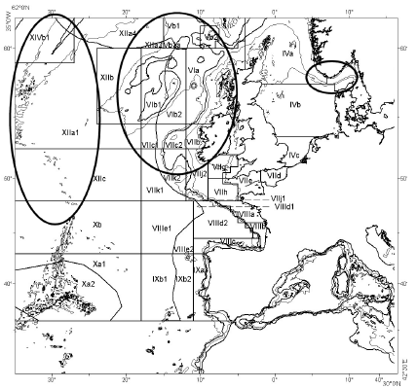

Figure 1.2.1.1. Areas of the main fisheries for roundnose grenadier, Skagerrak, west of the British Isles and mid-Atlantic Ridge. The isobaths displayed are 100, 200, 1000 and 2000 m (from Lorance et al. 2008).

Black scabbardfish (Aphanopus carbo)
The stock identity of black scabbardfish remains unclear in the Northeast Atlantic. This is a complicated issue because even the occurrence of species may be unclear in some areas. For example, it was realised only recently that two species of Aphanopus could occur in some areas. In a recent genetic study of Apahnopus carbo, two phylogroups were identified for the genus Aphanopus: All sequences from the Mid-Atlantic Ridge (Faraday seamount), mainland Portugal and Madeira were clustered together while all the sequences from the southern coast of Pico island (Azores, central group) were grouped. The remaining sampling localities in Azores, at Sedlo Sedlo seamount, to the North of the Azores and at Seine seamount, between Portugal mainland and Madeira had sequences represented in both phylogroups. The outcome from the comparison of the same mtDNA regions of the closely related Aphanopus intermedius from Angola clustered with the ones from phylogroup from the southern coast of Pico island, Azores (Stefanni and Knutsen, 2007). As the specimens from this study were not kept for taxonomic investigation, it could not be ascertained whether there is two populations of Aphanopus carbo or two species: A. carbo and A. intermedius (Stefanni and Knutsen 2007). It is unclear whether only A. carbo or both species occur at Madeira and in the Canaries. Unfortunately, this study did not include specimens from the west of the British Isles.Nevertheless only one species Aphanopus carbo is believe to occur to the west of the British Isles.
In a study based upon otolith microchemistry with samples from six different locations (Rockall Trough, Hatton Bank, Reykjanes Ridge, Mid-Atlantic Ridge, Portugal (mainland) and Madeira), only the Reykjanes Ridge formed a distinct cluster (clearly separated along Axis 1) (Swan et al., 2001). A more recent study using otolith microchemistry and stable isotope concluded that the black scabbardfish (A. carbo) may do a large scale ontogenetic migration.Certains areas in the North Atlantic are used for spawning and other for feeding and one single population occur from the West of the British Isles to West of Portugal, Madeira and the Azores (Longmore et al. 2010).
Previous results suggested several population could occur. In particular, a study of morphometric carried out under the BASBLACK project analysed specimens sampled at 3 different fishing regions (Madeira, Sesimbra and Rockall Trough). Cluster analysis of morphometric variables was applied to understand the influence of the different morphometric measurements, and to select the variables to be used on the subsequent discriminant analysis. Each variable was standardised, and then the Euclidean distance was taken as the dissimilarity measure to apply the Ward´s hierarchical method. The analysis showed a clear separation between individuals from Madeira and Sesimbra one the one hand and those from the Rockall Trough on the other hand. The results from this study are undermined by recent result of microchemistry and satble isotopes (Longmore et al. 2010). The problem that may have happen with morphometric analyses is that individual in the south of the area of distribution are adult and those from the West of the Rockall Trough are not and there may be change in some morphometric measures with sexual maturity and simply with size.
To summarise, maturity and sizes are different throughout the geographical distribution of the species. To the west of the British Isles, fish are smaller and immature. To the west of Portugal, they are slightly larger and maturing fish are found. Only in Madeira all maturity stages are found including mature fish and the length distribution of the landings is larger. This together with the result from morphotric and stable isotopes (Longmore et al. 2010) suggest that black scabbardfish from the west of the British Isles, west Portugal and Madeira may form one single panmitic population. Younger individual are distributed to the North and migrate south when they mature. Spawning occur at Madeira and eggs, larvae or early juveniles are carried/move to the North. This hypothesis is consistent with Madeira being the only known area where spawning occur and small fish found at Iceland but it requires to explain how juveniles are carried/move North (see also report of case study 3c).

Blue ling
The main knowledge on this species in described in Case study 1c. A few additional information have been collected at different occasions. Juvenile blue ling occur in significant number in Iceland surveys and landings (ICES 2009a). Juveniles blue blue are seldom caught on the Scottish shelf. Very small blue ling, possibly of group zero, occur at the coast of Iceland and are caught in an Icelandic survey for Norway lobster (Nephrops norvegicus) (Gudmundur Thordarson, MRI, Iceland, personal communication). Similar small fish are not known to occur at the Scottish coast where they would be unlikely to pass unnoticed (Francis Neat). See also blue ling case study report (CS 1c).

As juvenile blue ling seem to occur at the coast and on the shelf at Iceland, blue ling occuring in highsea area far away from coast might recruit from some coastal/shekf area. In the case of blue ling occuring on the western Hatton Bank (ICES Division XIIb) Iceland is the closest shallow area. It may also be the case for blue ling from the Faeroe area and West of Scotland (ICES Division Vb and VIa) as no small blue ling is known to occur at the Scottish shelf and only small number are reported from Faeroese surveys. It is also worth noting that blue ling abundance increased in recent years both at Iceland and to the West of the Bristish Isles. In both area this is visible from survey and commercial catch rates. A sa result the currently assumption of two blue ling stocks one in ICES Vb, VI and VII (southern component) and one in ICES Va and XIV (called Northern component) seems uncertain.

Greater forkbeard
Greater forkbeard occurs on the shelf and slope in the Northeast Atlantic and Mediterranean Sea. From the Norvegian Sea, northern North Sea, Faroe Islands, south Iceland down to Gilbraltar, around Madeira, at Azores and in the Mediterranean Bassin.To our knowledge, no study has addressed the population structure of greater forkbeard in the Northeast Atlantic.
Nevertheless, over the large geographical distribution of the species there might be barriers to dispersal of all life stages. For example, connectivity between population(s) in the Azores and along the Northeast Atlantic continental slope might be very limited. Surveys suggest that there are several discrete nursery areas for greater forkbeard as shown in the Bay of Biscay and Celtic Sea where two distinct patches occur to the south of Ireland in the Celtic Sea and to the southwest of Brittany in the Bay of Biscay (Figure 1.2.1.2) but this does not necessary indicate different population units, it may simply result from habitat suitability as for hake (Voilliez et al????) which nursery area seem quite similar to those of greater forkbeard.
Along the Northeast Atlantic slope, the main catching area for greater forkbeard are ICES Subareas VI and VII with smaller catches coming from ICES Subareas VIII and IX (ICES, 2009).

Figure 1. Geographical distribution of greater forkbeard in the Celtic Sea and Bay of Biscay, fish observed in abundance over the shelf are juveniles.

Deepwater sharks
The population identity of shark species in poorly known. No genetic studies were found from literature searches combining species names of (1) the leafscale gulper shark (2) the portuguese dogfish and 3 other important deep-water shatrks species (Table 1.2.1). Search were carried out in (i) ASFA, Aquatic Sciences and Fisheries Abstracts, and Oceanic abstracts and (ii) ISI web of knowledge. Some article were found with the search terms but no included population genetics work.

As for other species exploited by the demersal deep-water mixed fishery, the population identity of deep-water sharks remain hypothetical and based upon assumptions of what can be natural barriers to dispersal. Nevertheless, observation of the reproductive strategies of the species give some insight into the possible population identity.

Portuguese dogfish is widely distributed in the Northeast Atlantic, all the size range and maturity stages are found from the Faroese slope down to Gibraltar. This could allow for local population to exist in any particular area, individuals in all life stage are found. Nevertheless, preliminary genetic work (Moura et al., 2008) did not reject the null hypothesis of one panmictic population from the west of the British Isles to the West of Portugal. For assessment purposes, ICES considers on single unit in the Northeast Atlantic (ICES 2009d).
Leafscale gulper shark has a wide distribution in the Northeast Atlantic. The species can live as a demersal shark on the continental slopes (depths between 230–2400 m) or have a more pelagic behaviour, occurring in the upper 1250 m of oceanic water in areas with depths around 4000 m (Compagno 1984). Available evidence suggests that this species is highly migratory (Clarke et al. 2001,2002). Pregnant females and pups are found in southern area (off Portugal mainland and at Madeira) but only pre-pregnant and spent females have been reported from areas west of the British Isles.
.
It seem unlikely that significant progress with population identity of deep-water shark will be made without dedicated studies.

Table 1.2.1. Number of articles published in peer-reviewed journals from literature searches for population identity of deep-water sharks in (i) AFSA and Oceanic abstract and (ii) ISI web of knowledgesearch. For every species the search included the species and other search terms.

Species | Other search terms | ASFA and Oceanic abstracts | ISI web
Centrophorus squamosus | gene* | 8 | 2
Centrophorus squamosus | population | 3 | 2
Centroselachus coelolepis  or Centroscymnus coelolepis | gene* | 11 | 8
Centroselachus coelolepis  or Centroscymnus coelolepis | population | 10 | 8
Dalatias licha | population or gene* | 6 | 1
Daenia spp. (searched as Deania) | population or gene* | 10 | 2
Centroscyllium fabricii | population or gene* | 7 | 3

Is this robust? If not what studies are required to identify and delineate the stock more robustly?
The understanding of population structures of species exploited by the demersal deep-water mixed fishery is not robust. The population structure used for stock assessment purpose is most often hypothetical and the genetic structure has not been studied for all species. Recent improvements have been made or are on-going. Genetic studies of roundnose grenadier suggest the existence of several units. It is still unclear whether is it appropriate to treat ICES Divisions Vb and XIIb and Subareas VI and VII as a single stock unit for roundnose grenadier but it is clear that fish from the mid-Atlantic ridge from a separate unit. The distribution of population appears to be species-specific with some being highly structure (e.g. roundnose grenadier) and some homogeneous at large scale (e.g. black scabbardfish).

Assumed bathymetric barrier to the dispersal seem efficient in all case but the assumption from the genetic structuring of tusk (Brosme brosme) that delineating the stocks based upon bathymetric barriers may be appropriate is not sufficient for some species.
For tusk, it was found that bathymetric barriers shape the population structure (Knutsen et al. 2009). The authors concluded that the presence of deep basins (and perhaps also shallow waters) between habitable areas represents a potential structuring factor for population differnetiation. This structuring was found despite a prolonged pelagic larval phase and indicates that larval drift may not be an effective means for gene flow. The existence of prolonged pelagic phases for other species may therefore not prevent a strong spatial structuring of populations. Processes that limit gene flow in deep waters are not known. Knutsen et al (2009a) argued that these could be bathymetric forcing of ocean currents, creating retention with limited transport of larvae, or that survival of larvae is poor over deep waters that may be low in nutrition. For another deep-water species Greenland halibut Reinhardtius hippoglossoides) the gene flow was presumed to follow ocean currents and to be mediated by drift of eggs and larvae during the extended pelagic phase of Greenland halibut larvae (Knutsen et al. 2007). For roundnose grenadier, populations separated by bathymetric barrier separate show a large genetic distance but there is some structuring amongst population not separated by such barriers (Knutsen et al. 2010). As a result, all dispersal processes might be considered species specific.

Describe and review any past or ongoing studies of stock identity

Studies of blue ling and black scabbardfish are reviewed in case study report 1c and 3c respectively.

In 2007, an ICES workshop on the stock structure of species assessed by WGDEEP (ICES 2007a) made the following recommendations:

Roundnose grenadier
Roundnose grenadier was considered as a second priority, together with alfonsinos (Beyrx spp.) after orange roughy, blue ling and greater argentine considered first priority because of the depleted status of these species and their aggregating behaviour which could be consistent with the assumption of more than one stock (ICES 2007a).

black scabbardfish
The data available were considered inadequate to revise the current assumptions of stock structure. It was recommended that:
- a wide sampling area coverage of the genetic study that is now undertaken under the EURODEEP Project.
- in parallel with that study that aims at the identification of genetic stocks further cooperative investigation should be carried on in order to support the conclusion of that project. In particular, life history traits and ageing studies, should be implemented both at the northern and southern areas. A standardization of techniques should be firstly defined a joint workshop should be held to jointly analyse the results.

The workshop also made the general recommendation to hold the next WGDEEP/SIMWG when new genetics results are available.

Since this workshop, although it was considered a second priority, a genetic analysis of roundnose grenadier has been carried out and suggests a high population differentiation. Therefore geneticists appear to have choosen species of interest on different criteria that those of stock assessment scientists. It is likely that geneticists choose to work on species for which unexpected population structures or results of evolutionnary interest can be found rather than according to stock assessment issues.
In other respects, the high priority put on orange roughy should be maintained because the fishery for this species is now closed (EU TAC set to 0 from 2010) in all the ICES area (some fishing from non-EU countries may legally occur in international waters). It is expected that managers will consider that such fisheries should not be reoppened until it is demonstrated to be sustainable. Understanding of the genetic structure is part of this assessment of sustainability as for such an aggregative species the effect of exploitation and the risk of loosing diversity might be very different is the numerous small local aggregations are as many genetic populations or if they represent alltogether a common gene pool.
As a bentho-pelagic to meso-pelagic species (it is fished with pelagic trawls operated close to the seabed) occuring over a wide area, both on offshore shelves and at slope depths, greater argentine (Argentina silus) may not be of interest to geneticists because of a higher probably to find a large panmictic species.
Blue ling (Molva dypterygia) is a benthic species, is stock and species genetic status is of interest. In particular because the current assessment and management units separate blue ling in Va (Iceland) from blue ling to the west of the Bristish Isles is questionable.

Are there any stocks of this species adjacent to the Case Study stock?

There are stocks of roundnose grenadier further East. Low fish densities occur in some Norwegian Fjords and a major population is distributed in the Skagerrak. To the west, roundnose grenadier occurs at Iceland and on the mid-atlantic ridge.
Roundnose grenadier is intensively exploited in ICES sub-areas VIb and XIIb, (Northern and western slopes of the Hatton bank). Roundnose grenadier from the mid-Atlantic ridge can now be clearly considered a different unit as well as roundnose grenadier from Norwegian Fjords and the Skagerrak. at least some separation might exist between roundnose grenadier from the western Hatton Bank (XIIb) and northern Hatton Bank (VIb) but level of connectivity cannot be excluded.

Black scabbardfish occurs further south in the Bay of Biscay were is was never significantly exploited and to the West of Iberia were there is a longline fishery off South-West Portugal. Based upon new result reported above, all these form one single stock.

Adult greater forkbeard display a rather continuous population from the west of Scotland down to the Cantabrian Sea (ICES Division VIIIb). It is unknown whether these are adjacent or the same stock.

The situation of also unknown for sharks.

Migration
Migrations of the species exploited by the demersal deep-water mixed fishery are poorly known.

Roundnose grenadier
The roundnose grenadier is believed to be a poor swimmer (Koslow et al. 2000). Vertical migration are known to occur (Atkinson 1995) and the species was often recorded at several tens or hundredth of meters above the bottom. The structuring of genetic population suggest that despite its benthopelagic behaviour, roundnose grenadier does not migrate singificantly during its life span.
Little is known on migration of greater forkbeard. Significant migration seem unlikely because no seasonal pattern is commercial catch rates has been observed, the species is mainly benthic and individuals are solitary and association with benthic features. Video observations have shown it associated with biogenic (cold water corals) and mineral (stones) structures. The elongated pectoral fins seem to be used as sensors on the seabed and possibly to detect drifting organisms in the waters. Individuals seems to hold station facing the current and catching drifting preys. This behaviour suggests a rather sedentary and possibly territorial behaviour. Nevertheless, juvenile greater forkbeard are found on the shelf so that there in an ontogenic migration in this species.

Black scabbardfish
The recent work on stable isotope and microchemistry (Longmore et al. 2010) confirmed tht black scabbardfish is highly migratory. Individuals in the area of the demersal deep-water mixed fishery correspond to some life stages only and the species completes its life span in other areas. There may be a seasonal patterns in Landings per Unit of Effort, LPUEs in the demersal deep-water mixed fishery area (Biseau 2006). The catch rates are high in winter and low in summer (Figure 1.2.5.1). Nevertheless, it is not known if this observation is related to migrations and catch rates of black scabbardfish need to be revisited during the project based upon logbook statistics, on-board observations and tallybooks because several factors have explanatory power on the catch rates.
Figure 1.2.5. Catch rates of black scabbardfish from the French fleet of deep-water trawlers (1989-2006), redrawn from Biseau (2006).

Blue ling
Blue ling might do at leasts ontogenic migration as juveniles fish are not caught with the adults and are not know to occur in high abundance nearby the area of the demersal deep-water mixed fishery. Therefore, blue ling occurring in ICES Vb, XIIb, VI and VII could migrate at maturing stade from nursery ground around Iceland.
For blue ling, spawning migration might also occur as spawning aggregations are well known and occur as a more restructed depth range than the distribution of the fish during the rest of the year. Nevertheless, nothing is known on distance travelled by fish that aggregates on spawning grounds.

Deep-water sharks
Deep water sharks are likely to be migratory as some life stages are not caught by the fishery. It is likely that fish move away from the fishery area.

Tagging studies
[Have any tagging studies been carried out? If not please state why. If they have please summarise methods used and review results and conclusions.]

There have been no tagging study of roundnose grenadier, greater forkbeard, black scabbardfish, Portuguese dogfish and leafscale gulper shark. Roundnose grenadier occurs at great depth it has a gass filled swimbladder and can therefore not sustain barotrauma. A proportion of individuals reach the deck of commercial fishing vessels with everted stomacs, most have lost a significant proportion of their scales and skin and display severe damage at eyes.
Greater forkbeard and blue ling suffer the same damage with a higher proportion of everted stomacs. Juveniles greater forkbeard occur on the shelf shallower than 200 m and would have more chance to survive if caught with special care including low hauling in of the trawl and a codend designed to keep water and prevent damage to fish. Nevertheless, being primarily a by-catch species, greater forkbeard might not be a good target for dedicated and costly studies over several years (including tagging and return of recaptures). For both juvenile greater forkbeard and blue ling tagging experiments with protocols for minimising the damage to the fish during the catching process and surgery [trocard] to deflate the swimbladdr before release, as was done for hake (de Pontual et al. 2006) could be an option.
black scabbardfish caught in commercial trawls have lost their skin and most have everted stomacs. Beca use of their particular shape, their tendency to get hooked by their teeths in meshes and their fragile skin, black scabbardfish are not suitable for tagging from trawl catch. The possibility to tag individuals caught on longlines could worth investigating.
Deep water sharks are probably better candidates for tagging studies as they reach the surface alive. It is uncertain that they do not suffer lethal trauma, but this would worth investigating as they do not lokk damaged. Nevertheless, tagging of deep water sharks would meet other obstacles:
- these fish are caught is relatively small numbers and tagging a sufficient number for migration and mortality rate studies would required a lot of operations at sea;
- as they are likely to migrate far the advertisement scheme to recover tags should cover at least all the Northeast atalntic and possibly more;
- as TACs are now set to zero, there will be more targetted fishing and even by-catch will probably be minimised as areas with a higher proportion of sharks might no longer be fished.

It seems unlikely that the device developed in Iceland (Star Oddi) to tag fish in-situ would be suitable for roundnose grenadier, greater forkbeard and black scabbardfish because all 3 species might suffer significant damage in trawls at depth (Koslow et al. 2000; Lorance et al. 2008). As described above, these species have fragile skin and scales that got damage in contact to trawl meshes. This gear could be of more interest for sharks and beyond the scope of this case study for orange roughy and blue ling. Two by-catch species (the deepsea scorpionfish Trachyscorpia critulata echinata and the bluemouth Helicolenus dactylopterus dactylopterus) could probably be tagged in this way. However, only the bluemouth is caught in high numbers in some location, the deepsea scorpionfish is always only a small by-catch.

Tagging with a vital colour dyer (tetracycline) was done for a few individuals caught from a submersible in 1998. During the OBSERVHAL cruise in 1998 in the Bay of Biscay experiments were carried out in the Bay of Biscay for estimation of the deposition frequency of micro, supposedly dayly increments in otoliths. A submersible was used to catch fish. Two orange roughies could be caught in a scoop net and tagged with a live dyer (tetracycline). One of the fish was put straight in a cage on the bottom. Because of submersible autonomy, the other fish was brought to the surface, tagged, kept in a cooled water tank for 20 h, taken back to the bottom and put in another cage. Two deepsea scorpionfish (Trachiscorpia critulata echninata) were treated in the same way (one tagged on bottom and put straight in a cage, the other taken to the surface, tagged on board and taken down to the bottom the next day).

The fish were seen alive in the cage a few days later. One month after the tagging experiment, only one cage could be retrieved to the surface. The two fish (one orange roughy and one Trachyscorpia) were dead for unknown reasons and since an unknown time. The examination of the otoliths did not allow detecting the deposition of the tetracycline.

Unfortunately these experiments were not continued. They demonstrated some possibility to tagged orange roughy for growth validation purpose. Nevertheless, only small number of fish, i.e; not enough for tag re-capture experiments, can be tagged with such a methodology. The fish would have to be kept on the bottom in cages and then it is not known if micro-increments would be the same as in wild fish.
Detail of these experiement can be found in Latrouite et al. (1999).

Are there any aspects of stock identity knowledge data that [a] impact on assessments and/or [b] affect your ability to provide timely fisheries advice to managers?

The gaps in the knowledge of stock identity impacts assessments.
Following recent genetic studies, it is unclear whether the present stock unit used for roundnose grenadier should be kept or further split in a number of sub-units. If so, there would be several stock units in the area of the demersal deep-water mixed fishery. Iin particular, roundnose grenadier from the Rockall Bank should be treated as a different unit as roundnose grenadier from the continental slope west of Scotland and the Faeroe plateau.
For black scabbardfish little data support the current two assessment areas: IXa, west of Portugal and Vb, VI and VII, west of the British Isles and a recent study confirm that these are visited by different life stage of one single popualtion. Nevertheless, the impact on the assessment for black scabbardfish is not high at the moment because no stock modelling is carried out for assessment. Fishery advices rely mainly upon commercial CPUEs from trawler to the west of Scotland and artisanal longliners to the west of Portugal. Recent trends in both CPUE series are not strong. For the west of Portugal, LPUEs have been mostly stable since 1995 (Figueiredo and Farias 2009, see also Case study 3C report). To the west of the British Isles, LPUE have decline in the 1990s and may be stable at a lower level over recent years (Lorance and Dupouy 2001; ICES 2009a). Nevertheless, it is a completely different management perspective if there is one single stock or more. In the light of recent results, population modelling for black scabbardfish in DEEPFISHMAN should be carried out for one single population.
Nothing is known on stocks of greater forkbeard. Stocks indicators from surveys (French and Irish Western IBTS, Spanish survey on the Porcupine bank, FRS survey on the west of Scotand slope) suggest stability. Information on stock identity would allow to aggregate such indicator over relevant areas.

Based on the latest scientific advice for this stock (please append below), what is the current status of the stock?

Advice given below are for the (assumed) stocks of the species exploited by the fishery in ICES Division Vb, XIIb and sub-araeas VI and VII, see below stock identiy and status for description. The latest advice for the stocks exploited by the demersal deep-water mixed fishery was issued by ICES in 2008 (ICES 2008b). Advices are given below by stock for target and by-catch species. For blue ling and orange roughy see reports from case study 1b and 1c.

Target species

Roundnose grenadier
Due to its low productivity, roundnose grenadier can only sustain low rates of exploitation. Cpue in the areas has been at a reduced level. ICES recommends that catches should be constrained to 6000 t (50% of the level before the expansion of the fishery, 1990–1996). The fishery should not be allowed to expand unless it can be shown that it is sustainable.

Blackscabbard fish
Despite the lower landings in recent years, cpue in Areas Vb, VI, VII, and XII has declined to about 20% of its initial level. ICES recommends that catches should be constrained to 2000 t (50% of the level before the expansion of the fishery, 1993–1997). The fishery should not be allowed to expand unless it can be shown that it is sustainable.

By-catch species

Greater forkbeard
The only new information available for these species is landings information and it is not sufficient to change the advice from 2006. The advice for 2009 and 2010 is therefore the same as the advice given in 2006: “Fisheries on greater forkbeard should be accompanied by programmes to collect data. The fishery should not be allowed to expand unless it can be shown that it is sustainable.”.

Deep water sharks

Recent historical trend in the stock (increasing, decreasing, stable)
Template title [What is the recent historical trend in the stock (increasing, decreasing, stable)]
The trends since the onset of the demersal deep-water mixed fishery are a decrease in biomass of roundnose grenadier, black scabbardfish and deep water sharks. These decreasing trends were reflected in the 1990s by decreasing CPUE of the French trawl fishery (Lorance and Dupouy 2001; Basson et al. 2002). All ICES assessements are in line with this decreasing trends during the 1990s (ICES 2008c,2009a,d).
The situation in recent years is less clear. For roundnose grenadier, exploratory assessments suggest that the trends in recent years have been declining (ICES 2009a; Pawlowski and Lorance 2009). These recent assessments should be treated with caution due to several problems described in section 3.7. LPUEs based upon tallybook data from the years 2000-2008, not used in the exploratory assessment, also indicate a declining biomass.Therefore, the mortalities and total biomass estimated in the assessment are poorly reliable, but the declining trend in biomass can be considered reliable as both LPUEs and mean length give the same signal. Assessment carreid out in 2010 based upon a bayesian surplus production model suggested the the stock declined over time and stabilised at a low level in recnet years.

For black scabbardfish, no stock assessment was carried out inrecent years. Estimates of trends rely upon LPUEs trends. In 2009, LPUEs from tallybooks were presented to ICES and did not show any trend during the 2000s. In 2010, tallybook LPUE suggested a stability or slow decrease.

For greater forkbeard, there is no stock assessment. Times series of landings display a peak in 2000 in ICES sub-area VI and VII (ICES 2009a). Then the landings display a decreasing trend. From 2000 to 2004, landings of greater forkbeard were not TAC regulated so that it is likely that the decline in the landings durign these four years reflect a decline in fish abundance. However, other factors such as fishing grounds and fishing strategy may have played a role. From 2005, it is difficult to interpret trends in the landings because these were TACs regulated.

For deep water sharks there seems to have been a continuous declining trend. Nevertheless, this is only derived from trends in the landings and these are difficult to interpret because landings were regulated by TACs from 2005. It is therefore difficult to separate the effect of change in abundance and of the reduced fishing opportunities in the landings trends. French landings of deep water sharks in the Northeast Atlantic started to decrease in 2001, when the fishery was not yet TAC regulated. In 2001-2005, landings from longline fisheries increased. From 2005, landings decreased sharply and some national fisheries almost disappeared (ICES 2009d).

Table 1.2.9 Summary of trends for the main stocks exploited by the demersal deep-water mixed fishery.

Stock | Type of data | Trend in the 2000s | Reliability | Reference
Roundnose grenadier | Exploratory assessment from separable VPA, LPUEs | Decreasing | Good | ICES, 2009a  Pawlowski and Lorance 2009
Black scabbardfish | Tallybook based LPUEs | Stable | Intermediate | ICES 2009a
Greater forkbeard | Total landings  Survey on Porcupine bank | Decreasing | Poor | ICES 2009a
Portuguese dogfish |  | Unknown  (see siki sharks for combined species)
leafscale gulper shark |  | Unknown  (see siki sharks for combined species)
Siki sharks | International landings; landings from the French fishery | Decreasing | Poor | ICES 2009b
See other reports from case studies 1b and 1c for orange roughy and blue ling respectively.

Life history characteristics (LHCs)

Best estimate of LHCs
The best estimates of life history characteristics are synthesised below species by species. Due to the gaps in the knowledge of stock identity described in sections 1.2.1-1.2.7. the LHCs described should be understood as LHCs of the species in the area of the fishery and not as the LHCs for a given stock.

Roundnose grenadier
The length measurement of macrourid species most often used is the pre anal fin length (PAFL, from the tip of the snout to the first ray of the anal fin) because the long tail of macrourids is often broken during catch. Some individual have also been observed at depth with a broken and/or regenerated tail. However, total length (TL) and head length (HL) for example in Gordon (1979) were also used for some scientific studies. Table 1.3.1.1 is expressed in terms of PAFL, morphometric relationships are given in table 1.3.1.3.
Several studies estimated the coefficients of the Von Bertalanffy growth model (VBGM). Lorance et al. (2003) stressed that, in addition to the well known colinearity of K and L∞, these coefficients may be sensitive to the range of length sampled. If the proportion of old individual in the sampling is low due to fishing or catchability, the coefficients are more correlated and less reliable because the plateau of the VBGM is poorly estimated. This is the case for some estimates given in table 1.3.1.1. Due to this problem, estimates of L∞ from Lorance et al. (2003) are too high and estimate of K too low. Contrarily, estimates of L∞ from Kelly et al. (1997) seem low as they are below observed mean length of the oldest fish in the population (Lorance et al. 2001) and well below the maximum size in the landings. The best estimate would be somewhere between these. Comparison of roundnose grenadier growth to the west of the British Isles and in the Skagerrak suggested that the difference was minor (Lorance et al. 2008).
Maximum age is at least 50 years old, one individual was estimated at 60 years to the west of the British Isles (Lorance et al. 2001). In the Skagerrak, the oldest fish observed by Bergstad (1990) was 72 years old.
One single estimate of natural mortality was produced from Lorance et al. (2001) based upon catch curves from commercial landings at the onset of exploitation and survey data before the fishery. The length distribution of the landings in 1990 was combined with an age length key based upon fish sampled in 1996-97 to produce an age distribution of the landings. The year 1989 was the first year were landings of roundnose grenadier were reported separately, some landings might have occurred in 1987-88 but it is assumed that the length and age distribution of the population(s) was not significantly affected by fishing in 1990. Length distribution from German surveys from 1974 to 1980 (Ehrich 1983) and English surveys in 1973 and 1974 (Bridger 1978) were used in the same way. For these surveys, only the combined length distribution for all depth strata were used (Lorance et al. 2001). The natural mortality was estimated to be 0.1.
The roundnose grenadier is a batch spawner (Allain 2001) and the number of batches spawned per year could not be estimated, therefore the annual fecundity is unknown.

Table 1.3.1.1. Estimates of life history characteristics for roundnose grenadier in the area of the demersal deep-water mixed fishery

LHC | Best estimate | Derived from | Other estimates
Maximum observed length (PAFL, cm) | 29.5 | Allain, 2001
Maximum observed age  (year) | 54 | Allain, 2001 | 60 (Kelly et al. 1997)
Length at 50% maturity (PAFL, cm) | 11.5 | Allain, 2001
Age at 50% maturity  (year) | 14 | Allain, 2001
Length at recruitment (PAFL) | 4 (smallest fish in commercial catch) | Lorance et al. 2001 | 13 (size at which F=0.5*F of large adult fish)
Age at recruitment (year) | 3 (youngest fish in commercial catch) | Lorance et al. 2001 | 16-18 (age at which F=0.5*F of large adult fish) (1)
Growth parameters: (VBGM) | See table 1.3.1.2 | See table 1.3.1.2 | See table 1.3.1.2
Fecundity, egg size etc | Batch spawner, 4,000 to 70,000 oocytes per batch | Allain, 2001
Natural mortality (year⁻¹) | 0.1 | Lorance et al. 2001 | N/A
(1) from figure 10.2.21 of ICES (2008c)

Table 1.3.1.2. Growth parameters (VBGM) of the roundnose grenadier to the west of the British Isles
Sex | L∞ | K | T₀ | Reference
Male | 24.9 (23.1–27.2) | 0.042 (0.037–0.047) | -0.4 (-0.7,-0.2) | Lorance et al. 2003
Female | 31.9 (28.8–35.9) | 0.03 (0.026–0.036) | -0.4 (-0.7,-0.2) | Lorance et al. 2003
Male | 16.1 (15.7–16.5) | 0.128 (0.11–0.15) | 0.65 (0.2,-1.1) | Kelly et al. 1997
Female | 20.3 (19.7–21.0) | 0.101 (0.09–0.12 | 0.80 (0.40,-1.2) | Kelly et al. 1997

Table 1.3.1.3. Morphometric relationship for roundnose grenadier

Type of relationship | Formula | Reference
Conversion TL to PAFL | PAFL = 0.194TL + 1.67 | Gordon and Hunter 1994
Conversion TL to PAFL | PAFL = 0.196TL + 2.29 | Lorance et al 2001

Black scabbardfish
Black scabbardfish caught in the demersal deep-water mixed fishery are immature fish. Catches of fish smaller than 80 cm are rare so that 80 cm may be considered as the size at recruitment.
Estimates given below as best estimates are from the Canary Islands (Pajuelo et al. 2008). It is an open question if fish from the Canary Islands and the West of the British Isles belong to the same population (see section 1.2). Nevertheless different populations from the same species might have reasonably comparable growth. The study from Pajuelo et al. (2008) showed a very small difference in growth between males and females. As fish caught in the demersal deep-water mixed fishery all immature, only the growth for sex combined is given in table 1.3.1.4. Although they found some older fish, Morales-Nin and Sena Carvalho (1996) estimated a quite similar growth. Both studies include a validation based upon the nature of the otolith margin. In Madeira, opaque material seems to be deposited throughout the summer with a peak in the porportion of otolith with opaque margin nin October (Morales-Nin and Sena-Carvalho 1996); in the Canary Islands, the peak was observed during the third quarter of the year (Pajuelo et al. 2008). The rather young age and fast growth of black scabbardfish are surprising in the context of deep-water species being considered as slow growing and poorly biologically productive. Nevertheless, previous age estimates from the black scabbardfish also provide estimate of moderate ages. These results should also be regarded in relation to the taxonomy, behaviour and feeding biology of black scabbardfish. In terms of taxonomy, the family Trichiuridae, is part of the sub-order Scombroidei which include highly productive species such as tunas and mackerels. In terms of behaviour and feeding biology, black scabbarfish occur both in the bentho-pelagic environnement and in the actually open water. It comes well off bottom at night and feeds on blue whiting (Micromesistius poutassou) which forms mesopelagics shoals and abundant stocks. The biomass of the blue whiting stock from $$$$$ is over 3 millions tonnes (ref ICES assessment for BLUE WHITING). Therefore black scabbardfish has a very different life history, use different food resources and may be much more productive than other species with which it co-occurs at depth. Note that this species also occur in open waters around 500m higher at night. It has been captured between 200 and 1700m deep, being closer to the surface in the continental shelf, and deeper in the island slope (Nakamura and Parin, 1993; Morales-Nin and Sena-Carvalho, 1996; Morales-Nin et al., 2002). In was also recorded to occur between 700 and 1000 m over bottoms and 2000 m (Le Gall 1975).
Age at recruitment given in table 1.3.1.4. was estimates from the length at recruitement of 80 cm and the growth coefficients from Pajuelo et al. (2008). According to this growth estimate, the bulk of fish caught to the West of the British Isles would be of age 2 and 3. Owing to the low longevity estimated from Pajueloe et al. (2008) the natural mortality of black scabbardfish may be below 0.2.

Table 1.3.1.4. Estimates of life history characteristics for black scabbardfish in the area of the demersal deep-water mixed fishery (Figure 1.2.5), see also CS 3C report.

LHC | Best estimate | Derived from? | Other estimates
Maximum observed length (TL, cm) | 125 | French surveys 1996-99
Maximum observed age  (year) | No age estimation carried out in the fishery area |  | 8 (Morales-Nin and Sena-Carvalho 1996)  12 (Pajuelo et al. 2008)
Length at 50% maturity (PAFL, cm) | All immature |  | Males 109.5  Females 114.4  (Pajuelo et al. 2008)
Age at 50% maturity  (year) | All immature
Length at recruitment (TL) | 80 | French surveys 1996-99
Age at recruitment (year) | 2 | Pajuelo et al. 2008
Growth parameters: (VBGM) | L∞ : 1477 ± 18.73  K: 0.200 ± 0.016  T₀: −4.58 ± 0.413 | Pajuelo et al. 2008 | L∞ : 138.6  K: 0.251  T₀ :-2.284  (Morales-Nin and Sena-Carvalho 1996)
Fecundity, egg size etc | No mature fish in the fishery area
Natural mortality (year⁻¹) | <0.2 | Pajuelo et al. 2008

Greater forkbeard
Data on life history characteristics of greater forkbeard are limited. Nevertheless, the species grows to a total length slightly over 80 cm (Fishbase). Data suggest a strong sexual dimorphism. Casas et al., 2000 recorded that females reach 81 cm at 13 years and males reach 44 cm at 6 years. The difference in maximum age between males and females seems large and may require further studies. The species does not seem to reahc old ages; recruitment of juveniles occur on the shelf. In shelf surveys the first mode of the length distribution is easily identifiable and can be attributes to age 1 (Casas and Pineiro 2000). the growth of these young individual could be followed over months (Casas and Pineiro 2000). Larger individuals move to deeper waters.

Table 1.3.1.5. Estimates of life history characteristics for greater forkbeard in the area of the demersal deep-water mixed fishery, and in other areas.

LHC | Sex | Estimate | Area (month) | Reference
Maximum observed length (TL, cm) | Combined  Female  male | 50  84  44 | VIIIc and IXa  VIIIc and IXa  VIIIc and IXa | Sanchez et al., 1995  Casas and Piñeiro, 2000  Casas and Piñeiro, 2000
Maximum observed age (year) | Female  male | 14  6 | VIIIc and IXa  VIIIc and IXa | Casas and Piñeiro, 2000  Casas and Piñeiro, 2000
Length at 50% maturity (PAFL, cm) | Female  Male | 33 cm  18 cm | NE Atlantic and Med.  NE Atlantic and Med. | Cohen et al., 1990(1,2)  Cohen et al., 1990(1,2)
Age at 50% maturity  (year) | Combined | 3-4 yrs | Mediterranean sea | Muus and Nielsen, 1999
Length of smallest individuals caught (TL) | Combined | 6 cm  8 cm  8 cm | VIIIc and IXa  VIIIa,b,d (Oct.-Nov.)  VIIg-k (Oct.-Nov.) | Casas and Piñeiro, 2000  French western IBTS  French western IBTS
Age of youngest individuals caught (year) | Combined | < 1yr | VIIIc and IXa | Casas and Piñeiro, 2000
Length of the first mode of the length distribution | Combined | 13.9 cm  16.9 cm  17.4 cm  16 cm  16 cm | VIIIc, IXa (Apr.)  VIIIc, IXa (Sept.)  VIIIc, IXa (Oct.)  VIIIa,b,d (Oct.-Nov.)  VIIg-k(Oct.-Nov.) | Casas and Piñeiro, 2000  Casas and Piñeiro, 2000  Casas and Piñeiro, 2000  This study from western IBTS  This study from western IBTS

Portuguese dogfish
Table 1.3.1.6. Estimates of life history characteristics for Portuguese dogfish in the area of the demersal deep-water mixed fishery.

LHC | Best estimate | Source | Other estimates
Maximum observed length (TL, cm) | 120 | French landings
Maximum observed age
(year)
Length at 50% maturity (PAFL, cm) | Male 86 cm  Female 102 cm | (Girard and Du Buit 1999)
Age at 50% maturity
(year)
Length at recruitment (TL)
Age at recruitment (year)
Growth parameters: (VBGM)
Duration of gravid stage (months) | 8-26 | (Girard and Du Buit 1999)
Duration of reproductive cycle(years) | 3-9 | (Girard and Du Buit 1999)
Ovarian fecundity (nb of embryos) | 8-22  10-21 | (Girard and Du Buit 1999)  (Clarke 2000)
Uterine fecundity (nb of pups) | 8-19  8-21 | (Girard and Du Buit 1999)  (Clarke 2000)
Natural mortality (year⁻¹)

Leafscale gulper shark

Table 1.3.1.7. Estimates of life history characteristics for Portuguese dogfish in the area of the demersal deep-water mixed fishery.

LHC | Best estimate | Derived from? | Other estimates
Maximum observed length (TL, cm) | 140 | French landings
Maximum observed age  (year) | 70 | (Clarke et al. 2002)
Length at 50% maturity (PAFL, cm) | Male 98 cm  Female 124 cm | (Girard and Du Buit 1999)
Age at 50% maturity
(year)
Length at recruitment (TL)
Age at recruitment (year)
Growth parameters: (VBGM)
Duration of gravid stage (months) | 10-30 | (Girard and Du Buit 1999)
Duration of reproductive cycle(years) | 2.5-8 | (Girard and Du Buit 1999)
Ovarian fecundity (nb of embryos) | 7-11 | (Girard and Du Buit 1999)  (Clarke 2000)
Natural mortality (year⁻¹) | NA

The life history characteristics of other deep-water caught in the demersal deep-water mixed fishery are poorly known, only a few species have been subject to dedicated studies. The main available data are depth range and observed sizes (Table 1.3.1.8). Most of these sharks are discarded by the French fishery.

Tableau 1.3.1.8. Main deep-water shark species occuring in ICES sub-areas V, VI and VII and XII, together with their status in the French fishery.
Scientifique name | English name (FAO) | Depth range (m) | Size range (cm)  (1) | Commercial staus | FAO code | Comment, identification characteristic
Centrophorus squamosus | Leafscale gulper shark | 300 - 2000 | 44-140 | Landed | GUQ
Centroscymnus coelolepis | Portuguese dogfish | 180 - 2000 | 30-120 | Landed | CYO
Deania calcea | Birdbeak dogfish | 400 - 1 450 | 60 - 110 | Discarded
Centroscyllium fabricii | Black dogfish | 1000 - 1 600 | 20 - 80 | Landed | CFB
Centroselachus crepidater | Longnose velvet dogfish | 500 - 1 300 | 30 - 95 | Landed and discarded | CYP | previously: Centroscymnus crepidater
Etmopterus princeps | Great lanternshark | 700 - 1 900 | 20 - 80 | Discarded | SHL | One single FAO code for two species, none were landed in France
Etmopterus spinax | Velvet belly | 200 - 800 | 10 - 55 | Discarded | SHL | One single FAO code for two species, none were landed in France
Dalatias licha | Kitefin shark | 500 - 1 800 | 40 - 180 | ? | SCK | Caught in small amount, may have been confused with Portuguese digfish
Scymnodon ringens | Knifetooth dogfish | 400 - 1 000 | 30 - 120 | Discarded
Scymnodon obscurus | Small mouth knifetooth dogfish |  | ? - 70 | Discarded
Galeus melastomus | Blackmouth catshark | 200 - 1 200 | 30- 90 | Discarded |  | Presumed unpalatable
Galeus murinus | Mouse catshark | 450 - 1 200 | 10 - 60 | Discarded
Apristurus laurussonii | Atlantic ghost catshark | 500 - 1 500 | < 70 | Discarded
Apristurus aphyodes |  | 500 - 1 500 | < 70 | Discarded
Apristurus microps | Smalleye catshark | 500 - 1 500 | < 60 | Discarded
Hexanchus griseus | Bluntnose sixgill shark | 1 - 2500 | < 480 |  | SBL | Catch in the deep-water non comfirmed
Chlamydoselachus anguineus | Frilled shark | 120 - 1280 | < 200 | Discarded
(1) For C. squamosus and C. coelolepis the size given here are from birth to the large observe sizes, catch almost do not include individuals smaller than 80 cm to the West of the British Isles. For the other species, the size range is the rangr observed in the catch or in scientific literature.
Table 1.3.1.9. Summary of life history characateristic of species landed by deep-water fisheries to the west of the Bristish Isles.

Speciea | Sex | Maximum length (cm) | Longevity (years) | Length at maturity  (cm) | Age at maturity  (years) | K | L50/Lmax (1) | A50/Amax (1) | Natural mortality | Vulnerabilty to exploitation  (ICES 2005)
Roundnose grenadier | Male | 106 | 50 | 48 | 10 | 0.035 | 0.45 | 0.20 | 0.1 | 1
 | Femelle | 118 | 60 | 57 | 10 |  | 0.45 | 0.17 | 0.1
Black scabbardfishr | Combinés | 140 | 10-32 | 102 | 6 | 0.2 | 0.73 | 0.5 | 0.2 ou plus | 2
Blue ling | Combinés | 160 | 15-20 | 75-90 | 6-7 |  |  |  |  | 2
Leafscale gulper shark | Femelle | 145 | 70 | 128 | 44 |  | 0.88 | 0.62 | 0.07 | 1
 | Male | 122 | 53 | 102 | 25 |  | 0.83 | 0.47 | 0.08
Portuguese digfish | Combinés | 120 | N/A | N/A | N/A | N/A | N/A | N/A | N/A | 1
Orange roughy | Combinés | 60 | > 100 |  | 22-40 | N/A |  |  | 0.04 0.06 | 1
Ling | Combinés | >150 | N/A | 75 | N/A | 0.14 | ~0.5 |  |  | 2
(1) Length [age] at 50% maturity / maximum length [age]

What are the main gaps in knowledge regarding LHCs?
LHCs of roundnose grenadier seem to be quite well estimated. There has been validation of the age reading of young fish (Gordon and Swan 1996) and radiometric validation carried out on the closely related Coryphaenoides acrolepis from the Pacific also suggests that the order of magnitude of the longevity for such a species is right and that growth increments read on otolith sections are annual (Andrews et al. 1999). Nevertheless, estimating yearly age length keys seem difficult, high variance and poor consistency between otolith readers are obtained (ICES 2007b) so that it may not be the best option for assessment and management to rely upon age based assessment for the roundnose grenadier.

Black scabbardfish appears to be a short lived fast growing species. Although some age validation was included in age studies, this deserves further studies. A short live span is however consistant with the higher metabolic rateThe strong pattern in the monthly LPUEs in the fishery may be an indication of annual recruitment pulses. This would then be consistent with a short longevity and a few age classes being exploited. It seems necessary to carry out further age validation work and stock modelling to assess the consistency of all the data available to date (LPUEs, length distribution per area, age estimation, survey data). This latter aspect should be carried out during Deepfishman.

Age estimations of sharks are uncertain and unvalidated as for most shark species. Age and longevity were estimated for leafscale gulper shark based upon a method similar to that used and validated for dogfish (Squalus acanthias).

Can these gaps be addressed by regular monitoring or are dedicated research initiatives required? Please describe programmes required.
Although the annual fecundity of the roundnose grenadier is not known, this might not be a major problem for assessment and management. Every annual recruitment might only contribute little to the total stock biomass that comprise many yearclasses. For some deep water species, it has be hypothesised that recruitment may be episodic with long period without or only a very low recruitment, there is no evidence that this happens for the roundnose grenadier to the west of the British Isles and small fish have always been caught when sampling has been carried out. Even assuming a single batch per year, fecundity is significant and the species should not be regarded as poorly fecund.
Longevity and natural mortality of the roundnose grenadier is known with an accuracy similar to many shelf stocks (the universal 0.2 value cannot be considered something accurate). The main difference with shelf stock is the difficulty to estimate annual age length keys. In addition to this, length distribution of the roundnose grenadier changes with depth in a particular manner. Indeed, roundnose grenadier comprise mainly adults in the shallowest (500–750 m) part of the depth range, mixing with juveniles in the mid-range (1000 m); at greater depth, fish of intermediate size become increasingly dominant (Gordon 1979). These results combined data from several trawl types and years along the Hebridean slope (57-59°N) to the west of Scotland. Nevertheless, this depth distribution may not be the same everywhere (Lorance 2008). Therefore, changes over time in length and age distribution of the landings may come fromfishing mortality but also from the effect of changing fishing depths due to any fishing strategy aspect,a nd age strcuture model may not be the right option to assess the stocks of this species. Rather than increasing monitoring and research effort on the estimation of age and age length keys of the roundnose grenadier, alternative assessement options should be considered and refining LHCs may not be the priority.

For black scabbardfish, is seems essential to confirm the short life span and fast growth estimated for this species because it implies the species is much less vulnerable to exploitation than previously thought. Because exploitation should be precautionnary, fast growth and short longevity should not be translate into management scheme before being fully validated.

Greater forkbeard has been subject of little attention so far. Nevertheless, for this species too, longevity does not seem to be high. This is consistent with juveniles occurring on the shelf. Because landings of Phycis are small and this is primarily a by-catch species, analytical assessment is unlikely to be the way forward. More age estimations should nevertheless be carried out to confirm previous estimationa and assess whether age and growth vary spatially but the estimation of yearly age length key might not be the goal.

Age estimation of Chondrichthyes is a problem. The work carried out for Centrophorus squamosus should be continued to estimate the age of more individuals and have a better view of longevity. Its possible application to other species (in particular Centroscymnus coelolepis but also other deep water sharks such as Centroselachus crepidater and Centrocyllium fabricii) should be investigated in order to assess which species are the most vulnerable to fishing mortality induced by by-catch. Nevertheless, this is to be done as a research project and due to the difficulties in age estimation of sharks results are uncertain and cannot be expected to be yielded in a short time. Therefore, at least in the short term, monitoring of deep water sharks should rely upon catch rate in scientific surveys, on board observation and voluntary sampling scheme

Consequences for assessment and management
The LHCs of deep-water species are diverse so that diffirent species may sustain different levels of fishing mortality.
There are consequences for assessment. For long-lived species, age-structured assessment might not be an option because changes in the length and age composition as a reaction to exploitation may not be detected. In the New-Zealand fishery for orange roughy, the length and age structure did not change over time, probably because the removal of standing biomass was the main process and the shift towards smaller/younger population structure that should occur under exploitation was a slow process.
For shorter lived-species (greater forkbeard, blue ling and blackscabbardfish) age-structure assessment could be an option. It is probably not suitable for greater forkbeard also age estimates are possible for this species (Casas and Pineiro 2000) but the age composition of the landings may represent a mixture of the age composition of the population, the average fishing depth (which may vary over years) and the commercial interest for the species (which is rather low value and by-cacth, see other sections). For black scabbardfish, age have been estimated but has not been used for assessment. Whether age of black scabbardfish could be included in the state-space model developed in DEEPFISHMAN should be considered by the project.
Lastly for blue ling, there is no validation of age but age estimation seem reliable (see also section 4.3.3). Age structure could be an option for this species and there is no a priori reason that it would be less efficient than for the closely related shelf gadoids such ass cod and saithe. Age estimates presented in this report are new data collection started in 2009 in the framework of DCF and the project should analyse whether this should be continued and used for assessment or stopped to rely on other assessment methods.

The consequences in terms of management is that there are different species which might be managed in different ways. The efficiency of the closure of the orange roughy fishery might be high because this species was caught on targeted tows for aggregated fish. The efficiency of the ban of shark landings might be lesser because sharks are mainly a by-catch. Therefore, there is a need (1) to assess whether the by-catch of sharks is sustainable by these species; (2) to consider how some by-cacth could be landed (3) to consider what could be doen to reduce sharks by-catch levels, inparticular if they are not sustainable.

Life history pattern and general species ecology

Sexual type
[Reproductive type: is the species gonochoric or hermaphroditic? If hermaphroditic, please describe. ]
All target species of the demersal deep-water mixed fishery are gonochoric (See table 1.4.2).

Spawning type
[ is the species a determinate or batch spawner? Please give details.]

Table 1.4. 2.Reproduction and spawning of stock exploited by the demersal deep-water mixed fishery
Species | Sexual type | Fecundation | Spawning type | Spawning time
roundnose grenadier | Gonochoric (1) | External | Batch spawner (1) | Year round (1)
Black scabbardfish | Gonochoric | External | Determinate spawner (2) | September-december (2)
Greater forkbeard | Gonochoric | External | Determinate spawner (3) | Spring and early summer (4)
Blue ling | Gonochoric | External | Unkonwn | March-May (5)
Portuguese dogfish | Gonochoric | Internal | viviparous | year round
Leafscale gulper shark | Gonochoric | Internal | viviparous | year round
(1): Allain (2001)
(2): (Neves et al. 2009)
(3): based upon studies in the Mediterranean an unconfirmed (Rotllant et al. 2002)
(4) (Quéro and Vayne 1997), these authors mentioned the species was little studied. In the Mediterranean, i.e. in strongly different hydrological conditions, spawning was reported to occur from January to March (Rotllant et al. 2002)
(5) Large et al.(2010)
For black scabbardfish the spawning season given applies to Madeira, the only area where the species is known to spawn.

Spawning grounds
[ are the spawning grounds/areas known? If so please describe and include map.]
Spawning grounds of the roundnose grenadier are not known. Spawning concentrations have not been identified. As individuals in all maturity stage are found throughout the geographical range of the species and almost year round in the demersal deep-water mixed fishery area, spawning may occur over wide area. There might be some behaviour associated to spawning to enhance fecundation but these have not been observed.
The only known spawning area of black scabbardfish is in Madeira, together with the only areas for juvenile fish being in Madeira and Iceland, this suggests a wide ranging migration scheme.

Species | Spawning aggregation | Nurseries
Roundnose grenadier | Probably scattered, no known aggregation | Juvenile fish occur over (at varying density) most of the fishing grounds
Black scabbardfish | In Maderia | Distribution of fish >80 cm unkown
Greater forkbeard | Unknown | Nurseries occur on the shelf
Blue ling | Distribution of spawning aggregation was described in large (Large et al. 2010), see case study 1c report | Nurseries only known on the Icelandic shelf
Portuguese dogfish | Probably no | Unknown (juveniles not caught)
Leafscale gulper shark | Probably no | Unknown (juveniles not caught)

Spawning time: when does spawning occur? Does this differ by spawning ground/area? If so please describe.
Roundnose grenadier spawns year round to the west of the British Isles (Allain 2001). The spawning season in other stock may be different. For example, it spaws during a restricted period in the Skagerrak (Bergstad 1990). For other species see section 1.4.2.

Early life history: are the early life stages well described and documented in the scientific literature? If so please describe.
Early life history of the roundnose grenadier to the west of the British Isles is not well described. Egg and larval stage were described in the Skagerrak. In this area, egg diameter is 2.4–2.6 mm, postlarvae and pelagic juveniles have been caught with a plankton net from 150 to 550 m. The newly hatched larvae appear very primitive and the pelagic phase is extensive. The mean size of larvae, assumed to belong to the same cohort sampled repeatedly in the same year, increased from February to October, when they attained a demersal way of life (Bergstad and Gordon 1994). Thus the pelagic phase might last for almost a full year. It is not known if the early stages have similar duration to the west of the British Isles. Such long pelagic stages could result in dispersal during these stages and would imply a genetic homogeneity of stocks over wide areas.
Recent genetic studies suggest this is not the case and further work might be need on both the genetic and early life history aspects to understand how there may be genetic structuring over areas which should be connected by hydrological processes.

For black scabbardfish, see case studyc report.

Life stages and habitats
: whereabouts in the water column are the various life cycle stages found?

Nursery areas
: are there discrete nursery areas? Is so please describe and include map.

Species | Nurseries areas
Roundnose grenadier | Juveniles occur in the same areas as adult fish with a complex combination of depth (Gordon 1979; Lorance et al. 2008)
Black scabbardfish | No nursery area known in the area of the fishery.
Greater forkbeard | Base upon western IBTS survey, juveniles occur on the shelf and shelf break, shallower than adults
Blue ling | Icelandic shelf
Portuguese dogfish | No known nursery
Leafscale gulper shark | No known nursery

Are juveniles and adults associated with particular topographical features
and/or sea-bed substrates? If so please describe.
Roundnose grenadier, black scabbardfish, greater forkbeard and deep water sharks are considered to be mainly dispersed, i.e. non-aggregative deep water fish (Koslow 1996). All these species occur in almost all the area of the demersal deep-water mixed fishery.
Some aggregative behaviour may nevertheless exist. For example in an orange roughy aggregation observed by submersible on the Bay of Biscay slope, roundnose grenadier appeared to be much more abundant than in surrounding areas (Latrouite et al. 1999; Lorance et al. 2002).
Black scabbardfish is not known to be associated with particular features in the demersal deep-water mixed fishery area. As the only known spawning area is arounf Madeira, it is likely that adult fish are associated to some restricted habitat features.
greater forkbeard are widely distributed on the shelf (juveniles) and upper slope (adults). The species may also occurs in coral reefs (Figure 1.4.8) but there is no quantification of its ecological association with these features.

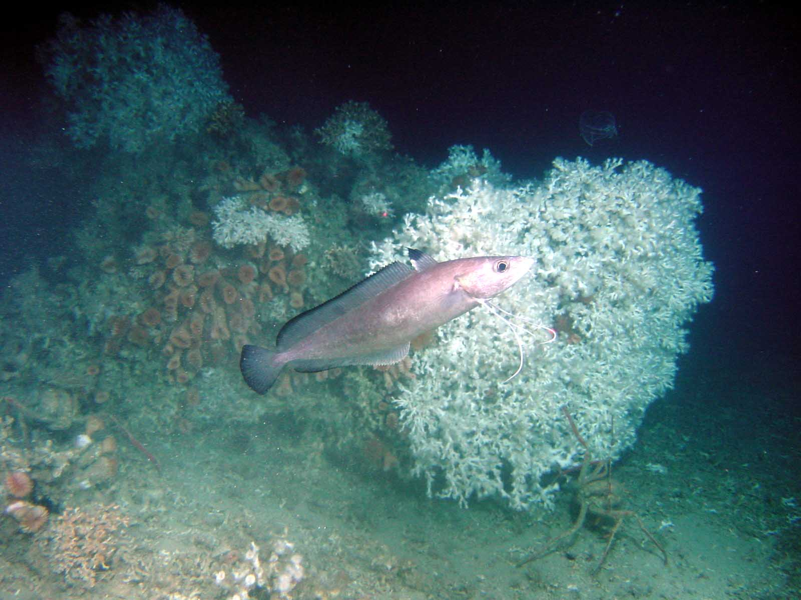

Figure 1.4.8. Greater forkbeard in a coral reef area, © Ifremer, Caracole cruise, south west Irleand, August 2001.

Recruitment
: what is the age and size of recruitment to the fishery? What is the age and size of smallest individuals in scientific cruises? What is known about recruitment variability and its causes?

Roundnose grenadier recruits to the fishery well before reaching commercial size so that high discard rates are observed (Connolly and Kelly 1996; Allain et al. 2003; Lorance 2007). Note that although there is no minimum landing size, small fish are not landed because they are not of interest to the filleting fishmonger workshops. Due to the particular shape of the roundnose grenadier, small amount of mucus on skin and poorly swimming capabilities, the larger mesh size of commercial trawl still catch significant amount of small fish.

Table 1.4.9. Size and age at recruitment

Species | Size (age) at recruitment | Size (age) of smallest individuals in scientific cruises
Roundnose grenadier
Black scabbardfish | 80 cm Based upon length distribution from on-board observations | 80 cm Based upon length distribution from French deep-water cruises
Greater forkbeard | Size distribution in the fishery unkown | Modal length of age 2 is 15-17 cm based upon French western IBTS data. Smallest caught individuals about 10 cm.
Portuguese dogfish | 70 cm (smallest individuals in the landings), small number caught below 80 cm | 70 cm
leafscale gulper shark | 85 cm (smallest individuals in the landings) | 85 cm
See case study 1c for blue ling. Data for siki sharks are derived from (Girard 2000).

Other salient aspects of the life cycles
There is no other salient aspect for roundnose grenadier, greater forkbeard and black scabbardfish. For deep-water a more difficult issue is to assess whether these species are viviparous, ovoviparous or oviparous.
Ovoviparous species are those where embryos develop in the egg within the uterus without maternal supply. In viviparous species, maternal supply occurs.
Based upon examination of the uterine wall, Girard (Girard 2000) considered that the leafscale gulper shark was viviparous. Uterus wall of this species are thick and display strong vascularisation, there is most probably some placentation as the uterine wall display villosities and ornamentation but no pregnant females of leafscale gulper shark were caught so that . The Portuguese dogfish is more clearly viviparous as embryos could be observed, their weight increase 55% during the uterine stage and uterine epithelium included cells likely to provide the maternal supply (Girard and Du Buit 1999).

Feeding
Species | Food items | Reference and comment
Roundnose grenadier |  | Feeds on small preys, mainly small planktonic crustaceans (Mauchline and Gordon 1984a)
Black scabbardfish |  | Mainly predator of large fish (primarily blue whiting)
Greater forkbeard |  | greater forkbeard is an epibenthic feeder, feeding on organisms associated with the surface sedimenst (Mauchline and Gordon 1984b). Similarly In the Cantabrian Sea, 86% of the diet is made of benthic organisms (Velasco et al. 1996)
Blue ling | 0.5% Caridea  0.8% Pandalus borealis, 0.1% P. multidentata  7.2% Trisopterus esmarki, 51.8% Micromesistius poutassou  0.1% Lycenchelys sarsi  39% unid. Teleostei. | (Bergstad 1991)  Blue ling is primarily piscivorous. See also Case study 1c report
Portuguese dogfish | Squid and fish predator (Mauchline and Gordon 1983) | Some scavenging behaviour lay occur (Mauchline and Gordon 1983)
leafscale gulper shark | 65% fish, 35 % cephalopod | (Cortes 1999)

Predators
The best up-todate compilation regarding predators of these species can be found in (Howell et al. 2009b,a).

What are the main gaps in knowledge regarding life history patterns and general species ecology?
For black scabbardfish the main gap is the migratory scheme and stock identity. It is a major issue to assess whether fish from the West of the British Isles, West of Portugal, Madeira from one single panmitic or several stocks. There is also a need for further validation of age and longevity as this is essential to the stock(s) vulnerability to fishing. Genetic analyses might be the best tool to assess stock structuring. There is however a need for other types of approaches such as analyses of seasonal LPUEs, catch rates and length distributions by areas in order the assess if migrations and growth are reflected in the catch.

Further data collection/research requirements
Landings of black scabbardfish from the demersal deep-water mixed fishery were not sampled because the fish is landed headed. Sampling have been initiated in 2008 from on-board observations. On-board sampling of length distribution should be continued.

Implication for assessment and management
Are there any aspects of life history pattern and general ecological information and data (quality, temporal and spatial extent, time series, availability, accessibility, flow) that [a] impact on assessments and/or [b] affect your ability to provide timely fisheries advice to managers.
Scientific advices are provided. Nevertheless, stock identity is a major issue and if the hypothetical stock units used for assessment are inappropriate advices may be seriously impacted. Strong trends in roundnose grenadier catch rates and mean length clearly reflect that, whatever there is one or several stocks the species have been heavily exploited since the late 1980s. The issue is quite different for future assessment and management. At the start of the fishery, there was an accumulated “virgin” biomass that could be fished down without damage to the biological productivity of stock (see e.g. Hilborn et al. 2006). This fishing down phase is surely now over and management should aim at stabilising the fishery at a long term sustainable level, which clearly needs to be estimated for every stock. The step by step reduction of TACs that was made from 2003 to 2010 is part of this process. This long term level can, and most probably will have to, be assessed on an adaptative process where stock indicators will be monitored and landings regulated to stabilize them at suitable levels.
In addition to this, Marine Protected Areas, whatever aim they are set for, are de facto already one of the management tools and will most probably be further developed. It is essential to understand the stock identity to advice on the proper size, geographical distribution and special regulations of these MPAs, if they are desired to be also and efficient fishery management tool. For example, if there is one single large stock, a single large MPA would devoid one part of the stock from fishing mortality. If they are several stocks several MPAs are required to achieve the same protection for every stock.

Historical development of the fisheries, including catches and fleets.

Background information

Fleet identity
[Please provide the following information on the fleets that are prosecuting/have prosecuted your stock: if possible please use table below or a separate spreadsheet/data table/database if too large. For EU fleets, please match DCF and/or ICES/InterCatch metiers, using additional sub-categories if necessary.]

Nationality | Gear type | Fleet ID for use in tables below and throughout qustionnaire2 | Fishery type:-  target/mixed fishery/bycatch | If mixed or bycatch what are other or target spp? | Number of vessels | Large scale or artisanal | Time period
French | Trawl |  | Mixed |  | ~50 | Large scale | 1973-2009
French | Gillnet |  | Target hake/monkfish | roundnose grenadier, greater forkbeard | 1 in some years | Large scale | year
Spanish | Freezer trawlers |  | roundnose grenadier | black scabbardfish  Deep water Blue ling  greater forkbeard |  | Large scale | year
Spanish
Scottish
Irish

This report builds primarly on the French deep-water fleets. Vessels in this fleet are mainly sytren trawlers fishing for fresh fish during fishing trips up to 12 days. In the past this fleet was fishing for saithe and demersal species, it started exploiting blue ling in the early 1970s and other deep-water species in the late 1980s (Charuau et al. 1995). Othe fleets are fishing for deep-water species in the same areas and in neighbouring areas posssibly for the same stocks. These are decribed in section2.1.2 but all data availability was not reviewed for all fleets.

Some Scottish vessels target monkfish (Lophius spp) on the continental slope of Subarea VIa and on the Rockall Bank. This fishery has a bycatch of deep-water species including ling, blue ling and siki sharks and a small number of these vessels occasionally fish in deeper water targeting roundnose grenadier, black scabbardfish and siki sharks.

Historical development and current activity of each fleet

French trawl fishery
French trawlers began to land increasing amounts of roundnose grenadier, black scabbard fish and deep-water sharks from the west of Scotland in 1987 (Charuau et al. 1995). Landings of these species have been reported separately in French landings statistics since 1989 (Lorance and Dupouy 2001).
Effort directed at deep-water species increased from 1989 to 1996 (Lorance and Dupouy 2001). In 1995, an effort regulation was introduced but was not a constraint to this fleet. TACs and a new effort regulation was introduced in 2003 (see section 6). Part of the fishing time of the licensed fleet is expended on the shelf mainly in the Celtic Sea.
Time series of fishing effort are available based upon logbook data (1987-2009) and VMS (2003-2009).

French gillnet fishery
This is a less clear picture. Deep water gillnetting has been regulated following observation of high discarding rates, bad fishing procedures and loss of fishing gears inducing ghost fishing (Hareide et al. 2005; Large et al. 2009).
A few, possible one single French vessel have fish with gillnets in deep-waters. This fishery has now stopped in ICES Subareas V, VI and VII owing to benning of gillnet below 600 m depth (see section 6).

Spanish freezer trawler fleet
A fleet of 29 Spanish stern bottom freezer trawlers fish in international waters of the Hatton Bank (ICES XIIb and VIb1). The presence of the majority of the vessels in this area is discontinuous. Vessels conduct fishing trips of variable duration. Fishing operations are conducted in a depth range of 800–1600 m, mainly at depths >1000 m or deeper. Roundnose grenadier and Baird’s smoothhead (3000–13 000 t per year in 1997–2005) are the most important species in the catches. Black scabbardfish (1000 t in 2002, then decreasing) and blue ling (600–1000 t/year) are also caught in significant amounts. Spanish landings formerly reported as roughhead grenadier have been included in the roundnose grenadier landings time series because roughhead grenadier was not recorded in significant quantities in the Spanish observer program, and is not known to occur in significant quantities on the Hatton Bank, were the Spanish fishery operates.
In 2010, the time series of Spanish landings back to 2002 was updated as landings per ICES Division were provided. Nevertheless, landings per ICES rectangles were not available (ICES 2010b).

Spanish fleet operating in ICES Division VIa, VIIb,c,k,j
In the mid 2000, almost all the catches obtained by this fleet can be considered as by-catches of the bottom trawlers, mainly “baka” otter trawl and longliners. The number of vessel in the Spanish, Basque fishery in ICES Divisions VI and VII reduced in the period 1994-2000 affecting both longliners and bottom trawlers (ICES 2004).
In the “Baka” trawl fishery in ICES Subarea VII landings of blue ling, ling and greater forkbeard, combined, represent about 25% of total landings. Hake can be considered as a bycatch (less than 10% of the landings)
The bottom longline fleet in Subarea VI, catches mainly deep-water species with ling, greater forkbeard, blue ling, tusk, bluemouth rockfish and conger, contributing to about 50% of the landings.

Data from the basque country fleet are available from AZTI.

Deep water red crab UK fleet

Other UK fleets
In the 1990s and early 2000s, UK Long-liners and gillnetters based in England and Wales, fished at depth targeting primarily hake anglers and megrim in VIa,b and VIj,k with deep-water sharks as a bycatch. Depending on market prices, sharks were frequently be the target species. Greater forkbeard was taken as a by-catch. The majority of landings from these fisheries were into Spain. As a consequence of regulations banning deep-water gillnetting below 600 m, these fleet are no longer fishing in deep waters and only minor landings were reported in recent years.

Irish fleet
The Irish deep-water fishery is based on the flat grounds and targets orange roughy, black scabbard, roundnose grenadier and siki sharks. The primary target of this fleet was orange roughy. Data relevant to this fleet are found in Case study 3b.

Time-series of fleet, effort and landings data
ICES WGDEEP compiles the best estimates of landings for the assessed species. Neverthless, poor track is kept of data used and corrections made. This is exemplified with blue ling data. Blue ling landingreported to ICESs from 1973 to 2008 were extracted using ICES data centre (http://www.ices.dk/fish/statlant.asp). The extraction included landings of all countries in ICES divisions Vb and VIIb,c and sub-areas VI and XII were extracted. These data are offcicial landings by country.
The restriction of landings in Subarea VII to Divisions VIIb,c was madebecause further south most of the catch reported as blue ling might be the closely related Spanish ling(Molva macrophthalma). Sub-area VII is anyway a minor component of blue ling landings, irrespective of assumptions about the species identity.
Based upon these data, blue ling landings were high in ICES Divisions Vb in the 1970s and 1980s. In the 1990s, landings from Subarea VI became dominant. Significant landings were also reported from Subarea XII, where landings peaked at close to 3000 t in 2001.
From the early 1970s to the early 1980s, the main fishing countries were Faeroe Islands, France, Germany and Norway. Landings from Germany decreased in the 1980s, and landings from Norway stabilised at a few hundred tonnes. In the 1990s, landings fromUK and Spain increased. The contribution of other countries to blue ling landings was always minor (Figure 2.1.2a).

Figure 2.1.2a. Time-series of blue ling landings in ICES divisions Vb and Subareas VI and VII, by country according to ICES landings statistics.

Based upon the same ICES landings statictics, cumulated blue ling landings from 1973 to 2008 in the ICES Divisions Vb and VIIb,c and Subareas VI and XII amount to slightly more than 400,000 t. data from ICES WGDEEP are not the same as ICES official landings (Figure 2.1.2b) and EUROSTAT data are also slightly different from ICES data with smaller landings reproetd in earlier years.

Figure 2.1.2b. Time-series of blue ling landings by ICES Subarea and Division from ICES WGDEEP (left), ICES landings statistics (centre) and Eurostat (right).

The time-series of landings used by ICES WGDEEP shows higher landings levels in the 1970s. From the1980s, landings from the 3 times series are similar. Complete knowledge of landings levels in early years is important to properly estimate reference points for the stock. Unfortunately, the strong year-to-year variations up to the mid-1980s suggest that landings were poorly reported. Higher landings levels in ICES WGDEEP data compared to the two other time-series results from accounting for French landings reported as lings (e.i. Molva molva and Molva Dypterygia)in French official landings that could clearly be ascribed to the early years of the French directed blue ling fishery based upon Moguedet (1988) and data previously reported to ICES North-Western working group (ICES 1989,1990,1991).
Further data mining was carried out in DEEPFISHMAN. Landings from French freezer trawlers, have not been treated together with landings from fresh fish vessels by the French administration. Then, they are not all available in the database held by Ifremer. Quantities of filleted blue ling landed in 1988-2000 by freezer trawlers were retrieved from Producers organisation files. The amount landed varied from a few to 2,500 t per year (Table 2.1.2.a)

Table 2.1.2a. Landings of blue ling from French Freezer trawlers, 1988-2000.

Year | Landings (t)
1988 | 31
1989 | 415
1990 | 1,233
1991 | 1,904
1992 | 2,260
1993 | 2,483
1994 | 365
1995 | 239
1996 | 1
1997 | 209
1998 | 92
1999 | 57
2000 | 351

Amount landed in 1988-89 were already included in ICES WGDEEP data, as they were reported to the North-Western working group. Using vessel identity, it was checked that landings from 1999 and 2000 were already in the Ifremer database used to provide French ICES landings while, there was no landings from freezer trawler in the database for years 1986-1998. These landings should therefore be taken into account for stock assessment purposes. As these data are from Producer Organisation sales records, they are not available by ICES Subarea. Nevertheless, the bulk of these landing come from ICES Division Vb and Subarea VI were freezer trawlers were operating at the time, with a possibly minor contribution from XIIb. These landings represent an addition cumulated catch of 8,800 tonnes of blue ling. These data are included in DEEPFISHMAN landings data.

Gaps in fleet data
[What are the main gaps in knowledge regarding the fleets fishing your stock? Please prioritise. ]

Overall the knowledge of the fleet activity at sea is not bad. Distribution of catch and effort at the resolution of ICES rectangle has been available For France, Ireland and UK (ICES 2006,2007a).
The French fleet is known based upon the licensing scheme since 2003. Before this time, catch composition was used to identify which vessels where fishing in the deep water. Therefore, composition of the fleet, number of vessels can be considered available since the early 1980s. At that time, French trawlers operating to the west of Scotland and on the Faeroese shelf were fishing for saithe (Pollachius virens), blue ling (Molva dypterygia) and redfish (Sebastes mentella). VMS data was not available in the past. Due to commitment in the Data Collection Framework (Commission decision of 6 November 2008 adopting a multiannual Community programme pursuant to Council Regulation (EC) No 199/2008 establishing a Community framework for the collection, management and use of data in the fisheries sector and support for scientific advice regarding the common fisheries policy) the French administration has provided data from 2003 (first year of the deep water licensing scheme).
For other fleets, contacts are being made with FRS and NEAFC for international data for all available years.

The activity of the Spanish fishery in international waters have been poorly. Only number of vessels were sporadically reported and the distribution of the catch and effort are poorly known. In 2010, more landings and effort data were reported to ICES. Landings data were checked against on-board observations and some correction were made. data by ICES rectangle were not available.

Can these gaps be addressed by regular monitoring? If so, how?
In recent years, monitoring of fishing activities in EU water increased strongly. There is no known serious problems of under- or mis-reporting of landings and effort of deep-water species in EU waters. data are better reported and the increasing consistency between time-series held for different purposes over recent year than for past decade (see figure 2.1.2b) suggest than the management of data improved.

The development of VMS might have played a role in improving the monitoring of fleet activities.
Monitoring under DCF includes some sampling (length and age composition of deep-water species) and available data increase in application of DCF. Nevertheless, data remain generally scattered. Landings and effort data are not provided to ICES under intercatch format, which is a standard for stock assessment data within ICES.

Please complete the table below on the extent of time-series data of landings and discards data:-

Fleet ID | Time-series of landings data | Time-series of discard data
FR-BTDWS (1) | 1970-2009 | 2004-2005 and 2008- (2)
UKSCOOT
UKEWOT
SPAOT excl BasqueBasque
Spanish fleet in VIb XIIb | 1996-2010 | Observer data 2002-2009 reported to WGDEEP 2010
FAROT | ? | ?
FARLL | ? | ?
NORLL | ? | ?
UKEWGILL | ? | ?
UKSCOTGILL | ? | ?
(2) Some discard data from 1996-97 arealso be available and some data from Scotttish observers have been collected (availability to the project unknown) in the early 2000s.

There was some discards data from Scottisch observer on-board French vessels.

Does the earliest data available correspond to the start of exploitation of the stock. If not please describe. If earlier data exist please list where these can be found.

Blue ling have been exploited since 1973 by the French fleet. There are anectodal reports that the blue ling fishery made some discarded bycatch of roundnose grenadier, black scabbardfish and deep water sharks in the 1970s and 1980s, but there are not data on the amount of these bycatch. Discards from tows targeting blue ling in recent years might not be appropriate to assess past levels of discards owing to changes in fishing strategy and abundance of deep water population. Nevertheless, up to the late 1980s, fishing was targeting blue ling aggregations (mostly spawning aggregations but some fishing throughout the year occurred) were discards levels might have been small. In the late 1980s, the fishery moved to deeper water to target roundnose grenadier, black scabbardfish and deepsea sharks. Time series of reported landings back to 1984 and 1972 for some ports will be available in early 2010 and can be used to assess possible amount of deep-water species landed and reported as miscellaneous species in the late 1980s.

Roundnose grenadier and black scabbardfish have been reported in French landings since 1989. Some landings may have occurred in 1987 and 1988. These are to be assessed (as case study work) from landings statistics where such landings, if they have occurred, might have been reported as "miscellaneous fish". The same approach can be apply to deep water sharks that have been reported separately since 1991 and might appear as "miscellaneous sharks” in previous years if they were landed.

Nevertheless, there was a strong increase in landings of deep water species in 1989, whether some landings occurred in years 1987 and 1988 needs revisiting but landings before 1989 are small compared to landings in the 1990s.

Rather for blue ling case study: The completeness of landings files before 1985 needs to be checked, some years may be incomplete.

For the Spanish fleet of freezer trawler in VIb and XIIb the start of the fishery was described in

If discard data are not available please indicate by fleet ID if, in your opinion, discards are likely to be significant

Fleet ID | Significant discards
FR-BTDWS (1) | Not significant for blue ling, black scababrdfish orange roughy, siki sharks in the past. Might have become signigficant for siki sharks from 2010 owing to ban of landings but not for orange roughy (see also appendix 1).  Significant discards of small roundnose grenadier and all non –commercial species
UKSCOOT
UKEWOT
SPAOT excl BasqueBasque | Likely level ok discarding similar to shelf demersal tarwl fisheries
Spanish fleet in VIb XIIb | Significant discards of small roundnose grenadier and all non –commercial species
FAROT | Unkown
FARLL | Not significant
NORLL | Not significant
UKEWGILL | Significant
UKSCOTGILL | Significant

If mis-reporting or under-reporting is/has been a problem please indicate years in table below:

Fleet ID | Occurrence of mis-reportings | Occurrence of under reporting
FR-BTDWS (1) | Probably reporting by ICES rectangle was unreliable in the 1990s for some species, mainly orange roughy as ship master tended to keep secret their fishing grounds. Might have occurred mainly for orange roughy (1) | No
UKSCOOT | Unknown | Following to introduction of TAC in 2003-2005
UKEWOT | Unknown | Unknown
SPAOT excl BasqueBasque
Spanish fleet in VIb XIIb | Landings of roundnose grenadier may have been misreported as other species | Landings of roundnose grenadier may have been underreported
FAROT | ? | ?
FARLL | ? | ?
NORLL | ? | ?
(1) Neverthless the distribution of effort from EC logbook and that estimated from aerial Scottish surveys in the early 1990s reported in Gordon and Hunter (1994) seem farily consistent.

Misreporting or under reporting is not known to have been a problem in the French trawling fleet. These vessels operated from Scottish and Irish port and are weel controlled at landing, They are not known to have been detected to underreport the catch. Concerns have been repeatedly expressed that misreporting could occur in international waters (NEAFC regulatory area). There are also been regular complains from the French Industry that IUU fish was landed in France and was pulling the prices down. This seems to have disappeared in recent years.
Misreporting is not an issue that scientists have the power to inquire and this should stay in hand on management and regulation authorities to monitor misreporting. No quantitative data on misreporting is available.

Gear selectivity
[Please document available information on gear selectivity by fleet ID.]

Deepwater trawling is not considered to be selective, nevertheless length distribution of the catch (based upon observer's data) are truncated compared to length distribution of the catch from scientific survey (with small mesh in the codend). No significant quantitative data available.

Mesh size have been increased in recent years. This is not though to reduce the fishing mortality of deep-water fish as individuals escaping through meshes may not survive. This may induce a loss of some commercial catch, in particular for black scabbardfish with is observed to get "meshed" (i.e. a lot of fish have the head through one mesh when pull on board).

Ity has been questionned whether the difference in size composition of black scabbardfish in southern area (mainland Portugal and Madeira) and the west of the British Isles was due to the actual size composition of the fish or to gear selectivity (longline in southern areas). The first option is considered the most likely.

Are there any aspects of data (quality, temporal and spatial extent, time series, availability, accessibility, flow) that [a] impact on assessments and/or [b] affect your ability to provide timely fisheries advice to managers?
A full knowledge of all fishing activities that have landed or discarded the studied deep-water stocks would be extremely usefull to estimated total cumulated catch over time, changes in catch rates and other aspects. For deep-water species a good knowledge of times series of catch would be an help to the definition of reference points including MSY (MacCall 2009).
Unfortunately, there are doulbts about the accuracy of time-series of catch supported by stocks. Some improvements were made in 2010 when Spanish landings of roundnose grenadier were revised (ICES 2010b). Landings and discards of sharks may be particularly a problem as a UK fishery which was active from the 1980s to 2006 and targeted deep-water sharks. The fleet was mostly composed of vessels based in Spain but registered in the UK, Germany and other countries outside the EU such as Panama (ICES 2010a). Landings from this fleet are not known, not available in databases but could have been the main fishing fleet at the time in term of deep-water sharks landings. Data on sharks may also be undermined by a high level of discarding at least in some fleets (Hareide et al. 2005). There are also discrepancies between time-series of landings depending of the data source used, so that expert groups still used some expert "best estimate" (see 2.1.2).

Review of stock assessments carried out thus far

General overview

Overview of previous assessments:

Roundnose Grenadier (Coryphaenoides Rupestris) in Vb, VI, VII, XIIb

Year | Assessment type3 | Assessment method(s) used | Assessment package/  program used | Are input data on DEEPFISHMAN website? | Assessment used for latest scientific advice? | If not, what was latest scientific advice based on? | Reference
2008-2009 | Exploratory | SVPA | VPA95 | YES | NO | ICES precautionary approach | (ICES 2008c,2009a; Pawlowski and Lorance 2009)
2009 | Benchmark | SVPA + bootstrap on Age length key | FLR | YES | NO | Not relevant (assessment for development of methods only) | (ICES 2009c)
2010 | Trends based assessment | Surplus production model | FLR / FLBAYES | YES | YES | - | (ICES 2010b)
2010 | Trends based assessment | Multi-year catch curve | FLR | YES | YES | - | (ICES 2010a,b)
2010 | Trends based  Assessment | LPUE based abundance indices | FLR | YES | YES | - | I(ICES 2010a,b)

Black scabbardfish in V, VI, VII, XII
No model of population dynamic was used for assessments 2008-2010. Some work has been done to use CPUE from the French fleet of deep-water trawlers as an indicator of trends in the deepwater fishery. In the past, assessments were done using De Lury and Schaefer production models (Basson et al. 2002).

Year | Assessment type3 | Assessment method(s) used | Assessment package/  program used | Are input data on DEEPFISHMAN website? | Assessment used for latest scientific advice? | If not, what was latest scientific advice based on? | Reference
2008-2009 | Exploratory | Trends on CPUE/LPUE | R | YES | NO | ICES precautionary approach | (ICES 2008c,2009a)
2010 | Exploratory | Trends in tallybook LPUE | GAM modelling (R, package MGCV) | YES | NO | ICES precautionary approach | (ICES 2010b)

Greater forkbeard
No quantitative assessment was carried out in 2008, 2009.

Year | Assessment type3 | Assessment method(s) used | Assessment package/  program used | Are input data on DEEPFISHMAN website? | Assessment used for latest scientific advice? | If not, what was latest scientific advice based on? | Reference
2008-2009 | Exploratory | Trends on Length distribution | N/A | ? | NO | ICES precautionary approach | (ICES 2008c,2009a)
2010 | Exploratory | Stock depletion model | R | ? | NO | ICES precautionary approach | (ICES 2010a,b)
2010 | Survey indicators |  |  | Survey data on ICES data centre, DATRAS | YES |  | (ICES 2010b)

Portuguese dogfish and leafscale gulper shark
Both stock are merged into a single “siki sharks” stock. The term “siki” is used to describe the combination of leafscale gulper shark and portuguese dogfish. Although these species have different biological traits, it has been necessary for ICES to combine them for assessment purposes. This is because landings data for both species were combined for some of the main countries for most of the time since the beginning of the fishery. The term “siki” as used here does not have the same meaning in French commercial fisheries, where it encompasses all commercially exploited deepwater sharks.

No assessment has been carried out since 2006. Some work has been done to use CPUE as an indicator of trends in the deepwater fishery. An exploratory model for Portuguese dogfish only was presented at the ICES WKDEEP benchmark workshop in 2010.

Year | Assessment type3 | Assessment method(s) used | Assessment package/  program used | Are input data on DEEPFISHMAN website? | Assessment used for latest scientific advice? | If not, what was latest scientific advice based on? | Reference
2007-2010 | Exploratory | Trends on CPUE LPUE | ? | ? | NO | ICES precautionary approach | (ICES 2007c,2009d)
2010 | Exploratory | Bayesian model | ? |  | NO | ICES precautionary approach | (ICES 2010a)

Assessment using De Lury and Schaefer production models were trialled in the early 2000s for both Portuguese dogfish and leafscale gulper shark combined (Basson et al. 2002).

How is the frequency of assessments linked to the advisory and management cycle?

Fisheries for deep-water species in the NE Atlantic were largely unregulated from their commencement in the 1970s (blue ling) or the 1980s (other deep-water species) to the early 2000s. Following repeated ICES advice that most stocks were “outside safe biological limits,” that “fishing effort on specified stocks should be reduced” while on others “fishing should not be allowed to expand faster than the acquisition of information necessary to provide a basis for sustainable exploitation” and that “new fisheries should be permitted only when fisheries expand very slowly, and are accompanied by programs to collect data which allow evaluation of stock status,” it was not until January 2003 that the EU introduced biennial TACs for deep-water species, including roundnose grenadier. As a first step towards effort management, a vessel licensing scheme with aggregate power and capacity of deep-water fishing vessels capped to levels observed in the years 1998–2000 was implemented.

The ICES advice for deep-water species stocks is delivered every second year. The mangement cycle is consistent with the delivery of ICES advice as TACs a set every second yerar since 2003. TACs levels were kept the same for the two subsequent years in 2003-2006 then from 2007 some TACs were adjusted annually although set in a TAC regultion valid for two years (see table 6.2.1). This derived from the rule of limiting TAC changes to 15% per year. Since 2009, the EU TACs for blue ling are set annual in the general TAC regulation (council regulation (EC) No 43/2009 of 16 January 2009) because the fishing opportunities for this species depend on the outcome of the annual negotiations between the EU and Norway (council regulation (EC) No 1359/2008 of 28 November 2008). As a result the scientific advisory cycle and the management cycle are no longer consistent for blue ling.

The EU TAC and national quotas from member countries apply to all vessels in EU EEZ and to EU vessels in international waters. For roundnose grenadier and black scabbardfish, ICES recommends that catches should be constrained to 50% of the level before the respective expansions of the fisheries. For greater forkbeard, ICES advice state that the landings of this species are mainly bycatch from traditional demersal trawl and longline fisheries targeting species such as hake, megrim, monkfish, ling, blue ling, etc. Fluctuations in landings are probably the result of changing effort on different target species and/or market prices and are not necessary linked with changes in the resource abundance. The species should not be managed in a single species context and any advice should take into account advice on other species/fisheries. For all the above species, ICES recommends those fisheries should not be allowed to expand unless it can be demonstrated that they are sustainable. There is no management objective for the above species.

For deepwater sharks, no assessment was performed in recent years and advice and management are based on the perception of the state of the stocks by the members of the WGEF working group from trends in CPUE. In 2006, ICES advised that no target fisheries should be permitted unless there were reliable estimates of current exploitation rates and stock productivity. ICES advised that the TAC should set to zero for the entire distribution area of the stocks and additional measures should be taken to prevent by catch of portuguese dogfish and leafscale gulper shark in fisheries targeting other species. In 2008, based again on information from CPUE, Portuguese dogfish and leafscale gulper shark stocks were considered to have declined to low levels and ICES recommended a zero catch. Portuguese dogfish and leafscale gulper shark were considered depleted despite the fact that the rates of exploitation and stock sizes of deep water sharks could not be quantified.

The TACs are not restricted to the two species of siki sharks but include the following species of deep-water sharks (EC regulation No 1359/2009 of the council of 28 November 2008):
Portuguese dogfish, leafscale gulper shark, birdbeak dogfish (Deania calceus), kitefin shark (Dalatias licha), greater lantern shark (Etmopterus princeps), velvet belly (Etmopterus spinax), black dogfish (Centroscyllium fabricii), gulper shark (Centrophorus granulosus), blackmouth dogfish (Galeus melastomus), mouse catshark (Galeus murinus), and Iceland catshark (Apristurus spp).

Input data

For all exploratory assessments or the latest benchmark or update assessment, please list the input data citing length of time-series (where appropriate) and source

Deep-water tallybook database
A collaboration with the French fishing industry has led to the use of data from skippers’ personal logbooks. A partnership between the French fishing industry involved in the deep-water fishery and the research and advisory establishment Ifremer was initiated in 2001. The industry created a database with landings per species and haul information, including the fishing depths from a panel of volunteer trawlers since the late 1990s. Moreover, some skippers’ personal logbooks have been retrieved back to 1992. This haul by haul database is further denoted French tallybook.

Roundnose Grenadier Vb, VI, VII, XIIb
-Total international landings 1990-2008 (ICES WGDEEP)
-Length distribution 1990-2008 (ICES WGDEEP)
-Samples of discards 1997-2001 & 2004-2006 (ICES WGDEEP)
-Aggregated Age-length key (ICES WGDEEP)
-Weight length relationships 1999 (Lorance, pers comm.)
-Effort: French fleet of deep-water trawlers haul by haul database 1992-2008
-Length distribution per depth strata (literature, scientific surveys)

Black scabbardfish in V, VI, VII, XII
-Total international landings 1988-2008 (ICES WGDEEP)
-Effort: French fleet of deep-water trawlers haul by haul database 1992-2008

Greater forkbeard
-Total international landings 1988-2008 (ICES WGDEEP)
-Estimates of discards data by the Basque Country trawler fleet 2003-2008 (ICES WGDEEP)
-LPUE by the Basque Country trawler fleet 1996-2008 in VI, VII, VIII (ICES WGDEEP)
-Length distribution in Porcupine surveys 2001-2008 (ICES WGDEEP)
-Abundance and mean length from surveys (DATRAS surveys, French IBTS, Irish survey, Scottish IBTS)

Portuguese dogfish and leafscale gulper shark
-Total international landings 1988-2008 (ICES WGEF)
-Landings by species (sharks and bycatch) by gear and area for the UK fishery in VIII and IX (ICES WGEF 2007)
- Landings by species (sharks and bycatch), gear, effort, depth and area for the Russian vessels in I, V, VI and IX (ICES WGEF 2009)
- French fleet of deep-water trawlers CPUE by ICES subareas (ICES WGEF 2007)
- Portuguese longline CPUE in IX (ICES WGEF 2007)

Are there any aspects of data (quality, temporal and spatial extent, time series, availability, accessibility, flow) that [a] impact on assessments and/or [b] affect your ability to provide timely fisheries advice to managers?

Roundnose Grenadier in Vb, VI, VII, XIIb

Landings data are considered uncertain in Division XIIb, because unreported landings may occur in international waters. In addition to this, all national landings data were not reported by new ICES divisions and some landings were allocated to divisions according to knowledge of the fisheries from the working group. Lastly, significant unallocated landings occurred in 2005. Substantial uncertainties and misreporting in XIIb has led to exclude this area from the ICES assessment in the past. Substantial revisions of the Spanish data were performed in 2010 and XIIb data were incorporated back in exploratory assessments. However misreporting as a result of incorrect identification of species of grenadier may still be a problem but does not seem to substantially change the outcome from the assessments.

Times series of discards are incomplete especially at the beginning of the fishery and in recent years. Length distribution of landings has substantially changed through time therefore it can be assumed that the discards distribution has also changed.

Age-Length Key is aggregated due to a low number of samples for the whole time series (rather than using ALKs only for short periods e.g. annual ALKs). Age reading method is not validated for this stock and is proven to be difficult requiring specific training.

LPUEs from French tallybooks have been integrated into the assessment after the WKDEEP benchmark in 2010. The time series is however limited to the period 2000-2009. Historical time series of effort from France and the other countries are expected to improve the overall quality of the assessment.

Black scabbardfish in V, VI, VII, XII
The time-series of the Spanish catch in ICES Division XIIb was revised according to Statlant data in 2009. No catch data were available for the Spanish trawling fleet operating on the Northern and Western Hatton Bank (Divisions VIb1 and XIIb) in 2008.

Maturity: so far, the information available for ICES Subareas Vb, VI, VII and XIIb consistently points out to the predominance of immature fish.

Times series of LPUE is not reliable for 2008 as it includes only a few fishing days and will not be available in the future, because vessels included in a reference fleet have all been decommissioned.

Data from the French fleet of deep-water trawlers will provide more reliable estimates of CPUE. The time series is considered short. Nevertheless, for a species with a short lifespan (see section 1) the current times series might be informative. Therefore, CPUEs from French logbook data are presently used. However, several factors, such as seasonal and depth effects and species directivity affect commercial CPUEs and these can be very difficult to interpret.

Greater forkbeard

This stock appears to be data deficient. ICES advice since 2006 repeats that “ Fisheries on greater forkbeard should be accompanied by programmes to collect data.”

Commercial landings are available from the Basque Country trawler fleet (OTB and PTB) operating in Subareas VI, VII and VIII from 2001 to 2008.Owing to the bycatch status of the species, they may be unreliable and significant discards occur in some fisheries, in particular on the shelf where juvenile greater forkbeards are found.

The species should not be managed in a single species context and any advice should take into account advice on other species/fisheries.

Data on abundance and length frequencies of greater forkbeard in areas covered by hauls from the Spanish survey in Porcupine and data of length frequencies from Spanish Cantabrian sea and French western, Scottish IBTS and Irish surveys have been used in the assessment. Most surveys do not cover the deeper part of the depth distribution of the species. However, survey data might allow deriving recruitments indices, which could be used for simple assessment method or HCR (e.g. keep the fishery at the same level as long as it does not appear to impair the recruitment).

Portuguese dogfish and leafscale gulper shark

Landings data on deepwater sharks remain problematic. For many countries, data are only available for combined deepwater sharks. Several countries continue to report landings in generic categories such as various sharks nei (i.e. deep-water sharks may be combined with sharks species from the shelf). In the demersal deep-water mixed fishery, French landings of deep-water sharks were reported separately from shelf sharks. Nevertheless, the two species of deep-water sharks were combined.

Estimates of total landings are a mix of deepwater sharks and sometimes integrate a small component of other species. France presented a split of landings of siki shark by species. In the 1990s, the split was derived from sampling data in one French Harbour (Concarneau, Girard, 2000). In the 2000s, the split was based upon sorting by species in another French port (Boulogne-sur-mer). The data were not used by WGEF because it was unclear to the expert group how they were derived. This was clarified at ICES WKDEEP 2010.

Discards: in the early years of the fishery, discarding was thought to be negligible in the majority of trawl and longline fisheries although some discarding may have occurred in the first years before markets were fully developed. With the quotas for deepwater sharks becoming restrictive, it is likely that discarding has increased as a consequence of management regulations (e.g. bycatch limits; quota may be limited for some fleets). Discarding can be expected to be greater where there are relatively high TACs for other species caught along with deepwater sharks. Between 2001 and 2004, Irish trawlers have discarded their entire catch of leafscale gulper sharks. This was based on crew preferences, not market factors. Some discarding of rotten deepwater sharks, due to excessive soak times, has been recorded in gillnet fisheries (STECF, 2006). Discarding in gillnet fisheries in the 1990s and early 2000s, before the ban on deep-water gillnetting is suspected to have been high (deepnet report).

There are no reliable estimates of levels of misreporting of these species but it is believed to be a minor problem. Immediately prior to the introduction of quotas for deepwater species in 2001, it is believed that some vessels may have logged deep-water sharks as other species in an effort to build up track record. It is also likely that, before the introduction of quotas for deepwater sharks, some gillnetters may have logged monkfish as sharks. Since the introduction of quotas on deep-water sharks in 2005, it is likely that some under-reporting has occurred. It can be expected that some vessels with restrictive quotas for deepwater fish may misreport more valuable species as deepwater sharks. IUU fishing is also known to take place, especially in international waters.

No new length distribution has been made available since 2006.

The ICES working group on Elasmobranch FishesWGEF repeatedly found it difficult to quantify landings data when countries report data for both live weight and for livers. This can lead to duplication of data and overestimation of landings. It has been unclear how landings of livers were raised to total live weight, and whether or not duplication of landings (as gutted bodies raised to total weight on the one hand and as liver weight rasied to live weight on the other hand) could happen.

Assessment methods

Justification of the method: for exploratory assessments please describe reasons for selecting the method(s) used. Was any guidance available as to the type of method to use? If so please describe.
Only assessment methods used since 2006 are taken into account in sub-section by stock. In the early 2000s, exploratory assessment used De Lury and Schaefer production models (Basson et al. 2002).

Roundnose Grenadier Vb, VI, VII, XIIb
This stock is in a data-poor situation with uncertainties in XIIb, and about the level of discards. Therefore, only exploratory assessments can be performed. Discards were taken into account in the assessment in 2008 (WGDEEP, 2008). In 2009 a comparison between assessments including or not discards or using a rebuilt catch time series from science surveys and industrial data showed biomass in recent year is at the same level for all methods (Pawlowski and Lorance, 2009). The inclusion of discards does not substantially change the estimated stock trend in recent years. At the beginning of the fishery, levels of biomass differed between methods. However, there is not enough information on the level of discards in the early 1990s to make sound assumptions that could give credentials towards a particular method to estimate biomass.

Due to the lack of information, all age- or length- based assessments were considered not suitable for further development at the ICES WKDEEP benchmark in 2010. A Bayesian surplus production model as well as indicators such as catch-curves and abundance indices from LPUEs were considered to be suitable to describe the trends of this stock.

Black scabbardfish in V, VI, VII, XII
No assessment is performed other than reviewing trends in CPUEs from the French fleet of deep-water trawlers database. However the time series is too short to be useful for stock assessment. The state-space model is under development as part of DEEPFISHMAN.

Greater forkbeard
No quantitative assessment is performed for this stock.

An exploratory model has been presented at the ICES WKDEEP 2010. This model is a Stock Depletion Model based on Roa-Ureta and Arkhipkin (2007) and is intended to be used for data-poor situations. It relies on historical series and landings and effort of the Basque Country trawlers operating in Subareas VI, VII and VIII from 2001 to 2008.

For greater forkbeard, it is likely that only trends in survey indicators can be used for assessment purposes because of the by-catch status of the species.

Portuguese dogfish and leafscale gulper shark
For both species, no assessment has been carried out since 2006 other than reviewing trends in CPUEs.

An exploratory model has been presented at the ICES WKDEEP 2010 for portuguese dogfish only. The population model is a state-space model that divides the population system dynamics into two processes running in parallel: an unobserved process that describes the female shark’s population abundance in number and an observational model on annual catches.

Surplus production model like the one used for Roundnose grenadier is considered as a potential candidate for leafscale gulper shark but not assessment has been carried out so far.

Description of benchmark assessments, agreed best practise and rationale

Roundnose Grenadier Vb, VI, VII, XIIb
A benchmark of this stock has been done in February 2010 (ICES WKDEEP). Due to uncertainty in the landings occurring in division XIIb, this area has been excluded from the assessment. As a preparatory process, the main challenges (changes in the fishing depth, discards, uncertainties on ALKs) with the assessment and available data have been presented during the ICES Method Working Group (WGMG, 2009) and some work was performed to quantify the effect of uncertainties on age-length key over the assessment. The members of the working group considered age- or length- based models not adequate for this stock and suggested other approaches such as analysis of commercial LPUEs and life stage-based models. Uncertainties about discards and errors from ALKs are possibly the major weaknesses of the assessment for this stock.

Multi-Year Catch Curve: this model brings mortality estimates. From assumption on natural mortality, it is therefore possible to estimate the fishing pressure. This model makes use of catch and landings in number data and quite easy to implement although it is still under development.

Abundances indices from LPUEs make full use of haul-by-haul data provided by the French industry based upon tallybooks from volunteer vessels. The details from haul-by-haul database permit to estimate reliable abundance indices as information such as changes in practices and fishing gear/grounds is taken account. Standard logbook data do not have such resolution therefore their reliability is limited to the appropriateness of the assumption made on fishing effort.

The adopted assessment model at the ICES WKDEEP benchmark workshop was a Bayesian surplus production model (based on Pella Tomlinson biomass dynamic model). This approach, only considered as indicative of trends, was selected as it was considered as the most parsimonious approach with respect to the lack of data and short time series. The reliability of the model output is expected to improve over time when more data accumulate.

Black scabbardfish in V, VI, VII, XII
No benchmark assessment has been performed.

Greater forkbeard
No assessment method has been adopted at the ICES WKDEEP benchmark workshop in 2010. This stock should be assessed based upon survey indicators.

Portuguese dogfish and leafscale gulper shark
No assessment method has been adopted at the ICES WKDEEP benchmark workshop in 2010.

Addressin uncertainty

Roundnose Grenadier Vb, VI, VII, XIIb
Previous exploratory assessments have not included so far uncertainties. Uncertainties on ALKs and level of otolith samplings have been included in a benchmark assessment by bootstrapping the ALK and evaluating the effects for the assessment of using ALKs of different sizes.

The current Surplus Production model used for this stock within ICES WGDEEP is Bayesian and therefore provides probabilities of distribution of biomass and fishing mortality for each year of the run as well as probabilities of distribution of MSY indicators.

Black scabbardfish in V, VI, VII, XII
No quantitative assessment carried out.

Greater forkbeard
No quantitative assessment carried out.

Portuguese dogfish and leafscale gulper shark
No quantitative assessment carried out.

Multispecies: is your stock included in any multi-species assessments? If so please describe. If not should it? If yes, please describe a suitable way to go forward

Monospecific assessments have been mostly exploratory, poorly reliable, most often strongly driven by a single time series of abundance index from the French trawl fishery. Abundance index need to be revisit using (1) longer time series now available (more years with both additional recent years and files from 1984 put back into the current format of the Ifremer statistics database). In addition to this archive data back to 1972 have also been made available recently (at least years 1972-79 being incomplete and reliability need checking). Ttally book data on a haul by haul basic allows for better assessment of the impact of fishing tactics on catch. This could allow for a better interpretation of trends in abundance indexes. The most obvious example is with change over the fishing depth over time. On-board observation data also provide knowledge of the species composition of the catch according to fishing strategy

The project could consider developing range of indicators by species, for groups of species and the total catch. This should provide some multispecies assessment to analyse questions such as:
- did the proportion of (1) blue ling; (2) roundnose grenadier; (3) black scabbardfish; (4) roundnose grenadier and black scabbardfish combined; (5) deepsea sharks ; (6) deepwater species vs other species (monkfish/megrim, saithe ...) varied over time ?
- what are the factors for these variations (depth/latitude/gear)?
- based on this how are the species ranking is term of proportion of biomass reduction (starting from any virgin/initial level) to which extend does this allow to set what should be the relative levels of each species TAC?

Lastly, a multispecies modelling is envisaged for the case study in WP4.

Retrospective analyses of assessments

No retrospective analysis is performed on the Roundnose Grenadier assessment nor for any other deep-water species assessed in ICES Subareas V, VI, VII and XII.

Biological reference points (BRPs):

Roundnose Grenadier Vb, VI, VII, XIIb
Type | Limit | Target | Precautionary | Comments
Biology: | Ulim = 0.2*virgin biomass | Not relevant | Upa= 0.5*virgin biomass | Virgin biomass unknown. Russian data estimates biomass around 400 000-700 000t during the 70s-80s
Economic: | Not defined | Not defined | Not defined
Social: | Not defined | Not defined | Not defined
Ecosystem: | Not defined | Not defined | Not defined
Other (e.g interaction limits with PETs) | N/A | N/A | N/A

Black scabbardfish in V, VI, VII, XII
Type | Limit | Target | Precautionary | Comments
Biology: | Ulim = 0.2*virgin biomass | Not relevant | Upa= 0.5*virgin biomass | Virgin biomass unknown
Economic: | Not defined | Not defined | Not defined
Social: | Not defined | Not defined | Not defined
Ecosystem: | Not defined | Not defined | Not defined
Other (e.g interaction limits with PETs) | N/A | N/A | N/A

Greater forkbeard
Type | Limit | Target | Precautionary | Comments
Biology: | Ulim = 0.2*virgin biomass | Not relevant | Upa= 0.5*virgin biomass | Virgin biomass unknown.
Economic: | Not defined | Not defined | Not defined
Social: | Not defined | Not defined | Not defined
Ecosystem: | Not defined | Not defined | Not defined
Other (e.g interaction limits with PETs) | N/A | N/A | N/A

Portuguese dogfish and leafscale gulper shark
Type | Limit | Target | Precautionary | Comments
Biology: | Ulim = 0.2*virgin biomass | Not relevant | Upa= 0.5*virgin biomass | Virgin biomass unknown
Economic: | Not defined | Not defined | Not defined
Social: | Not defined | Not defined | Not defined
Ecosystem: | Not defined | Not defined | Not defined
Other (e.g interaction limits with PETs) | N/A | N/A | N/A

Projections of future stock status
No projection is done for none of these stocks.

Short, medium and/or long-term projections
Not relevant.

Are projections deterministic or stochastic?
Not relevant.

How is recruitment simulated in the projection/ (historical geometric mean, using S/R model etc)
Not relevant.

How is stock growth simulated (e.g. exponential survival equation)?
Not relevant.

How are biological parameters projected (stochastically, mean of last 3 years etc)
Not relevant.

What reference points are used in the projections?
Not relevant.

Harvest control rules (HCRs) and management strategy evaluation (MSE): does the stock have a pre-defined HCR? If so, please specify.
None of these stocks is managed by HCR.

Has this rule been agreed with all stakeholders?
Not relevant.

Has the rule been simulation tested using MSE? If so please describe methods and outcomes
Not relevant.

Is the rule robust to uncertainties within the fishery system?
Not relevant.

Do you have an estimate of virgin biomass, if so what is it, how was it derived and how reliable is it?

Roundnose Grenadier Vb, VI, VII, XIIb
Estimates of biomass at the beginning of the fishery are compromised by the lack of information on discards and efforts. Exploratory assessments have shown the initial estimates are highly sensitive on the assumptions made about discards distribution and fishing efforts (WGDEEP, 2009). Russian data from the 1970s-80s estimated stock biomass to be between 400 000 and 700 000 tons. Some estimates of virgin biomass were based upon survey data and swept area method. Gordon and Hunter (1994) used this method to estimate this biomass in an area bound by latitudes 53°N - 62°N and longitudes 5°W - 15°W. This area includes the continental slope of Scotaland and Ireland from the Porcupine Bankj to the Faeroes and the offshore banks (Rockall, George Blight, Hatton, Lousy, Bill Bailey…). The total area of the seabed between 5000 m and 2000 m countours was estimated 247,000 km². Based upon estimated catch efficiency of 40 to 50 % (i.e. 40 to 50 % of fish present on the trawl path would be caught) the following biomass estimated were derived from Scottish Association of Marine Science (SAMS) survey data: 1,200 x 10³ t (900 x 10³ - 1,600x 10³) for a catch efficiency of 40%; 990 x 10³ t (730 x 10³ - 1,240x 10³) for a catch efficiency of 50%. As stated by the authors, these values should be considered with caution. Based on these estimated biomass, maximum sustainable yields of 13,000 to 17,000 tonnes were estimated. On average, since the early 1990s, annual landings were about 13,000 tonnes and are estimated to correspond to an overexploitation of the stock (WGDEEP, 2010)

Other species
For black scabbardfish, greater forkbeard, Portuguese dogfish and leafscale gulper shark, tThere are no estimate of the virgin biomass for this species. However, exploratory assessments using DeLury and Schaefer production model provided some estimated of virgin biomass and carrying capacity (Basson et al. 2002), but are likely to be strongly dependent upon model assumptions.

Assessment packages/programs used (e.g. FLR, CEDA, ASPIC, Lowestoft XSA etc)

This section is relevant only to Roundnose Grenadier only in Vb , VI, VII, XIIb as the other stocks are not quantitatively assessed.

Were any technical problems encountered, were these resolved and if so how?
Roundnose grenadier is a long-lived species. The current separable VPA packages VPA95 and FLR are limited to 25 age groups. This problem has not been solved mostly because the code is complex (FLR) or compiled (VPA95).

Past assessment were carried out using CEDA package (Basson et al., 2002).

Current assessment is carried out using a surplus production model form the FLR FLBayes library. The distribution of this package online being problematic (due to erratic website), the library and example code is available from http://code.google.com/p/wgdeep-rng/ .

Were the packages/programs used suitable for use by scientists with little or no experience of them?

Separable VPA is a quite straightforward approach with few parameters to use although selectivity-at-age is generally poorly defined. The VPA95 suite is easy to use and provides a single output files containing biomass at age, population numbers, fishing mortalities and residuals.

SepVPA using the FLR package provides FLStock objects, one of the standard output format of the FLR package. Using this routine requires some knowledge in R programming. Documentation on SepVPA is poor. Using the same initial parameters as for VPA95 does not provide exactly the same results. SepVPA does not provide residuals of adjustment as well. This routine as part of the R environment can easily be implemented into scripts which is convenient for running several assessments in batch (such as in the case of quantifying uncertainties).

Experts in R will have few difficulties to use SepVPA mostly due to the poor documentation. Scientists with little or no experience especially in programming may prefer using VPA95.

The Surplus production model is easy to implement and its code natively provides MSY indicators.

If not, how could they be improved?

The sepVPA manual should be more documented and the sepVPA code should be reviewed against VPA95 code to understand why results are different.

Were the assessment diagnostics fit for purpose? If not how could they be improved?

No assessment diagnostic is performed for roundnose grenadier in Vb, VI, VII, XIIb.

Did you receive any training in the use of the assessment packages/programs?

No.

Quality control/peer review

Were the assessments subjected to quality appraisal and/or peer review and if so how and by whom?
Assessments are presented during the ICES expert group WGDEEP plenary session and reviewed by the experts attending the working group. After the expert group meeting, the ICES framework includes a review group which reviews all assessments carried out by the expert group. To used the outcome from the assessment to deliver a scientific advice for management there is an advice drafting group and a web conference.

What were the outcomes for the latest benchmark/update assessment and for all exploratory assessments?

Roundnose Grenadier Vb, VI, VII, XIIb
This species presents major assessment challenges largely driven by: life history characteristics (long lived (ca. 60 years) and slow growing), changes in exploitation pattern resulting from changes in the geographical and depth distribution of trawl fisheries in relation to stock distribution, a lack of fisheries independent survey data, and discontinuity in the availability of time series discard data (fisheries on this stock generate high discards) and of age data. Abundance indices based on French trawl catch and effort logbook data are available but their use in assessments is problematic because of changes in spatial and depth distribution of fishing and also changes fleet composition/fishing power. Time series of length distribution data are available for French trawl landings. Time series haul by haul data on catch and effort by French trawlers, collected in collaboration with the industry, is now available from year 2000-2009.

The members of the ICES Method Working group 2009 recommended not using any length or age based methods for roundnose rrenadier in Vb, VI, VII and XIIb but rather focusing on production models or effort based approaches such trends on effort using for example the industry haul by haul database. Another suggested approach is to develop a life-stage based model. One recurring criticism is also the use of SVPA for a long-lived species with only 19 years of data.

The adopted assessment model at the ICES WKDEEP benchmark workshop was a Bayesian surplus production model (based on Pella Tomlinson biomass dynamic model). This approach, only considered as indicative of trends, was selected as it was considered as the most parsimonious approach with respect to the the lack of data and short time series.

Black scabbardfish in V, VI, VII, XII
Some alternative methods to stock assessments to estimate stock trends are necessary. Possible options for a benchmark include refining LPUE calculation from EU-Logbook data, use additional data. For this latter, the French tallybooks database seem to be an interesting opportunity as it is more accurate than EU logbooks, being haul by haul and including data on fishing depth (ICES WGDEEP, 2009).

Greater forkbeard
This is a gadoid species and is considered to likely exhibit typical gadoid life history characteristics, although these are not known with any accuracy. Commercial landings are significant but this almost entirely a bycatch species taken in other fisheries.

The stock depletion model presented at the ICES WKDEEP benchmark was considered exploratory.

Portuguese dogfish and the leafscale gulper sharks
Leafscale gulper sharks is long lived (up 60 years). There is no data on age of Portuguese dogfish but longevity is presumed similar. Length and age data are not available and historical landings data are not available by species (although in recent years the quality of landings data has improved). Haul by haul data from French trawlers fishing in Vb, VI and VII by species back to the mid 1990s were made available in 2008. No fishery for these species is currently not permitted but deep-water sharks are still taken as a bycatch of fishing for other species and are discarded. Due to the ban of landings of deep-waters sharks, data on catch are disrupted, only on-board observations and surveys will now provide data on these species.

An exploratory model presented at the ICES WKDEEP benchmark is under development by IPIMAR. Surplus production model is considered as a potential candidate for leafscale gulper shark but not assessment has been carried out so far.

How could assessments be improved in terms of the data used and the methods used?

Roundnose Grenadier Vb, VI, VII, XIIb
- Age reading technique on needs to be properly validated.
- Haul by haul database from the French fleet of deep-water trawlers should be analysed.
- Historical time series of effort should be extended back in time if possible.

Black scabbardfish in V, VI, VII, XII
- Not relevant as no assessment has been carried out other than reviewing trends in CPUEs.
- analysis of haul by haul database from the French fleet of deep-water trawlers have been analysed. These data provide a 10 years time-series of abundance indices
- one major problem for this species have been stock identity. recent studies suggest that black scabbardfish in the Northeast Atlantic from one single migratory population (longmore). This population structure supports the approach taken in DEEPFISHMAN to develop a state-space model for black scabbardfish.
- Historical time series of effort should be extended back in time and analyse to take into account impact of factor affecting the Landings Per Unit of Effort are necessary. One possible approach is to take into account the fishing strategy from the species composition in logbook record as the species composition informs about the directivity of fishing. Analysis are on-going to estimated the explanatory power of the catch composition on black scabbardfish CPUE in the French demersal deep-water mixed fishery.

Greater forkbeard
- The species should not be managed in a single species context as it is caught as a bycatch in both shelf, upper slope and deep-water fisheries. candidate assessment methods for such a by-catch species are unclear.

Portuguese dogfish and leafscale gulper shark
- Not relevant as no assessment has been carried out other than reviewing trends in CPUEs.
- The French tallybook database from the French fleet of deep-water trawlers is being analysed.
- Historical time series of effort should be extended back in time if possible (see section on black scabbardfish).

What additional data and information would be required?

Roundnose Grenadier Vb, VI, VII, XIIb
For roundnose grenadier, levels and size distribution of discards at the beginning of the fishery would be useful. Nevertheless, only limited archive data might be available

Black scabbardfish in V, VI, VII, XII
The time-series of LPUE from French tallybook allows assessing recent trends. It could be used in a surplus production model as for roundnose grenadier. Nevertheless, owing to the migratory behaviour of the species, fisheries occurring in ICES areas Vb, VI and VII does not exploit a full population but only one life stage (pre-adults) which recruit to the area and leaves it a few years later. The situation where fish recruit and leave the fishing ground it not unique to black scabbardfish in the context of DEPFISHMAN, the same might occur for Greenland halibut in Case Study 5, and this may be the case for a number of deep-water and not deep-water stocks and fisheries worldwide. How to assess fish abundance and manage fishery in such situations is an open question.

Greater forkbeard
The ICES advices since 2006 state that fisheries on greater forkbeard should be accompanied by programmes to collect data. Sufficient data may provide basis to develop an assessment. However, it does not seem appropriate to try to rely upon fishery data. Catch and effort data may not be accurate for this species for the following reasons:
  - It is a bycatch species, it is probably never the target of a fishing operation
  - Bycatch of marketed greater forkbeard occur in fisheries for hake, monkfish and megrims on the upper slope and deep-water species deeper. Therefore a number of different fishing strategies and gears may prevent for having any reliable catch rates
  - As a low value bycatch species, it may be that greater forkbeard is discarded to variable rates depending on other catches (i.e. when species of higher values are abundant greater forkbeard could be discarded and sorted out when other catches are limited). There is not data on this issue, but the low value of the species is clear from data reported in section 3 of this report..
  - Recruitment of this species occur on the shelf, where juveniles greater forkbeard are caught and discarded. Discard data are available and can be analysed to assess the relative impact of shelf and slope fisheries on greater forkbeard.

As a result, assessment based upon survey data might be considered for this species. The outcome of the FISBOAT project could be used to define an assessment method.

Portuguese dogfish and leafscale gulper shark
Owing to the current zero TAC only on-board observation data and survey data will be available in future years. It seems unrealistic to assess the age composition of the catch of these species as there is currently no method for age estimation of Portuguese dogfish and, although consistent with other biological knowledge and age observed for other sharks species, age estimation of leafscale gulper shark is not validated. Length distribution of the (discarded) catch should be collected. Nevertheless, is has not been observed that the length distribution reacted to exploitation for these species.
Therefore, mainly abundance indices for on-board observations and surveys should be used to assess trends in abundance of deep-water sharks.

Data inventory

Fisheries data

Fleet composition
For recent years, fleet composition data were extracted from CFR (Common fleet register). For French fleets these data are provided in the file Licensed_DWfleetFR_CFR2003-08.csv. It includes French vessels that were licensed to prosecute deep-water fishing from 2003 to 2009.
Deep-water licenses where issued in application of council regulation (EC) No 2347/2002 of 16 December 2002 establishing specific access requirements and associated conditions applicable to fishing for deepseastocks. The regulation entered into force on 01/01/2003.

Table 4.1.1. Variables in the file Licensed_DWfleetFR_CFR2003-08.csv

Variable name | Description
year | Year for which the license applies. Vessels that were licensed for several years appears as many time in the file
vessel_id | Vessel Identifier
startDate | Date of start validity of license in a given year (1)
endDate | Date of end validity of license in a given year (1)
NAVS_CFR_COD | Code of vessel in Common Fleet Register (CFR)
(1) Licenses may not be valid all years. A new vessel may enter the fleet at any time in the year and an old vessel may be decommissioned. Also, if a vessel is sent to the shipyard for a time, then it is no longer in records of active vessels during this time and its license is suspended. In 2003-206, licenses have been attributed for full year. Only from 2007, licenses may apply to part of the year only in application of the rules above.

Effort data

Please complete the tables below for each fleet ID and append all available time-series data disaggregated by fleet if possible. Please label with (1) an asterisk if data exist but are not available (but state where they exist), (2) leave blank if no data exist at all and (3) label N/K if the existence of data is not known.

For demersal and pelagic trawlers:-

Fleet ID | Trawl type (single, double etc) | Min codend mesh size | Effort (days at sea) | Effort (days fishing) | Effort (hrs fishing) | GRT/GT of individual vessels | KW of individual vessels
Example | Single | 70mm | 1990- | 2000- | 2000- | 1990- | N/A

Please cite the minimum level at which anonymised data in each field can be provided (haul/day/trip/month/year) and detail any additional relevant information here (e.g. data source – official logbooks or skippers tallybooks or both)

Anonymised data: catch per species and effort by month are statistical rectangle (1984-2008, i.e. including a long blue ling time series) are included in DEEPFISHMAN data website before the case study meeting. For more detailled levels, I'm unclear at which levels confidentiality becomes a problem. For dedicated analysis during the project, data can be aggregate in different way.

Data from other fleet (Spanish/Basque country fleet in VI and VII; Spanish fleet in International waters) are not available as case study data. Nevertheless, they may be obtained during the project if usefull for some analysis.

Tally book data were made available to ifremer by the industry (1992-2008 with most data in 2000-2007). Option for anonymisation and availability to the project will be discussed with the industry (not commitment at the moment)

For longliners:-

Not relevant

For netters:-

Fleet ID | Net type (gill, trammel etc) | Number of fleets | Length of fleets | Mesh size | Effort (days at sea) | Effort (days fishing) | Effort (soaktime) | GRT/GT of individual vessels

Please cite minimum level at which anonymised data in each field can be provided (haul/day/trip/month/year) and
add any additional relevant information here (e.g. data source – official logbooks or skippers tallybooks or both).

[Not relevant]

Improvement of fishing effort data
How could the content, availability and quality of fishing effort data be improved for the fleets fishing your stock?

Fishing effort data of past years can be improved from tallybooks. In EU logbooks, fishing operations (individual tows and lines and net setting) carried out in the same day and rectangle are cumulated. For the French trawling fleet, tallybooks of haul by haul data were provided by the industry and allowed for better account of all factors in LPUEs (Lorance et al. 2009). Applied to all fleets such data would allow effort to be properly handled. Electronic logbook are under development on French vessels and data will be reported haul by haul including depth. It should be noted that this improvement is particular to deep-water fisheries where depth may vary a lot in a single statistical rectangle. Therefore, haul by haul data and fishing depth are much more crucial in deep water fisheries than in shelf fisheries were most of the depth information is conveyed by the statistical rectangle.

VMS data also allows for improvement of effort data as is allows for some particular uses such as estimating the fishery footprint and fine scale changes in effort distribution. Nevertheless, data such as tallybooks provided to Ifremer by the industry includes all the effort information (tow duration, depth, location) coupled with catch, while using VMS requires assumptions to identify fishing and steaming activities and coupling catch to VMS data is an unresolved issue.

Landings and discards data

Landed species
This description is based upon the he list of deep-water species from Annex I of EU regulation 2347/2002 of the council of 16 December 2002. The main species in the landings of the French fleet have been roundnose grenadier, black scabbardfish, blue ling, orange roughy, greater forkbeard, siki sharks (leafscale gulper shark and Portuguese dogfish) and black dogfish. Since the onset of the fishery, siki sharks were reported combined, only from 2002 an increasing proportion of the landing have been reported as either leafscale gulper shark or Portuguese dogfish. Black dogfish was mainly discarded in the first years of the fishery and began to be landed in the late 1990s.
A number of species from Annex I of the regulation have never been landed and some other were landed as minor quantities only (Table 4.1.3.1). Minor quantities may not be reliable as a few coding errors in landings of important species may appear as small amount of another species. For example, the FAO code for leafscale gulper shark is GUQ, if it happesn to be mistyped as GUP this will appear as Gulper shark (Centrophorus granulosus).
The total landings reported landings of all species quoted as "minor landings" in table 4.1.3.1. were 42 tonnes from 2003 to n2008.
Table 4.1.3.1. Species from Annex I of EU regulation 2347/2002 of the council of 16 December 2002 and status in French landings.
Scientific name | Common name | Status in French landings
Aphanopus carbo | Black scabbardfish | Major species
Apristurus spp. | Iceland catshark | Never landed (1)
Argentina silus | Greater silver smelt | Small landings
Beryx spp. | Alfonsinos | Small landing (ca 30 tonnes per year), mainly from ICES subarea VIII (i.e. not the deep-water fishery)
Centrophorus granulosus | Gulper shark | Minor landings
Centrophorus squamosus | Leafscale gulper shark | Major species (before TAC closure)
Centroscyllium fabricii | Black dogfish | Significant landing in the 2000s
Centroscymnus coelolepis | Portuguese dogfish | Major species (before TAC closure)
Coryphaenoides rupestris | Roundnose grenadier | Major species
Dalatias licha | Kitefin shark | Minor landings
Deania calcea | Birdbeak dogfish | No landings (2)
Etmopterus princeps | Greater lanternshark | No landings (1)
Etmopterus spinax | Velvet belly | No landings (1)
Galeus melastomus | Blackmouth dogfish | Minor landings
Galeus murinus | Mouse catshark | Minor landings
Hoplostethus atlanticus | Orange roughy | Major species (before TAC closure)
Molva dypterygia | Blue ling | Major species
Phycis blennoides | Forkbeards | Major species
Centroscymnus crepidater | Longnose velvet dogfish | no landings
Scymnodon ringens | Knifetooth dogfish | Minor landings
Hexanchus griseus | Six-gilled shark | Minor landing
Chlamydoselachus anguineus | Frilled shark | No landings (3)
Oxynotus paradoxus | Sailfin roughshark (Sharpback shark) | No landings (3)
Somniosus microcephalus | Greenland shark | No landings (3)
(1) not suitable for the market owing to small size
(2) Birdbeak dogfish is caught in significant quantities, but it was never marketed mainly because it cannot be skinned easily
(3) not marketable on the domestic fresh fish market

Time-series of landings and discards

Data from the French fleet
Times-series of landings from the French fleet area available and will be update in due course during the project. Currently French landings and effort data prior to 1999 are not available in the same database as data from 1999. The loading of archive data in the current database is under way. Deep-water species ladings and effort will be updated as and when all database revison is finalised.

In tables below, times series of, fleets size (number of vessels), fleet power, fishing time, fishing effort and landings are given for vessels having landed more than a certain amount of deep-water species.
These estimates are available in DEEPFISHMAN data for blue ling, roundnose grenadier, black scabbardfish, deep-water sharks and all deep-water species. For every species or group, fleet number, effort and total landings of vessels having landed more than threshold levels (5, 50 100 and 500 tonnes of the species or group of species) were calculated. The 5 tonnes threshold allows excluding vessels with small deep-water fishing activity and assessing the size of the fleet for which this activity is significant. Higher threshold allow to assess the size of the fleet and the effort directed to deep-water species.The list of species considered as deep-water for this analysis includess: blue ling, roundnose grenadier, black scabbardfish, orange roughy, greater forkbeard, alfonsinos, roughhead Grenadier, common mora, deepsea cardinalfish, deepsea scorpionfish, deep-water sharks and chimaeras.

Table. 4.1.3.2a. French fleet of fresh fish trawlers, vessels having landed more than 5 tonnes of blue ling per year, number of vessels, total power (kw), number of days at sea and days fishing, fishing effort (fishing days* 1000 kw), landings of blue ling, landings of deep-water species (including blue ling) and all species (including deep-water).
Year | Number  of vessels | Total  power (kw) | Days at  sea | Fishing  days | Fishing  effort | Landings of  Blue ling (t) | Landings of  deep-water  species (t) | landings of  all species  (t)
1985 | 60 | 0 | 53795 | 7647 | 0 | 14021 | 14258 | 122897
1986 | 51 | 0 | 56524 | 6492 | 0 | 13992 | 14202 | 106895
1987 | 50 | 0 | 59157 | 6873 | 0 | 12669 | 12936 | 91238
1988 | 50 | 0 | 58564 | 6900 | 0 | 10274 | 10483 | 82471
1989 | 46 | 58750 | 4736 | 4736 | 6018 | 9615 | 12905 | 55757
1990 | 48 | 12541 | 5231 | 5231 | 1114 | 6618 | 15999 | 51658
1991 | 53 | 8808 | 5923 | 5923 | 833 | 6780 | 20744 | 54368
1992 | 61 | 67191 | 6927 | 6927 | 7721 | 4265 | 24441 | 50753
1993 | 54 | 2208 | 6569 | 6569 | 203 | 4748 | 21890 | 55140
1994 | 52 | 2502 | 6235 | 6235 | 248 | 3246 | 19397 | 49419
1995 | 55 | 56043 | 6666 | 6666 | 6225 | 3554 | 19837 | 44970
1996 | 46 | 45639 | 6453 | 6453 | 6027 | 3481 | 19487 | 37074
1997 | 50 | 49861 | 6551 | 6551 | 6341 | 4282 | 18730 | 38916
1998 | 39 | 6472 | 6102 | 6102 | 799 | 3498 | 12425 | 24678
1999 | 48 | 10179 | 6556 | 5872 | 595 | 5582 | 20641 | 27403
2000 | 48 | 8432 | 7734 | 6532 | 897 | 5699 | 24411 | 34774
2001 | 45 | 24578 | 7107 | 5897 | 3115 | 3569 | 22125 | 30845
2002 | 36 | 15453 | 5647 | 4380 | 2018 | 3072 | 18807 | 24450
2003 | 30 | 30848 | 4878 | 3873 | 4188 | 3646 | 15763 | 21536
2004 | 29 | 5705 | 5240 | 4189 | 415 | 3967 | 16550 | 22628
2005 | 27 | 15388 | 4584 | 3451 | 1592 | 3070 | 11881 | 18208
2006 | 23 | 13768 | 3660 | 2876 | 1597 | 3040 | 9698 | 16454
2007 | 17 | 0 | 2787 | 2229 | 0 | 2711 | 8358 | 13450
2008 | 16 | 4760 | 3211 | 2484 | 618 | 2357 | 8421 | 19708

Table. 4.1.3.x1. French fleet of fresh fish trawlers, vessels having landed more than 500 tonnes of blue ling per year, number of vessels, total power (kw), number of days at sea and days fishing, fishing effort (fishing days* 1000 kw), landings of blue ling, landings of deep-water species (including blue ling) and all species (including deep-water).
Year | Number  of vessels | Total  power (kw) | Days at  sea | Fishing  days | Fishing  effort | Landings of  Blue ling (t) | Landings of  deep-water  species (t) | landings of  all species  (t)
1985 | 7 | 0 | 7180 | 902 | 0 | 5706 | 5724 | 21778
1986 | 6 | 0 | 6608 | 844 | 0 | 5862 | 5889 | 18131
1987 | 4 | 0 | 3236 | 433 | 0 | 5213 | 5213 | 10617
1988 | 5 | 0 | 3628 | 553 | 0 | 5354 | 5355 | 10404
1989 | 5 | 7257 | 462 | 462 | 664 | 3806 | 4432 | 7928
1990 | 1 | 1472 | 134 | 134 | 197 | 513 | 1439 | 2033
1991 | - | - | - | - | - | - | - | -
1992 | - | - | - | - | - | - | - | -
1993 | - | - | - | - | - | - | - | -
1994 | - | - | - | - | - | - | - | -
1995 | - | - | - | - | - | - | - | -
1996 | - | - | - | - | - | - | - | -
1997 | - | - | - | - | - | - | - | -
1998 | - | - | - | - | - | - | - | -
1999 | 2 | 1560 | 484 | 362 | 236 | 1156 | 2400 | 2833
2000 | 3 | 1472 | 901 | 688 | 398 | 1797 | 5618 | 6118
2001 | - | - | - | - | - | - | - | -
2002 | - | - | - | - | - | - | - | -
2003 | 1 | 1472 | 237 | 170 | 250 | 534 | 1325 | 1509
2004 | - | - | - | - | - | - | - | -
2005 | - | - | - | - | - | - | - | -
2006 | 1 | 1850 | 240 | 161 | 298 | 521 | 1101 | 1520
2007 | 1 | 1850 | 197 | 133 | 246 | 504 | 955 | 1225
2008 | 1 | 1850 | 220 | 151 | 279 | 513 | 1065 | 1392
Table. 4.1.3.2b. French fleet of fresh fish trawlers, vessels having landed more than 5 tonnes of roundnose grenadier per year, number of vessels, total power (kw), number of days at sea and days fishing, fishing effort (fishing days* 1000 kw), landings of roundnose grenadier, landings of deep-water species (including blue ling) and all species (including deep-water).
Year | Number  of vessels | Total  power (kw) | Days at  sea | Fishing  days | Fishing  effort | Landings of  roundnose grenadier (t) | Landings of  deep-water  species (t) | landings of  all species  (t)
1989 | 39 | 48639 | 4361 | 4361 | 5473 | 2753 | 12850 | 47194
1990 | 46 | 56314 | 4980 | 4980 | 6186 | 7126 | 15942 | 49079
1991 | 61 | 59434 | 6086 | 6086 | 6580 | 9544 | 20839 | 54492
1992 | 60 | 64453 | 6834 | 6834 | 7516 | 9117 | 24580 | 48192
1993 | 53 | 53976 | 6903 | 6903 | 6948 | 8779 | 23023 | 49599
1994 | 54 | 52180 | 6514 | 6514 | 6175 | 8224 | 20242 | 41496
1995 | 52 | 50715 | 6304 | 6304 | 5622 | 8404 | 19951 | 36234
1996 | 44 | 43063 | 6460 | 6460 | 6051 | 7471 | 19539 | 35170
1997 | 39 | 38061 | 5896 | 5896 | 5605 | 7373 | 18474 | 30928
1998 | 40 | 35143 | 6147 | 6147 | 5493 | 5219 | 12479 | 24831
1999 | 45 | 36703 | 6512 | 5842 | 5045 | 8738 | 20499 | 27123
2000 | 47 | 41897 | 7716 | 6516 | 5949 | 10120 | 24407 | 34625
2001 | 46 | 44902 | 7351 | 6116 | 6355 | 8742 | 22347 | 31160
2002 | 38 | 38577 | 5859 | 4562 | 4851 | 8519 | 18942 | 24501
2003 | 31 | 31878 | 4924 | 3896 | 4163 | 6880 | 16028 | 21466
2004 | 29 | 30194 | 5235 | 4190 | 4483 | 7504 | 16564 | 22476
2005 | 28 | 30049 | 4679 | 3532 | 3766 | 4498 | 11912 | 18386
2006 | 26 | 23804 | 4260 | 3282 | 3181 | 3167 | 10103 | 17329
2007 | 19 | 18772 | 3008 | 2373 | 2488 | 2275 | 8482 | 13781
2008 | 16 | 17080 | 3247 | 2522 | 2705 | 1836 | 8502 | 17157

Table. 4.1.3.2c. French fleet of fresh fish trawlers, vessels having landed more than 500 tonnes of roundnose grenadier per year, number of vessels, total power (kw), number of days at sea and days fishing, fishing effort (fishing days* 1000 kw), landings of roundnose grenadier, landings of deep-water species (including blue ling) and all species (including deep-water).
Year | Number  of vessels | Total  power (kw) | Days at  sea | Fishing  days | Fishing  effort | Landings of  roundnose grenadier (t) | Landings of  deep-water  species (t) | landings of  all species  (t)
1989 | 3 | 4519 | 311 | 311 | 466 | 1830 | 4271 | 5735
1990 | 6 | 8935 | 561 | 561 | 835 | 4054 | 8442 | 12420
1991 | 1 | 1472 | 100 | 100 | 147 | 520 | 1341 | 1404
1992 | 3 | 4519 | 301 | 301 | 455 | 1636 | 3965 | 4847
1993 | 1 | 1575 | 108 | 108 | 170 | 521 | 1258 | 1549
1994 | 4 | 5991 | 513 | 513 | 769 | 2253 | 5092 | 6032
1995 | 1 | 1575 | 117 | 117 | 184 | 574 | 1283 | 1505
1996 | 1 | 1575 | 133 | 133 | 210 | 577 | 1249 | 1458
1997 | - | - | - | - | - | - | - | -
1998 | 2 | 0 | 546 | 401 | 0 | 1597 | 2876 | 3205
1999 | 5 | 2944 | 1368 | 1022 | 661 | 3948 | 8604 | 9397
2000 | 5 | 7463 | 1282 | 929 | 1385 | 3013 | 7035 | 8203
2001 | 6 | 8935 | 1366 | 931 | 1383 | 3978 | 7168 | 8591
2002 | 5 | 7360 | 1198 | 860 | 1267 | 2854 | 6075 | 7286
2003 | 6 | 9210 | 1254 | 1062 | 1624 | 3763 | 6479 | 7773
2004 | 3 | 4794 | 752 | 494 | 790 | 1564 | 2990 | 3781
2005 | 1 | 1472 | 261 | 202 | 297 | 547 | 1156 | 1551
2006 | - | - | - | - | - | - | - | -
2007 | - | - | - | - | - | - | - | -
2008 | 3 | 4519 | 311 | 311 | 466 | 1830 | 4271 | 5735

Table. 4.1.3.2d. French fleet of fresh fish trawlers, vessels having landed more than 5 tonnes of black scabbardfish, number of vessels, total power (kw), number of days at sea and days fishing, fishing effort (fishing days* 1000 kw), landings of black scabbardfish, landings of deep-water species (including blue ling) and all species (including deep-water).
Year | Number  of vessels | Total  power (kw) | Days at  sea | Fishing  days | Fishing  effort | Landings of  black scabbardfish (t) | Landings of  deep-water  species (t) | landings of  all species  (t)
1989 | 39 | 48639 | 4361 | 4361 | 5473 | 2753 | 12850 | 47194
1990 | 46 | 56314 | 4980 | 4980 | 6186 | 7126 | 15942 | 49079
1991 | 61 | 59434 | 6086 | 6086 | 6580 | 9544 | 20839 | 54492
1992 | 60 | 64453 | 6834 | 6834 | 7516 | 9117 | 24580 | 48192
1993 | 53 | 53976 | 6903 | 6903 | 6948 | 8779 | 23023 | 49599
1994 | 54 | 52180 | 6514 | 6514 | 6175 | 8224 | 20242 | 41496
1995 | 52 | 50715 | 6304 | 6304 | 5622 | 8404 | 19951 | 36234
1996 | 44 | 43063 | 6460 | 6460 | 6051 | 7471 | 19539 | 35170
1997 | 39 | 38061 | 5896 | 5896 | 5605 | 7373 | 18474 | 30928
1998 | 40 | 35143 | 6147 | 6147 | 5493 | 5219 | 12479 | 24831
1999 | 45 | 36703 | 6512 | 5842 | 5045 | 8738 | 20499 | 27123
2000 | 47 | 41897 | 7716 | 6516 | 5949 | 10120 | 24407 | 34625
2001 | 46 | 44902 | 7351 | 6116 | 6355 | 8742 | 22347 | 31160
2002 | 38 | 38577 | 5859 | 4562 | 4851 | 8519 | 18942 | 24501
2003 | 31 | 31878 | 4924 | 3896 | 4163 | 6880 | 16028 | 21466
2004 | 29 | 30194 | 5235 | 4190 | 4483 | 7504 | 16564 | 22476
2005 | 28 | 30049 | 4679 | 3532 | 3766 | 4498 | 11912 | 18386
2006 | 26 | 23804 | 4260 | 3282 | 3181 | 3167 | 10103 | 17329
2007 | 19 | 18772 | 3008 | 2373 | 2488 | 2275 | 8482 | 13781
2008 | 16 | 17080 | 3247 | 2522 | 2705 | 1836 | 8502 | 17157

Table. 4.1.3.2e. French fleet of fresh fish trawlers, vessels having landed more than 100 tonnes of black scabbardfish per year, number of vessels, total power (kw), number of days at sea and days fishing, fishing effort (fishing days* 1000 kw), landings of black scabbardfish, landings of deep-water species (including blue ling) and all species (including deep-water).
Year | Number  of vessels | Total  power (kw) | Days at  sea | Fishing  days | Fishing  effort | Landings of  roundnose grenadier (t) | Landings of  deep-water  species (t) | landings of  all species  (t)
1989 | - | - | - | - | - | - | - | -
1990 | 5 | 7463 | 461 | 461 | 687 | 1146 | 6348 | 8645
1991 | 8 | 11820 | 791 | 791 | 1160 | 1509 | 10033 | 15404
1992 | 16 | 23152 | 2219 | 2219 | 3185 | 3020 | 17150 | 22789
1993 | 15 | 21680 | 1844 | 1844 | 2648 | 2466 | 14285 | 22077
1994 | 9 | 13439 | 921 | 921 | 1377 | 1816 | 8552 | 11780
1995 | 14 | 17831 | 2011 | 2011 | 2432 | 2209 | 13006 | 17135
1996 | 13 | 17832 | 1805 | 1805 | 2404 | 2273 | 11309 | 15462
1997 | 9 | 12533 | 1175 | 1175 | 1613 | 1359 | 7537 | 9289
1998 | - | - | - | - | - | - | - | -
1999 | 6 | 7360 | 1275 | 1054 | 1240 | 815 | 5611 | 7222
2000 | 12 | 13248 | 2834 | 2186 | 2374 | 2509 | 14518 | 17494
2001 | 13 | 18885 | 2995 | 2297 | 3319 | 3685 | 14133 | 17041
2002 | 18 | 23947 | 3791 | 2767 | 3669 | 3813 | 15793 | 19252
2003 | 13 | 15703 | 2739 | 2103 | 2567 | 2470 | 10738 | 13605
2004 | 10 | 11332 | 2375 | 1757 | 2000 | 2119 | 7830 | 10299
2005 | 9 | 14254 | 1913 | 1317 | 2043 | 2066 | 7704 | 10406
2006 | 3 | 5550 | 694 | 495 | 917 | 1311 | 3187 | 5519
2007 | 3 | 5550 | 620 | 468 | 865 | 1385 | 3484 | 5445
2008 | 5 | 9250 | 1213 | 853 | 1577 | 2000 | 5856 | 10260

Table. 4.1.3.2f. French fleet of fresh fish trawlers, vessels having landed more than 5 tonnes of deep-water sharks, number of vessels, total power (kw), number of days at sea and days fishing, fishing effort (fishing days* 1000 kw), landings of deep-water sharks, landings of deep-water species (including blue ling) and all species (including deep-water).
Year | Number  of vessels | Total  power (kw) | Days at  sea | Fishing  days | Fishing  effort | Landings of  roundnose grenadier (t) | Landings of  deep-water  species (t) | landings of  all species  (t)
1989 | - | - | - | - | - | - | - | -
1990 | 6 | 8935 | 545 | 545 | 811 | 360 | 7096 | 10158
1991 | 10 | 14911 | 1091 | 1091 | 1623 | 1084 | 11285 | 18676
1992 | 40 | 46034 | 5285 | 5285 | 6070 | 2876 | 23691 | 37690
1993 | 44 | 46002 | 6253 | 6253 | 6332 | 3336 | 22701 | 43484
1994 | 48 | 46957 | 6143 | 6143 | 5899 | 3319 | 20059 | 39941
1995 | 49 | 48361 | 6008 | 6008 | 5398 | 3249 | 19743 | 34968
1996 | 44 | 43063 | 6460 | 6460 | 6051 | 3346 | 19539 | 35170
1997 | 40 | 38059 | 5977 | 5977 | 5617 | 2737 | 18468 | 30996
1998 | 36 | 31759 | 5907 | 5907 | 5295 | 1820 | 12297 | 23957
1999 | 41 | 34225 | 6252 | 5583 | 4887 | 2520 | 20255 | 26369
2000 | 45 | 38617 | 7602 | 6428 | 5825 | 3266 | 24006 | 33835
2001 | 47 | 46374 | 7358 | 6121 | 6362 | 3409 | 22395 | 31344
2002 | 38 | 39019 | 5920 | 4600 | 4911 | 1978 | 18987 | 24919
2003 | 29 | 29744 | 4843 | 3834 | 4112 | 1320 | 15864 | 21232
2004 | 27 | 28944 | 5099 | 4068 | 4408 | 1218 | 16460 | 22139
2005 | 23 | 26813 | 4045 | 3015 | 3430 | 866 | 11523 | 16866
2006 | 24 | 23362 | 4024 | 3119 | 3129 | 759 | 9935 | 16910
2007 | 18 | 18110 | 2999 | 2368 | 2484 | 847 | 8474 | 13755
2008 | 16 | 17025 | 3197 | 2485 | 2680 | 841 | 8492 | 17128

Table. 4.1.3.2g. French fleet of fresh fish trawlers, vessels having landed more than 100 tonnes of deep-water sharks per year, number of vessels, total power (kw), number of days at sea and days fishing, fishing effort (fishing days* 1000 kw), landings of deep-water sharks, landings of deep-water species (including blue ling) and all species (including deep-water).
Year | Number  of vessels | Total  power (kw) | Days at  sea | Fishing  days | Fishing  effort | Landings of  deep-water sharks (t) | Landings of  deep-water  species (t) | landings of  all species  (t)
1989 | - | - | - | - | - | - | - | -
1990 | - | - | - | - | - | - | - | -
1991 | 6 | 8935 | 561 | 561 | 835 | 1022 | 8442 | 12420
1992 | 8 | 11879 | 889 | 889 | 1319 | 1635 | 10690 | 11713
1993 | 14 | 20356 | 1727 | 1727 | 2489 | 2243 | 13627 | 20416
1994 | 9 | 13439 | 1010 | 1010 | 1509 | 1701 | 8823 | 11725
1995 | 11 | 15794 | 1457 | 1457 | 2056 | 2083 | 11755 | 14949
1996 | 13 | 18738 | 1754 | 1754 | 2505 | 1971 | 11560 | 15671
1997 | 7 | 9906 | 1023 | 1023 | 1426 | 1106 | 7359 | 9075
1998 | 5 | 6771 | 936 | 936 | 1266 | 578 | 4286 | 5910
1999 | 9 | 8832 | 1959 | 1615 | 1615 | 1287 | 9700 | 11699
2000 | 12 | 13248 | 2986 | 2321 | 2573 | 2178 | 15932 | 18379
2001 | 12 | 17855 | 2745 | 2055 | 3053 | 2272 | 14346 | 16799
2002 | 5 | 6918 | 1145 | 810 | 1116 | 614 | 5658 | 6766
2003 | 3 | 4794 | 610 | 431 | 677 | 466 | 3128 | 3692
2004 | 2 | 3322 | 420 | 359 | 589 | 356 | 2311 | 2756
2005 | 1 | 1850 | 265 | 165 | 305 | 132 | 1038 | 1260
2006 | 2 | 3700 | 464 | 307 | 568 | 216 | 1941 | 2679
2007 | 2 | 3700 | 424 | 312 | 577 | 232 | 2184 | 3234
2008 | 3 | 5172 | 560 | 388 | 681 | 406 | 2636 | 3283

Table. 4.1.3.2h. French fleet of fresh fish trawlers, vessels having landed more than 5 tonnes of deep-water species per year, number of vessels, total power (kw), number of days at sea and days fishing, fishing effort (fishing days* 1000 kw), landings of all deep-water species and all species (including deep-water).
Year | Number  of vessels | Total  power (kw) | Days at  sea | Fishing  days | Fishing  effort | Landings of  deep-water  species (t) | landings of  all species  (t)
1985 | 69 | 0 | 61101 | 9217 | 0 | 14322 | 129837
1986 | 55 | 0 | 60320 | 7220 | 0 | 14251 | 109454
1987 | 58 | 0 | 66450 | 8379 | 0 | 13016 | 95572
1988 | 59 | 0 | 66378 | 8254 | 0 | 10563 | 87623
1989 | 51 | 63090 | 5147 | 5147 | 6338 | 12961 | 57930
1990 | 59 | 69365 | 5737 | 5737 | 7007 | 16117 | 57846
1991 | 70 | 66942 | 6565 | 6565 | 7057 | 20976 | 58485
1992 | 74 | 75909 | 7673 | 7673 | 8234 | 24801 | 52763
1993 | 67 | 67072 | 7697 | 7697 | 7783 | 23235 | 59950
1994 | 64 | 63540 | 7152 | 7152 | 6955 | 20376 | 51919
1995 | 59 | 60163 | 6806 | 6806 | 6330 | 20070 | 45551
1996 | 48 | 47625 | 6692 | 6692 | 6300 | 19599 | 37850
1997 | 50 | 49861 | 6551 | 6551 | 6341 | 18730 | 38916
1998 | 40 | 35143 | 6147 | 6147 | 5493 | 12479 | 24831
1999 | 49 | 42233 | 6653 | 5946 | 5100 | 20658 | 28166
2000 | 51 | 46023 | 8077 | 6802 | 6118 | 24491 | 35158
2001 | 51 | 51640 | 7627 | 6340 | 6498 | 22436 | 31885
2002 | 43 | 42328 | 6076 | 4735 | 4999 | 19089 | 25207
2003 | 37 | 35630 | 5405 | 4267 | 4402 | 16219 | 22458
2004 | 32 | 32108 | 5614 | 4480 | 4646 | 16659 | 23279
2005 | 32 | 31355 | 4970 | 3756 | 3854 | 11997 | 18759
2006 | 29 | 25276 | 4465 | 3437 | 3219 | 10191 | 17581
2007 | 25 | 21123 | 3522 | 2751 | 2606 | 8564 | 14405
2008 | 27 | 21143 | 5330 | 4225 | 3259 | 8752 | 22969

Table. 4.1.3.2i. French fleet of fresh fish trawlers, vessels having landed more than 500 tonnes of deep-water species per year, number of vessels, total power (kw), number of days at sea and days fishing, fishing effort (fishing days* 1000 kw), landings of all deep-water species (including blue ling) and all species (including deep-water).
Year | Number  of vessels | Total  power (kw) | Days at  sea | Fishing  days | Fishing  effort | Landings of  deep-water  species (t) | landings of  all species  (t)
1985 | 7 | 0 | 7180 | 902 | 0 | 5724 | 21778
1986 | 6 | 0 | 6608 | 844 | 0 | 5889 | 18131
1987 | 4 | 0 | 3236 | 433 | 0 | 5213 | 10617
1988 | 5 | 0 | 3628 | 553 | 0 | 5355 | 10404
1989 | 8 | 11305 | 926 | 926 | 1281 | 6091 | 12979
1990 | 9 | 13439 | 942 | 942 | 1402 | 9040 | 14770
1991 | 18 | 26096 | 2326 | 2326 | 3358 | 15825 | 30664
1992 | 21 | 30512 | 2956 | 2956 | 4271 | 20788 | 29459
1993 | 20 | 29188 | 2704 | 2704 | 3925 | 17792 | 30488
1994 | 18 | 26391 | 2161 | 2161 | 3164 | 14045 | 23037
1995 | 12 | 17266 | 1543 | 1543 | 2183 | 12305 | 15758
1996 | 14 | 20210 | 1871 | 1871 | 2678 | 12119 | 16411
1997 | 14 | 19893 | 2080 | 2080 | 2945 | 11896 | 16008
1998 | 6 | 8243 | 1119 | 1119 | 1536 | 4816 | 6718
1999 | 14 | 14808 | 3030 | 2481 | 2592 | 14536 | 17777
2000 | 15 | 17752 | 3497 | 2717 | 3165 | 18329 | 21637
2001 | 14 | 20799 | 3195 | 2382 | 3535 | 16247 | 19165
2002 | 16 | 22329 | 3450 | 2475 | 3434 | 14984 | 18042
2003 | 14 | 19321 | 3068 | 2258 | 3081 | 13106 | 16186
2004 | 14 | 19596 | 3119 | 2379 | 3260 | 13439 | 16588
2005 | 9 | 13876 | 2113 | 1469 | 2246 | 8408 | 11158
2006 | 6 | 10722 | 1419 | 1004 | 1782 | 6284 | 9749
2007 | 6 | 10722 | 1211 | 878 | 1565 | 5997 | 8845
2008 | 6 | 10722 | 1333 | 948 | 1717 | 6472 | 11035

Based upon the same logbook data another time series of effort was calculated for year 2000 to 2009 (data incomplete at the time of processing) using the format and data requirements from the Official Data Call 2010 for Scientific Assessments and Evaluation of Fishing Effort Regimes requested in the DCF (see https://datacollection.jrc.ec.europa.eu/data-calls). The data format for this call is provided as appendix 2 to this report.

The effort estimated for this data call (Table 4.1.3j) show that fishing effort increased in the 1980s, as that time it was mainly target to blue ling (see table 4.1.3.2a, where the landings of blue ling almost equates the landings of all deep-water species until 1988). The fishing effort increased in the early 1990s and stayed high during the 1990s and then declined in the 2000s. The fishing effort either measured in kw multiplied by days at sea or gross tonnage multiplied by days at sea was divided by more than 3 from 2000 to 2008 (Table 4.1.3j and Figure 4.1.3a).

Table 4.1.3j. Fishing effort for deep-water species by year. Nominal effort is given in vessel power (thousand kw) times days at sea. GT.days.at.sea is given in gross tonnage times days at sea divided by 1000.

Year | Nominal effort | GT.days.at.sea
2000 | 7573 | 3732
2001 | 6237 | 3100
2002 | 4294 | 2183
2003 | 3435 | 1702
2004 | 3428 | 1697
2005 | 3031 | 1478
2006 | 2695 | 1314
2007 | 2484 | 1229
2008 | 2239 | 1119
2009(*) | 1146 | 580
(*) data for 2009 incomplete

Figure 4.1.3a. Trends in fishing effort for deep-water species, French fleet of the demersal deep-water mixed fishery. Nominal effort in thousand kw times days at sea, GT days at sea in Thousand Tons x days at sea.

Data from other fleet
Landings and effort data from Irish and UK fleet are made available to ICES, landings and effort by rectangle have been available from several years and the distribution of landings and effort is shown in ICES reports (see e.g., ICES 2010b). Attention should be drawn to the distribution of fishing effort in some fleets that may not allow using landings data in stock dynamic models because they may be restricted to a few areas (see for example Figure 4.1.3b) and therefore only represent local variation on abundance.

Figure 4.1.3b. Geographical distribution of the landings of greater forkbeard from the basque Country flett in 2010.

VMS data

Time-series of VMS data or VMS plots
Fleet ID | Is VMS monitoring mandatory? | Range of years where VMS data exist | Availability of VMS data for scientific analysis | VMS funded the DCF (EU fleet only, Y/N) | Link between VMS data and logbook or observer data (Y/N) | Post-processing to identify fishing gear (Y/N) | Availability of VMS footprint
FR-BTDWS (1) | Y | 2003-2009 (possibly back to 2001) | from 2009 | Yes | No | Yes, VMS data link with CFR data | under request
UKSCOOT | For vessels >15m | Yes  2006 - 2010 | Yes | Yes | Yes | Yes | Could be if required
UKEWOT | For vessels >15m | Yes from 2000 onwards (vessels >24 m) and 2006 onwards for others | Yes | Yes | Yes | Yes | Could be if required
SPAOT excl Basque  Basque | Yes  Yes | ?  Yes | No  No | Yes  No | No  No | No  No | No  No
FAROT | For vessels >15m | 2008- | No | ? | No | No | No
Spanish fleet in VIb XIIb | to be documented | ? | ? | ? | ? | ? | ?
FARLL | For vessels >15m | 2008- | No | ? | No | No | No
NORLL | ? | ? | ? | ? | ? | ? | ?
UKEWGILL | As per UKEWOT | As per UKEWOT | As per UKEWOT | As per UKEWOT | As per UKEWOT | As per UKEWOT | As per UKEWOT
UKSCOTGILL | N/K | N/K | N/K | N/K | N/K | N/K | N/K
(1) stands for French Bottom Trawl deep-water species (intercatch ID, to be checked)

VMS data of all vessel entering Scottish waters were made available to Marine Scotland – Science. Marine Scotland is allowed to provide "data products" i.e. result of analysis but not the data. This is most probably appropriate to estimate fishing footprint and VMS based fishing effort.

Available analyses of VMS data
[Please review any analyses of VMS data carried out for fleets fishing your stock.]

No previous analyses of VMS data was made. VMS data have no been available for scientific projects before 2009. A time series of VMS data from 2003 to 2008 has been made available and updates will be provided yearly. This is in line with the requirement from the Data collection regulation. Charts of the effort distribution of the French deep-water licensed fleet show that (i) the fleet operates on deep-water grounds to the west of Scotland, as expected, (2) a significant proportion of the effort of licensed vessels is spend on the shelf, namely in mixed trawl fisheries in the Celtic Sea and in saithe fishery in the Northern North Sea.

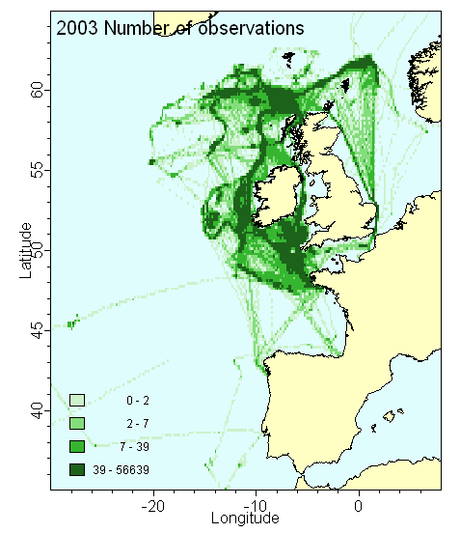 | 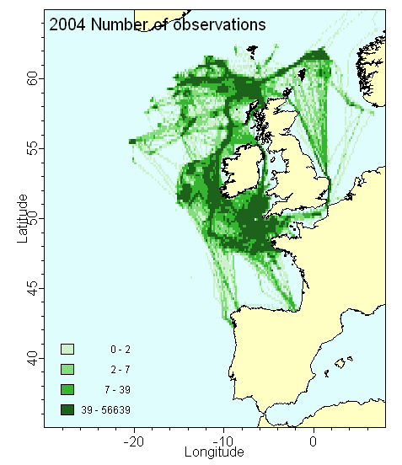 | 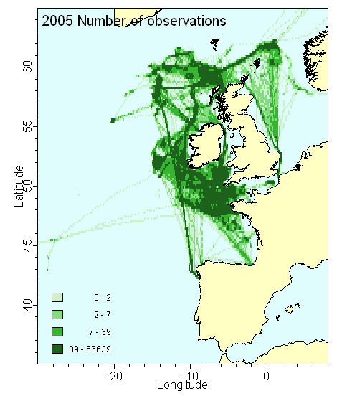
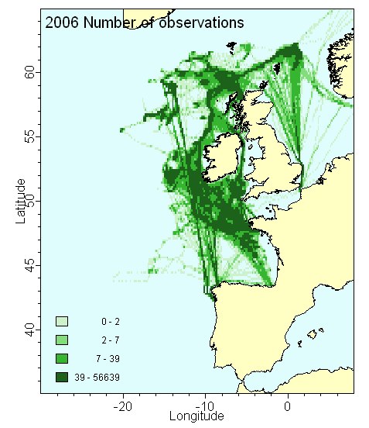 | 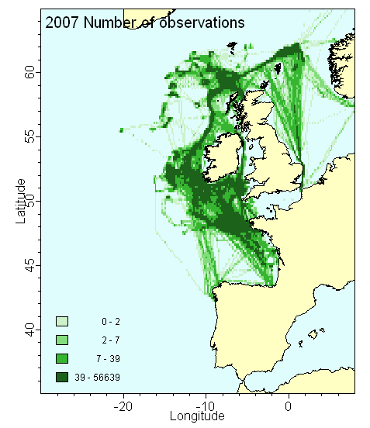
Figure 4.1.4.2a. Number of VMS observations of the French deep-water licensed fleet 2003-2007.

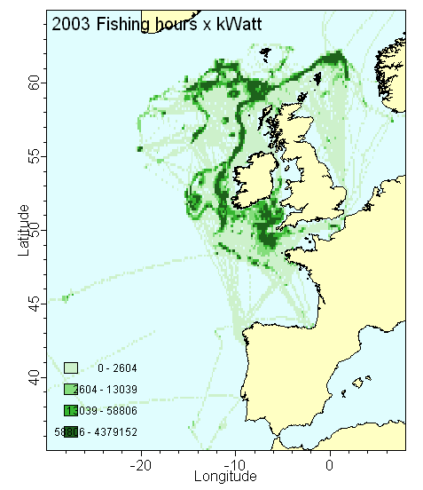 | 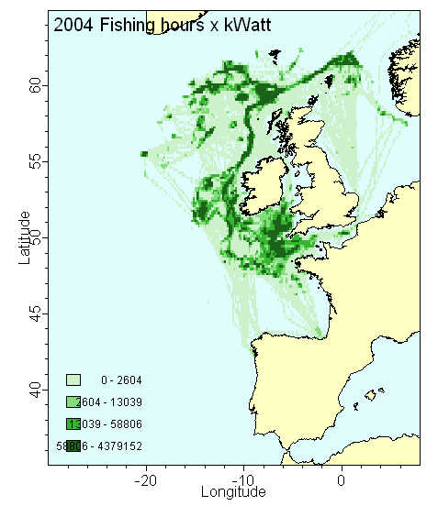 | 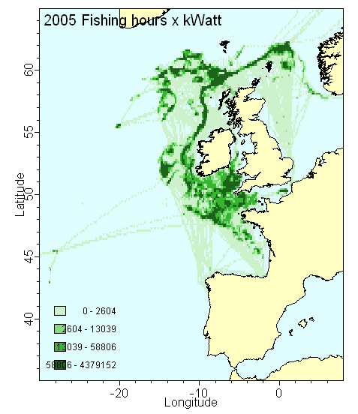
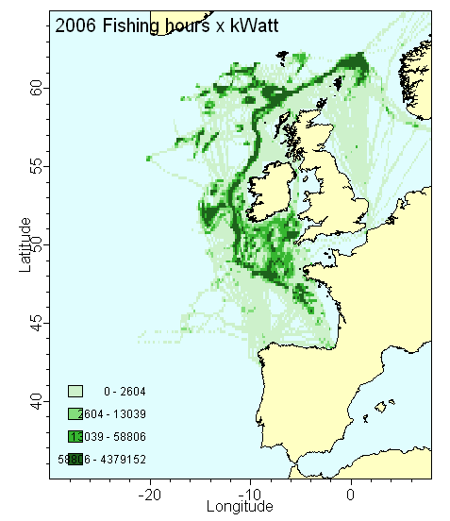 | 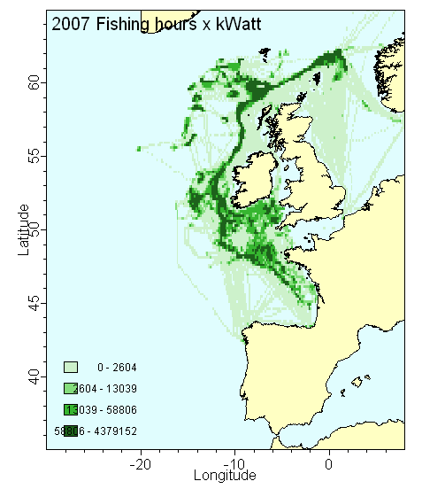

Figure 4.1.4.2b. Estimation of the spatial distribution of fishing effort from the French deep-water licensed fleet, estimated niumber of hours fishing by 10’ x 10’ rectangles multiplied by vessel power. Base dupon VMS data.

Improvement of availability, quality and use of VMS data
[How could the coverage, availability, quality and use of VMS data be improved?]

It is likely that increasing the frequency of recording to 15-30 minutes would improve VMS data. This however requires confirmation based upon analysis during the project and depend upon the interest for management of VMS data. VMS data allows to identify where fisheries operate and are efficient for control issues. Their usefulness for scientific and assessment issues in deep-water fisheries requires confirmation. The distribution of the French demersal deep water fleet effort based upon VMS is consistent with other data and may not provide significant additional knowledge and data for stock assessment. The usefulness of VMS data with regards to Vulnerable Marine Ecosystem (VMEs) is another question, which might addressed both in Deepfishman and CoralFISH.

Observer data

Observer activity
In the past there was some scientific observation of deep-water fishing. These were carried out for scientific projects, aims could be be collection of biological data, including the distribution and habitat of species. Several fishing trip were observed to analyse the abundance, distribution and reproductive strategy of sikis sharks (Girard 2000). Similarly, Allain (1999) observed a number of fishing trips in 1996-97 to collect biological data and samples on several species and also analysed the discards of the deep-water fishery (Allain et al. 2003).
In the 2000, sampling plan for on-board observations were developed in application of the data collection framework (Decision from the commission of 6 November 2008) and regulation (EC) N°2347/2002. Data from the application of these two regulations are fully availably in national databases and data from Allain (1999° were made available to the project.

Table 4.1.5.1 Observer data available in Franch national databases
Fleet ID | Observer type: enforcement or scientific or both? | If EU vessels – funded under DCF or compliance with EC Deep-water Licensing Reg? | % of vessel trips covered | Sampling Plan /SOP available? | Data made available to stock assessments?
FR-BTDWS (1) | Scientific | Scientific project | NA | NA | NA
FR-BTDWS (2) | Scientific | Scientific project | NA | NA | Yes, include in roundnose grenadier assessment using discards data (ICES 2009a)
FR-BTDWS (1) |  | Compliance with EC regulation 2347/2002 |  | Y | Y (COST format)
FR-BTDWS (4) | DCF | Funded under DCF
SP-BTDWS

(1): data collected by Girard
(2) collected by Allain, available to DEEPFISHMAN, not transferred to COST format
(4) merged into data collected for Compliance with EC regulation 2347/2002

Data were available to stock assessment and, the quantities and length distribution of the discards on roundnose grenadier were included in the stock assessment in 2008 (ICES, 2008). For the other main deepwater species exploited by the French fleet the on-board observations only confirmed that discards were minor and had no impact on assessment. It was always known that this fishery did not catch significant amount of small black scabbardfish, blue ling and siki sharks, simply because small individuals of these species do not occur on the fishing grounds. The situation is more complex for orange roughy where small fish may be caught. However, due to the high value of this species, only very small individuals would be discarded.
The on-boards observations also confirmed that the main species in the discards were smoothhheads, mainly Alepocephalus bairdi, which forms a high proportion of the biomass by 1000-1400 m, is discarded in large quantities.

Fisheries data recorded by observers
[4.1.4.2 Fisheries data recorded by observers: please complete yes/no and cite time-series in the cells in the table below. Please append all available time-series data disaggregated by fleet ID if possible.:-]
The specification on fishery data to record by observers are available on the webpage:
http://www.ifremer.fr/sih/affichagePageStatique.do?page=collecte_donnees/observations_mer/documentation/documentation_obsmer.htm
This documentation is in French. It includes general protocole and guidelines for all on-board observations and specific guidelines for some fisheries including deep-water fisheries. A number of tools useful to observers are also made available on the same page. The table 4.1.5.2 is filled in according to protocols from this webpage.
Since 2010, data are organised under COST format (Jansen et al. 2009). data from Allain (1999) are organised under a different format and will be provided to the project with relevant metadata.

Table 4.1.5.2. Data collected by on-board observed on French deep-water fishing vessels

Fleet ID | Species composition of retained catch? | Species composition of discarded catch? | Fishing effort details (see under 4.1.2) | VME spps e.g.  corals and sponges etc | PET5  spp | Seabirds | Marine mammals | Turtles
FR-BTDWS (1) | Y | Y | Y | Y | Y | Y | Y | not relevant
Until 2010, the forms and database for on-board observations did not included section for VMEs, the protocole for deep-water fishery specified that this data should be reported as comment for every fishing tow or set. From 2010, the protocole requires that catch of live corals and sponges are reported together with discards species. This is in line with the NEAFC Recommendation XI: 2010, that catch of live coral over 60 kg and catch of live sponges over 800 kg should be reported by deep-water fishing vessels. Note that, in on-board observation catch of live coral and sponges of any weight will be reported while the requrement from identification of VMEs rely upon some threshold catch (to be specified in ICES advices 2010).

Species identification in retained and discarded catches
[4.1.4.3 Are all species in retained and discarded catches recorded? If not please describe by fleet ID.]
The protocoles require identifying all species. Nevertheless, it might be realized that the work by observers who are trained but which taxonomic skills cannot be equivalent to that of taxonomy scientist.
In fact, most commercial species, chimaeras which identification criteria are rather easy and several common discarded species are identified to the species levels. There are identification problems with deep-water sharks. Some deep-water sharks species are indeed difficult to indetified to species level. For example, it does not seem realistic to expect Apristurus species to be identified to the species level. In addition to this, some observers did not sorted out the catch of commercial shark better than it is sorted for commercial purposes. Therefore, a significant part of the sharks landings are reported as siki (Centrophorus squamosus + Centroscymnus coelolepis) in the on-board observations. For some other groups the identification to the genus level is reliable, the identification of species may not be. This may be the case for the families Alepocephalidae (although the bulk of the discards is Alepocephalus bairdii) and Macrouridae, where Coryphaenoides rupestris is identified reliably, while the identification of small macrourid species may required a treatment with caution.

As the on-board observations are carried out by private companies contracted on a year-by-year basis, there are few deep-water trained on-board observers. Contracts are passed between the French fisheries directorate and these companies. Observers are employed by contracting companies under yearly contracts. In this context, contracting companies may minimise the investment in observers training, because observer are not permanent staff.

Species ID keys
4.1.4.4 Are species ID keys available and are they fit for purpose?

Observers use keys available from the Ifremer website (see address above) and an identification field book in French:
Quéro, J.-C., Porché, P., Vayne, J. J. (2003). Guide des poissons de l'Atlantique européen, identifier 955 espèces. Lonay (Suisse), Paris, Delachaux et Niestlé.
This field book is unfortunately out of print. For the time being a number of exemplaries are still available to observers.
Electronic book with photos of most species are available for chondrychthyans and Actynopterygians in French and English at the followiung address http://www.mnhn.fr/iccanam/ and on the Ifremer website. Identifications keys used during survey on research vessels are also available to observers on the ifremer website. they include deep-water species mainly because the French western IBTS includes tows down to 600m. In 2010, an identification keys for wharks rays and chimeara was published. It is available at:
http://agriculture.gouv.fr/sections/thematiques/peche-aquaculture/fichiers-peche/ and on the Ifremer website for observers. See only the link on the DEEPFISHMAN WIKI (page in French).

Ifremer and MNHN (Museum National d’Histoire Naturelle) provide training available to observers from all institutes and sub-contractors in France. This is currently organised as a one week yearly training period. Lastly, Deep-water fleet observers are encourage to provide photos with their identification for check.

Species recording
4.1.4.5 Are species recorded as presence/absence, by weight or by number? Please describe by fleet ID

Species are recorded by weight and/or number. Protocole specify how samples and subsamples should be handled. In the deep-water fishery, the weight of the landings in container is known (either from on-board scales or for estimated weight per species per container type). When available, on-board scales are used for sample weight, otherwise the training of observers include visual estimation of weight and training in using standard container to estimate the weights.

Effort recording
4.1.4.6 Please list fishing effort details recorded by observers on vessels in each fleet.

Fishing effort detail include all fishing effort data defined in DCF and record types TR and HH of the COST project standard exchange formats.

Recording of coral, sponges and other VMEs encounter
4.1.4.7 Are corals and sponges recorded as presence/absence, by weight or by number? Please describe by fleet ID.

coral, sponges and other VMEs encounter are mandatory to recorded by weight from 2010 onwards, some data might be available for previous years.

Corals and sponges identification
4.1.4.8 To what taxonomic level are corals and sponges identified? Please describe by fleet ID

Coral and sponges are only recorded as coral and/or sponges.

Coral and sponge ID keys
4.1.4.9 Are coral and sponge ID keys available and are they fit for purpose? Please describe by fleet ID

PET species
Please list any PET spp captured by fleet. What details are recorded?

available for fish species
One single species of bird the Balearic shearwater (Puffinus mauretanicus) has been assessed by IUCN. No by-catch of birds have been recorded in French deep-water surveys nor in on-board observations of the French fleet. There is no anecdotal report of these and bord by-catch should therefore be very rare in the demersal deep-water mixed fishery for trawl fleet. The situation in deep-water longline fleets in the same area is not known.
To date all marine mammals and sea turtles worldwide have been assessed by (International Union for Conservation of Nature and Natural Resources). Extraction of IUCN assessments was carried out all assessed species, sub-species subs-species and varieties, stocks and populations (table 4.15.10).
For Marine mammals, 34 species or populations have been assessed in the Northeast Atlantic (table 4.15.10). There is no known incidental catch of marine mammals in the demersal deep-water mixed fishery.

Three sea turtle species are recorded to occur in the oceanic and deep benthic habitats of the Northeast Atlantic (table 4.15.10). They are classified Endangered or Critically Endangered according to IUCN classification criteria. The demersal deep-water mixed fishery is not known to generate incidental by-catch or any other mortality of sea turtles.
For fish, only three Actynopterygian species occurring in the Oceanic and deep-benthic Northeast Atlantic have been assessed by IUCN, the Dusky grouper Epinephelus marginatus, the wrekfish Polyprion americanus, and the Atlantic salmon, Salmo salar. None has been reported in the catch of the demersal deep-water mixed fishery. Nevertheless, occasional catches of wreckfish might occur.
For Chondrichthyans, 94 species have been assessed by IUCN (table 4.15.10).

No invertebrate from the oceanic and deep benthic habitats of the Northeast Atlantic have been assessed by IUCN. Amongst invertebrates, only Echinus esculentus from the coastal and shelf benthic habitst have been assessed and was classified Lower Risk/near Threatened –LR/nt) and it is not impacted by deep-water fisheries.

Search terms for the IUCN data extraction were as follow:
Search by taxonomy:
ANIMALIA
FUNGI
PLANTAE
PROTISTA
Search by location:
Atlantic – northeast (Native, Introduced, Vagrant, Uncertain)
Search by systems:
Marine
Match any habitat:
10. Marine Oceanic
11. Marine Deep Benthic
When species were assessed at species level and at a sub-species varieties, stocks or population level more relevant to the Northeast Atlantic, only this more relevant level was included in the case study data.

Table 4.15.10a. Marine species, sub-species varieties, stocks and population, occurring in the oceanic and deepbenthic Northeast Atlantic environment, assessed by IUCN.

Class | Order | Family | Species | English name | Red List  status | Red List criteria | Red List  criteria  version | Year assessed | Pop. trend
Actinopterygii | Perciformes | Polyprionidae | Polyprion americanus (Bloch & Schneider, 1801) | Wreckfish | DD |  | 3.1 | 2003 | U
Actinopterygii | Perciformes | Serranidae | Epinephelus marginatus (Lowe, 1834) | Dusky Grouper | EN | A2d | 3.1 | 2004 | D
Actinopterygii | Salmoniformes | Salmonidae | Salmo salar Linnaeus, 1758 | Atlantic Salmon | LR/lc |  | 2.3 | 1996
Chondrichthyes | Carcharhiniformes | Carcharhinidae | Carcharhinus galapagensis (Snodgrass & Heller, 1905) | Galapagos Shark | NT |  | 3.1 | 2003 | U
Chondrichthyes | Carcharhiniformes | Carcharhinidae | Carcharhinus longimanus (Poey, 1861) | Oceanic Whitetip Shark | VU | A2ad+3d+4ad | 3.1 | 2006 | D
Chondrichthyes | Carcharhiniformes | Carcharhinidae | Carcharhinus obscurus (Lesueur, 1818) | Dusky Shark | VU | A2bd | 3.1 | 2007 | D
Chondrichthyes | Carcharhiniformes | Carcharhinidae | Galeocerdo cuvieri (Peron & Lesueur, 1822) | Tiger Shark | NT |  | 3.1 | 2005 | U
Chondrichthyes | Carcharhiniformes | Carcharhinidae | Prionace glauca (Linnaeus, 1758) | Blue Shark | NT |  | 3.1 | 2005 | U
Chondrichthyes | Carcharhiniformes | Pseudotriakidae | Pseudotriakis microdon Capello, 1868 | Atlantic False Catshark | DD |  | 3.1 | 2004 | U
Chondrichthyes | Carcharhiniformes | Scyliorhinidae | Apristurus aphyodes Nakaya & Stehmann, 1998 | White Ghost Catshark | DD |  | 3.1 | 2004 | U
Chondrichthyes | Carcharhiniformes | Scyliorhinidae | Apristurus manis (Springer, 1979) | Ghost Catshark | LC |  | 3.1 | 2004 | U
Chondrichthyes | Carcharhiniformes | Scyliorhinidae | Apristurus microps (Gilchrist, 1922) | Smalleye Catshark | LC |  | 3.1 | 2004 | U
Chondrichthyes | Carcharhiniformes | Scyliorhinidae | Galeus atlanticus Vaillant, 1888 | Atlantic Sawtail Catshark | NT |  | 3.1 | 2007 | U
Chondrichthyes | Carcharhiniformes | Scyliorhinidae | Galeus murinus (Collett, 1904) | Mouse Catshark | LC |  | 3.1 | 2008 | U
Chondrichthyes | Carcharhiniformes | Scyliorhinidae | Scyliorhinus canicula (Linnaeus, 1758) | Small Spotted Catshark | LC |  | 3.1 | 2008 | S
Chondrichthyes | Carcharhiniformes | Sphyrnidae | Sphyrna mokarran (Rüppell, 1837) | Great Hammerhead | EN | A2bd+4bd | 3.1 | 2007 | D
Chondrichthyes | Carcharhiniformes | Triakidae | Galeorhinus galeus (Linnaeus, 1758) | Tope shark | VU | A2bd+3d+4bd | 3.1 | 2006 | D
Chondrichthyes | Carcharhiniformes | Triakidae | Mustelus mustelus (Linnaeus, 1758) | Common Smoothhound | VU | A2bd+3bd+4bd | 3.1 | 2004 | D
Chondrichthyes | Chimaeriformes | Chimaeridae | Chimaera monstrosa Linnaeus,1758 | Rabbitfish | NT |  | 3.1 | 2007 | S
Chondrichthyes | Chimaeriformes | Chimaeridae | Hydrolagus affinis (Capello, 1867) | Smalleyed Rabbitfish | LC |  | 3.1 | 2007 | U
Chondrichthyes | Chimaeriformes | Chimaeridae | Hydrolagus lusitanicus Moura, Figueiredo, Bordalo-Machado, Almeida & Gordo, 2005 | 0 | DD |  | 3.1 | 2008 | U
Chondrichthyes | Chimaeriformes | Chimaeridae | Hydrolagus mirabilis (Collett, 1904) | Large-eyed Rabbitfish | NT |  | 3.1 | 2007 | D
Chondrichthyes | Chimaeriformes | Chimaeridae | Hydrolagus pallidus Hardy & Stehmann, 1990 | Pale Chimaera | LC |  | 3.1 | 2007 | U
Chondrichthyes | Chimaeriformes | Rhinochimaeridae | Harriotta raleighana Goode & Bean, 1895 | Bentnose Rabbitfish | LC |  | 3.1 | 2006 | S
Chondrichthyes | Chimaeriformes | Rhinochimaeridae | Rhinochimaera atlantica Holt & Byrne, 1909 | Broadnose Chimaera | LC |  | 3.1 | 2006 | U
Chondrichthyes | Hexanchiformes | Chlamydoselachidae | Chlamydoselachus anguineus Garman, 1884 | Lizard Shark | NT |  | 3.1 | 2003 | U
Chondrichthyes | Hexanchiformes | Hexanchidae | Heptranchias perlo (Bonnaterre, 1788) | One-finned Shark | NT |  | 3.1 | 2003 | U
Chondrichthyes | Hexanchiformes | Hexanchidae | Hexanchus griseus (Bonnaterre, 1788) | Bluntnose Sixgill Shark | NT |  | 3.1 | 2005 | U
Chondrichthyes | Hexanchiformes | Hexanchidae | Hexanchus nakamurai Teng, 1962 | Bigeyed Sixgill Shark | DD |  | 3.1 | 2008 | U
Table 4.15.10a. Continued

Class | Order | Family | Species | English name | Red List  status | Red List criteria | Red List  criteria  version | Year assessed | Pop. Trend
Chondrichthyes | Lamniformes | Alopiidae | Alopias superciliosus Lowe, 1840 | Bigeye Thresher Shark | VU | A2bd | 3.1 | 2007 | D
Chondrichthyes | Lamniformes | Alopiidae | Alopias vulpinus (Bonnaterre, 1788) | Common Thresher Shark | VU | A2bd+3bd+4bd | 3.1 | 2007 | D
Chondrichthyes | Lamniformes | Cetorhinidae | Cetorhinus maximus (Gunnerus, 1765) Northeast Atlantic subpopulation | Basking Shark | EN | A2ad | 3.1 | 2005 | D
Chondrichthyes | Lamniformes | Lamnidae | Carcharodon carcharias (Linnaeus, 1758) | Great White Shark | VU | A2cd+3cd | 3.1 | 2005 | U
Chondrichthyes | Lamniformes | Lamnidae | Isurus oxyrinchus Rafinesque, 1810 Atlantic subpopulation | Shortfin Mako | VU | A2bd+3bd+4bd | 3.1 | 2004 | D
Chondrichthyes | Lamniformes | Lamnidae | Isurus paucus Guitart Manday, 1966 | Longfin Mako | VU | A2bd+3d+4bd | 3.1 | 2006 | D
Chondrichthyes | Lamniformes | Lamnidae | Lamna nasus (Bonnaterre, 1788) Northeast Atlantic subpopulation | Porbeagle | CR | A2bcd+3d+4bd | 3.1 | 2006 | D
Chondrichthyes | Lamniformes | Mitsukurinidae | Mitsukurina owstoni Jordan, 1898 | Elfin Shark | LC |  | 3.1 | 2004 | S
Chondrichthyes | Lamniformes | Odontaspididae | Odontaspis ferox (Risso, 1810) | Small-tooth Sand Tiger Shark | VU | A2bd+4bd | 3.1 | 2007 | D
Chondrichthyes | Orectolobiformes | Ginglymostomatidae | Ginglymostoma cirratum (Bonnaterre, 1788) | Nurse Shark | DD |  | 3.1 | 2006 | U
Chondrichthyes | Rajiformes | Arhynchobatidae | Bathyraja pallida (Forster, 1967) | Pale Ray | LC |  | 3.1 | 2007 | U
Chondrichthyes | Rajiformes | Arhynchobatidae | Bathyraja richardsoni (Garrick 1961) | Deepsea Skate | LC |  | 3.1 | 2007 | U
Chondrichthyes | Rajiformes | Arhynchobatidae | Bathyraja spinicauda (Jensen, 1914) | Spinytail Skate | NT |  | 3.1 | 2006 | U
Chondrichthyes | Rajiformes | Mobulidae | Mobula mobular (Bonnaterre 1788) | Giant Devilray | EN | A4d | 3.1 | 2006 | D
Chondrichthyes | Rajiformes | Myliobatidae | Myliobatis aquila (Linnaeus, 1758) | Common Eagle Ray | DD |  | 3.1 | 2005 | U
Chondrichthyes | Rajiformes | Rajidae | Amblyraja 87yperborean (Collett 1879) | Arctic Skate | LC |  | 3.1 | 2007 | U
Chondrichthyes | Rajiformes | Rajidae | Amblyraja jenseni (Bigelow & Schroeder, 1950) | Jensen’s Skate | LC |  | 3.1 | 2008 | U
Chondrichthyes | Rajiformes | Rajidae | Amblyraja radiata (Donovan, 1808) | Thorny Skate | VU | A2b | 3.1 | 2004 | D
Chondrichthyes | Rajiformes | Rajidae | Dipturus batis Linnaeus, 1758 | Blue Skate | CR | A2bcd+4bcd | 3.1 | 2006 | D
Chondrichthyes | Rajiformes | Rajidae | Dipturus linteus (Fries, 1838) | Sailray | LC |  | 3.1 | 2006 | U
Chondrichthyes | Rajiformes | Rajidae | Dipturus nidarosiensis (Storm, 1881) | Norwegian Skate | NT |  | 3.1 | 2007 | D
Chondrichthyes | Rajiformes | Rajidae | Dipturus oxyrinchus (Linnaeus, 1758) | Long-nosed Skate | NT |  | 3.1 | 2007 | U
Chondrichthyes | Rajiformes | Rajidae | Leucoraja circularis (Couch, 1838) | 0 | VU | A2bcd+3bcd+4bcd | 3.1 | 2008 | D
Chondrichthyes | Rajiformes | Rajidae | Leucoraja fullonica (Linnaeus, 1758) | Shagreen Ray | NT |  | 3.1 | 2006 | D
Chondrichthyes | Rajiformes | Rajidae | Leucoraja naevus (Müller & Henle, 1841) | Cuckoo Ray | LC |  | 3.1 | 2008 | U
Chondrichthyes | Rajiformes | Rajidae | Malacoraja kreffti (Stehmann, 1977) | Krefft’s Skate | LC |  | 3.1 | 2007 | U
Chondrichthyes | Rajiformes | Rajidae | Malacoraja spinacidermis (Barnard, 1923) | Roughskin Skate | LC |  | 3.1 | 2007 | U
Chondrichthyes | Rajiformes | Rajidae | Neoraja caerulea (Stehmann, 1976) | Blue Pygmy Skate | DD |  | 3.1 | 2004 | U
Table 4.15.10a. Continued

Class | Order | Family | Species | English name |  | Red List  status |  | Red List criteria |  | Red List  criteria  version |  | Year assessed |  | Pop. Trend
Chondrichthyes | Rajiformes | Rajidae | Neoraja iberica Stehmann, Séret, Costa & Baro, 2008 |  | Iberian Pygmy Skate |  | DD |  |  |  | 3.1 |  | 2008 |  | U
Chondrichthyes | Rajiformes | Rajidae | Raja asterias Delaroche, 1809 |  | Starry Ray |  | LC |  |  |  | 3.1 |  | 2007 |  | S
Chondrichthyes | Rajiformes | Rajidae | Raja clavata Linnaeus, 1758 |  | Thornback Skate |  | NT |  |  |  | 3.1 |  | 2005 |  | D
Chondrichthyes | Rajiformes | Rajidae | Raja miraletus Linnaeus, 1758 |  | Brown Skate |  | LC |  |  |  | 3.1 |  | 2003 |  | S
Chondrichthyes | Rajiformes | Rajidae | Raja montagui (Fowler, 1910) |  | Spotted Ray |  | LC |  |  |  | 3.1 |  | 2007 |  | S
Chondrichthyes | Rajiformes | Rajidae | Raja radula Delaroche, 1809 |  | Rough Ray |  | DD |  |  |  | 3.1 |  | 2006 |  | U
Chondrichthyes | Rajiformes | Rajidae | Raja undulata Lacepède, 1802 |  | Undulate Ray |  | EN |  | A2bd+3d+4bd |  | 3.1 |  | 2003 |  | D
Chondrichthyes | Rajiformes | Rajidae | Rajella bathyphila (Holt & Byrne, 1908) |  | 0 |  | LC |  |  |  | 3.1 |  | 2008 |  | U
Chondrichthyes | Rajiformes | Rajidae | Rajella bigelowi (Stehmann, 1978) |  | Bigelow's Skate |  | LC |  |  |  | 3.1 |  | 2008 |  | U
Chondrichthyes | Rajiformes | Rajidae | Rajella fyllae (Lütken, 1887) |  | Round Skate OR Ray |  | LC |  |  |  | 3.1 |  | 2008 |  | U
Chondrichthyes | Rajiformes | Rajidae | Rajella kukujevi (Dolganov, 1985) |  | Mid-Atlantic Skate |  | DD |  |  |  | 3.1 |  | 2008 |  | U
Chondrichthyes | Rajiformes | Rajidae | Rostroraja alba (Lacepède, 1803) |  | Bottlenose Skate |  | EN |  | A2cd+4cd |  | 3.1 |  | 2006 |  | D
Chondrichthyes | Rajiformes | Torpedinidae | Torpedo marmorata Risso, 1810 |  | Spotted Torpedo |  | DD |  |  |  | 3.1 |  | 2003 |  | U
Chondrichthyes | Rajiformes | Torpedinidae | Torpedo nobiliana Bonaparte, 1835 |  | Black Torpedo |  | DD |  |  |  | 3.1 |  | 2004 |  | U
Chondrichthyes | Rajiformes | Torpedinidae | Torpedo torpedo (Linnaeus, 1758) |  | Ocellate Torpedo |  | DD |  |  |  | 3.1 |  | 2003 |  | S
Chondrichthyes | Squaliformes | Centrophoridae | Centrophorus granulosus (Bloch & Schneider, 1801) |  | Gulper Shark |  | VU |  | A2abd+3d+4d |  | 3.1 |  | 2006 |  | D
Chondrichthyes | Squaliformes | Centrophoridae | Centrophorus lusitanicus Bocage & Capello, 1864 |  | Lowfin Gulper Shark |  | VU |  | A2bd+4bd |  | 3.1 |  | 2008 |  | U
Chondrichthyes | Squaliformes | Centrophoridae | Centrophorus squamosus (Bonnaterre, 1788) |  | Leafscale Gulper Shark |  | VU |  | A2bd+3bd+4bd |  | 3.1 |  | 2003 |  | D
Chondrichthyes | Squaliformes | Centrophoridae | Centrophorus uyato (Rafinesque, 1810) |  | Little Gulper Shark |  | DD |  |  |  | 3.1 |  | 2003 |  | U
Chondrichthyes | Squaliformes | Centrophoridae | Deania calcea (Lowe, 1839) |  | Shovelnose Spiny Dogfish |  | LC |  |  |  | 3.1 |  | 2003 |  | U
Chondrichthyes | Squaliformes | Dalatiidae | Dalatias licha (Bonnaterre, 1788) Northeast Atlantic subpopulation |  | Kitefin Shark |  | LR/nt |  |  |  | 2.3 |  | 2000 |  | U
Chondrichthyes | Squaliformes | Dalatiidae | Isistius plutodus Garrick & Springer, 1964 |  | Bigtooth Cookiecutter |  | LC |  |  |  | 3.1 |  | 2006 |  | U
Chondrichthyes | Squaliformes | Dalatiidae | Squaliolus laticaudus Smith & Radcliffe, 1912 |  | Big-eye Dwarf Shark |  | LC |  |  |  | 3.1 |  | 2006 |  | U
Chondrichthyes | Squaliformes | Echinorhinidae | Echinorhinus brucus (Bonnaterre, 1788) |  | Bramble Shark |  | DD |  |  |  | 3.1 |  | 2003 |  | U
Chondrichthyes | Squaliformes | Etmopteridae | Centroscyllium fabricii (Reinhardt 1825) |  | Black Dogfish |  | LC |  |  |  | 3.1 |  | 2008 |  | U
Chondrichthyes | Squaliformes | Etmopteridae | Etmopterus princeps Collett, 1904 |  | Great Lanternshark |  | DD |  |  |  | 3.1 |  | 2006 |  | U
Chondrichthyes | Squaliformes | Etmopteridae | Etmopterus pusillus (Lowe, 1839) |  | Smooth Lanternshark |  | LC |  |  |  | 3.1 |  | 2008 |  | U
Chondrichthyes | Squaliformes | Etmopteridae | Etmopterus spinax (Linnaeus, 1758) |  | Velvet Belly Lanternshark |  | LC |  |  |  | 3.1 |  | 2008 |  | U
Chondrichthyes | Squaliformes | Oxynotidae | Oxynotus centrina (Linnaeus, 1758) |  | Angular Rough Shark |  | VU |  | A2bcd+4bd |  | 3.1 |  | 2007 |  | U
Table 4.15.10a. Continued

Class | Order | Family | Species | English name |  | Red List  status |  | Red List criteria |  | Red List  criteria  version |  | Year assessed |  | Pop. Trend
Chondrichthyes | Squaliformes | Oxynotidae | Oxynotus paradoxus Frade, 1929 |  | Sailfin Roughshark |  | DD |  |  |  | 3.1 |  | 2008 |  | U
Chondrichthyes | Squaliformes | Somniosidae | Centroscymnus coelolepis (Bocage & Capello, 1864) |  | Portuguese Dogfish |  | NT |  |  |  | 3.1 |  | 2003 |  | U
Chondrichthyes | Squaliformes | Somniosidae | Centroselachus crepidater (Bocage & Capello, 1864) |  | Longnose Velvet Dogfish |  | LC |  |  |  | 3.1 |  | 2003 |  | U
Chondrichthyes | Squaliformes | Somniosidae | Scymnodon ringens Bocage & Capello, 1864 |  | Knifetooth Dogfish |  | DD |  |  |  | 3.1 |  | 2008 |  | U
Chondrichthyes | Squaliformes | Somniosidae | Somniosus microcephalus (Bloch & Schneider, 1801) |  | Greenland Shark |  | NT |  |  |  | 3.1 |  | 2006 |  | U
Chondrichthyes | Squaliformes | Somniosidae | Somniosus rostratus (Risso, 1827) |  | Little Sleeper Shark |  | DD |  |  |  | 3.1 |  | 2008 |  | U
Chondrichthyes | Squaliformes | Somniosidae | Zameus squamulosus (Günther, 1877) |  | Smallmouth Velvet Dogfish |  | DD |  |  |  | 3.1 |  | 2006 |  | U
Chondrichthyes | Squaliformes | Squalidae | Squalus acanthias Linnaeus, 1758 Northeast Atlantic subpopulation |  | Spurdog |  | CR |  | A2bd+3bd+4bd |  | 3.1 |  | 2006 |  | D
Chondrichthyes | Squaliformes | Squalidae | Squalus blainvillei (Risso, 1827) |  | Longnose Spurdog |  | DD |  |  |  | 3.1 |  | 2008 |  | U
Chondrichthyes | Squaliformes | Squalidae | Squalus megalops (Macleay, 1881) |  | Cosmopolitan Spurdog |  | DD |  |  |  | 3.1 |  | 2003 |  | U
Chondrichthyes | Squatiniformes | Squatinidae | Squatina oculata Bonaparte, 1840 |  | Angel Shark |  | CR |  | A2bcd+3cd+4bcd |  | 3.1 |  | 2007 |  | D
Reptilia | Testudines | Cheloniidae | Chelonia mydas (Linnaeus, 1758) |  | Green Turtle |  | EN |  | A2bd |  | 3.1 |  | 2004 |  | D
Reptilia | Testudines | Cheloniidae | Eretmochelys imbricata (Linnaeus, 1766) |  | Hawksbill Turtle |  | CR |  | A2bd |  | 3.1 |  | 2008 |  | D
Reptilia | Testudines | Dermochelyidae | Dermochelys coriacea (Vandelli, 1761) |  | Leatherback turtle |  | CR |  | A1abd |  | 2.3 |  | 2000 |  | D
Mammalia | Carnivora | Odobenidae | Odobenus rosmarus (Linnaeus, 1758) |  | Walrus |  | DD |  |  |  | 3.1 |  | 2008 |  | U
Mammalia | Carnivora | Phocidae | Cystophora cristata (Erxleben, 1777) |  | Hooded Seal |  | VU |  | A2b |  | 3.1 |  | 2008 |  | D
Mammalia | Carnivora | Phocidae | Halichoerus grypus (Fabricius, 1791) |  | Grey Seal |  | LC |  |  |  | 3.1 |  | 2008 |  | I
Mammalia | Carnivora | Phocidae | Pagophilus groenlandicus (Erxleben, 1777) |  | Harp Seal |  | LC |  |  |  | 3.1 |  | 2008 |  | I
Mammalia | Carnivora | Phocidae | Phoca vitulina Linnaeus, 1758 |  | Harbour Seal |  | LC |  |  |  | 3.1 |  | 2008 |  | S
Mammalia | Cetartiodactyla | Balaenidae | Balaena mysticetus Linnaeus, 1758 |  | Bowhead Whale |  | LC |  |  |  | 3.1 |  | 2008 |  | I
Mammalia | Cetartiodactyla | Balaenopteridae | Balaenoptera acutorostrata Lacépède, 1804 |  | Common Minke Whale |  | LC |  |  |  | 3.1 |  | 2008 |  | S
Mammalia | Cetartiodactyla | Balaenopteridae | Balaenoptera borealis Lesson, 1828 |  | Sei Whale |  | EN |  | A1ad |  | 3.1 |  | 2008 |  | U
Mammalia | Cetartiodactyla | Balaenopteridae | Balaenoptera musculus (Linnaeus, 1758) |  | Blue Whale |  | EN |  | A1abd |  | 3.1 |  | 2008 |  | I
Mammalia | Cetartiodactyla | Balaenopteridae | Balaenoptera physalus (Linnaeus, 1758) |  | Fin Whale |  | EN |  | A1d |  | 3.1 |  | 2008 |  | U
Mammalia | Cetartiodactyla | Balaenopteridae | Megaptera novaeangliae (Borowski, 1781) |  | Humpback Whale |  | LC |  |  |  | 3.1 |  | 2008 |  | I
Mammalia | Cetartiodactyla | Delphinidae | Delphinus delphis Linnaeus, 1758 |  | Common Dolphin |  | LC |  |  |  | 3.1 |  | 2008 |  | U
Mammalia | Cetartiodactyla | Delphinidae | Globicephala macrorhynchus Gray, 1846 |  | Short-finned Pilot Whale |  | DD |  |  |  | 3.1 |  | 2008 |  | U
Mammalia | Cetartiodactyla | Delphinidae | Globicephala melas (Traill, 1809) |  | Long-finned Pilot Whale |  | DD |  |  |  | 3.1 |  | 2008 |  | U
Table 4.15.10a. Continued

Class | Order | Family | Species | English name |  | Red List  status |  | Red List criteria |  | Red List  criteria  version |  | Year assessed |  | Pop. Trend
Mammalia | Cetartiodactyla | Delphinidae | Grampus griseus (G. Cuvier, 1812) |  | Risso's Dolphin |  | LC |  |  |  | 3.1 |  | 2008 |  | U
Mammalia | Cetartiodactyla | Delphinidae | Lagenorhynchus acutus (Gray, 1828) |  | Atlantic White-sided Dolphin |  | LC |  |  |  | 3.1 |  | 2008 |  | U
Mammalia | Cetartiodactyla | Delphinidae | Lagenorhynchus albirostris (Gray, 1846) |  | White-beaked Dolphin |  | LC |  |  |  | 3.1 |  | 2008 |  | U
Mammalia | Cetartiodactyla | Delphinidae | Orcinus orca (Linnaeus, 1758) |  | Killer Whale |  | DD |  |  |  | 3.1 |  | 2008 |  | U
Mammalia | Cetartiodactyla | Delphinidae | Pseudorca crassidens (Owen, 1846) |  | False Killer Whale |  | DD |  |  |  | 3.1 |  | 2008 |  | U
Mammalia | Cetartiodactyla | Delphinidae | Stenella coeruleoalba (Meyen, 1833) |  | Striped Dolphin |  | LC |  |  |  | 3.1 |  | 2008 |  | U
Mammalia | Cetartiodactyla | Delphinidae | Stenella frontalis (G. Cuvier, 1829) |  | Atlantic Spotted Dolphin |  | DD |  |  |  | 3.1 |  | 2008 |  | U
Mammalia | Cetartiodactyla | Delphinidae | Steno bredanensis (G. Cuvier in Lesson, 1828) |  | Rough-toothed Dolphin |  | LC |  |  |  | 3.1 |  | 2008 |  | U
Mammalia | Cetartiodactyla | Delphinidae | Tursiops truncatus (Montagu, 1821) |  | Bottlenose Dolphin |  | LC |  |  |  | 3.1 |  | 2008 |  | U
Mammalia | Cetartiodactyla | Monodontidae | Delphinapterus leucas (Pallas, 1776) |  | Beluga |  | NT |  |  |  | 3.1 |  | 2008 |  | U
Mammalia | Cetartiodactyla | Monodontidae | Monodon monoceros Linnaeus, 1758 |  | Narwhal |  | NT |  |  |  | 3.1 |  | 2008 |  | U
Mammalia | Cetartiodactyla | Physeteridae | Kogia breviceps (Blainville, 1838) |  | Pygmy Sperm Whale |  | DD |  |  |  | 3.1 |  | 2008 |  | U
Mammalia | Cetartiodactyla | Physeteridae | Kogia sima (Owen, 1866) |  | Dwarf Sperm Whale |  | DD |  |  |  | 3.1 |  | 2008 |  | U
Mammalia | Cetartiodactyla | Physeteridae | Physeter macrocephalus Linnaeus, 1758 |  | Sperm Whale |  | VU |  | A1d |  | 3.1 |  | 2008 |  | U
Mammalia | Cetartiodactyla | Ziphiidae | Hyperoodon ampullatus (Forster, 1770) |  | North Atlantic Bottlenose Whale |  | DD |  |  |  | 3.1 |  | 2008 |  | U
Mammalia | Cetartiodactyla | Ziphiidae | Mesoplodon bidens (Sowerby, 1804) |  | Sowerby's Beaked Whale |  | DD |  |  |  | 3.1 |  | 2008 |  | U
Mammalia | Cetartiodactyla | Ziphiidae | Mesoplodon densirostris (Blainville, 1817) |  | Blainville's Beaked Whale |  | DD |  |  |  | 3.1 |  | 2008 |  | U
Mammalia | Cetartiodactyla | Ziphiidae | Mesoplodon mirus True, 1913 |  | True's Beaked Whale |  | DD |  |  |  | 3.1 |  | 2008 |  | U
Mammalia | Cetartiodactyla | Ziphiidae | Ziphius cavirostris G. Cuvier, 1823 |  | Cuvier's Beaked Whale |  | LC |  |  |  | 3.1 |  | 2008 |  | U
Aves | Procellariiformes | Procellariidae | Puffinus mauretanicus Lowe, 1921 |  | Balearic Shearwater |  | CR |  | A4bcde |  | 3.1 |  | 2009 |  | D

Population trends: U unknown, D decreasing ,S stable , I increasing

The OSPAR commission listed the Threatened and/or Declining Species and Habitats in the OSPAR area (OSPAR List of Threatened and/or Declining Species and Habitats (Reference Number: 2008-6). The list includes invertebrates, birds, fish, reptiles, mammals and habitats. The listed invertebrates are coastal and are not impacted by deep-water fisheries and they are therefore not given here. A number of seabird are liste das endangered (Table 4.15.10b), none is known to be impacted by the demersal deep-water mixed fishery. Deep-water trawl fisheries are not none to have significant negative impact on threatened seabird, the situation is different with longlines fisheries where accidental catches of seabirds may occur and have significant impact (Nel et al. 2002; Arnold et al. 2006) although mitigation devices exist (Ryan and Watkins 2002).

Table 4.15.10b. Seabirds pecies threatened or declining according to OSPAR.

Scientific name | Common name | OSPAR Regions where the species occurs | OSPAR Regions where the species is under threat and/or in decline
Larus fuscus fuscus | Lesser black-backed gull | I | All where it occurs
Pagophila eburnea | Ivory gull | I | All where it occurs
Polysticta stelleri | Steller's eider | I | All where it occurs
Puffinus assimilis baroli (auct.incert.) | Little shearwater | V | All where it occurs
Puffinus mauretanicus | Balearic shearwater | II, III, IV, V | All where it occurs
Rissa tridactyla | Black-legged kittiwake | I, II, III, IV, V | I, II
Sterna dougallii | Roseate tern | II, III, IV, V | All where it occurs
Uria aalge – Iberian population (synonyms: Uria aalge albionis, Uria aalge ibericus) | Iberian guillemot | IV | All where it occurs
Uria lomvia | Thick-billed murre | I | All where it occurs

The OSPAR Regions are:
- I - the Arctic: the OSPAR maritime area north of latitude 62°N, but also including Iceland and the Færoes;
- II - the Greater North Sea: the North Sea, the English Channel, the Skagerrak and the Kattegat to the limits of the OSPAR maritime area, bounded on the north by latitude 62°N, on the west by longitude 5°W and the east coast of Great Britain, and on the south by latitude 48°N;
- III - the Celtic Seas: the area bounded by, on the east, longitude 5°W and the west coast of Great Britain and on the west by the 200 metre isobath (depth contour) to the west of 6°W along the west coasts of Scotland and Ireland;
- IV - the Bay of Biscay/Golfe de Gascogne and Iberian coasts: the area south of latitude 48°N, east of 11°W and north of latitude 36°N (the southern boundary of the OSPAR maritime area);
- V - the Wider Atlantic: the remainder of the OSPAR maritime area

The OPSAR list of threatened fish species include a number a deep-water species (Table 4.15.10c), those, which have been caught by deep-water fishing and that occur in region I and V where the demersal deep-water mixed fishery operates are highlighted in yellow.

Table 4.15.10c. Fish species threatened or declining according to OSPAR.

Scientific name | Common name | OSPAR Regions where the species occurs | OSPAR Regions where the species is under threat and/or in decline
Acipenser sturio | Sturgeon | II, IV | All where it occurs
Alosa alosa | Allis shad | II, III, IV | All where it occurs
Anguilla anguilla | European eel | I, II, III, IV | All where it occurs
Centroscymnus coelolepis | Portuguese dogfish | All | All where it occurs
Centrophorus granulosus (1) | Gulper shark | IV, V | All where it occurs
Centrophorus squamosus | Leafscale gulper shark | All | All where it occurs
Cetorhinus maximus | Basking shark | All | All where it occurs
Coregonus lavaretus oxyrinchus (Linnæus, 1758) | Houting | II | All where it occurs
Dipturus batis (synonym: Raja batis) | Common Skate | All | All where it occurs
Raja montagui | Spotted Ray | II, III, IV, V | All where it occurs
Gadus morhua | Cod | All | II, III
Hippocampus guttulatus (synonym: H. ramulosus) | Long-snouted seahorse | II, III, IV, V | All where it occurs
Hippocampus hippocampus | Short-snouted seahorse | II, III, IV, V | All where it occurs
Hoplostethus atlanticus | Orange roughy | I, V | All where it occurs
Lamna nasus | Porbeagle | All | All where it occurs
Petromyzon marinus | Sea lamprey | I, II, III, IV | All where it occurs
Raja clavata | Thornback skate / ray | I, II, III, IV, V | II
Rostroraja alba | White skate | II, III, IV | All where it occurs
Salmo salar | Salmon | I, II, III, IV | All where it occurs
Squalus acanthias | Spurdog | All | All where it occurs
Squatina squatina | Angel shark | II, III, IV | All where it occurs
Thunnus thynnus | Bluefin tuna | V | All where it occurs

(1) Centrophorus granulosus does not occur to the North of the Bay of Biscay) and is therefore not caught by the demersal deep-water mixed fishery
The OPSAR list of threatened marine mammals and reptile does not include species known to be caught by the demersal deep-water mixed fishery (Table 4.15.10d). Sea turtle rarely occur to the North of 50°North and large marine mammals are not caught in trawls.

Table 4.15.10d. Marine reptiles and mammalshabitats threatened or declining according to OSPAR.

Scientific name | Common name | OSPAR Regions where the species occurs | OSPAR Regions where the species is under threat and/or in decline
REPTILES
Caretta caretta | Loggerhead turtle | IV, V | All where it occurs
Dermochelys coriacea | Leatherback turtle | All | All where it occurs
MAMMALS
Balaena mysticetus | Bowhead whale | I | All where it occurs
Balaenoptera musculus | Blue whale | All | All where it occurs
Eubalaena glacialis | Northern right whale | All | All where it occurs
Phocoena phocoena | Harbour porpoise | All | II, III

The OPSAR list of threatened marine habitats includes some habitats impacted by deep-water trawling (Table 4.15.10e). Note that what is termed "habitat" by OSPAR" may be termed "VMEs" is other contexts. OSPAR habitats which threat include deep-water fishing are highlighted in yellow in table 4.15.10e. Note that other species not classified are deep-water may also generate impact and may be the major problem owing to the depth distribution of habitats.
In particular, OSPAR has adopted the following definition for Carbonate mounds (Descriptions of habitats on the OSPAR list of threatened and/or declining species and habitats (OSPAR Agreement 2008/7)): Carbonate mounds are distinct elevations of various shapes, which may be up to 350 m high and 2 km wide at their base (Van Weering et al. 2003). They occur offshore in water depths of 500-1100 m with examples present in the Porcupine Seabight and Rockall Trough (Kenyon et al. 2003). Carbonate mounds may have a sediment veneer, typically composed of carbonate sands, muds and silts. The cold-water reef-building corals Lophelia pertusa and Madrepora oculata, as well as echiuran worms are characteristic fauna of carbonate mounds. Where cold-water corals (such as L. pertusa) are present on the mound summit, coral debris may form a significant component of the overlying substratum.
Fisheries for roundnose grenadier, black scabbardfish, blue ling [as well as orange roughy and deep-water sharks] extend much deeper than the depth range 500-1000m (see figure 4.1.6.4) where they interaction with a number of other fisheries for hake, monkfish, ling, megrims and nephrops.

Table 4.15.10e. Marine habitats threatened or declining according to OSPAR.

Habitat | OSPAR Regions where the habitat occurs | OSPAR Regions where such habitats are under threat and/or in decline
Carbonate mounds | I, V | V
Coral Gardens | I, II, III, IV, V | All where they occur
Cymodocea meadows | IV | All where they occur
Deep-sea sponge aggregations | I, III, IV, V | All where they occur
Intertidal Mytilus edulis beds on mixed and sandy sediments | II, III | All where they occur
Intertidal mudflats | I, II, III, IV | All where they occur
Littoral chalk communities | II | All where they occur
Lophelia pertusa reefs | All | All where they occur
Maerl beds | All | III
Modiolus modiolus beds | All | All where they occur
Oceanic ridges with hydrothermal vents/fields | I, V | V
Ostrea edulis beds | II, III, IV | All where they occur
Sabellaria spinulosa reefs | All | II, III
Seamounts | I, IV, V | All where they occur
Sea-pen and burrowing megafauna communities | I, II, III, IV | II, III
Zostera beds | I, II, III, IV | All where they occur

In recent background documents, OSPAR revised the classification of habitats and their threats and stated that "The original evaluation states that carbonate mounds and associated epifauna may suffer from physical damage caused by demersal fishing gear. However, since coral carbonate mounds are robust geological features their numbers will not decline as a result of human activity although habitats associated with the mounds have been damaged by demersal fishing. The different habitats that occur on coral carbonate mounds will differ in the degree to which they are affected by anthropogenic impacts. It is therefore preferable to identify and assess the decline of individual habitats associated with coral carbonate mounds separately, as has been done for Lophelia pertusa reefs which are included in the OSPAR list of threatened and/or declining habitats and species" (OSPAR Commission 2010a).
Similarly for seamounts "The evaluation of threats and impacts is most relevant to the biological communities associated with seamounts rather than the physical structure of the feature itself. Threats arise mainly from the physical impact of fishing gears on benthic habitats and communities, and from the removal of pelagic species through overfishing and by-catch. There is also the possibility that some areas may be targeted by deep-sea mining companies that are already looking at the possibility of extracting ferromanganese crusts and polymetallic sulphides from seamounts, and where the potential physical damage could also be considerable .
Therefore carbonated mounds and seamounts might be be considered as threatened habitats, Lophelia pertusa, sponge aggregations and coral garden are threatened habitats, for which manegement action for conservation is required.

Seabird species
4.1.4.11 Please list seabird spp captured by fleet. What details are recorded?
e
No catch reported from past surveys, past and current on-board observation, no anectodal report of seabird catch in the fishery.

Marine mammals
4.1.4.12 Please list marine mammal spp captured by fleet. What details are recorded?

No catch reported in deep-water fleet. ID keys available to observers protocols for recording well defined as there was an observation scheme dedicated to marine mammals and all observation protocoles have been harmonized to provide data for all purposes

Please list turtle spp captured by fleet. What details are recorded?
4.1.4.13 Please list turtle spp captured by fleet. What details are recorded?

No catch reported from past surveys, past and current on-board observation, no anectodal report of seabird catch in the fishery.

How could observer coverage, availability and quality of observer data, and the use of data be improved?

Availability and quality considered medium to good. Improvements were made over time from (i) improving protocols, (ii) increasing availability of ID keys, (iii) training observers.
A quality check project is developed at Ifremer for all observational data. Deep-water fleet observation is scrutinised under this project databases are being transfered under a web based facility.

In other words the technical aspects for data quality and availability are good, the use of data will be facilitated by the transfer of the data under a new web based database. Observer coverage was increased in 2009 under national fundings.

An overview of the amount of data available and some preliminary analysis made from on-board observations is provided as appendix 1 to this report

Fishing footprint

Does a spatial and temporal fishing footprint of effort exist for each of the fleets fishing your stock?
No fishing footprint was previously defined in EU waters. Available logbook and VMS data allow the definition of such a footprint. A fishing footprint of the French fleet in the NEAFC regulatory area was defined

If so please describe the data used (VMS, logbook data etc) and include the latest charts.

How has the fishing footprint changed over time for each fleet
[Not relevant]

Is there any information on the distribution of fishing effort by depth strata? If so please describe trends with time.
There information on fishing effort by depth, the trend in fishing depth over time was derive from the haul-by-haul landings and effort data provided by the French industry (tally book). See Lorance et al.(Lorance et al. in press) for details on the haul-by-haul data.
Since the early 1990s, fishing depth increased until 2003-04 and then decreased in recent years.
Figure 4.1.6.4. Distribution of fishing time per depth range for 30 French vessels targeting roundnose grenadier in ICES divisions Vb, VI, VII. The percentages represent the proportions of the total fishing time each for each year spent in each depth band (from Pawlowski and Lorance 2009).

Please describe highest level of resolution and lowest level of disaggregation available for data of position of fishing recorded in logbooks.
In the demersal deep-water mixed fishery, logbook data are reported according to the EU regulation. Landings and effot are reported by ICES statictic rectangle, day and fishing gear. All vessels from all EU countries engaged in the fisheries within and outside the EU EEZ should report such logbook data. Nevetheless, all logbook data are not available to this resolution. They have been regularly available from the UK, Irish and French fleets.

Abundance indices derived from commercial catch and effort data

Available abundance indices
Abundance indices were computed by Lorance and Dupouy (2001) by calculating LPUE (Landings Per Unit Effort) based on a simple linear model on the log scale with month and year factors. The data for these abundance indices were aggregated catch and effort by month for different sub-fleet. Data were considered reliable only for a sub-fleet of large trawlers with and almost exclusive deep-water fishing activity (Fleet A in Figure 4.1.7.1, further denoted reference fleet).
This time series was updated until 1998 and updated indices were included in further work (Basson et al. 2002).
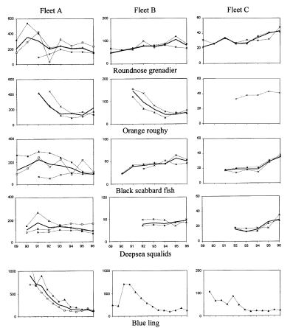
Figure 4.1.7.1a. Abundance indices for deep-water species (open square: ICES Division Va, full triangle: Subarea VI; cross Subarea VII, bold line: combined).

From 1999, the data series was disrupted owing to changes in data format of the catch and effort database.
In the 2000s, raw LPUEs (i.e. sum of yearly landings divided by sum of yearly effort were provided to the ICES working group). It should be noted that these time-series did not account for seasonal, geographical (i.e. rectangle or even ICES division effect) but were simply the total catch by species of the reference fleet divided by the total effort of the same fleet.
An analysis of factors impacting LPUEs (Biseau 2006) showed that:
- Overall LPUEs must not be considered as indices of abundance
- The distribution of fishing ground changed over time with some fishing grounds being continuously fished from the Eearly 1990s to 2005 and some "new" fishing grounds being exploited in the 2000s only.
- LPUEs show different trends in different areas (see example areas in Figure 4.1.7b and the example of roundnose grenadier LPUEs in Figures 4.1.7b) are the best indices given the available data.
- Even within each reference area, and especially in the ‘VI Edge Area’, changes of fishing strategy were reported. Mainly fishing occurred deeper over time and this effect could not be accounted for. In such cases, CPUE trends could not reflect the variation in stock abundance.

Table 4.1.7.1a. Definition of refences areas used for estimation of LPUE (see Figure 4.1.7b) by Biseau (2006).
Area for LPUE estimation | ICES rectangle
Reference in VI - Edge | 38D9, 39D9, 39E0, 40E0, 41E0, 42E0, 43E0, 44E0, 45E0, 45E1, 46E1, 46E2, 47E3, 48E3
Reference in VI - Others | 46E0, 47D9, 47E0, 47E1, 47E2, 48E1, 48E2
Reference in V | 49E0, 49E1, 49E2, 49E3
Reference in VII | 29D8, 30D5, 30D6, 30D8, 31D4, 31D5, 31D6, 31D8, 32D4, 32D5, 32D7, 33D4, 33D5, 35D6, 36D5, 36D6, 36D7, 37D6, 37D7, 37D8, 37D9
New Grounds in VI | 46D4, 46D5, 47D4, 47D5, 48D5, 48D6, 48D7, 48D8, 48D9
New Grounds in V | 49D7, 49D8, 49D9, 50D8, 51D8, 51D9, 51E0, 52D8

Figure 4.1.7.1b. LPUEs of roundnose grenadier by reference area, all deep-water sub-trips of the French fleet (see full analysis in Biseau, 2006, available on the WIKI).

Having identified the factors that affect LPUE and the unaccounted factors, especially the fishing depth, LPUEs estimates were developed using haul-by-haul data provided by the French industry. these come from the own logbooks of the fishing master and are further denoted tallybook.
Further analysis of EC logbook data are on-going in order to derive long term time-series of abundance indices. Nevertheless, owing to the strong depth effect observed in tallybook data (see below) and the effect of fishing strategies tallybook data provide more accurate abundance indices.

Please include tables and figures of all available indices and append data at the lowest disaggregation level possible (ideally haul by haul)
Please include tables and figures of all available indices and append data at the lowest disaggregation level possible (ideally haul by haul)
see previous ection

Please describe how the indices are calculated. Are they standardised and if so please describe method used.
Please describe how the indices are calculated. Are they standardised and if so please describe method used.

Method for abundance indices based upon tallybook
Haul by haul data derived from skippers' personal logbooks (tallybooks) from the French deep-water fishery to the west of the British Isles were used to calculate standardised landings per unit effort (LPUE) for the period 2000-2009 for blue ling, roundnose grenadier and black scabbardfish. LPUEs were estimated using Generalised Additive Models (GAMs) with depth, vessel, statistical rectangle, area and year as explanatory variables (Lorance et al. in press). Because of their statistical distribution, landings were modelled using a Tweedie distribution, which allows datasets to contain many zeros or with a Gamma distribution where only positive tows targeted at the species (target tows were defined as those where the species made up 10% or more of the total landings).

Following, the detection of different trends in EC-logbook based LPUEs (Biseau 2006), LPUEs were estimated in five small areas, refined from the analysis from Biseau, (2006), represented in Figure 4.1.7.3a:
- slope to the west of Scotland, along the Rockall Trough (denoted edge6);
- other rectangles in ICES Division VIa that were fished in the 1990s and 2000s, according to EC logbooks (other6)
- rectangles in ICES Subarea VI that were fished in the 2000s but not in the 1990s (new6)
-rectangles in ICES Subarea V that were fished in the 1990s and 2000 (ref5)
-rectangles in ICES Subarea V that were fished in the 2000s but not in the 1990s (new5)

Data filtering
Data from tallybooks were filtered to restrict the analysis to a data subset most appropriate for each species. Although tallybook data included hauls back to 1992, there were sufficient numbers of haul during the 1990s for area edge6 only (Lorance et al. in press). The data were therefore restricted to the years 2000-2009.

For blue ling, hauls between 200 and 1100 m bottom depth of duration from 30 mins to 10h were selected. Local depletion of blue ling spawning aggregations such a reported by Magnùsson and Magnùsson (1995) implies contraction of the habitat occupied by the species. It was argued that the tows where blue ling is a bycatch only (defined as tows with less than 50% blue ling in weight) might provide the most reliable index of abundance because the interpretation of LPUE when the species is aggregated, mainly during the spawning season, may not track abundance (Lorance et al. in press).

For roundnose grenadier, tows carried out between 700 and 1500m and of duration from 30 mins to 10 h were selected. Two models were fitted to this distribution, in model 1 a Tweedie distribution was applied, this model included N=15114 hauls. In model 2, a further filter was included to restrict the modelling to hauls were roundnose grenadier was the target species (landings of grenadier/total landings >0.1), this dataset included N= 10899 hauls. The trends were similar, only the results of model 1 were included in the report.

For black scabbardfish, hauls between 500 and 1500 m and of duration from 30 mins to 10 h were selected. The modelling was restricted to hauls where black scabbardfish made up more than 10% of the total landings, this dataset included 5579 hauls.

The model included an interaction between year and area, therefore a different level of the factor was estimated for each year and area. The model also included a statistical rectangle factor with no interaction (i.e. the rectangle effect was estimated constant across all years).
The model was expressed as:

log(E[landings]) = s(haul duration) + s(depth) + vessel.id + rectangle + year:area (1)

where E[] denotes expected value, s() indicates a smooth non-linear function (cubic regression spline), vessel.id the vessel identity and year:area an interaction term. As described above, the LPUEs used in this report as abundance indices were fitted assuming a Tweedie distribution of the dependent variable with a log-link function using the mgcv package in R (Wood 2006) for blue ling and roundnose grenadier and a xxx distrubition for black scabbardfish.
Note that the dependent variable was landings and not LPUE, which allows to include tow duration as explanatory variable and have a non-proportional relationship between landings and fishing time.
The Tweedie distribution has mean μ and variance φμ^{p}, where φ is a dispersion parameter and p is called the index. As a Poisson-Gamma compound distribution was used, 1<p<2, the index p could not be estimated simultaneously with the model parameters, hence a detailed study was carried out. For roundnose grenadier p=1.7 provided the best fit and for blue ling p for the bycatch subset. Subsequently p=1.7 and p=1.3 were fixed for roundnose grenadier and blue lings respectively. Model fit and assumptions were judged by visual inspection of residual plots.

This LPUE standardisation method allowed estimating LPUE time-trends for the 5 small areas. In order to derive standardised LPUE for the whole area, LPUE were predicted for all 50 rectangles in the five small areas (using average haul depth in rectangle and 5 hours duration) and averaged.

In 2010, for roundose grenadier, a slightly different method was benchmarked to combine roundnose grenadier LPUEs in the 5 small areas at WKDEEP 2010. LPUEs from the small areas were combined with a weighting corresponding to the proportion of the landings per area. Here the abundance index used in the Surplus Production Model for roundnose grenadier was calculated according to the benchmark method. It is clearly more appropriate to combine LPUEs based upon the surface of the areas, what the average over all rectangles does. Nevertheless, for roundnose grenadier, the trends derived from both methods were similar.

Figure 4.1.7.3a. Small areas defined for the estimation of LPUE from French tallybook. Purple: edge 6; red: other 6; light grey:new6; blue: ref5; dark grey: ref6.

The number of tows and total landings by small area used to estimated LPUE indices are given in figure 4.1.7.3b.

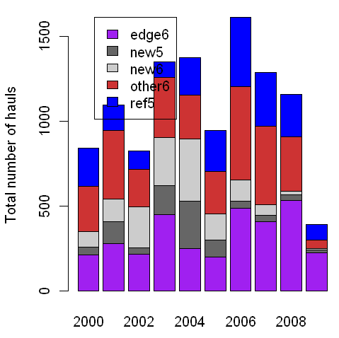 | 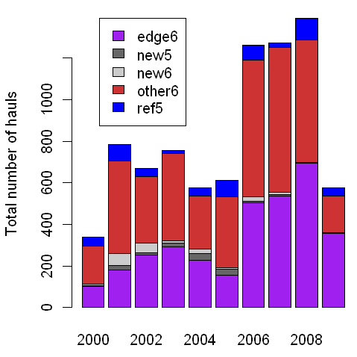 | 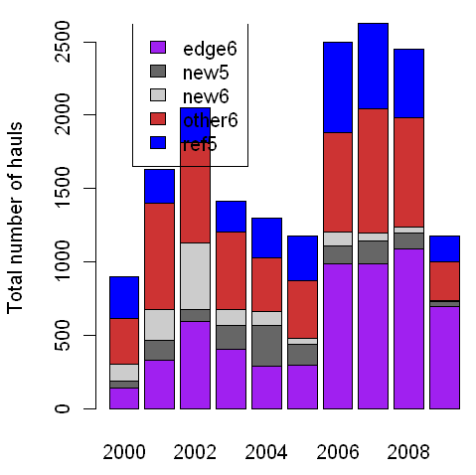
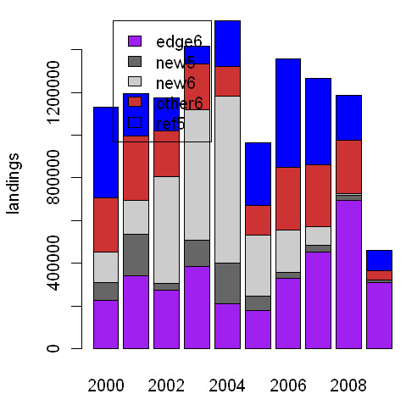 | 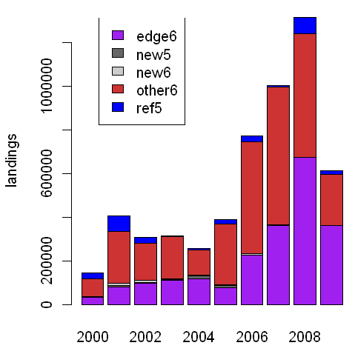 | 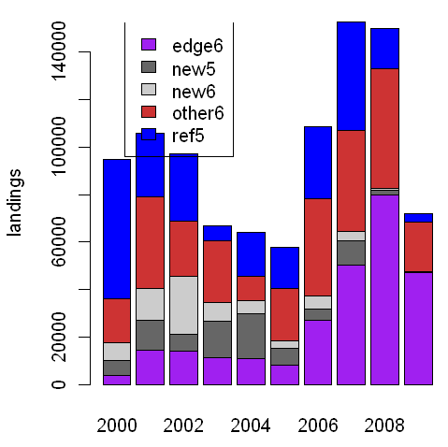
Figure 4.1.7.3b. Number of hauls (top) and total landings (kg, bottom) included in the LPUE modelling for roundnose grenadier (left) , black scabbardfish (centre) and blue ling (right).

For blue ling, Figure 4.1.7.3c. shows predicted LPUEs in the five small areas based upon different data subset. The subset blue ling by-catch was considered more reliable (Lorance et al. in press). Note that the trends estimated by the blue ling by-catch was not sensitive to the threshold level when it was varied from 50 to 20 %. For roundnose grenadier, Figure4.1.7.3d shows the predicted LPUEs based on model 1 and 2, the difference wre only minor. For black scabbardfish only targeted hauls were used (Figure 4.1.7.3e). The combined indices for the 3 species are given in Figure 4.1.7.3f.
The same approach was applied to siki sharks (Centrophorus squamosus and Centroscymnus coelopis combined). For siki sharks, the LPUEs were less reliable probably owing to smaller catch in the tallybook data and in some years only one or two vessels contributed to sharks landings in some small areas, preventing to properly estimate the vessel effect for these species.

a) Full data
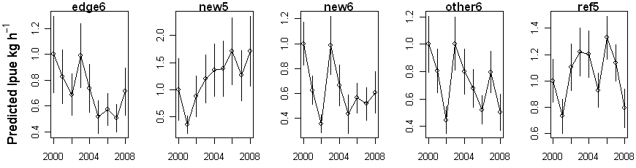
b) Outside spawning season data
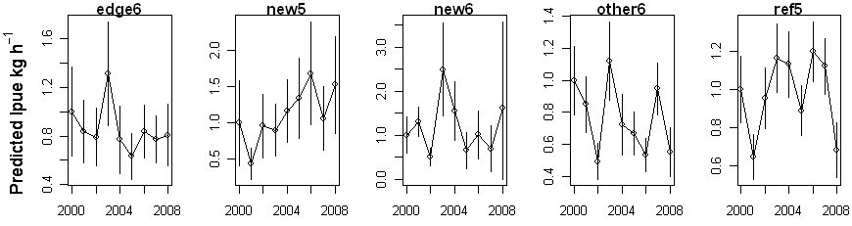
c) Spawning season data
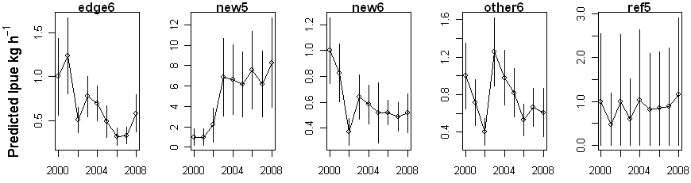
d) Blue ling bycatch data (threshold 50%)
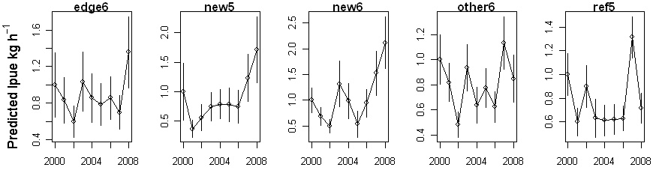
e) Blue ling bycatch data (threshold 20%)
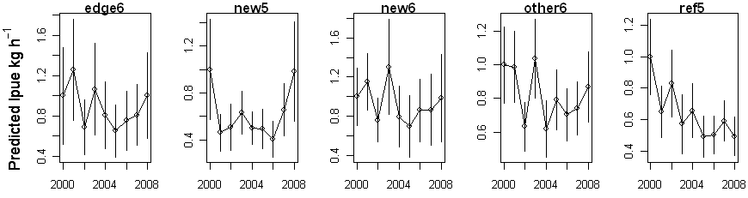
Figure 4.1.7.3c. Predicted blue ling LPUE in the 5 areas. Full dataset: using all hauls at depth 200-1100 m, in the tallybook data; outside spawning season: all data expect months 3-5 (where blue ling aggregated for spawning); spawing season: months 3-5 only; blue ling by-catch (50%): filtering haul where the landings of blue ling does not exceed 50% of total landings; blue ling by-catch (20%): filtering haul where the landings of blue ling does not exceed 20% of total landings.
a) all tows
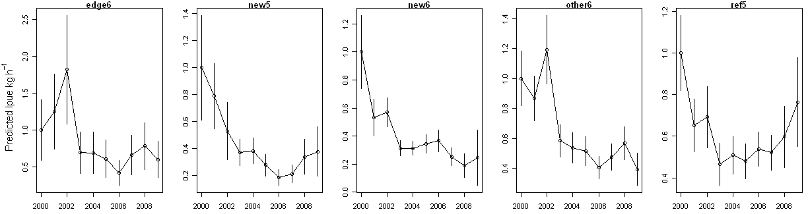
b) Targeted tows (roundnose grenadier>= 10% total catch)
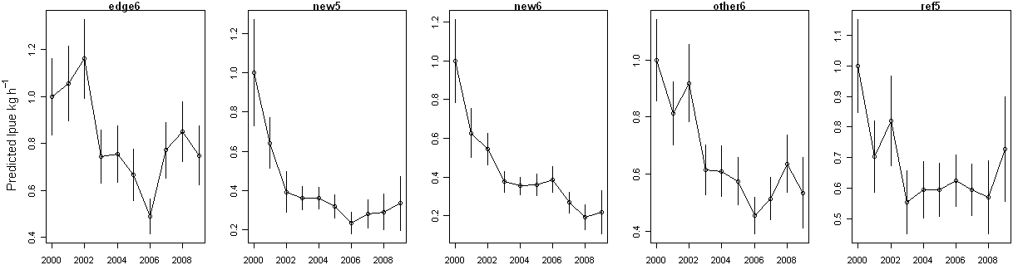
Figure 4.1.7.3d. Predicted roundnose grenadier LPUE in the 5 areas. a) all tows at depth 700m–1500 m b) tows at 700-1500 m where roundnose grenadier exceeded 10% of the total landings.

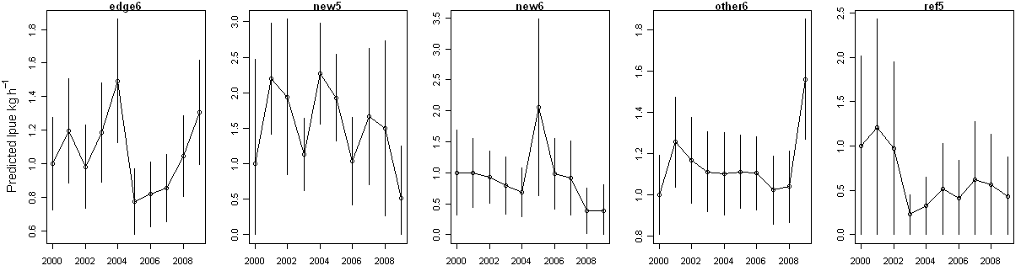
Figure 4.1.7.3d. Predicted black scabbardfish LPUE in the 5 areas, tows at 700m–1500 m where black scabbardfish exceeded 10% of the total landings.

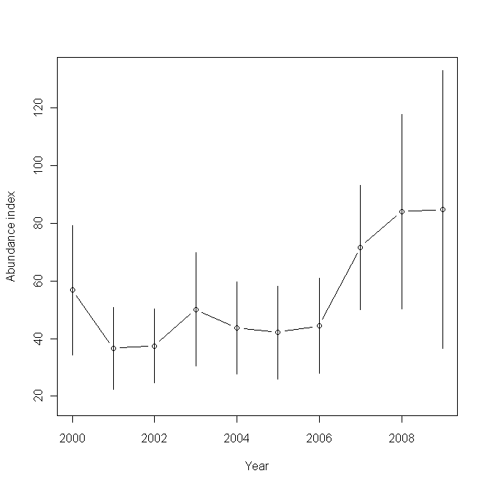 | 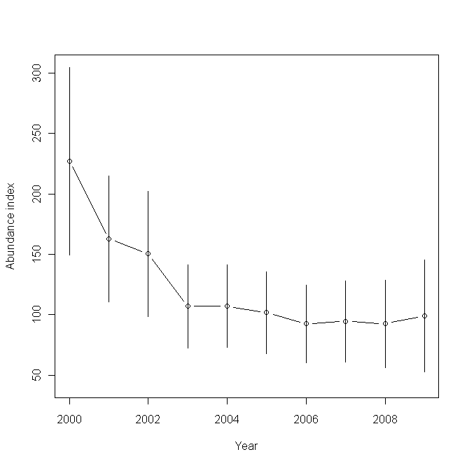 | 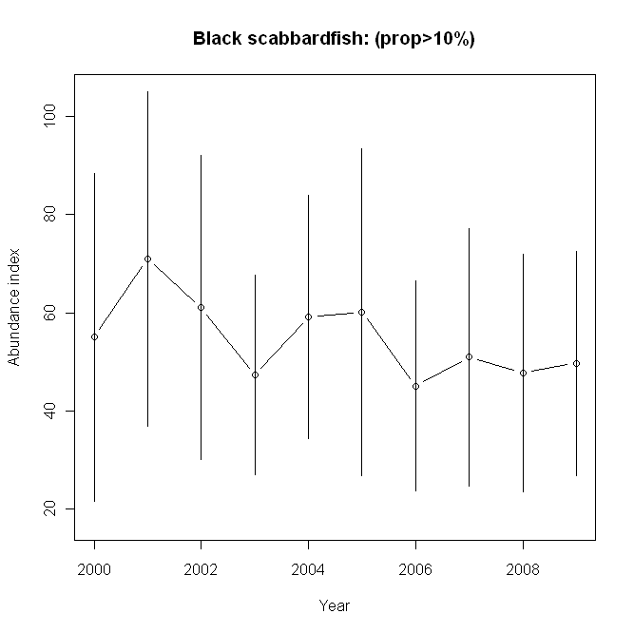
a) blue ling | b) roundnose grenadier | c) black scabbardfish

Figure 4.1.7.3f. Abundance indices for blue ling, roundnose grenadier and black scabbardfish combining the LPUE predicted in the 50 statistical rectangle of the five small areas depicted in Figure 4.1.7.3a.
Logbook based abundance indices are under development.

Please describe strengths and weaknesses of each index and if not used in assessments please explain why.
The indices based upon EC logbook are indermined by one main problem: several tows possibly carried out at different depth are aggregated in one single record. Nevertheless, further analysis are carried out to derive long term abundance indices. This objective is to use the landings of other species reported in a logbook as explanatory variables when estimating the LPUE for one species.

LPUEs based upon tallybook are much more accurate than LPUE based upon EC logbook because there are based upon fully disaggregated (haul-by-haul) data. the only weakness is the the time-series is shorter and the additional of data in the future depends upon the provision by the industry. With the development of electronic EC-logbook a usefull way to secure the provision of these data would be the request EC-logbook to be reported haul-bay-haul for deep-water fisheries.

How can these indices be improved and are there any potential new indices that can be used in assessments.

An accurate modelling of tallybook data was developed to produce abundance indices based upon tallybooks. The abundance index in used for the assessment of the roundnose grenadier in ICES division Vb and XIIb and sub-areas VI and VII. Indices are used as indicators of abundance for blue ling and black scabbardfish.

New indices are under development using the species composition in EC-logbookas additional explanatory variables.

Information and data made available by fishers, fisher organisations or other stakeholders

Existing data collection programmes in place.

There is a data collection in place for tallybook. This is so far unformal. The industry collects and punches tallybook from fishing master and makes data available to Ifremer.

List of the data and information for each fleet ID and use in monitoring and/or assessments.
Tallybook data were provided to Ifremer. To data the data include close to 30 000 tows.

How could fishers play a stronger role in providing data and information for monitoring and assessments?

Yes under stakeholder involvement in deepfishman.

Fisheries data in general

Aspects of fisheries data that [a] impact on assessments and/or [b] ability to provide timely fisheries advice to managers.

Access to fishery database (catch and effort) was disrupted in 1998, this had severe impact on the availability of time series. Plans to have a full times-series of log book data back to the mid-1980 were not achieved in 2010 owing to problem with 2009 catch and effort data which were not yet fully available at mid-2010.
Nevertheless, a time seire sof deep-water catch and effort data back to the late 1989 was rebuilt and is used in the project to estimate long term time-series of abundance indices.
Electronic log book seem to represent a major opportunity to improve data reliability and availability.

Fisheries-independent survey data

Please complete the table below for any surveys that are currently carried out or have taken place in the last 10
see CS 1c report. Survey data are the same for case study 1b, 1c and 2.
There are also archive surveys that do to provide timme series but may be useful to assesss reference points. Results from archive survey are described in (Bridger 1978), (Ehrich 1983), (Gordon and Duncan 1985) and literature therein. Data from surveys along the Hebridean Terrace slope were compiled in a database available to the project.

Description of surveys
see CS 1c report. Survey data are the same for case study 1b, 1c and 2 with the exception that survey carried out under DCF by France, Ireland and Scotland might be used for the greater forkbeard. Description of these survey are available under DATRAS (http://www.ices.dk).

Are the survey data used in assessments? If so please describe how. If not please explain why.
Abundance indices of blue ling from survey were used in assessment in 2010 (ICES 2010b) for blue ling as indicators but were not integrated in a quantitative assessment. For the other species, survey abundance indices of roundnose grenadier were available (Neat and Burns 2009) but not used. Survey indices were used as indicators for greater forkbeard and black scabbardfish.

Please identify strengths and weakness of each survey and identify if and how they could be improved.

See CS1c (blue ling) report.

If any surveys have been terminated within the last 10 years please explain why.

Are any new surveys being considered? If so please describe.

New surveys are being considered by WGNEACS, see CS 1c report.

Available survey abundance indices available for your stock (tables and figures) and comment on their strengths and weaknesses
Survey abundance indices were provided at WGDEEP 2010 for blue ling as reported below.
An index was available from a Scottish deep-water survey to the west of Scotland The fish community of the continental shelf slope to the northwest of Scotland has been surveyed by Marine Scotland - Science [formerly Fisheries Research Services, (FRS)] since 1996, with strictly comparable data available between 1998 and 2008. This has focussed on a core area between 55-59°N, with trawling undertaken at depths ranging from 300 to 1900m with most of the hauls being conducted at fixed stations, at depths of around 500m, 1000m, 1500m and 1800m. Further hauls have been made on seamounts in the area, and on the slope around Rockall Bank, but these are exploratory, irregular and not included in the survey dataset. This survey was conducted biennially, in September, until 2004, since when it has been carried out on an annual basis. In total, the data set comprises 233 valid hauls. From 1998 to 2008 the bottom trawl was rigged with 21” rock-hopper ground gear, however in 2009, a switch was made to lighter ground gear, with 16” bobbins (ICES 2010b). The trend in annual mean CPUE is shown in figure 4.2.7a.

A new index was available from an Irish deepwater trawl survey of the fish community of the continental shelf slope to west and northwest of Ireland carried out since 2006. Methodology is standardised in accordance with the Scottish deep-water survey with trawling at fixed stations around 500m, 1000m, 1500m and 1800m. The gear used throughout the surveys series is the same as that used by Scotland in 2009. To be consistent across the years the haul data used for the CPUE calculation only includes the areas that are covered in all four years and the depth bands (500-1500 m) that are covered in all four years. In total, the data set comprised 42 valid hauls. The mean catch per unit effort in each year is shown in Figure 4.2.7b.
Abundance index of roundnose grenadier and other macrourids were published by Neat and Burns (2009). For roundnose grenadier the abundance and biomasss indices showed no clear trend over 2000-2008. Ther was also no change in mean length but a slight change in maximum length. Overall, the results from this study demonstrated that the grenadiers from the NE Atlantic have not declined in the past ten years.
and the relative stability observed across seven macrourid species was suggested to reflect the introduction TACs and a management regime and that this may have been sufficient to prevent the further decline of the grenadier fishes. Amongst the smaller macrourids analysed in this study, 2 species increased in abundance in the other were stable, the authors noted that the smaller macrourids have a much shorter life span than the roundnose grenadier.

A Spanish survay on the Porcupine banks provides abundance indices for shelf and upper slope species. In the contaxt of Deepfishman, this survey provides a useful index for the greater forkbeard. In this survey the recruitment of greater forkbeard in well visible and the time-series suggest than a strong recruitment occurred in 2003 (Figure 4.2.7c). Abundance indices are clearly impacted by this strong recruitment as the abundance in number peaked in 2003 and the biomass in following growth. This survey data seem of major interest for the greater forkbeard as in might both allow to validate growth of the species.
For the same species, shelf surveys carried out under DCF by France in the Celtic Sea, Spain and Scotland also provide abundance indices and length distribution from which trecruitment indices could be derived. Total abundance may not be available from these surveys that are restricted to bottom shallower than 600 m. nevertheless, the usefulness of survey indicators from surveys carried out under DCF might be considered. In the context of DEEPFISHMAN, this applies to greater forkbeard only.

Figure 4.2.7a. Abundance index of blue based upon the Scottish Deep-water Survey – trend in annual mean CPUE (± 1 s.e.)

Figure 4.2.7b. Abundance index of blue based upon the Irish Deep-water Survey – trend in annual mean CPUE (± 1 s.e.)

Figure 4.2.7c. Mean stratified length distributions of Phycis blennoides in Porcupine surveys (2001-2009)

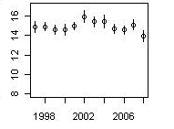 | 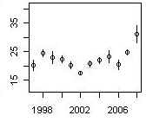
Figure 4.2.7d. Greater forkbeard (Phycis blennoides) - raised abundance (swept area method, Log scale) and mean length in the Celtic Sea (top) from the French western IBTS survey (also known as EVHOE).

Aspects of fisheries-independent survey data (quality, temporal and spatial extent, time series, availability, accessibility, flow) that [a] impact on assessments and/or [b] affect ability to provide timely fisheries advice to managers.
As reporetd in CS 2 report, regarding [a]: The best way forward for future assessments is to use an abundance index from an internationally coordinated fisheries-independent trawl survey of Vb, VI, VII and XIIb as put forward at WGDEEP in 2009, and formally proposed by ICES PGNEACS. Such survey would also be a platform for monitoring ecosystem indicators. However concerns expressed at recent WKDEEP regarding the relatively small number of stations in relation the geographical area covered and statistical optimisation of survey design.

Biological data for your stock

4.3.1 Please complete the table below for each fleet/survey inserting in each cell the time series of data available, if quarterly (q) or annual (a), and if collected by observers (O), by market sampling (MS) or both (OMS). Please append all available time-series of quarterly and annual data.
4.3.1 Please complete the table below for each fleet/survey inserting in each cell the time series of data available, if quarterly (q) or annual (a), and if collected by observers (O), by market sampling (MS) or both (OMS). Please append all available time-series of quarterly and annual data.

 | Retained or Survey |  |  |  |  | Discarded
Fleet ID/  Survey ID | Length comp. | Age  comp. | Sex comp. | Length &  weight at age | Maturity comp. | Length comp. |  | Age comp. | Sex comp. | Length &  weight at age | Maturity  comp.

For the most recent assessment, how was total international catch data raised from fleets and what are the strengths and weakness of the current raising regime?
French landings were extracted from logbook data. For roundnose grenadier, concerns were expressed over time about the reliability of the landings from international waters. In 2010, data of the Spanish fleet fishing in ICES division VIb and XIIb were provided. All data are not provided by statistical rectangle. Nevertheles, in ICESDivision Vb, VIa and Subarea VII the landings data are available for all fishing fleets.There is no major concern with the rasing regime.
Conversion coefficients (between landed and live weight) may be a problem. This is a common concern for several species from the shelf as well as from the deep-water. This might require an specific review of how conversion coefficnet are applied over species, areas and fleets.

Age determination materials and methods used.

Age data are available for roundnose grenadier. The most recent assessment was not age structure and age structure assessment may not be the best option for this species. Age estimation method was decribed in Lorance et al (2003). Further an intercalibration working group suggested a low level og agreement between readers.

Age data were collected in the past for blue ling. Age estimation were resumed in 2009 under DCF, 750 blue ling otolith were read in 2009. The preparation of otoliths and age estimations methods followed the standard used for gadoid species. Although age reading of blue ling were abandoned in the early 1990s because they were considered poorly reliable, the otolith sections obtained with modern equipment seem quite straightforward to interpret (Figure 4.3.3). Note that fish are sampled from auction market were blue ling is landed gutted, therefore the sex of the individuals is unkown while there is a known sexuel dimorphism in this species (Ehrich and Reinsch 1985; Thomas 1987; Moguedet 1988).

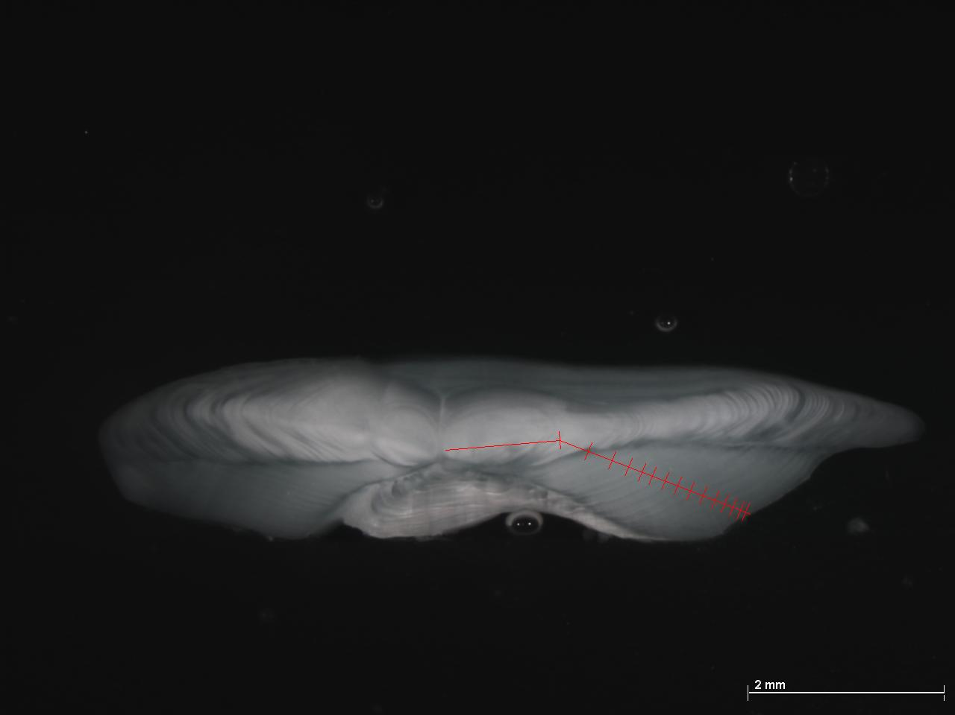 | 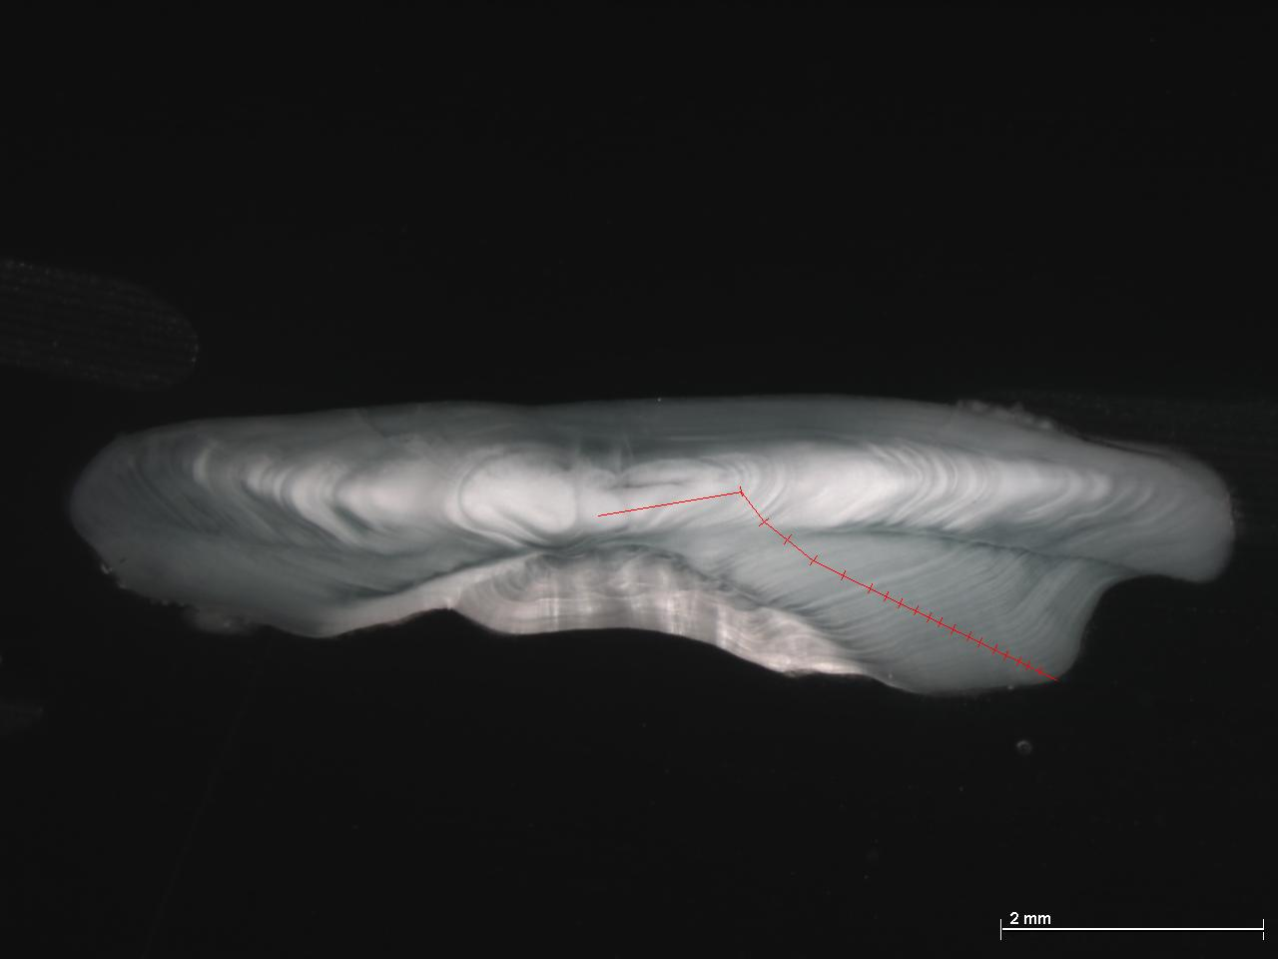
Figure 4.3.3. Cross section of otoliths of blue ling. Left individual of 121 cm, 15 years; Right individual of 125 cm, 19 years.

Ages validation
Age were validated for juvenile roundnose grenadier based upon the seasonal variation of the otoltih margin (Gordon and Swan 1996). Ages of blue ling were not validated but ages estimated from otoliths of 1–2 group blue ling corresponded well with assumed ages based on modes in the length frequency distributions from Icelandic groundfish surveys (Bergstad et al. 1998) and available growth parameters from different authors are fairly consistent (Ehrich and Reinsch 1985; Thomas 1987; Moguedet 1988; Magnussen 2007).
Age estimation of black scabbardfish for the west of the British Isles are not available. Nevertheless, age estimation carried out further south on fish caught to the West of Portugal (ICES division IXa), in the canaries and Madeira suggest this sugest is short lived and fast growing. For this species age validation were carried out based upon the seasonal variation of the aspect of the otolith margin (see also CS 3c report).

Are the age data considered to be reliable?
The growth increments observed on otolith have been validated as annual for some species and life stages. Where otoliths readings suggested high ages, this was confirmed by radiometric estimates (Andrews et al. 1999; Andrews et al. 2009).
For roundnose grenadier age were considered poorly relaible based upon standard used from shelf species were a high

Age estimation workshops
For roundnose grenadier, the exchange program followed by an intercalibration working group was done in 2007 (ICES 2007b).
Altogether 66 sectioned otoliths were read on the slides and on images by 7 persons during the exchange program. All images were annotated. The overall agreement for sectioned otoliths agreement was low with 30.2 % (CV=10.4%). Similar level of aggrement between four otolith readers participating to the workshop was obtained by re-dearding 40 otoliths during the workshop.
It was recommended that sectioning of otoliths should be used for the age determination of Roundnose grenadier. It is recognized that among readers random differences with respect to interpretations and age estimate errors will remain. The occurrence of such differences may only be reduced through frequent otolith exchanges and comparative readings.

It should be noted that the low level of agreement was estimated using the standards for shelf species. For a longlived species, it may not be essential that readers estimate exactky the same age in year for the same individual provided that there is not systematic bias between readers. In other words, instead of the level of agreement on individual otolith, what should be assessed is whether readers allocated the same mean age of fish in the same size class.

An intercalibration was carried out for black scabbardfish were reported age estimation based upon an exchange of a collection of otoliths and a workshop (Morales-Nin et al. 2002). The age precision was significantly improved by the intercalibration exercises but remained low. Nevertheless, the growth increments used by the readers for age estimation were consistent.
In addition to this intercalibration, age in black scabbardfish were further validated for fish form the Canaries (Pajuelo et al. 2008). Nevertheless, for this species, alternative validation method would be useful.

Quality of biological data (quality, temporal and spatial extent, time series, availability, accessibility, flow)
[a] impact on assessments and/or [b] affect your ability to provide timely fisheries advice to managers.
Significant biological data have been accumulated for deep-water species. These are not given sufficient attention. Clearly the ranking of deep-water species by vulnerability carried out by ICES almost ten years ago should be revised as new data accumulated and deep-water species appears to be much more constrasted in terms of life history characteristics than previously thought. It is only in recent years that it was realised that black scabbardfish may live much less than 20 years, possibly 10-12 years only, i.e. less than most large commecial shelf demersal species. Age data for blue ling were not used in the past, while they probably convey valuable information on the stock status.
Managers and stakeholders did not weel realized how much deep-water species are diversity. Their morphological, trophic and behavioural diversity was already stressed (Mauchline and Gordon 1985; Merrett and Haedrich 1997; Lorance and Trenkel 2006). This diversity seems to also applies to the essentiel live history parameters for the populations dynamics. Therefore, the different deep-water species exploited in this case study may sustain very different harvest rates and this has not been recognized so far.

4.4 Ecosystem, biodiversity and VME data (see footnote 1 on page 2 for definition of VME)

This section 4.4 will clearly requires some work from CS. I didn't complete anything but there is (i) significant knowledge to review; (ii) interaction with CoralFISH. Table 4.4.2.1 can be filled in, with some NAs.

4.4.1 Background information

Please list the known ecosystem types in your stock area (include maps if available).
The OSPAR commission recently defined deep-water habitats types to be integrated in the EUNIS classificition. These include coral gardens, Lophelia pertusa reefs, carbonated mounds (OSPAR Commission 2009,2010b,a). These reports include maps of known occurrence of these habiat types.

If these are not known, are there any research programmes currently underway to identify and delineate ecosystems in your area? If so please describe.

Mapping of the UK's deep-water ecosystem is on-going (howell 2010)

Data available in support of ecosystem based management.

Data availability

For biological diversity, the column data issue was not completed. All the diversity is not known. Most data on diversity of invertebrate and habitats, are rather in published literature and in scientific organisation than publicly available.

Marine Strategy descriptor | Data in support of ecosystem based management | Data source(s) | Are there any data issues?
(1) Biological diversity | Species assemblage composition | Landings  On-board observations  Surveys
 | VME -spatial distribution | WGDEC database on VMEs (to be available in 2011)
 | VME – species composition | scientific literature  OSPAR
 | Fishery interactions with VMEs | VMS
 | Presence of PET – spp
 | PET – population biology
 | PET – fishery interactions
(2) Non-indigenous species | Invasive
 | Introduced
(3) Populations of commercially exploited fish and shellfish | Addressed in Sections 1, 3, 4
(4) Food webs | Data on prey, predators.  Fishery impacts on prey/predators abundance, addressed in 4.4.4
(5) Eutrophication
(6) Sea-floor integrity | Addressed in 4.4.5 and 4.4.7 below
(7) Hydrographical conditions
(8) Contaminants in waters/ecosystem | Any data on levels of e.g. metals PCBs
(9) Contaminants in fish and other seafood | Addressed in 4.6.6 below
(10) Properties and quantities of marine litter |  | Data insufficient (Galgani et al. 2010)
(11) Introduction of energy, including underwater noise |  | No data

Marine Strategy descriptor | Data in support of ecosystem based management | Data source(s) | Are there any data issues?
(1) Biological diversity | Species assemblage composition (fish) | Archive and current surveys  on-board observations
 | Species assemblage composition (invertebrates) | WGDEC  OSPAR
 | VME -spatial distribution | OSPAR  WGDEC database to be available in 2011
 | VME – species composition
 | Fishery interactions with VMEs | VMS and WGDEC database to be available in 2011
 | Presence of PET – spp
 | PET – population biology
 | PET – fishery interactions
(2) Non-indigenous species | Invasive
 | Introduced
(3) Populations of commercially exploited fish and shellfish | Addressed in Sections 1, 3, 4
(4) Food webs | Data on prey, predators.  Fishery impacts on prey/predators abundance, addressed in 4.4.4
(5) Eutrophication
(6) Sea-floor integrity | Addressed in 4.4.5 and 4.4.7 below
(8) Contaminants in waters/ecosystem | Any data on levels of e.g. metals PCBs
(9) Contaminants in fish and other seafood | Addressed in 4.6.6 below

Marine Strategy descriptor | Data in support of ecosystem based management | Data source(s) | Are there any data issues?
(1)Biological diversity | Species assemblage composition | HERMIONE, HERMES, EuroSITES, CoralFISH.  JNCC Report No 324 – Effects of fishing on Deep-water fish species to the west of Britain.  Invertebrate and fisheries data from the Irish and Scottish deepwater surveys | No: EuroSITES water column data is downloadable from their website, HERMIONE and HERMES will/have published their data in the PANGAEA information system (www.pangaea.de), and CoralFISH is working with the DeepFishMan project.  Irish data has not been published yet- Scottish data would need to be acquired
 | VME -spatial distribution | HERMES, HERMIONE, CoralFISH, GEOMOUND, TRACES, WGDEC Reports, INSS | No: see above. GEOMOUND also submits data to PANGAEA. TRACES has not collected any data as yet.
 | VME – species composition | HERMES, HERMIONE, CoralFISH, GEOMOUND, TRACES | As above
 | Fishery interactions with VMEs | CoralFISH | As above
 | Presence of PET – spp | CoralFISH, HERMIONE, HERMES, EUROSITES | As above
 | PET – population biology | CoralFISH, HERMES, HERMIONE, EUROSITES | As above
 | PET – fishery interactions | CoralFISH | As above
(2) Non-indigenous species | Invasive | SAHFOS CPR data for plankton (Edwards 2008)
 | Introduced | No information available
(3) Populations of commercially exploited fish and shellfish | Addressed in Sections 1, 3, 4 | POORFISH  WGDEEP | No: Cefas were involved as a partner (Graham Pilling)
(4) Food webs | Data on prey, predators. Fishery impacts on prey/predators abundance, addressed in 4.4.4 | HERMIONE (fish)  Modelling for Howell et al. ((2009) | No.
(5) Eutrophication |  | Not presumed to be an issue  World databases of primary production
(6) Sea-floor integrity | Addressed in 4.4.5 and 4.4.7 below
(7) Hydrographical conditions |  | HERMES, HERMIONE, GEOMOUND. | No.
(8) Contaminants in waters/ecosystem | Any data on levels of e.g. metals PCBs | HERMIONE (chemical contaminants in sediments) Cefas DEEPFISHMAN review | No.
(9) Contaminants in fish and other seafood | Addressed in 4.6.6 below | Some scientific literature  Cefas DEEPFISHMAN review
(10) Properties and quantities of marine litter |  | HERMIONE  Loss fishing gear reported in Large et al. (Large et al. 2009) | data clearly insufficient on marine litter (Galgani et al. 2010)
(11) Introduction of energy, including underwater noise |  | No data.

Where data are available please describe, review and append4.

Oceanography, primary production and plankton data
The ICES Working Group on Oceanic Hydrography (WGOH) provides synthesis and trends of the oceanography at regional scale. Time-series of Sea surface tempetarure, salinity are provide by region (see example figure 4.4.2.2 as an example).
Figure 2. Sea surface temperature anomaly from Malin Head (Ireland) 1960–2008 (from, ICES 2010c).

The ICES Working Group on Operational oceanographic products for fisheries and environment (WGOOFE) aims to address the problem that the large amount of freely available operational oceanographic data, which is under utilised by in the context of fisheries and ecosystem assessment, despite the regular complaint by researchers that they cannot develop the ecosystem approach due to lack of data and process understanding. WGOOFE’s approach is operational and it aims to act as an interface between ICES and operational oceanography producers in the development of products designed for ICES needs for the ecosystem approach (ICES 2009b).
A core part of WGOOFE is to determine what oceanographic products (and what format) are needed for work in fisheries and the environment. these may be available from institutions or project consortia (e.g. the Met Offices, MyOceansetc.). the website http://www.wgoofe.org/objectives is coordinated by the WGOOFE and aims to improve the accessibility of data and time series. this site is currently under construction for most areas.

For UK waters, monitoring reports can be found at the following website http://www.defra.gov.uk/environment/marine/science/stateofsea.htm. of the Department for Environment food and rural affairs (DEFRA). The National Centre for Ocean Forecasting (NCOF, http://www.ncof.co.uk/index.htm) provides operational forecasting and monitoring of the world's oceans, and specifically seas around the UK, including the deepseas.

In the south of the area the climotology of the Bay of Biscay extend North to 50°N, i.e. the south of the area is include in the climatology of temperature, salinity and physical parameters (http://www.ifremer.fr/climatologie-gascogne/index.php)

See also case study 1b, orange roughy and 1c blue ling

In the area inhabited by your stock are there any research initiatives related to climate change? If so please review (Descriptor 7).

See CS1c report
One aspect poorly considered so far in ocean acidification. Acidification is likely to have an adverse impact in the future on deep-water ecosystem.

Has there been any baseline studies on ecosystems in your stock area? If so please describe.
See CS1c report.

Are you aware of any major changes e.g. regime shifts, in ecosystems in your stock area? If so please review.
See CS1c report.

How is the health of ecosystems in your stock area monitored? e.g. size spectra studies, biodiversity studies, diversity indices, presence/absence of indicator species, other indicators etc. Please describe and review (Descriptor 1)
Fish communties studies including size spectra, diversity indices , presence /absence of sharks were carried out by Basson et al. (Basson et al. 2002). A number of scientific studies have analysed diverses aspects of the fish and benthic communities.
Scientific advice on the ecosystem health are provide by ICES based upon the report of the ICES/NAFO joint expert group on Deep-water Ecology (WGDEC). Request from NEAFC, the EC and countries are addressed to this expert group (ICES 2010d).
The OSPAR commission provides studies on the ecosystem health and an overall assemment of the wider Atlantic, including of the area of distribution of the demersal deep-water mixed fishery was provide in the Quality Status Report (QSR), 2000 (OSPAR Commission 2000). A 2010 QSR will be available in 2010.

Commercial fishing impacting the eocystem include deep-water fisheries and other fisheries not considered deep-water such as fisheries for hake, monkfish and megrims occurring at the upper slope. No estimatation of the contribution of every fishery to the ecosystem disturbance is available. There have been a major emphasis given to VMEs protection and signifant protected area have been developed and will be further enlarged. Nevertheless, it should be noted that the most extended and diverse VMEs may occur mostly shallower than fisheries for deep-water species. ICES (2010d) reported that the continental margin off the UK and Ireland has hundreds of L.pertusa reefs at 650 - 1000 m depth (Wilson 1979; De Mol et al. 2002; Roberts et al. 2008; Wheeler et al. 2007). As a result, some of the closed area for VMEs conservation (e.g. on the Rockall bank) include seabed fom 200 down to 1000 m

Figure 4.4.2.10.Lophelia pertusa records in the OSPAR area, based on data in the OSPAR habitat database from Contracting Parties and other sources up to December 2008 (from (OSPAR Commission 2009).
In the future, for EU waters, the ecosystem health will be monitored through the Marine Framework strategy directive.

Is primary production monitored in your stock area? If so please review.
Continuous plankton recorded (http://www.sahfos.ac.uk/research.htm) and sattelite data are available. At the scale of the North East Atlantic, data on primary production are available from global databases, in particular National Oceanoraphic Data Center (NODC). Data on chlorophyll and plankton are available (http://www.nodc.noaa.gov/General/getdata.html).

Are changes in the spatial and temporal distribution of plankton species monitored? If so please review.
These aspects have been subject to scientific studies (Beaugrand 2005) based upon CPR data. In the future, for EU waters, palnkton will be monitored through the Marine Framework strategy directive as it is relevant to dualitative descriptor 1 (biodiversity) and 4 (food web) of the directive.

Are there any aspects of ecosystem data and knowledge (quality, temporal and spatial extent, time series, availability, accessibility, flow) that [a] impact on assessments and/or [b] affect your ability to provide timely fisheries advice to managers.

This is the general question of integrated ecosystem assessment, cannot be treated as part of this factual report.

Are there any other human activities that impact the ecosystem significantly? If so please describe.
There is localised oil and gas exploration around the west of Ireland and the west of Shetland, for more details and locations see:
http://www.dcenr.gov.ie/Natural/Petroleum+Affairs+Division/
http://www.ospar.org/v_publications/download.asp?v1=p00334.

Protected, Endangered and Threatened (PET) species (part of Descriptor 1)
See section 4.1.5.10

Please list any PET species in your area that interact or could interact with fisheries for your stock.
See section 4.1.5.10

Are there currently any research programmes active to identify the presence and extent of these interactions? If so, please review.
Deep-water sharks stock status is analysed by the ICES expert group on elasmobranch fish. Habitasts and VMEs are assessed by OSPAR.

Please describe any mitigation methods applied to reduce the impact of fishing on PET species.
Closed area have been implemented to protect VMEs, these are expected to be enforced owing to the obligation for deep-water fishing vessels to be equipped with VMS.
Fishing for sharks and orange roughy are actually banned from TACs being set to 0. This measure might be very efficient for orange roughy, which used to be caught in directed hauls. It is surely less efficient for sharks that are primarily a by-catch. The measure has nevertheless some efficiency by (i) halting/preventing the development of targeted longline fisheries for deep-water sharks (ii)
There are little other mitigation method currently implemented to protect PET species and VMEs. Sorting devices may be efficient to reduce the by-catch of deep-water sharks, but there have been no trial. The efficiency of sorting devices depend upon (i) the difference in size and shape between species to retain and avoid, and this difference is not important between depp-water sharks and target deep-water species and (ii) the difference in swimming behaviour between species to to retain and avoid. Sharks are more active swimmer than other deep-water species (Lorance and Trenkel 2006), they have solid skin and scale so that sorting experiment may be worthwhile.

Are there any aspects of PET data and knowledge (quality, temporal and spatial extent, time series, availability, accessibility, flow) that [a] impact on assessments and/or [b] affect your ability to provide timely fisheries advice to managers.

Ecosystem modelling (Descriptors 4,5)

Ecosystem modelling
The ecosytem to the West of Scotland, eastern slope of the Rockall trough in ICES division VIa was modelled using ECOPATH (Howell et al. 2009b,a).

Predator/prey relationships
There is an extentive literature on diet of deep-water fish in this area.

Sampling of stomach contents
No regular on-going sampling of fish diet. Such work is carried out under scientific project, some data collection may occur during surveys.

Fishery interactions (Descriptors 1,6)

Gear trials conducted to assess gear/habitat interactions
Nothing known to be specific to the case study.

Research into environmentally friendly gears
No known research was specifc to the deep-water. Trawls designed to reduced impact on the seabed were developed in the EU-Degree project. Adaptation of such gear to the deep-water might require significant further development.

Do you have a reporting system for lost and abandoned fishing gear (particularly gillnets)? If so how effective is it and is it supported by interviews with fishers?
None. Trawl gear are not known to be significantly lost. The current fishery operates on known fishing grounds and has no incentive to explore new fishing ground because available fishing opportunities are caught on current fishing grounds

Are there any lost/abandoned fishing gear retrieval survey/mitigation exercises regularly carried out? If so please review.
None.

If bait is used in any of your fisheries, is the bait sourced sustainably? Is its use monitored? If so, how?
No bait.

Are there any aspects of data and knowledge relating to fishery interactions (quality, temporal and spatial extent, time series, availability, accessibility, flow) that [a] impact on assessments and/or [b] affect your ability to provide timely fisheries advice to managers?

Pollutants and contaminants (Descriptor 9):

Are contaminant levels in your stock species monitored? If so how and by whom? Please review results.
There is no monitoring framework. Levels of organic and heavy metals contaminants have been estimated in scientific studies. These have been reviewed in a dedicated DEEPFISHMAN review.

Do you assess the ecosystem effects (negative and positive) of marine debris and examine options for its collection and disposal? (Descriptor 10) If so how?
Marine litter induce three categories of "harm": social, economic and ecological. For the purpose of this section, only ecological harms are considered as social and economic harm have been mainly considered in the context of coastal ecosystem were they arise from loss of social interest of ecosysteml and loss of tourism attractivity. Nevertheless, lost fishing gears may constituted and ecocnomic loss for deep-water fisheries if they induce ghost fishing of commercial resources (Hareide et al. 2005). Ecological harm from marine litter include mortality or sublethal effects on plants and animals through entanglements, captures and entanglement from ghost nets, physical damage and ingestion including uptake of microparticles (mainly microplastics) and the release of associated chemicals, facilitating the invasion of alien species, altering benthic community structure).
Knowledge and data currently available on marine litter on the deep-sea floor is scarce (Galgani et al. 2010). The suggested monitoring for marine litter in the Marine Strategy framework Directive includes four types of indicators, three of which are potentially relevant to the case study (i)Trends in the amount of litter floating at the surface, in the water column and deposited on the sea-floor, including analysis of its composition, spatial distribution and, where possible, source (ii) Trends in the amount, distribution and composition of micro-particles (in particular micro-plastics) and (iii)Trends in the amount and composition of litter ingested by marine animals (e.g. stomach analysis).
The spreading of marine litter in the deep-water and on the deep seafloor might not have been a significant issue before, say the 1950s but no data is available to assess past trends of these indicators.
The amount of litter on the deep seafloor in the area in unknown, nevertheless plastic debris from terrestrial and marine human activities occur at the deepsea floor in European seas (Galgani et al. 2000) and the Rockall Trough may be an area of accumulation owing to hydrology. Moreover, lost gillnets were identified as an issue in deep-water ecosystem, some fisheries may have lost significant amount of gillnets (Hareide et al. 2005) and retrieval systems were studied (Large et al. 2009). In the OSPAR area, the overall amount of marine litter is consistently high and is not reducing despite recent efforts, the situation in the Azores where litter from both land-based and marine (mainly fishing) activities were found suggest that the all wider Atlantic OSPAR region is impacted by litter sourcing from both land-based at marine activities (OSPAR 2009). VMEs are likely to be more impacted by marine litter because gillnet fisheries may have targeted these habitats (Figure 4.4.7). One the other hand, drifting/floating marine litter tend to accumulated in areas of soft sediments where currents are lower, while VMEs are rather distributed in area of higher hydrodynamics.
With respects to the other indicators, the effect of micro plastic is poorly known but is could potentially cause physical damage to marine organisms (e.g. filter- or deposit feeders) by ingestion or chemical damage by transport of hazardous substances (OSPAR 2009). The amount of litter ingested by organism is estimated for a few species and areas only (OSPAR 2009), no data specific to the case study are available.

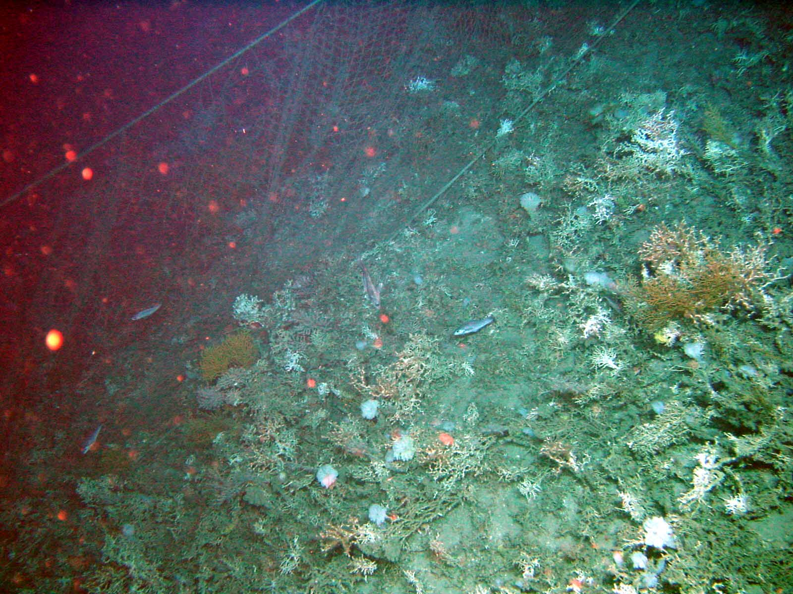
Figure 4.4.7. Lost gillnet on a carbonate mound covered of Lophelia reef to the South West of Ireland (photo Ifremer, cruise Caracole 2001).

Are there any aspects of data and knowledge (quality, temporal and spatial extent, time series, availability, accessibility, flow) that [a] impact on assessments and/or [b] affect your ability to provide timely fisheries advice to managers?

Vulnerable Marine Ecosystems (VMEs) (Descriptor 1)

FAO have recently circulated guidelines on VME identification and composition, how have you interpreted these in your stock area?
See case study 1c blue ling report

Has any mapping of VMEs been carried out in your stock area? If so, please provide information on location, extent and mapping methods used (multi-beam sonar, ROV, etc). Please attach maps where available.
See case study 1c blue ling report

Please complete the following table for your stock area:

VME | Present | How Monitored? | Issues?
Seeps | No
Vents | No
Carbonate mounds | Yes
Corals | Yes
Sponges | Yes
Fish components
Seamounts | Yes
Others

There is not monitoring of the VMEs, some are protected. It is uncertain whether monitoring is required. What is required is (i) inventory, (ii) appropriate conservation measures in order to prevent biodiversity losses, (iii) monitoring of a few location for scientific purposes including the effect of global change (warming, acidification) on these ecosystems.
There is also a need for reference points. The deep-watr ecosytem are now exploited and standards for the status of exploited ecosystem are not "pristine" ecosystems (Cardoso et al. 2010). For VMEs, the

If your stock area, or a substantial part of your area, has not been mapped, do you consider it likely that VMEs may exist? If so, have any precautionary measures (e.g. closed areas) been implemented (e.g. to protect seamounts that have not been specifically mapped)? If so please describe.
See case study 1c blue ling report

Have you any plans to develop/extend mapping activities with regard to VMEs? If so please describe.
See case study 1c blue ling report

If management measures have been introduced to protect VMEs, how have these impacted on fishing?
Not assessed, to be carried out as part of the project.

Are there any aspects of data and knowledge (quality, temporal and spatial extent, time series, availability,
accessibility, flow) that [a] impact on assessments and/or [b] affect your ability to provide timely fisheries advice
to managers?

Socio-economic data

Introduction
The French vessels involved (often part-time) in the deep-species fisheries are a fairly small fraction of the national fleet, and it is hard to find public socio-economic statistics dealing specifically with that fishery, its proceeds and those of related businesses. The most helpful source of data is the Annual Economic Report (AER) compiled by JRC (for STECF) from data collected by national institutes under the Data Collection Framework (formerly DCR) scheme. The DCF specifies a standard list of fleet segments for which data are assembled. For France, the data that most closely reflect the indicator values for the deep-species fishery are those for the segment ‘Demersal trawl and demersal seiner > 40m’ (for the larger, company-owned industrial trawlers), and to a lesser extent the segment ‘Demersal trawl and demersal seiner 24m-40m’ for the 33-38 m semi-industrial vessels. However, both segments (notably the latter) include a much broader diversity of vessels than those targeting deep-water species. Indicators in the AER are therefore not specific to that fishery; they are just the best approximations. Also, the latest issue of AER (2009) reports data up to 2007 at the latest; table 4.5 below will thus give data for the 2005-2007 instead of 2006-2008.
For employment at sea, most French administrations collate the data by ‘type of navigation’, i.e. Petite pêche for trips < 24h, Pêche côtière for trips 24-96 h, Pêche au large (offshore) for trips > 96 h (4 d.), and Grande pêche for vessels > 1000 t and trips > 20 days. The deep-species fishery typically falls in the Pêche au large category, but this is also where all the offshore trawlers and netters for wetfish in the North Sea, Channel, Bay of Biscay etc. fall. Not quite helpful. Employment at sea is also subdivided by work time duration (i.e. < 3 months; 3-6 m.; 6-9 m; > 9 m). In the AER, the data are standardised to Full-Time Equivalent (FTE) employment.
Because many processing and wholesale businesses are fairly small companies, it seems that access to data on their activities is particularly awkward, and more so for details of what they do with deep-species landings. National statistics on employment often group fishing and related industry under the same item as agriculture and forestry. Also, figures for seafood processing are often merged with data on the much larger agro- and food industries. The figures given here probably reflect just the order of magnitude.

Data-mining was done and yielded no study or data at the scale of the fleet prosecuting deep-water fishing.

Table 4.5. Main socio-economic characteristics of the French fleet engaged in the demersal deep-water mixed fishery.

Fisheries socio-economic data | Indicate which fleet IDs | How are the data currently used in MSE and stock/fisheries management? | Are the data available to you? If so please append as a separate document. If not please identify source. Are there any data issues?
Demographics | FR-BTDWS | Not used | N/K
Migration | FR-BTDWS | Not used | No data at all
Sexual equality | FR-BTDWS | Not used | Faf peche
Full-time vs part-time employment | FR-BTDWS | Not used | FranceAgriMer; INSEE
Sea based employment | FR-BTDWS | Not used | AER, INSEE
Land based employment | FR-BTDWS | Not used | FranceAgriMer
Grey5 market data | FR-BTDWS | Not used | N/K
Dependency and distribution links | FR-BTDWS | Not used
Ethnicity data | FR-BTDWS | Not used | No data at all
Fish consumption | FR-BTDWS | Not used | FranceAgriMer
Export data | FR-BTDWS | Not used | FranceAgriMer
Import data | FR-BTDWS | Not used | FranceAgriMer
CITES | FR-BTDWS | Not used
Capital costs | FR-BTDWS | Not used | AER
Repair costs | FR-BTDWS | Not used | AER
Equipment/gear | FR-BTDWS | Not used
Global markets | FR-BTDWS | Not used | FranceAgriMer
HACCP6 | FR-BTDWS | Not used | N/K
Catch values |  | Not used | AER
Fuel costs |  | Not used | AER
Web addresses for sources:
Faf pêche: http://www.fafpcm.com/formation-professionnelle/observatoire-metiers.php
FranceAgriMer (Ofimer): http://www.ofimer.fr/99_up99load/2_actudoc/1723d1_01.pdf
AER 2009: https://stecf.jrc.ec.europa.eu/c/document_library/get_file?uuid=e912ddce-9932-4c56-8eff-334d9ba71318&groupId=1416
INSEE: http://insee.fr/fr/themes/theme.asp?theme=10&sous_theme=3&nivgeo=0&type=2

Data on migrations are not known to exist. Nevertheless, skippers and crewmen are mainly people native from the port where the French Deep-water vessels are based. Ethnicity data are not legal in France and national statistics do not include any sensitive data such as membership of religious and ethnic.

Detailed descrition

Geographic location of fishing grounds

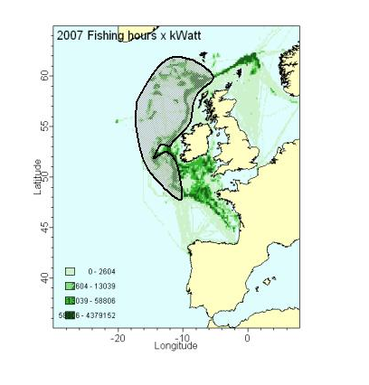
Figure 4.5.1.1. Geographical distribution of the fishing grounds of the French fleet involved in the demersal deep-water mixed fishery. The grey area represents the main area for catches of deep waters species. The green dots depict the distribution of fishing effort of the fleet of vessels holding a deep-water fishing licence (see figure 4.1.4.2). This fleet fishes for both deep-water and shelf species.

Distance between fishing grounds and home ports
4.5.1.2 An estimate of the mean distance from home port to main fishing grounds, by season/quarter if variable.

Distance between fishing grounds and landing ports
4.5.1.3 An estimate of the mean distance from main fishing grounds to landing ports (if different from homeport), by season/quarter if variable.
Home ports (ports of registry)of French vessels engaged in the demersal deep-water mixed fishery are Boulogne-sur-mer and Lorient in France. A few years ago, a third port Concarneau hosted a significant part of the fleet but is now marginal as most vessels from Concarneau were moved to Lorient. The bulk of the landings are not landed in these French ports but in UK (Scotland) and Irish Ports. In 2009, fish was landed in Lochinver (Scotland). In previous years, other ports were used Ullapool (Scotland) and Killybegs (Ireland).

Jurisdiction of fisheries
4.5.1.4 Jurisdiction of fisheries i.e. within national EEZs (please list countries) or in international waters (please indicate RFMO responsible for management).

The buck of the landings of the French fleet are caught in the UK EEZ. A marginal part of the catch have been fished in international waters (NEAFC regulatory area). The contribution of international water to the French landings have declined over recents years.

Fleet size
4.5.1.5 Number of vessels, vessel size in terms of length or GRT (average, min, max and stdev), mean engine power : kW or BHP (average, min, max and stdev).

Table 4.5.15. Number of vessels, gross tonnage and mean engine power of fleet segments relevant to the French deep-water fishery for which socio-economic data are available (*)
 | 2005 | 2006 | 2007
B. trawl 24-40m | N: 125  GT: 23070  KW: 61440 | 117  21530  57130 | 116  21010  56100
B. trawl > 40 m | N: 18  GT: 12590  KW: 30460 | 13  13490  23480 | 13  13490  23480
Source: AER 2009
(*) see introduction of section 4.5. Number given are all French vessels in the length categories, not all these vessels are fishing in the deep-water as the number of licensed deep-water vessels since 2003 never exceeded 50.

Fishing gear
4.5.1.6 Main type of fishing gear used (please supply as much information as possible).
The French fleet operated with bottom otter trawl. Mainly bottom single otter have been used. Nevertheless, new vessels entered in activity in the 2000s are equipped for twin bottom trawl and used it for some time for deep-water fishing. In 2008, only single trawl were used. In some years in the 1990s, some fishing targetting roundnose grenadier with bottom trawl operated at great depth was done. This fishing method is not know to be still used by this fishery.

Fishing trip duration and crew number
4.5.1.7 An estimate of the average length of trips and the average number of crew per vessel.
The larger trawlers can be away from home port for up to 29 days, but land in Scotland or Ireland every 9 day (where part of the crew is relieved, and the catch carried to France by lorries). The 30-38m trawlers carry out trips of 24 days but with landings in Ireland or France every 6-7 day.

The number on crew on vessels over 45 m are 14 or 15 depending on conventions between crew unions and the shipowning companies.
On board smaller smaller vessel (30-38 m) there are 9 crewmen. Lastly, two 25 m trawlers are engaged in the fishery and thre are 6 or 7 crewmen on board.
These numbers of crewmen are numbers on-board durinf fishing trips. The total number of crew for each vessel is higher because there is a turn-over of crew between fishing trips (time at sea of vessels is higher than what could be done with a single crew.
Trawlers with 14 and 15 crewmen on board have an additional crew of 6 and 5 crewmen respectively. Trawlers with 6 or 7 crewmen on board have an additional crew of 2 or 3. This system of crew turn-over is not implemented on 30-38 m long trawlers.

People employed in fishing fleet
4.5.1.8 Total number of fishermen in the fleet, split into full-time/part-time if appropriate, and by gender.

Table 4.5.18. Number of employement in full time equivalent (FTE) in the fleet segments of the vessels engaged in deep-water fishing.
Fleet seglment | 2005 | 2006 | 2007
B. trawl 24-40m | 746 | 657 | 641
B. trawl > 40 m | 331 | 264 | 264
Source: AER 2009

For comparison, the total employment in the French fleet given by AER is 13400 FTE in 2006 and 13155 in 2007. Hence, the two segments represent less than 7% of the total employment at sea.
A recent survey (Faf pêche) has looked at gender issues in the fishing industry. For 2008, it found that 818 women were employed at sea; however, 616 (75%) were in the shellfish culture segment and 182 (22%) in the Petite pêche category (trip < 24 h). Only 5 were employed in the Pêche au large category, and no indication is given on their activity in the deep-water fishery.

Vessel ownership
4.5.1.9 Main type of vessel ownership within the fleet e.g. fishing companies, skipper/owner, co-operative etc

In effect, the bulk of the deep-water fishery is carried out by 5 large trawlers (2 companies), with two others participating on a smaller scale (1 company each). All are company-owned (‘industrial’ in the French sense, i.e. these vessel never fish for fishmeal, industrial here refers to the type of fish ownership).
NB: some 40 vessels, including smaller skipper-owned artisanal vessels, apply for a deep-water fishing licence under under EU regulation 2347/2002 of the council of 16 December 2002 but do not use it, or only use it to legalize incidental by-catch e.g. in the anglerfish fishery on the outer shelf.

total quantity and value landed
4.5.1.10 Total quantity and value of the case study species landed and all species landed in each of the last 3 years
Altough landed in UK and Irish ports (see section 4.5.1.3) deep-water fish are sold in French auction market in Boulogne-sur-mer, Lorient and Concarneau. Fish price are therefore available from national sales statistics provide by the auction market network (Réseau Inter Criées, RIC) and fed into databases held by Ifremer. Based upon these data, total quantities, value landed and price at first sales of deep-water fish in France were calculated.
Boulogne-sur-mer, Lorient and Concarneau
Deep-water fish price in French auction markets vary greaty per species (Table 4.5.1.10). There are additional variations by landings port, month and year. Raw average are given in Table 4.5.1.10). The highest-priced species was orange roughy, which price increased from 3.8 € per kg in 1999 to more than 6 € in 2007-08. Blue ling and black scabbardfish were of similar prices, slighty over 2 €/kg. Prices of roundnose grenadier, greater forkbeard and siki sharks were lower(respectively about 1.8, 1.3 and 1.6 €/kg on average over 1999-2008). Price of orange roughy increased strongly from 1999 to 2008 (Table 4.5.1.10) while prices were more stable for other species, although there was some increasing trend for roundnose grenadier and siki sharks. These variations could be mainly related to the variations in landings with a strong decrease in landings for orange roughy (roughly a factor 10), landings of roundnose grenadier and siki sharks were also divided by 3 to 4. Nevertheless, landings of blue ling were divided by 2 without clear impact on the price.
As a result of these variations, the first species in landed values were roundnose grenadier and blue in 2008, they are now black scabbardfish and blue ling. The landed value of roundnose grenadier, orange roughy and siki sharks decreased sharply.

Table 4.5.1.10. Total quantity, total value and mean price per year of deep-wtaer species sold in France (all quantities actually landed in French port or landed in UK and Irish ports and carried to France by Lorries included). All values and prices are given as current prices (prices not corrected for inflation)

Value per year (thousands euros)
Year | Roundnose  grenadier | Blue ling | Greater forkbeard | Orange roughy | Black  scabbardfish | Siki sharks
1999 | 11,556 | 9,652 | 572 | 4,855 | 6,003 | 3,840
2000 | 13,510 | 9,542 | 708 | 4,126 | 6,301 | 4,072
2001 | 12,937 | 7,154 | 644 | 3,856 | 7,356 | 3,962
2002 | 13,366 | 6,522 | 533 | 1,930 | 7,063 | 3,216
2003 | 11,476 | 6,804 | 495 | 2,923 | 7,124 | 2,454
2004 | 11,701 | 6,950 | 479 | 2,694 | 7,109 | 2,282
2005 | 8,753 | 5,892 | 586 | 1,704 | 7,323 | 1,773
2006 | 6,629 | 6,728 | 745 | 3,037 | 7,006 | 1,545
2007 | 5,418 | 6,728 | 817 | 1,154 | 6,743 | 1,723
2008 | 3,805 | 5,529 | 1,005 | 831 | 7,007 | 1,401

Landing per year (tonnes)
 | Roundnose  grenadier | Blue ling | Greater forkbeard | Orange roughy | Black  scabbardfish | Siki sharks
1999 | 8,241 | 5,354 | 444 | 1,276 | 2,159 | 3,334
2000 | 9,840 | 4,918 | 512 | 987 | 3,648 | 3,328
2001 | 8,432 | 3,253 | 487 | 1,122 | 4,477 | 3,154
2002 | 8,502 | 3,078 | 418 | 461 | 4,313 | 2,004
2003 | 6,938 | 3,792 | 388 | 554 | 3,577 | 1,323
2004 | 7,545 | 4,111 | 364 | 515 | 3,191 | 1,177
2005 | 4,564 | 3,175 | 415 | 288 | 2,971 | 904
2006 | 3,189 | 3,104 | 496 | 540 | 2,565 | 765
2007 | 2,683 | 3,282 | 537 | 176 | 2,709 | 979
2008 | 2,054 | 2,580 | 695 | 131 | 3,160 | 820

Mean price per year (euros)
 | Roundnose  grenadier | Blue ling | Greater forkbeard | Orange roughy | Black  scabbardfish | Siki sharks
1999 | 1.40 | 1.80 | 1.29 | 3.81 | 2.78 | 1.15
2000 | 1.37 | 1.94 | 1.38 | 4.18 | 1.73 | 1.22
2001 | 1.53 | 2.20 | 1.32 | 3.44 | 1.64 | 1.26
2002 | 1.57 | 2.12 | 1.27 | 4.19 | 1.64 | 1.60
2003 | 1.65 | 1.79 | 1.28 | 5.28 | 1.99 | 1.86
2004 | 1.55 | 1.69 | 1.32 | 5.23 | 2.23 | 1.94
2005 | 1.92 | 1.86 | 1.41 | 5.92 | 2.46 | 1.96
2006 | 2.08 | 2.17 | 1.50 | 5.62 | 2.73 | 2.02
2007 | 2.02 | 2.05 | 1.52 | 6.54 | 2.49 | 1.76
2008 | 1.85 | 2.14 | 1.45 | 6.34 | 2.22 | 1.71

Revenues, costs and profits
4.5.1.11 Total revenues, costs and profits in each of the last 3 years.
The table below gives annual income, i.e. the sum of value of landings, subsidies, tourism etc. The value of landings alone is given under 4.5.1.18.
Table 4.5.11. Total Income (I), Cost (C) and profit (P) (millions €) of the fleet segments of the vessels engaged in deep-water fishing.

 | 2005 | 2006 | 2007
B. trawl 24-40m | I: 84.12  C: 91.17  P: -7.05 | 85.66  89.42  -3.76 | 89.94  85.86  +4.08
B. trawl > 40 m | I: 48.71  C: 52.47  P: -3.76 | 50.04  55.48  -5.44 | 46.30  50.88  -4.58
Source: AER 2009

Unionisation or other types of fishermen’s association
4.5.1.12 Unionisation or other types of fishermen’s association present.
By law, there is a strong presence of unions in many institutions overseeing fisheries, their management, the social structures etc. The number of seats taken by each union in boards, general assemblies etc. depends on the results of elections, where only registered unions (approved by government) may present candidates. In addition, there is often a specified allocation of seats for crews and employees, for ship owners, for processing industries, for cooperatives, for mariculture etc. Some unions are established with fishing as their unique scope, but other unions are ‘generalist’ in the sense that they assemble workers from all sectors, even though they may have a specific section for seamen or fishers. Strange enough, skippers and crews can be members of the same section in some of these unions; usually, skippers speak louder than crews and the positions claimed by these unions (e.g. on social issues) may at time be a bit ambiguous.
The four companies active in the deep-species fishery are member of the same union (Union des Armateurs à la Pêche de France, UAPF), which typically represents fishing companies, including the tropical tuna fleet segment. Historically, this union has been very influential in key negotiations, notably for the CFP in the 1970-1980s or in the Law of the Sea Conferences.

Wage structure
4.5.1.13 Main wage structure (e.g. fixed wages or share wages etc)

The 5 bigger trawlers are all under a regime of a fixed minimum wage plus a part of the sales, excluding such costs as fuel, gear etc. The two smaller vessels also have a minimum and a share, but here fuel costs are deducted before sharing.

Marketting
4.5.1.14 Are landings of case study species (1) sold on local market(s) for direct consumption, (2) sold on local markets for processing (3) sold on non-local markets (please describe where) for direct consumption or processing, (4) exported fresh or (5) other (please describe).

In France, all the deep-water species catches from French vessels are landed fresh (no freezing at all) and sold on the domestic market, with the possible exception of some deep-water sharks being exported to Spain and Italy but no statistic about these, probably small, amounts was found. Up to the 1980s, blue ling was fished by French freezer trawlers, these vessels ceased to fish blue ling in the late 1980s or possibly early 1990s. The product of these vessels was then processed in landed-based factories to be sold as frozen filets or ready-cook dished.

Market characteristics
4.5.1.15 What are the market characteristics (1) open auction, (2) contract, (3) single buyer, (4) other (please describe)

All landings are sold in auctions. Even though one of the companies involved in the deep-species fishery is a subsidiary of a supermarket business, which also owns processing plants, it has no preferential arrangement for the sale of its catch, which all ends up in auctions.

Landings and average prices
4.5.1.16 What were total landings and the average prices for each category above, in each of the last 3 years.

See section 4.5.1.10, all the landings reported are sold in auctions.

Fish processing
How is the case study species processed (fresh, frozen, salted, cured, canned etc) and in what form? (fillets, wholefish, fishmeal etc).

The catch is landed as whole fish for orange roughy. Other species are to some extend processed on board for a better preservation. Blue ling and greater forkbeard are landed gutted, roundnose grenadier is gutted and tail cut, black scabbardfish is gutted and headed. There has been some marketing of blue ling roe, but no separate statistics on the amount and price of this product was found.
Almost all of deep-water fish landings are bought by processing factories and filleted. The bulk of the deep-water landings are found on the French market as fresh fish fillet in retail shops and supermarkets. Whole deep-water fish are rarely displayed both because their aspect is not considered attractive and because large fish are increasingly sold as filet. Whole cod or saithe are now much less frequent on French market than the fillets of the same species. Amongst, large species, only the most expensive such as seabass, Pollack, meagre or turbot and most almost presented to the consumler as whole fish (and possibly cut at the retail shop). Deep-water sharks are sold as "saumonette", i.e. not filleted but headed, tailed and skinned whole fish. The species used to produce most of the saumonette sold on the French market is the lesser spotted catshark (Scyliorhinus canicula) so that deep-water sharks may not be distinguishable to lesser spotted catshark by consumers. Nevertheless, the actual species is more and more often specified together with the commercial name saumonette.
In the early 1990s, one company started producing orange roughy roe prepared such as heering roe, salmon roe or caviar. This product was quite similar in aspect to salmon roe, the production was disrupted due to the unsecured and very seasonal supply (in relation to the short spawning season of orange roughy) of fresh orange roughy roe.

Total quantity and value of product
4.5.1.18 What was the total quantity and value of the product produced in each of the last 3 years.
Table 4.5.18. Total quantity ('000 tonnes)vand total value (millions €) of products sold by the tow fleet segments of the vessels engaged in deep-water fishing (*)
Watch: .
 | 2005 | 2006 | 2007
B. trawl 24-40m | Q:39.09  V: 102.74 | 39.67  104.59 | 39.76  113.17
B. trawl > 40 m | Q: 27.16  V: 47.69 | 37.51  64.78 | 34.64  60.14
(*) these figures include deep-water species and other landings. Deep-water species represent a small contribution only. Source: AER 2009.

Processing units
4.5.1.19 Number and location of processing units and the total number and gender split of employees.

A FranceAgriMer annual leaflet provides some figures for 2006 in its 2009 issue. There were 324 companies in the wholesale sector, 287 in processing and 50 in mixed wholesale-processing. The turn-over was 1703, 3753 and 522 millions €, respectively. The same source indicates 5500 persons employed in wholesale and 13000 in seafood processing, but no detail is given on age structure, etc. The vast majority of processing plants is located in coastal regions (12% in the North, 6% in Normandy, 26% in Brittany, 21% along the Atlantic coast and 13% in the Mediterranean area); 36% of the annual turn-over is generated in Brittany.

Revenues, costs and profits of processing units
4.5.1.20 Revenues, costs and profits of processing units in each of the last 3 years

Subsidies
4.5.1.21 Please describe any subsidies currently in force.

Figures on subsidies to the fishing industry, with details by object, can be found on the Ministry of Food, Agriculture and Fisheries website at:
http://agriculture.gouv.fr/sections/thematiques/budget-soutiens-publics/soutiens-publics-peche
These are for the whole fishing (and aquaculture) industry, not specifically for the deep-species segment. Due to the implementation of a two-year rescue plan in 2008, subsidies (excluding pension and health insurance) rose from 201.7 m€ in 2007 to 351.6 m€, of which 59.6 (17%) came from the EU budget. Some 38 millions € are for decommissioning and temporary tie-up. However, French authorities also include the state contribution to the fishers’ social security fund as a subsidy (partly because exemptions on social charges are often used to reduce fuel and operating costs). This contribution was 620 millions € in 2007 and rose to 665.3 millions € in 2008. Hence, the total in 2008 was 1017 millions € (of which less than 6% were provided by the EU). In 2007, the total value of landings was 1725 millions € (including 381 by shellfish farming), and the total subsidy was 1017 millions € (59% of landed value). The subsidy figures given above do not include aids from regions, cities etc. which are not compiled nationally.
Again, this is for the whole fleet, and the so-called artisanal vessels may benefit more (even per vessel) than the bigger industrial boats.

Other aspects
4.5.1.22 Please supply data on any other issues listed in table at 4.5

Employment
4.5.2 For the country of each fleet ID please provide/detail/describe:-

Contribution of employment in fisheries to national employement
4.5.2.1 Proportion of total national employment in (1) catching, marketing, processing etc of all species and (2) catching, marketing, processing of the case study species.

For 2006, INSEE (the national institute for population and economic statistics) indicates a total active population of 27.56 million people. Various sources indicate 19936 people employed in the fish catching sector and 18500 in processing. The total (38346) amounts to only 0.14% of the active population. No data are available to estimate this proportion (2) for the deep-water fishery alone.

Fisheries and national gross domestic product
4.5.2.2 Proportion of total national gross domestic product (GDP) in (1) catching, marketing, processing etc of all species and (2) catching, marketing, processing of the case study species.

An INSEE leaflet (http://www.insee.fr/fr/pdf/intfrcbref.pdf) reports a national GDP of 1892.2 billion € for 2007 (1441.4 in 2000). No equivalent data is provided for the fishing and seafood sectors.

Percentage unemployment in total population and catching sector
4.5.2.3 Percentage unemployment in (1) total population (2) fishermen in general

The same INSEE leaflet indicates an unemployment ratio of 8.0-8.3% for 2007 in the total active population, but there is no data on unemployment in the fishing sector. Indications are that unemployment is not a major problem in sea fishing; on the contrary, it is a shortage of workforce willing to stay in fishing which seems to be currently a major problem, for small and large vessels as well.

Annual earnings in total population and catching sector
4.5.2.4 Average annual earnings in (1) total population (2) fishermen in general

According to INSEE the average net annual wage in 2006 was 23261 € in the private sector and 26182 € in the public sector. Earnings in the fishery remain largely mysterious; rumours are they largely exceed earnings on shore, but with fluctuations due to fish stock abundance, fishing success, markets etc. A website of the Ministry of the Environment, Sustainable Development and the Sea indicates gross monthly salaries in the range 1900-10000 € for a skipper, and 1500-3800 € for a deckhand.

Immigration/emigration
4.5.2.5 Please describe any immigration/emigration issues impacting on your case study stock

Even though shortage of crew can be a problem at times, employment of foreign crew is very limited. First, employing non-EU citizens is such an administrative nightmare that people don’t even try. Second, even for EU citizens, things are not simple and only long-term contracts justify the burden (no enrolment on demand). Lastly, foreign crews are under the same wage, social security etc. regime as French crews (hence the administrative hassle).

General

Account of economic and social factors in scientific analyses and management advices
4.5.3.1 How are economic and social factors considered in scientific analyses and advice to fisheries management?
Management advice provided by ICES does not consider (explicitly) social and economic factors. Indeed, managers from various organisations have repeatedly instructed ICES that it should NOT consider such factors, and keep with biology only. For EU fisheries, STECF is the arena were economic and social considerations may be added to the biological advice; initially, the DCR data were collected to enable economists in STECF to evaluate the economic consequence of the recommendations made by ICES (Economic Interpretation of ACFM Advice - EIAA) as a routine. When the Commission asks STECF to conduct studies on some specific issues, economic assessments can also be involved. When a problem is very local or affects some specific fleet sub-groups, the lack of detailed and accurate data may make the exercise particularly difficult, as we have seen with the attempt here to fetch data for a small, specialised segment of the fleet.
Nevertheless, it would be abusive to infer that management decisions under the CFP ignore social and economic implications. Indeed, in its 2009 Green paper, the Commission complains that all too often the Council has turned back its proposal on the ground that they would be socially or economically intolerable, even though ministers were just unable to put forward any analyses based on hard data. So, when it is about increase in TAC or effort, lack of data does not mean lack of success; different if the debate is about reduction in catch or effort.

Coordination of socio-economic studies
4.5.3.2 How are socio-economic studies coordinated, and how may they be improved?
Mostly through STECF, EU projects and perhaps EAFE.

Priorities for future monitoring, data collection and analysis
4.5.3.3 What are the priorities for future monitoring, data collection and analysis?
We assume that expert economists in STECF do take care of this.

Relation with DCF (EU fleets only)
4.5.3.4 For EU fleets, are socio-economic data provided under the DCF? Please list.
See Annex VI of Commission Decision 2008/949/EC on DCF or https://datacollection.jrc.ec.europa.eu/dcf-modules.

Availability of socio-economic data and knowledge for assessment and management of fisheries and stocks
4.5.3.5 Are there any aspects of data and knowledge (quality, temporal and spatial extent, time series, availability, accessibility, flow) that [a] impact on assessments and/or [b] affect your ability to provide timely fisheries advice to managers?

There are difficulties to access socio-economic data and make a decent assessment when a major issue in the fishery erupts. Although the industry keeps asking economic impact assessments for each management measure, this would require routine collection of data with a high resolution in terms of details, that it is not willing to provide. As for political authorities, the question remains, whether they are genuinely willing to know the true facts about the socio-economics in the fishing sector, and hence to facilitate access to the data.

Review of known and likely impact of the fisheries on deep-water biodiversity and VMEs

Previous and current studies of biodiversity
5.1 Please list below all previous and current studies of biodiversity in the area inhabited by your stock and append time-series data used.

General reviews of the impact of fisheries on deep-water biodiversity and VMEs have been carried out by the Regional Seas Programme of the United Nations Environment Programme (UNEP), the Food and Agriculture Organsiation (FAO), the International Union for Conservation of Nature and Natural Resources (IUCN), ICES and a number of NGOs. A review of work from these organisations is given below.

One major impact of deep-water fisheries on deep-water biodiversity is the impact of VMEs and bio-ingeeners species forming 3-dimensional structures. The main of which is Lophelia pertusa but a number of other cold water coral species are recorded worldwide and in the Case study area. The impact of deep-water fisheries on these VMEs is being analysis by the EU coralfish project.

ICES
ICES work on the deep-water environment is mainly synthesised in report of the ICES-NAFO joint Working Group on Deep-water Ecology. Imapct of fisheries on cold-water coral and sponges have been central to the activity of WGDEC over recent years. WGDEC has also review most (if not all) available data and publiscation relevant to case study 2.

IUCN
IUCN provides assessment of the threat and conservation satus of species and hold the red list now of standard use (http://www.iucnredlist.org/). Deep-water cnidarians from the North East Atlantic have been assessed by IUCN. Currently, only five species of deep-water cnidarian species for the Pacific Ocean were assessed by IUCN and were categorised Data Defficient (IUCN 2010).
In an assessment of Ecosystems and Biodiversity in Deep Waters and High Seas, UNEP and IUCN concluded that ""While pollution, shipping, military activities and climate change also threaten marine biodiversity and ecosystems, fishing currently presents the greatest threat." This report give some overview of impact on cold water corals and sponges and review impact on other ecosystem components such as bird and marine mammals. IUU fishing is given a significant contribution to global impact of deep-water fishing in the high seas by this report.

OSPAR
OSPAR made a review of coral gardens and threat to this habitat type now included in the list of OSPAR habitats.
This report list EUNIS habitats where coral gardens occur. Threats according to the Texel-Faial criteria were identified. Coral gardens were assessed to be "Currently threatened. In particular, considering the relatively high fishing pressure in deep waters in the OSPAR area, the probability of decline and the degree of threat may be higher than in other oceans" (OSPAR Commission 2010b).

FAO
FAO have been involved in managements of deep-water fisheries in the high-seas. Recommendation made for the used of bottom trawling were mainly driven by the impact on deep-water VMEs.

NGOs
NGOs have reported impact on VMEs, sometimes based upon published scientific material.
WWF considered that the Darwin Mounds were at immediate risk from bottom trawling based upon High frequency sidescan sonar observations (carried out by Dr. A. Wheeler, Cork) and photographic observations (carried out by Drs D. Masson and D. Billett, Southampton) (Lutter).

Other reviews
The deepnet study provided a review of the impact of deep-water gillnets on the environment. The main impacts identified by this study was the unaccounted moratlity of fish due to suspected misreporteing and inappropriate gear handling leanding to loose of gears then genratic ghost fishing (Hareide et al. 2005). The study only refered to cold water coral to mention that restricting fishing on cold water coral would limit the amount of flost gear. It is actually likely that fixed gears tend to target VMEs much more than trawlers because (i) on flat grounds, set gears may be destroyed by trawlers and (ii) the higher fish density observd on some VMEs might be of interest to these gears.

Aims, methods and data used, outcomes and recommendations made of biodiversity studies

5.2 Please review each study identifying the aims, methods and data used, outcomes and recommendations made.

Relationship between biodiversity trends and fishing impact
Have any of these studies related biodiversity trends to fishings impacts? If so please review.

Unexploited biodiversity data
If biodiversity studies have not been carried out are there any existing data that can be used? Please append.

The way forward to investigate the impacts of fishing on biodiversity
What in you opinion would be the best way forward to investigate the impacts of fishing on biodiversity in your stock area?

Previous and current studies of the condition of VMEs
5.6 Please list below all previous and current studies of the condition of VMEs in the area inhabited by your stock.

Aims, methods and data used, outcomes and recommendations of VMEs studies
5.7 Please review each study identifying the aims, methods and data used, outcomes and recommendations made.

Impacts of fishing on VMEs
5.8 Have any of these studies investigated the impacts of fishing on VMEs? If so please describe.

The way forward to investigate the impacts of fishing on VMEs
5.9 If VME/fishing interaction studies have not been carried out are, what in you opinion would be the best way forward to investigate the impacts of fishing on VMEs in your stock area ?

Data and knowledge availability
5.10 Are there any aspects of data and knowledge (quality, temporal and spatial extent, time series, availability, accessibility, flow) that [a] impact on assessments and/or [b] affect your ability to provide timely fisheries advice to managers?

Review of current and historical management and monitoring procedures

Management procedures
The following fisheries management regimes exist within the area of the demersal deep-water mixed fishery:
- the EU common fisheries policy for EU waters
-Faroese national fisheries policy and regulation for Faroese waters
- North East Atlantic Fishery Commission: NEAFC decides upon conservation and management measures for the regulatory area (see article 5 of the NEAFC Convention. These measures can be stock, species, area or time specific. In order to fish within the regulations in the NEAFC Area vessels must abide by BOTH the current management measures and the NEAFC Scheme of Control and Enforcement (see http://www.neafc.org/managing_fisheries)

6.1.1 Existing management mechanisms to manage stocks, fisheries, ecosystems, VMEs and PET species

Management mechanism | Stock | Fisheries | Ecosystems | VMEs | PETs
Free access (totally unregulated)
TAC | ✓
ITQ (individual transferable quotas)
IQ (individual non-transferable quotas)
TURF (territorial use of right fishing)7
Effort limitation (gear, days at sea etc) |  | ✓
Licensing |  | ✓
Capacity limits |  | ✓
Technical Measures |  | ✓
Spatial closures |  | ✓ | ✓ | ✓ | ✓
Temporal Closures
VME Encounter protocols
PET Encounter protocols
Others |  | ✓

Other regulation includes designated harbours, mandatory sampling plan (EC regulation N° 2347/2002)
The deep-water stocks managed by TACs are roundnose grenadier, black scabbardfish, deep-water sharks (Portuguese dogfish and leafscale gulper shark, combined), greater forkbeard, ling and tusk.
Orange roughy and blue ling, dealt with in CS1b and CS1c are also managed by TACs. Regulation of orange roughy and blue ling have implication for this fishery. The spatial closure of orange roughy fishing in sub-area VI and VII have reduced fishing effort in sub area VII where orange roughy was the main target. There was a by-catch of other species during orange roughy targeted tows (this requires further analysis during the project). The protection of spawning aggregations of blue ling from 2009 might also affect fishing strategies, this amlso need to be analysed during the project. Fishing effort formerly targeted at blue ling spawning aggregations might be redirected to other fishing activities, nevertheless, during the 2000s, the proportion of targeted blue lign fishing may have been smaller than further back in time. nevertheless, any egulation to one species in particular might impact of the fishing strategy for other species. This applies both amongst deep-water species but also interacts with fisheries for shelf species as most vessels are not fishing full time in the deep-water.
Tusk is a minor bycath in this fishery
The main by-catch commercial species not managed by TACs are: Common mora, Mora moro (small bycath); chimaerids (significant bycatch), rays (minor bycatch), Bluemouth (Helicolenus dactylopterus), deepsea scorpionfsih (Trachyscorpia echinata), deepsea cardinal fish (Epigonus telescopus), small by-catch.

Deep-water fishing also induce a minor by-cath of greater silver smelt and blue whiting, although there are TACs for these species, they are not landed by all fleets and possibly by none. The French deep-water fishing fleet does not land these species, which are not suitable for the market of fresh fish. These bycacth are mainly discarded.

Possibilities of entry in the fishery
6.1.2 What are the possibilities of entry i.e. how and how easily newcomers can enter the fishery? Are there legal, economic or social barriers to entry?

The fishery is regulated by a licensing system where the total power of the licence fleet is capped for each country holding quotas. For the French fishery, only fishing companies that were fishing in the 1990s can stay in the fishery and other cannot enter. There have been changes in these fishing companies, some have merged and the vessels fishing in the deep-water are now mainly based in two harbour (Boulogne-sur-mer and Lorient), vessels based in Concarneau, Douarnenez and Fécamp have now a minor contribution to the fishery.

EU Deepwater permits were only issued to vessels that were able to demonstrate catches of deepwater species from 1998-2000 of >10 tons in any of these years. In 2003-2005, new vessels entered the fleet. In 2002-2206 new vessels entered the fleet, they replaced decommissioned vessel. These vessels based in Lorient and Boulogne sur mer were designed for a combined deep-water and shelf fishing.

Control of the fishing area

6.1.3 Who controls the fishing area, sets the management polices and carries out surveillance (i.e. monitoring and enforcement of fisheries management)? Please describe the monitoring and surveillance methods used
Fishing is managed by the national fisheries ministries of Iceland, Norway, the Faroe Islands (Denmark) and Greenland, the European Commission and other countries.
NEAFC collect VMS data from all vessels operating inside the NEAFC area. NEAFC can ask countries to send patrol vessels into the area to control or arrest fishing vessels on behalf of NEAFC (K. Høydal. Pers. com). VMS surveillance is carried out both by national states and by NEAFC.
Monitoring of EU vessels in EU waters is carried out by EU Member States. In EU, availability of VMS data is compulsory under DCF from 2009. For the French fleet the time series back to 2003 was made available by the French fisheroies directorate. UK Scotland made VMS data of vessel entering UK water available to science. these data are analysed by Marine Scotland-Science, Marine Laboratory, P.O. Box 101, 375 Victoria Road, Aberdeen AB11 9DB, UK. There availability to the project might be subject to confidentiality issues. In any case only aggregates and anonynised data are useful to scientific analyses.

Evaluation of IUU fishing
6.1.4 Is IUU (Illegal, unregulated and unreported) fishing a problem for your stock? If so please describe.
Concern have been expressed in the past the IUU fishing (or at least unreported fishing) might have occur in the NEAFC regulatory area and probably also in in EU waters (ICES 2006)To be reviewed based upon WGDEEP report, NEAFC data, analysis of VMS data during the project. Problem with reporting of several species of grendier
There is no IUU in the fleet French bottom trawler fleet because it is easy to control (EC regulation N° 2347/2002). There may be/have been IUU fishing on the same stocks at least in international waters. ICES has expressed concerns several times.

Interaction of research institute with other agencies and fisheries management bodies to combat IUU fishing

Ifremer is not involved in IUU regulation. Control and in particular, regulation of IUU fishing is not a research task.

Measures in place in place to track the products of harvested species
6.1.6 Are measures in place in place to track the products of harvested species? If so, please describe and review.
There are measures up to landings place. reporting of landed/transborded quantities are compulsory as for all marine fisheries. In addtion, landings of deepwater species can only be made in designated habour out of which of any mixture of deep-sea species in excess of 100 kg is illegal (EC regulation N° 2347/2002).
There are statistical of the amount of seafood products, exported/imported and consumed on the French market. These are available at France-Agri-Mer and INSEE.

Past management procedures
6.1.7 At each level (stock, fisheries etc), please describe any management procedures that have been tried in the past and (Hareide et al. 2005)have not been successful. Please describe why they did not work?

At fisheries level, effort regulation starting in 1995 was not efficient because it set effort cap at a higher level than the effort at the time. It also applies only to EU waters and not to interxater water in the NEAFC regulatory area.
The licensing set in 2003 by EC have been efficient at capping the fleet capacity and preventing any further entry in the fleet. Is was conflictual because the reference period used to define the authorised fleet by country did not allow all AU member states involved in deep-water in 2003 to keep a significant deep-water fishing fleet.
TAC introduced in 2003 may have been compromised by under-reporting in the next years. In particular there was anecdotal account of quantities of deep-water fish entering illegally the French market, coming from countries which TACs in 2003 were much smaller than the landings in 2000-2002. There is no confirmed evaluation of this and ther have been no known case of prosecusion of foreign landings of deep-water fish by the French administration.

Temporal development of the fishery
6.1.8 Please prepare for your stock a figure similar to the example shown below:

Management procedures at the stock level

Current procedures

6.2.1 Please describe the management procedures currently in place.

Target species of deep-water fishery are restricted by TACs set on a biennal basis, deep-water TACs species occurring in the ICES division Vb and XIIb and subareas VI and VII roundnose grenadier, black scabbardfish, orange roughy, deep-water sharks, greater forkbeard, alfonsiions and red seabream and blue ling. Since 2009, TACs for blue ling are set annually because the fishing opportunities for this species is included in the negociation with Norway and the Faeroe Islands. For these species (including blue ling), scientific advices are also delivered biannually by ICES. Alfonsions and red seabream are not caught to any significant level in ICES Divisions Vb and XIIb aand Subareas VI and VII
Some additional data collection requirements for these stock are defined in the commission decision of 6 November 2008 adopting a multiannual Community programme pursuant to Council Regulation (EC) No 199/2008.

TAC of all deep-water species have been reduced over time from 2003 to 2010 (table 6.2.1). Starting from 2010, TACs are set to zero for orange roughy and deep-water sharks.

Tableau 6.2.1. Time-series of the main TACs (tonnes) of deep-water species exploited by the deep-water mixed fishery

Species | Orange roughy |  |  | Deepsea sharks | Roundnose grenadier |  | Black scabbard fish | Blue ling | Tusk | Greater forkbeard
Area | VI | VII | Other areas | V-IX | Vb, VII, VII | VIII, IX, X, XII, XIV | V, VI,  VII, XII | VI, VII | V, VI, VII | V, VI, VII
2003 | 88 | 1349 | (1) | (1) | 5106 | (1) | 3110 | 3678 | 710 | (1)
2004 | 88 | 1349 | (1) | (1) | 5106 | (1) | 3110 | 3678 | 710 | (1)
2005 | 88 | 1148 | 102 | 6763 | 5253 | 7190 | 3042 | 3137 | 604 | 2028
2006 | 88 | 1148 | 102 | 6763 | 5253 | 7190 | 3042 | 3137 | 604 | 2028
2007 | 51 | 193 | 44 | 2472 | 4600 | 6114 | 3042 | 2510 | 483 | 2028
2008 | 34 | 130 | 30 | 1646 | 4600 | 6114 | 3042 | 2309 | 435 | 2028
2009 | 17 | 65 | 15 | 824 | 3910 | 5197 | 2738 | 2309 | 435 | 2028
2010 | 0 | 0 | 0 | 0 | 3324 | 5197 | 2547 | 2032 | 294 | 2028

Additional management procedures at stock level include:
- seasonal closure for blue ling (see CS1c case study report section 6.3.1, where it is considered as a management procedure at fishery level)
- permanent closure for orange roughy on most of the slope of the Porcupine Bank. This closure is part of the biennal TAC regulation, see artcile 7 of EC regulation 1359/2008 of 28 November 2008 fixing for 2009 and 2010 the fishing opportunities for Community fishing vessels for certain deep-sea fish stocks
- from 01/01/2010 to 21/06/2011, in order to prevent high grading, all catch of species managed by TACs should be landed (EC regulation of the council 1288/2009 of 27 November 2009). This regulation was introduced as a transitional mesure, expending to all ICES Areas the rule included in the EC council regulation from the council No 43/2009 of 16 January 2009 for the North Sea and Skagerrak. For deep-water species exploited in ICES Divisions Vb and XIIb and Subareas VI and VII, it applies to roundnose grenadier, black scabbardfish, greater forkbeard, ling blue ling and tusk. It should only impact the landings of roundnose grenadier were there are significant discards (Allain et al. 2003; Lorance et al. 2008) while discards of the other species are insignificant, mostly restricted to fish damaged during fishing operations.

Minimum landings size
In EU waters there are no minimum landings size for deep-water species. These are presumed inefficient because deep-water species are not considered to be able to survive the damages due to the fishing gear and handling on-board fishing vessels. Therefore, small individuals discarded at sea might not have any survival. Nevertheless there are minimum landings size in Faroese waters.There are minimum landing sizes of 60cm for blue ling and 40 cm for roundnose grenaider in the Faroes. Other deep-water species not considered in detail in this project are also managed with minimum landing size in Faeroese water: 28 cm for greater silver smelt, 60 cm for ling, 40 cm for tusk(ICES 2008c,2009a). The efficiency of minimum landing size is highly questionable for these species too. Gadoids species tend to be hauled on board with everted stomacs so that ling and blue ling are unlikely to survival when returned at sea. Roundnose grenadier are also strongly damaged when caught by trawlers, there are obvious trauma at eyes, stomacs are often everted and large areas of the fish body area usually scaleless. Contrarily, these may not apply to deep-water sharks, which tend to be brought on-board alive and not apparently damaged (see section 7).
It is unclear whether these minimum landing sizes apply to all vessels, because EU vessels fishing in Faeroese waters are subject to discards bans so that the regulation applying to Faroese vessels and vessels from other countries may be different.

Strengths and weakness of these procedures
6.2.2 What has been the strengths and weakness of these procedures?

Strength
Misreporting into other areas of fish caught in excess of quotas hev been prevented from TACs set to zero or a very low level in areas where a given species was not known to occur or be caught at a significant level. This procedure was new in the EU context where historically TACs have been set where stock and exploitation occurred and there was no TAC in neighbopuring areas where a given species was not significant. The measures included in regulation n02347/2002 (licenses, designated harbours) might have been efficient to ease control.

Weaknesses
Regulation was introduced late after the beginning of fishing although it should be acknowledged that the process was fast compared to what happened for all shelf fisheries. For example, consider Case study 3a, red seabream, case of the Bay of Biscay stock. The stock collapsed in the early 1980s and was no regulation was introduced before 2003.

It is unknown whether VMS was used for enforcement
(concerning this fishery French vessels have been fishing in waters under the jurisdiction of Ireland and UK, any information, data that you have can access about the use of VMS for regulation purposes of this fishery by UK could be included here, I think).

No or little review of sampling plans

Possible improvements
6.2.3 How could they be improved?

Address in WP2 review of management assssement and and monitoring in the NE Atlantic and WP2.
Considering the green paper for the reform of the CFP, the involvement of stakeholders in the definition of mamangement procedure is weak and should be improved.

TACs have been the primary management tools for deep-water fisheries as for all fisheries in EU waters. For deep-water fisheries there as been also a management of capacity and effort and a number of technical measures were implemented. Because the dynamics of deep-water species is slow, the effect of management on stock and fisheries might take more time than in shelf fisheries. In 2010, deep-water fisheries have been managed fro 7 years and the management constraints (TAC limitation, effort andd technical measures) have been increasing every year with some measures (i.e. 0 TAC for orange roughy and deep-water sharks and the ban on discarding) being implemented only for 2010 and other (i.e. spawning area closures for blue ling) for 2009. TACs for all species are in 2010 set at the lowest level since their introduction. Therefore, stocks cannot be considered at equilibrium with respect to TACs on other regulations. It may be argued that some stocks are currently improving owing to their regulation (Lorance et al. in press) but the evaluation of the effect of management measures is likely to lag some years after their implementation.
TACs have the advantage of being straightforward to implement and control. In the case at hand, the number of vessels is small, vessels are licensed, they land in designated harbours. Fishing trips are long (7 to 11 days for the French fleet, about one and a half month for Spanish freezer trawlers operating in ICES division VIb and XIIb) so that the control effort in landings state is moderate with respect to the amount of landings to control.
There are on-going debate about the relative advantages of TACs vs effort management and this question remains open in the green paper for the reform of the CFP "What should the main management system be for Community fisheries and to which fisheries should it apply? Catch limitations? Fishing effort management? A combination of the two? Are there any other options?". The relative advantage of TAC vs effort management or the best combination of both needs to be considered further in the project taking account of factors that may undermine the use of effort management, because measure and metrix are no so obvious as for catches (Marchal et al. 2007; Eigaard 2009).

Alternative management options
6.2.4 Should other types of management procedures be considered? Is so please describe and identify expected benefits.
The primary need is an integration of all management options in a single management framework, this is the aim of the project. Management framework should take into account the overaching manegement procedures retained in the reform of the CFP, the Marine Strategy Framework Directive (MSFD), the marine spatial planning and the MSY objective include in WSSD commitments and on the way to be implemented first within the advice procedure of ICES.

Management procedures at the fisheries level
6.3 Management procedures at the fisheries level

Please describe the management procedures currently in place.
6.3.1 Please describe the management procedures currently in place.
.The EU regulation 2347/2002 set the following procedures:
- fishing activities which lead to catch and retain on board more than 10 tonnes of deep-sea species per calendar year per vessels flying their flag and registered in their territory shall be subject to a deepsea fishing permit
- the total capacity of vessels holding deep-sea fishing permits isestricted to the aggregate capacity of the vessels that fished more than 10 tonnes of deep-sea species in any of the years 1998 – 2000 inclusive (2000 – 2003 for the new Member States)
- In addition to standard logbook data some Information (listed in annex III of regulation 2347/2002° concerning fishing gear characteristics and fishing operations should be reporetd by the masster of fishing vessels
- deep-water fishing vessel are subject to stricter use of the vessel monitoring system (VMS) than othe fleet, in particular in case of failure of the device
- landings of deep-water species are restructed to designated harbours.
- a national observer scheme is mandatory on deep-water fishing fleets

The EC Regulation (EC) No 27/2005 from the council sets a limit of effort (kilowatt*days) at 90% the 2003 level for 2005, and in at 80% for 2006.

The Council Regulation (EC) No 41/2007 banned the use of gillnets by Community vessels at depths greater than 600 m in ICES Divisions VIa, b, VII b, c, j, k and Subarea XII. A maximum bycatch of deep-water shark of 5% is allowed in hake and monkfish gillnet catches. The ban on deep-water gillnets does not cover Subareas VIII or IX. In 2006, the ban on gillnetting applied to waters deeper than 200 m, but this was revised to 600 m, in 2007, following advice from STECF (N° des regulations). Council Regulation (EC) No 881/2008 prohibited fishing for deepsea sharks in Community waters and waters not under the sovereignty or jurisdiction of third countries of V, VI, VII, VIII and IX by vessels flying the flag of Portugal.

A gillnet ban in waters deeper than 200 m is also in operation in the NEAFC regulatory Area (all international waters of the ICES Area). NEAFC also ordered the removal of all such nets from these waters by the 1st February 2006.

What has been the strengths and weakness of these procedures?
6.3.2 What has been the strengths and weakness of these procedures?
It is not enough recognised that the political will to manged deep-water fisheries has been strong and that a mangement framework was developed in a few years. there are some overlap and inconsistencies that need to be addressed. Stakeholders from the catching sectors has been seeing more and more constraints (reduced TACs and effort, closed areas) being implemented without a clear objective about targets of capacities, effort, catch and allowed fishing grounds.

How could they be improved?
6.3.3 How could they be improved?
When management was first introduce in 2003, these objectives were difficult to defined, it was only clear that on-going fisheries were strongly overexploiting the resources. There is now a nedd to define target and have them discussed witht eh industry. Targets are needed for catch and effort levels but also for closed areas. Some aspects need to be revised. For examples to closure of orange roughy fishing to the west of the Porcupine Bank is now an overlap with the zero TACfor that species. It is no longer useful for the stock management. Nevetheless this closure applies to an area were VMEs are abundant, so that it provides protections to some VMEs. As it was designed for the management of the orange roughy stock it may not be optimal of VMEs protection. In particular the main VMEs tends to be distributed at shallower depth than the main fishing grounds for orange roughy. Thefore most probably an improvement mangement could be achived by defining an area to protect VMEs on the slope of the Porcupine Bank. The best option to do this might be first to freeze the current footprint of all fisheries operating below some depth (e.g. 400 m). This footprint might be defined at a very fine scale, particularly in this area where there are clearly some large scattered carbonates mounds covered with dense reefs of live corals over sidementary bottom where a number of bottom fisheries have been fishing for gadoids, megrim monkfish and diverse species. Work with stakeholder is required to define which rules would allow to ascertain that fisheries that have not been impacting VMEs in that area will keep going with the same tactics and technics.

Should other types of management procedures be considered? Is so please describe and identify expected benefits.
Should other types of management procedures be considered? Is so please describe and identify expected benefits.
Some management procedures have not been considered at all, e.g. Individual Transferable Quotas (ITQs). In the current CFP, it is the responsibility of members state to decide how national quotas are distributed between Proffesional Organisation (POs). Nevertheless, the pro and cons of ITQs in deep-water fisheries need to be considered.

Management procedures at the ecosystem level
6.4 Management procedures at the ecosystem level

Ecosystem management procedures currently in place.
6.4.1 Please describe the management procedures currently in place.
At the moment there is little management procedure at ecosytem levels in the context of the CFP or under regulation by RFMOs such as NEAFC. There are some interactions between management procedure taken at population, stock or fishery level and the ecosystem level. For example, the zero TACs for deep-water sharks and orange roughy and the areas closed to orange roughy fishing provide some protection of ecosystem properties such as diversity. As fishing for orange roughy was ban on most of the Porcupine slope, the fishing pressure on the fish community and on benthic ecosystems in this area have been released. Similarly, the reduction of sharks TACs down to 0 in 2010, might have limited sharks catches (although a signifcant bycatch might remain) so that the diversity of the fish community and the proportion of large fish in the community is to somee xtedn subject of regulation. More obviously the protection of VMEs induce protection of the ecosystem service provide by VMEs.
Nevertheless, there is no ecosystem manegement procedure at the moment, this is being introduced with the implemenation of the MFSD.

Strengths and weakness of these procedures
6.4.2 What has been the strengths and weakness of these procedures?
Not relevant

Possible improvements
6.4.3 How could they be improved?
Year have to go before one can judge the achievements of the MSFD and be able to suggest improvements.

Possible other types of management procedures
6.4.4 Should other types of management procedures be considered? Is so please describe and identify expected benefits.
The MSFD framework provides an overarching framework for the management of all human uses of marine ecosystem. It is a much more advanced framework that anything previously developed. Therefore, the priority for the next 10 years seems to properly implement the MSFD. In the case of deep-water ecosytem, this implies doing and initial assessment of ecosytems in a data poor context, then defining programmes of monitoring, ecological targets and programme of measures (in other words management programmes) to meant the ecological target in 2021. Because the dynamics of deep-water ecosytem is often slow, properties of the ecosystem that are currently far from the Good Environmental Status targeted by nthe MSFD might be slow to recover and this the time frame required for recovery should as much as possible be assessed together with the initial assessment of the ecosystems.

Management procedures relating to VMEs
P. Lorance on the basis of WGDEEP, WGDEC, WGRED reports, EU regulation and CoralFISH (not much procedures)

Management procedures currently in place
6.5.1 Please describe the management procedures currently in place.
The main management tool to prtect VMEs is closed areas. A number of closed areas have been introduced in the 2000s.

Cold water corals on the Darwin Mound, West of Scotland
The European Commission regulated the fishing activities around the Darwin mound. The technical conservation regulation (850/98) was amended in 2004 to protect cold water corals in the area around the Darwin Mound. The measure prohibits bottom trawling and fishing with static gear including bottom set gill-nets and longlines. The UK have proposed the Darwin Mound as a SAC as part of the Natural 2000 network under the habitat directive.

Cold water coral SACs off Ireland
In October 2007,the European Commission has adopted the proposal to protect cold water corals off the Atlantic coast of Ireland (Com 2007-570 final). The four sites comprise a total area of 2,500km2 and include the Belgica mound province, the Hovland mound province, the south west Porcupine Bank and the North-west Porcupine Bank. This regulation entails the prohibition to conduct bottom trawling and fishing with static gear including bottom set gill-nets and longlines.

NEAFC closures of cold coral habitats off the Rockall and Hatton
In 2004, NEAFC requested ICES to provide information on the distribution of coldwater corals in the NEAFC Regulatory Area, inter alia on the Hatton Bank and on the western slopes of the Rockall Bank, and to indicate appropriate boundaries of any closure of areas where coldwater corals are affected by fishing activities; ICES identified one such area on the Hatton bank, and a number of areas on the Rockall Bank, some of which were heavily fished and others less heavily fished or not fished. In the light of this information, the Contracting Parties, in accordance with Article 5of the Convention, have agreed that bottom trawling and fishing with static gear shall be prohibited in areas of the Hatton Bank, the Rockall Bank, the Logachev Mounds and the West Rockall Mounds. This measure is in force for the period 1 January 2007 – 31 December 2009.

See figure 6.1 in CS1c report for a map of these closed areas.

Strengths and weakness of these procedures
It is clear that these closed areas have provided some conservation of VMEs. Nevertheless, they were implemented when fisheries were already on-going. As a results, setting closed areas without a fine analyses of the distribution a fishing ground present the risk the displace fisheries towards areas where they were not previously fishing, while for VMEs conservation the main issue is to prevent the first impact which is the worste impact.

Possible improvements
6.5.3 How could they be improved?
If additional closed areas for VMEs conservation are to be introduced the best option is clearly to first "freeze the fishing footprint" and then further manage area within the footprint. If significant part of fishing grounds become closed in this process, environmental Impact Assessment (EIA) could be developed to define areas out of the known footprint that can be open to fishing. nevertheless, the knowledge of the distribution of VMEs might stillbe too limited to do this with sufficient accuracy and reliability.

Possible other types of management procedures
6.5.4 Should other types of management procedures be considered? Is so please describe and identify expected benefits?

Close area is an obvious primary management tool for the conservation of VMEs. Additonal management procedure may be defined. It is currently unclear which would be efficient. Nevertheless it might be considered that some VMEs in good conditions exist in areas that were fishing for long so that fishing sedimentary seabed wihtou significant impact on neighbouring VMEs is possible. This might be subject to change, i.e. if a fllet move to more aggressive fishing gears. Clearly trawl became large and more robust over time, they were equipped with larger/heaver trawl door and groundrope and rockhoppers were introduced to exploited fishing that remained devoid of pressure from trawlers until the 1980s and more in the deep-water. Although it may be less likely now owing to other management and the almost diseppearance of subsidies to fishing fleet, some more gear "improvements" coul occur. Therefore, communication with stakeholder is required to define mangement rules which would allow to prevent any further impact on VMEs. It should also be considered how to reduce current impact to all seabeds. To this end, some fishing technology developed are still in infancy but project such as the FP6 DEGREE developed prototype of trawl doors with minimised impact on bottom.

Management procedures relating to PET species

Management procedures currently in place
6.6.1 Please describe the management procedures currently in place.
There are no explicit management procedure for PET species. Some fishery management measures have been introduced because species were strongly overexploited, this is mainly the case of zero TACs for deep-water sharks and orange roughy.

Strengths and weakness of these procedures
6.6.2 What has been the strengths and weakness of these procedures?

Possible improvements
6.6.3 How could they be improved?

Alternative types of management procedures
6.6.4 Should other types of management procedures be considered? Is so please describe and identify expected benefits.

Comparison of management measures introduced against scientific advice

Please complete the following table for your stock and related fisheries. In your opinion has the scientific advice been followed by Management Bodies? Please score 0 (not at all) to 10 (fully adhered to) in column on right.

Year | Scientific advice | Agreed management measures | Adherence (score 0 to 10)
2000
2001
2002
2003
2004
2005
2006
2007
2008
2009

Data-poor stocks and the Precautionary Approach
OK

In your opinion, is your stock/fishery data-poor? Please score on a scale 1 (extremely data-poor) to 10 (extremely data-rich). Please justify your scoring.

Definition of data poor in unclear

In your opinion have Management Bodies made adequate use of the Precautionary Approach. If they have, please cite examples. If they have not, please cite examples.

It requires more than opinion, the reply such question. This can be analysed of part of DEEPFISHMAN WP7.

Ecosystem and socio-economic considerations.

Describe and review how existing managing procedures take into account ecosystem considerations.
6.9.3 Describe and review how existing managing procedures take into account socio-economic considerations.

The fishery management have been primarily stock based. The main measures for ecosystem management have been the poretction of VMEs by closed areas and the ban on deep-water gillnetting.
The limitation of effort is a management measure at the scale of the fishery but not at that of the ecosystem.

possible improvement
6.9.4 How can this be improved?

The framework for the shift towards and ecosystem management is the MSFD which seems as much appropriate for deep-water ecosystem than for shelf and coastal ecosystems.

Stocks under moratorium/collapsed fisheries

Is your stock under moratorium or have fisheries recently collapsed?

Fisheries for orange roughy and deep-water sharks may be considered under moratorium as TACs are set to zero. These fisheries did not collapse. The orange roughy fishery collapse in ICES subarea VI but not in VII where the species was exploited by Irish trawler until the implementation of TACs and their reduction to 0.

If yes, is a Recovery Plan in place? If yes, please describe.
There is no recovery plan. For orange roughy and deep-water sharks (at least the two siki sharks species) recovery can only be very slow.

6.10.3 Please review the strengths and weaknesses of the plan and, if appropriate, please identify how it could be improved.
Not relevant

If a recovery plan is not in place please explain why and express what, in your opinion, is required .
For sikis sharks it is unclear whether the current fishing mortality is sustainable. The ban of deep-water gillnets and the zero TACs might have strongly reduced the fishing mortality but the F level was never estimated. The biomass was reduced since the start of the fishery. It is unclear which proportion of the virgin b iomass represents the current level. reference points for these species are also unknown and these reference points should now be the main focus of research.
For orange roughy, fish still occur on the Porcupine Bank slope and further south in the Porcupine Seabight and Bay of Biscay. A recovery plan for this species could only be implemented at a decadal scale as it is clear that only small abudndance increase could be expected in 10 years. For orange roughy in ICES Division VIa there is probably little else to do than keep the fishery closed. The potential rebuilding of fish aggregations could be investigated by dedicated survey every 10 years or more. Nevertheless, biomass rebuilding seem possible for this species (Dunn 2010). In ICES subarea VII, there remain a significant fish biomass . It could be indeed that at the scale of the Porcupine Bank the current biomass is at or above Bmsy depending on the steepness for this species (Hilborn and Stockes 2010). Unfortunately, steepness and other stock dynamics parameters are poorly known for orange roughy. So that the main need would be biomass estimates and definition of level of catch consistent with the standing biomass. No appropriate method to assess the biomass of orange roughy is available and it is noteworthy that stocks assessment model for orange roughy stock in New Zealand were considered wrong and abandoned. Despite a significant research effort spent on orange roughy stocks in New Zealand it was recently stated that biologists need to develop new ideas and hypothesis to understand how orange roughy population work (Dunn 2010). As stock assessment using fishery and other data did not work, it is likely that only direct estimation of biomass from surveys could be an option. Estimating biomass at great depth for a species occurring over rough bottoms and which distribution is patchy might be very costly. It could require acoustics, video, cachting gears, and predictive habitat modelling or a combination of all. It is likely that it would cost more the potential economic revenues of a sustainable fishery unless the already high price of this species increases several folds.

6.11 Stocks managed under a management strategy framework

No management strategy framework

6.11.1 Is a management strategy framework in place for your stock? If yes please describe.

6.11.2 Please review the outcomes from the most recent Management Strategy Evaluation and describe what
effects the outcomes have had on management.

6.12 International Plan of Action (IPOA)

6.12.1 Where applicable do the fisheries for your stock follow IPOA guidelines8? If so please describe
Not relevant

6.13 Current/short term (<5 yrs) management issues

6.13.1 What are the main management issues currently facing your stock/fisheries Please prioritise.

Priority | Description of issue | Is issue being addressed? Yes /no
1
2
3
4
5
6
7
8
9
10

6.13.2 If the issue is currently being addressed, please describe how, below.

6.13.3 If the issue is only partially or not being addressed please describe what further/additional procedures/measures
are required.

6.14 Long-term (>5 yrs) management issues

6.14.1 What are the main management issues currently facing your stock/fisheries? Please prioritise.

Priority | Description of issue
1 | Rank species according to the level of exploitation that they may sustain
2 | define reference points, MSY reference points but also indicators reference such ass desirable mean length in th population/catch for some species
3
4
5
6
7
8
9
10

6.14.2 Express in your opinion how these issues could be addressed.

6.15 Monitoring procedures

6.15.1 What are the main monitoring issues currently facing your stock/fisheries? Please prioritise.

More than opinion is needed here.

6.15.2 Express in your opinion how these issues could be addressed.

6.16 Monitoring at sea
P. Lorance
For each fleet identified in 2.1.1 with vessels carrying observers:-

6.16.1 Please list and prioritise the problems observers encounter at sea.

6.16.2 How can these problems be addressed?

6.16.3 Is there any coordination of observer sampling plans and observer activity across and between fleets from different Member States and other non-EU countries? If so please review.

6.16.4 Please describe and review any other sea-going monitoring programmes in place.

6.16.5 Please identify the strengths and weaknesses of existing monitoring programmes at sea

6.16.6 How could they be improved?

6.17 Port-based monitoring

For each fleet identified in 2.1.1:-

6.17.1 Please review any port-based sampling schemes, citing % landings/discards coverage, essential data collected and other non-essential data collected?

6.17.2 Please list and prioritise the problems encountered sampling landings/discards from your stock.

6.17.3 How can these problems be addressed?

6.17.4 Is there any coordination of port sampling plans across and between Member States and non-EU countries? If so
please review.

6.17.5 Please describe and review any other shore-based monitoring programmes in place

6.17.6 Please identify the strengths and weaknesses of existing shore-based monitoring programmes.

6.17.7 How could they be improved?

6.18 EU Data Collection Framework (DCF)
6.18.1 For each fleet identified in 2.1.1, please list data and information currently collected under the DCF.

6.18.2 Please identify the strengths and weaknesses of the EU DCF?

6.18.3 How could it be improved for your stock?

6.19 Gap analysis of past and present scientific projects and data collection programmes

6.19.1 What are the main gaps in scientific knowledge and in data collection programmes. Please prioritise.

Category | Issue
Scientific
Data collection

6.20 Fisheries monitoring in general

6.20.1 Are there any aspects of monitoring data and information (quality, temporal and spatial extent, time series, availability, accessibility, flow) that [a] impact on assessments and/or [b] affect your ability to provide timely fisheries advice to managers?

Key uncertainties about the biology, data and management; other issues relevant to DEEPFISHMAN
Section 7: Please review the key uncertainties about the biology, data and management for your stock and any other issues relevant to DEEPFISHMAN

It is then essential that catch and effort data from this fleet are available for stock assessment purposes. The data required are total catch in tonnes, total effort, geographical distribution of the catch and effort (catch and effort by ICES statistical rectangles). Sampling data from this fleet, as required by council regulation (EC) No 2347/2002 of 16 December 2002 establishing specific access requirements and associated conditions applicable to fishing for deepsea stocks should also e made available.

Needs for further research

Stock identity
There are needs in stcok identity some are being addressed by genetic work, nevertheless genetic is not the only way to address stock identity, other options are for example, analyses of trends in abundance, CPUE, yearly and seasonal variations in length, seasonal variations of abundance. These latter method could be used for blue ling and greater forkbeard. For blue ling high number of juveniles are only observed in Icelandic waters, where small juveniles (below 20 cm) probably one year old occur at the coast and individual of 20-60 cm are caught in both commercial fisheries and surveys. Some juveniles are also reported in Faerose surveys but densities seem to be low compared to the adult stock size in ICES Division Vb and XIIb and Subareas VI and VII. Over recent years, there was apparently concommittant increases in blue ling abundance indices from both the fishery and survey in Icelandic waters (Va) and in ICES Division Vb and XIIb and Subareas VI and VII.
Greater forkbeard is mainly a by-catch species, total landings are rather small, juveniles occur on the shelf and adult down to 1000 in ICES Division Vb and XIIb and Subareas VI and VII as weel as futher south (Bay of Biscay) and North. The recruitment can be identified in length distributions from surveys. Therefore, survey time-series could be used to assess temporal coherence of recruitment signals.

Survivals of discarded sharks
In 2010, the landings of a minor by-cath of sharks only was allowed. From 2011, no landings will be allowed so that all deep-water sharks will be discarded. This implies an economic loss for the fishery but the ecological benefit is unknown. Some benefit might come from the incentive to avoid areas where sharks form a high proportion of the catch. nevertheless, because they are rarely the dominant species and have moderate market value, sharks have been mainly caught as a by-catch. A high proportion of this by-catch might continue.
Based upon visual observation of the conditions of deep-water catch, it has been considered that the survival of deep-water fish returned at sea should be considered zero(Koslow et al. 2000). This may not fully apply to sharks which tend to be brought on-board alive and not apparently damaged. The survival of sharks returned to sea quicky after capture is unknown. Several traumas may occur, including by exposing eyes of deep-water animals adapted to low light level to the sunlight (it could be for exmple that only sharks brought to the surface at night time will survive). Nevertheless, the survival of sharks returned at sea might worth studying. Options for tag-recapture could be considered. One possibility could be to have sharks tagged by commercial vessels with marks allowing to confirming the stay at depth. Because high numbers of marks might be necessary, electronic system might be too expensive and this option requires some technical review.

Selective gear/devices
Another option for sharks would be to avoid their capture by selective devices. Because some species of sharks are larger than the main target species (blue ling, roundnose grenadier and black scabbardfish) and they have a different behaviour (Lorance and Trenkel 2006) a sorting device could be efficient. No developpement has been done so far but starting from device used to exclude dophins, turtles and large pelagic sharks the definition of a sorting grid and the intallation in commercial trawls could be considered. This could be the best option to reduce the fishing mortality of sharks but it strongly depend upon the sufficient difference in size and behaviour in the trawl between sharks and other species. Most probably it can only be efficient for the larger species (Centrophorus squamosus, Centrocymnus coelolepis, Deania calcea and Dalatias licha) as other species (Apristurus spp., Centroselachus crepidater, Centroscyllium fabricii, Etmopterus spp.) are probably to close to size of target species to be efficiently selected. Netherless, because larger species might be the most long-lived and vulnerable to overfishing, selectivity trials seem appropriate. For sharks, it is unlikely that significant damages due to abrasion if the fishing gears occur.

References

ICES, 2007a. Report of the working group on biology and assessment of deep-sea fisheries resources (WGDEEP), 8-15 May 2007, Copenhagen, Denmark. International Council for the Exploration of the Sea (ICES), Copenhagen ICES CM 2007/ACFM:20, 478 pp.

Ices, 2007b. Report of the workshop on age reading of roundnose grenadier (WKARRG). International Council for the Exploration of the Sea (ICES), 4-6 September 2007, Boulogne-sur-mer, France ICES CM 2007/ACFM:36 Ref. RMC and PGCCDBS, 31 pp.

ICES, (2008). Report of the working group on biology and assessment of deep-sea fisheries resources (WGDEEP), 3-10 March 20008, Copenhagen, Denmark, Copenhagen, ICES CM 2008/ACOM:14, 478 pp
Knutsen H., Jorde, P.E., Skogen, M., Stenseth, N.C., 2009. Large-scale population structure in roundnose grenadier. ICES international Symposium, Issues confronting the deep oceans: the economic, scientific, and governance challenges and opportunities of working in the deepsea, Horta, Azores, Portugal, April 27-30 2009.

Lorance, P., Large, P.A., Bergstad, O.A., Gordon, J.D.M., 2008. Grenadiers of the NE Atlantic - distribution, biology, fisheries and their impacts, and developments in stock assessment and management. Grenadiers of the world oceans: biology,stock assessment and fisheries, Bethesda, MS, USA, 365-397.

Pajuelo, J.G., Gonzalez, J.A., Santana, J.I., Lorenzo, J.M., Garcia-Mederos, A., Tuset, V., 2008. Biological parameters of the bathyal fish black scabbardfish (Aphanopus carbo Lowe, 1839) off the Canary Islands, Central-east Atlantic. Fish. Res., 92, 2-3, 140-147.

Quéro, J.-C., Porché, P., Vayne, J.J., 2003. Guide des poissons de l'Atlantique européen, identifier 955 espèces. Les guides du naturaliste, Delachaux et Niestlé, Lonay (Suisse), Paris, 465, pp.

Appendix 1: overview of available observer data for the French deep-water fishing fleet

Number and distribution of observation
The sampling plan required by regulations 2347/2002 was initiated in 2004. The sampling required two full time observers. Nevertheless, due to problems with contracts, the fleet was not observed at the same intensity every years and there was no observation in 2008. In 2009, the sampling was resumed with a higher sampling intensity (Table 1).
The number of days at sea carry out by observer varied between 188 and 333 per years. On average about one deep-water fishing tow was observed per day. This low number of tow per day comes from two reasons: (i) tows are long usually 6 to 10 hours, (ii) most vessels carry out a mixed fishing activity with deep-water and shelf tows during the same fishing trips. Tows targeting saithe and other shelf species when observers are on-board were most often not observed in 2004-05, in recent years these tows have been observed but are not included in table 1 where tows were selected according to DCF criteria to represented tows for deep-water species.

The fleet of deep-water fishing vessels is small and operated from Irish and Scottish ports (mainly Scottish in recent years). this poses problems to French observers as it is not always practical to find another fishing trip to observe starting one of two days after the end of a trip in a Scottish harbour. therefore rule for choosing vessels to observed were kept simples. Observers were required not to make two consecutive trips on the same vessels and to cover as much as possible all vessels over time.
Vessels holding a fishing license because they catch a by-catch of deep-water species (mainly greater forkbeard) while fishing for hake and demersal species in the Celtic sea were not considered priority. For these vessels, deep-water species are minor in their catch. They are however required to hold a deep-water fishing permit if they land more than 10 t per year of deep-water species or more than 100 kg in a single fishing trip (EC regulation No 2347/2002).,As a consequence a large number of vessel hold a deep-sea fishing permit do only occasional deep-water fishing or catch only greater forkbeard as a small by-catch. Over years, 6 to 22 vessels were observed. Matching these results with section 4.5.3.1 of the Case Study report, suggests that this coverage represent all the fleet of vessel which deep-water fishing is a main component of their activity.

table 1. Number of deep-water fishing trips, number of vessels, numbers of tows and catch observed.
Year | 2004 | 2005 | 2006 | 2008 | 2009
Number of fishing trips | 29 | 15 | 9 | 9 | 22
Number of vessels | 22 | 13 | 6 | 8 | 11
Number of tows | 280 | 152 | 118 | 130 | 320
Number of days at sea of observers | 333 | 172 | 119 | 118 | 249

Table 2. Total catch landings, total discards and proportion of landings and discards observed.

Year | 2004 | 2005 | 2006 | 2008 | 2009
Total catch observed (t) | 660 | 341 | 180 | 264 | 719
Total landings observed (t) | 401 | 213 | 93 | 202 | 538
Total discards observed (t) | 258 | 129 | 86 | 61 | 181
Proportion of the total catch landed | 0.61 | 0.63 | 0.52 | 0.76 | 0.74
Proportion discarded | 0.39 | 0.37 | 0.48 | 0.24 | 0.26

Observed species

The main species observed in the catch of the deep-water fishing fleet were roundnose grenadier, black scabbardfish, smoothheads and blue ling (Table 3). Data in table 3 should no be interpreted for other purpose that description of the data available as proportion of the species over years may have been impacted by the spatial distribution of fishing and fishing depth which are known to have changed over time.

Table 3. Main observed species in French observations of the deep-water fishery (all species which total observed catch from 2004 to 2009 in greater than 1 tonne)
Species | 2004 | 2005 | 2006 | 2008 | 2009 | total
Coryphaenoides rupestris | 227 | 108 | 35 | 22 | 77 | 469
Aphanopus carbo | 54 | 60 | 4 | 100 | 166 | 384
Alepocephalus bairdii | 131 | 46 | 36 | 6 | 48 | 267
Molva dypterygia | 38 | 0 | 21 | 31 | 132 | 222
Centroscymnus coelolepis  + Centrophorus squamosus | 11 | 4 | 1 | 3 | 14 | 33
Argentina silus | 0 | 0 | 0 | 9 | 14 | 23
Hoplostethus atlanticus | 12 | 0 | 1 | 0 | 7 | 20
Reinhardtius hippoglossoides | 0 | 0 | 0 | 0 | 15 | 15
Sebastes | 12 | 1 | 0 | - | 2 | 15
Centrophorus squamosus | - | 0 | 0 | 4 | 4 | 8
Centroscymnus coelolepis | - | 2 | 0 | 0 | 6 | 8
Chimaera monstrosa | 0 | 1 | 3 | 0 | 4 | 8
Alepocephalus rostratus | - | 0 | 1 | 3 | 0 | 4
Centroscyllium fabricii | 0 | 1 | 0 | 0 | 2 | 3
Malacocephalus laevis | 0 | 0 | 0 | 2 | 1 | 3
Deania calcea | 0 | 0 | 0 | 0 | 2 | 2
Molva molva | 2 | - | 0 | 0 | 0 | 2
Sebastes marinus | - | - | - | 0 | 2 | 2
Somniosus microcephalus | - | - | - | - | 2 | 2
Trachyrincus murrayi | 2 | 0 | 0 | 0 | 0 | 2
Brosme brosme | 0 | 0 | 0 | 0 | 1 | 1
Epigonus telescopus | 1 | 0 | 0 | 0 | 0 | 1
Etmopterus spinax | 0 | 1 | 0 | 0 | 0 | 1
Lophius piscatorius | 0 | 0 | 1 | 0 | 0 | 1
Notacanthus chemnitzii | 1 | 0 | 0 | 0 | 0 | 1

Length distribution
Length distribution were collected for some species

Further studies

The results given below apply only to years 2004-06, data from 2008-09 were not re-analysed since the data were formatted according to EU-COST format. This section is shown to provided an overview of change the information include in French on-board observations.

Catch and CPUE per depth
On board observation provided all associated data to computed CPUE depending on several factor. Mainly the effect of depth was investigated. Expectedly, CPUE of all species were found to vary with depth (Figure 1). CPUE were calculated separating landings and discards. For black scabbardfish and blue ling there was no discards. Discards formed a significant proportion of the total catch for roundnose grenadier and all smoothhead were discarded.
The CPUE of black scabbardfish was mainly stable from 700 m down to 1100 m and decreased quickly deeper. The CPUE of blue ling showed a peak at 700 m. CPUE of roundnose grenadier increased from 700 m down to 1400 m. The CPUE of smoothheads wads high between 900 and 1400 m with a peak at 1200 m. The high CPUE at 1500 m should be regarded with caution owing to small number of tows.

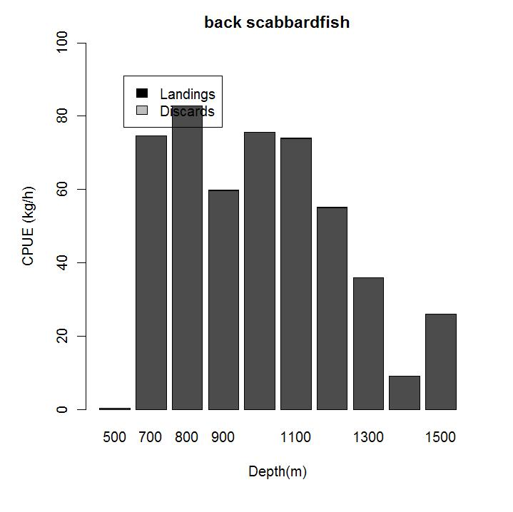 | 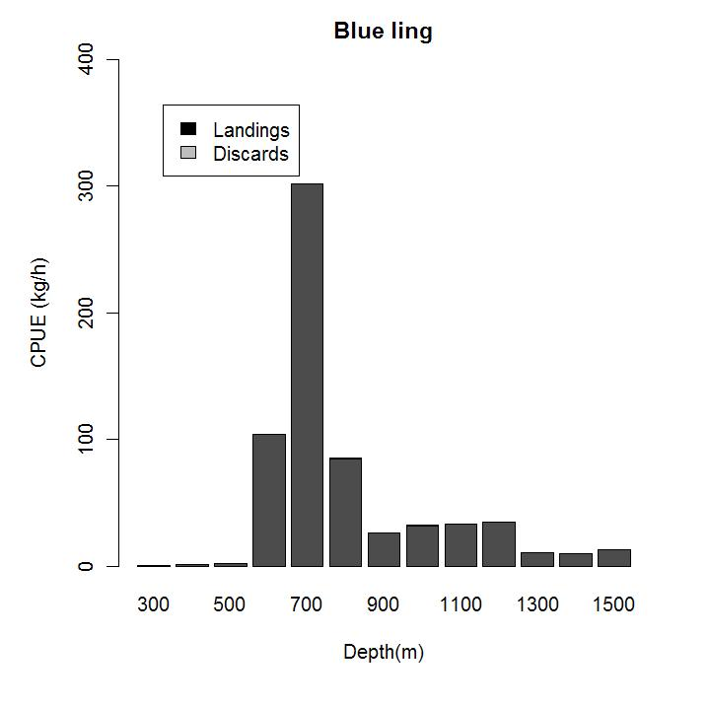
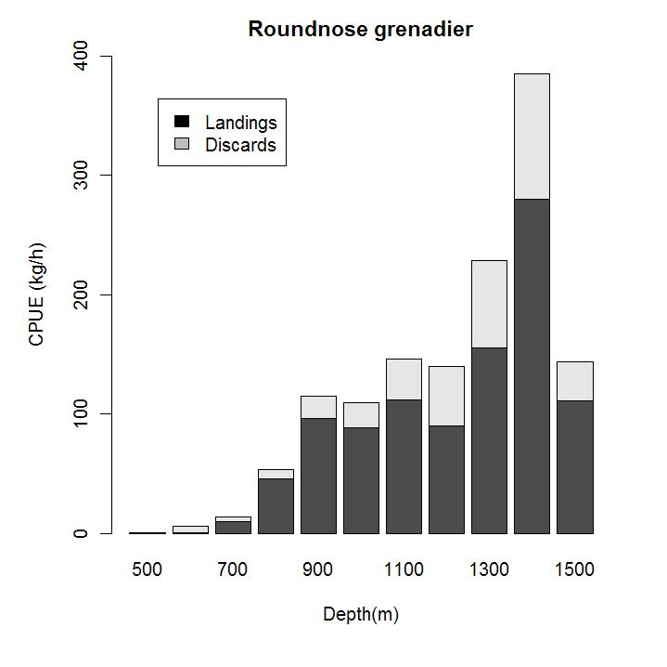 | 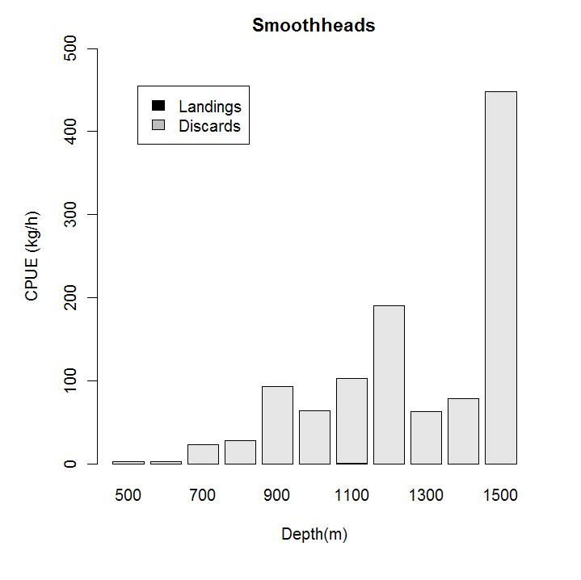
Figure 1. CPUE of black scabbardfish, blue ling , roundnose grenadier and smoothheads by depth.

CPUE according to target species
In the previous on-board observation format the haul data included the target species reported by the fishing master before hauling in the trawl. This data may no longer be available in recent observation were fishing station data are recorded according to DCF (Commission decision of 6 November 2008 pursuant to EC regulation 199/2008). Target species that were previously reported in French on-board observation as black scabbardfish, roundnose grenadier, blue ling, orange roughy or [miscellaneous] deep-water species will be now only available as deep-water species.

These analyse suggest that vessels may target one species rather than another. this might be based upon knowledge of fishing ground. For example, the CPUE of black scabbardfish when fishing for black scabbardfish is roughly twice to three times as much as the CPUE of black scabbardfish when fishing for roundnose grenadier (Figure 1). The CPUE of black scabbardfish seem low when fishing for blue and at a similar levels when fishing for roundnose grenadier of [miscellaneous] deep-water species (Figure 1).Fishing master might know that at a particular location a given species tends to be more abundant/dominant than elsewhere. further analysis may be required to analyses seasonality of this pattern.

Similar patterns are found with CPUE of roundnose grenadier (Figures 2 ), the CPUE is higher when fishing for roundnose grenadier or [miscellaneous] deep-water species, CPUE levels seems the same in both case. Lower CPUE are observed when fishing for blackscabbardfish and still lower when fishing for blue ling. Lastly CPUE of siki sharks are similar when fishing for roundnose grenadier and black scabbardfish and slightly higher when fishing for [miscellaneous] deep-water species (Figure 3).

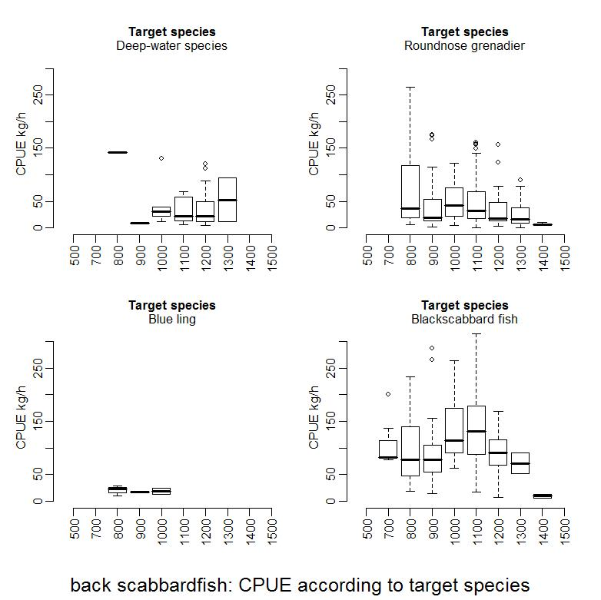
Figure 1. CPUE of black scabbardfish, depending on target species and fishing depth

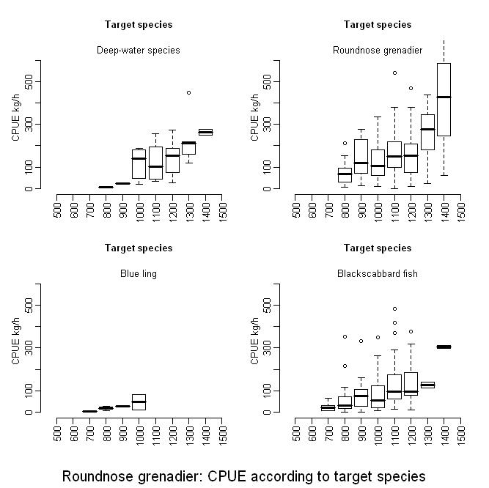
Figure 2. CPUE of roundnose grenadier, depending on target species and fishing depth

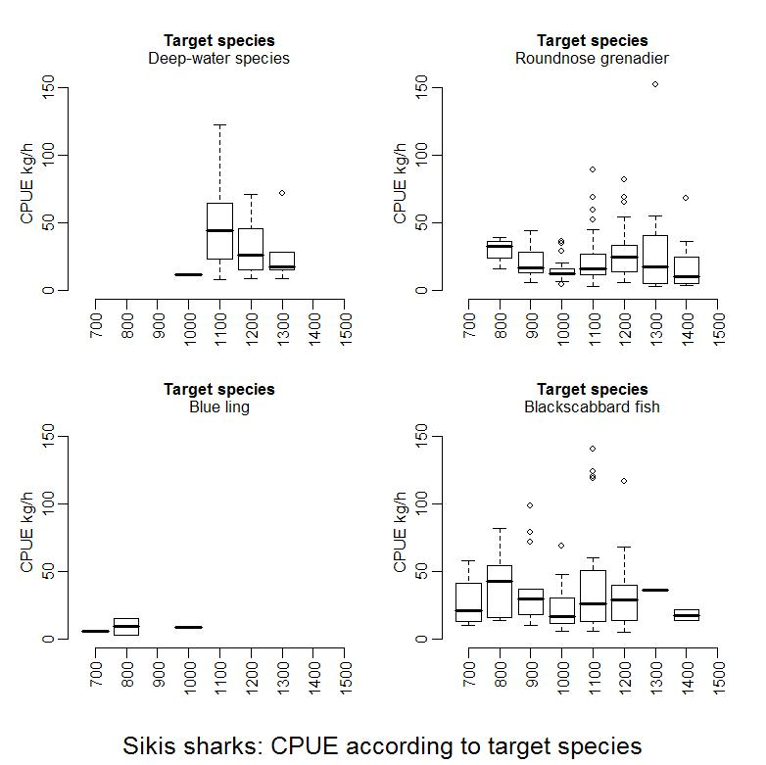
Figure 3. CPUE of siki sharks, depending on target species and fishing depth

1 For a definition of VMEs please see FAO TECHNICAL CONSULTATION ON INTERNATIONAL GUIDELINES FOR THE MANAGEMENT OF DEEP-SEA FISHERIES IN THE HIGH SEAS Rome, 4–8 February and 25–29 August 2008 ftp://ftp.fao.org/docrep/fao/011/i0605t/i0605t00.pdf
Moura, T., Figueiredo, I. and Gordo, L. 2008. Analysis of genetic structure of the Portuguese dogfish Centroscymnus coelolepis caught in the Northeast Atlantic using mitochondrial DNA (Control Region), Preliminary results. Working Document to ICES WGEF (Working Group on Elasmobranch Fish) meeting.
2 e.g. SPAOT – Spanish otter trawlers
3
3
3
3 Exploratory, Benchmark (to identify best practise), Update (repeat of previous years’ assessment using same method and settings but with the addition of data for another year).
developed by IPIMAR for Portuguese dogfish only, no model for leafscale gulper shark
5 PET – protected, endangered or threatened species.
4 Aspects to be reviewed for each marine strategy descriptor, may be further refined according to the outcome of on-going work from ICES/JRC task groups on these descriptors.
Council regulation (EC) No 199/2008 of 25 February 2008 concerning the establishment of a Community framework for the collection, management and use of data in the fisheries sector and support for scientific advice regarding the Common Fisheries Policy. Commission decision of 6 November 2008 adopting a multiannual Community programme pursuant to Council Regulation (EC) No 199/2008 establishing a Community framework for the collection, management and use of data in the fisheries sector and support for scientific advice regarding the common fisheries policy).
5 Grey market, that is where fish is distributed without sales records and is opaque to the competent authorities.
6 HACCP -Hazard Analysis Critical Control Points – analytical process and EU requirement relating to global trade and food quality.
7 Rights-based mechanism where right to fish is associated with a specific area where the management authority is at the local (TURF) level.
8 FAO website: http://www/fao.org/fishery

